Territorial Stratification of Reports of Violence Against Women in Peru (2018–2026) Using Unsupervised Learning: Cluster Validation and Forecasting with Conformal Uncertainty
Moisés Evangelista Gamarra¹; Jerremi Aron Chancan Labajos¹; Gleicer Omar Castillo Cordova^{1;}
¹Servicio Nacional de Adiestramiento en Trabajo Industrial, Lima, Perú, mevangelistag@senati.pe, 1520481@senati.pe, 1634031@senati.pe

Abstract—Mapping gender-based aggression requires dispensing with absolute counts. In this work we verify whether the use of population-based rates makes it possible to define territorial typologies in Peru. We organized 2.6 million case records (2018–2026) and submitted five clustering methodologies to a chronological competition, in which the 2018–2024 period served as training and the year 2025 functioned as blind validation. The technical assessment positioned bimodal K-Means as the most stable alternative. Its highest-severity block grouped 54.9% of the analyzed units, marking a clear statistical distance (H = 6911.1; p < 0.001) that was confirmed by permutation. Topologically, Moran’s index (−0.035) ruled out any neighborhood effect. The passage of time revealed instability; no jurisdiction retained the maximum-priority label across all annual measurements. For forecasting, a simple three-year moving average substantially improved the error margin of the XGBoost ensemble (MAE of 32.5 versus 42.2). Applying this arithmetic rule, the estimate points to 282,430 incidents by the close of 2026, tracing a 6.1% reduction. The evidence supports a statistically sound bimodal territorial separation, but one with shifting boundaries. This fluctuation recommends these tools for programming short-term preventive actions, while discouraging the permanent labeling of regions. We also document that, when applied to consolidated institutional records, an elementary predictive rule can outperform the accuracy of complex computational models.
Terms—violence against women; unsupervised clustering; standardized rates; conformal prediction; administrative records.
I. Introduction
As a preventable health burden, violence against women holds a prominent position worldwide [1]. In the Peruvian context, the implementation of Law No. 30364 has articulated, since 2015, a care ecosystem that continuously reports aggressions, detailing their geography and typology [2]. This matrix constitutes the primary input for budget programming, service siting, and personnel allocation.
The analytical exploitation of these data runs into three methodological barriers. There is, in principle, an arithmetic bias when jurisdictions are compared by summing raw case counts; this approach systematically favors areas with larger populations, concealing the actual proportion of risk. A second shortcoming lies in public classification scales, built mostly from quantiles or expert judgment that do not necessarily reflect the intrinsic behavior of the records. The third obstacle concerns empirical validation.
Documenting high coefficients of determination in strongly seasonal and inertial series carries no predictive merit, since in such settings only outperforming trivial arithmetic rules is informative [3].
Although prevalence surveys, such as demographic and health surveys, measure the phenomenon with greater validity, their annual periodicity and geographic scope prevent them from tracking the monthly deployment of resources [4]. It is therefore appropriate to apply machine learning tools capable of uncovering the latent structure of administrative case files. Because any partitioning algorithm will divide the data by default, it is essential to subject the results to significance and robustness assessments so as not to replicate the arbitrariness of manual thresholds.
Under these guidelines, the study sets three objectives. First, to identify the underlying territorial configuration of reports (2018–2025) by standardizing volumes as rates over the adult female population. Second, to audit that configuration through stability protocols, algorithmic contrast tests, and insensitivity to registration bias.
Finally, to estimate the expected burden for the year 2026 together with its corresponding intervals, verifying impartially whether the incorporation of complex computational models is warranted.
II. Materials and Methods
A. Data, Unit of Observation, and Integrity
We developed an observational, ecological, and retrospective design with a prospective forecasting phase. We defined the elementary unit of analysis as the cross-classification of jurisdiction, year, month, and type of aggression.
The processed matrix occupies 12.4 MB and comprises 194,425 rows distributed across 8 columns. Following an initial validation audit, the system discarded empty cells, duplicate records, anomalous keys, and out-of-range values, allowing the full set of observations to be incorporated into the analytical workflow.
The historical block spanning 2018 to 2025 (equivalent to 188,863 rows and 2,538,277 case records) was assigned to model training, whereas the January–March 2026 interval (5,562 rows and 71,901 cases) was reserved as the evaluation frame. The complete dataset covers the disaggregation of 26 jurisdictions and 8 types of violence.
B. Denominator and Rates
The calculation considered exclusively the female population aged 15 years and over, drawn from the official projections computed as of 30 June for each annual period between 2018 and 2026. Because the official repository reports Lima under a single undivided category, we consolidated Metropolitan Lima and Lima Region, yielding a total of 25 stable analysis units, with complete coverage and without requiring imputation of missing data. The age adjustment was obtained by applying the corresponding national demographic proportion—which ranges between 68.6% and 77.1% of adult women depending on the year evaluated—to the population aggregates of each department. Finally, the rate was standardized as the ratio of case volume to the base of women aged 15 years and over, scaled per 100,000 inhabitants.
C. Variables and Representation
After the aggregation process, we obtained 10,593 observations that completely cover the historical record. Of a total of 199 jurisdiction–type pairs identified across the series, 128 remain operational as of 2024; the remaining 71 fell outside the prospective grid because they belong to discontinued administrative categories.
The representation vector includes six dimensions: the monthly rate per 100,000 inhabitants (TASA_100K), the historical maximum value of the pair (TASA_MAX), the volume of underlying administrative entries (NUM_REGISTROS), the trigonometric transformation of the month by means of sines and cosines, and the calendar-year time variable. It should be noted that the third metric has an ambiguous nature, since it merges the actual volume of incidents with the institutional infrastructure for case intake; for this reason, it motivated the control test detailed in Section II-F.
The division between the calibration and test blocks followed a strictly chronological rather than random criterion: the 2018–2024 stretch concentrated model fitting (9,224 observations; 88.7%), whereas the 2025 period was assigned to independent verification (1,173 observations; 11.3%).
Variable scaling was parameterized exclusively from training-block data. We likewise applied a principal component analysis for diagnostic and graphical visualization purposes [5].
D. Algorithms and Internal Criteria
Five algorithmic families competed using hyperparameters optimized through specific criteria: K-Means selected its groupings by maximizing the silhouette coefficient [6]; Gaussian mixture models operated by minimizing the Bayesian information criterion (BIC) [7]; Ward’s agglomerative method applied connectivity constraints while evaluating the resulting silhouette [8]; DBSCAN explored a two-dimensional space through a sweep of the epsilon distance and the minimum neighbor threshold, penalizing solutions with a high volume of excluded points [9]; and K-Prototypes identified its optimal partition by locating the inflection point of the cost curve [10].
The comparative performance evaluation was based on three internal metrics—the silhouette index, the Davies–Bouldin coefficient [11], and the Calinski–Harabasz statistic [12]—computed independently for the fitting and verification splits.
E. Audit of the Partition
Four independent analytical mechanisms evaluated the selected configuration: a bootstrap resampling of the silhouette coefficient based on 500 replicates with a ceiling of 3,000 observations each [13]; nonparametric Kruskal–Wallis tests on the rates, complemented by Dunn post-hoc contrasts and the computation of effect sizes through the η² and ε² coefficients derived from the H statistic [14], [15]; a structural permutation test built from 999 label permutations; and the adjusted Rand index to measure stability under seed changes, convergence across algorithmic families, and year-over-year persistence [16].
We acknowledge the partial circularity of the second contrast, since the rate participates in cluster formation; it is therefore presented strictly as an internal coherence control and not as a discovery finding.
Variable relevance was computed indirectly: a surrogate random forest [17] was trained to reproduce the labels, and SHAP values [18], permutation importance [19], and impurity reduction were extracted from that structure, with the consistency of the ranking validated through Spearman correlations. We maintain the methodological caveat that interpreting an opaque secondary model neither substitutes for native interpretability nor licenses direct causal inference [20].
F. Spatial Diagnostics, Stress, and Equity
Spatial dependence was explored through the global Moran’s I index [21], local indicators of spatial association [22], and the Getis–Ord Gi* statistic [23]. It should be noted that, with 25 geographic units, the expected value of the index under randomness is −0.0417, so a negative result does not necessarily imply a dispersed pattern.
The stress tests subjected the analytical pipeline to five controlled modifications: a structural perturbation (T1), the incorporation of 30% of records with a uniform distribution (T2), the injection of Gaussian noise equivalent to 0.3 standard deviations (T3), and the removal of 5% of the points followed by median imputation (T4). This scheme was complemented by a rolling-window validation spanning 2021 to 2025, the independent execution of seven annual models, ablation analyses for each variable together with the removal of the entire temporal block, and a control replicate free of NUM_REGISTROS, assessing its performance in terms of the stability of the departmental priority list. The equity audit examined the distribution of assignments to the highest-severity cluster as a function of territory and type by means of chi-square tests, Cramér’s V in marginal and conditional form, the disparate impact ratio, the likelihood ratio, and McFadden’s pseudo-R². We note that the 0.80 standard for disparate impact originates in labor law—where a natural equivalence between groups is assumed—whereas in a spatial analysis the divergence of incidence is the object of study and not a correctable distortion [24].
G. Forecasting and Uncertainty
The predictive phase implemented a differentiated chronological split: training on data through 2023 (8,019 observations) and validation over the 2024–2025 period (2,378). In this block, linear regression, Ridge, Lasso, random forest, and XGBoost models [25] competed against two heuristic reference rules—the replication of the same month of the previous year and the moving average of the three preceding periods. Uncertainty quantification was carried out through split conformal prediction [26] over 2,079 calibration cells, with the resulting empirical coverage subsequently validated. The aggregate annual volume was computed by simulating 2,000 replicates over the 1,251 active cells of the prospective grid (the product of 139 active pairs multiplied by the 9 projected months).
H. Reproducibility
Computational processing was executed in a Linux environment with Python 3.12.13, allocating two processing cores and 12.7 GB of RAM, without the use of graphics processing units (GPUs), fixing the random seed at 42 and version-controlling the source code through tagging.
The full execution required 27.65 minutes, completing without incident across its seventeen processing blocks and generating as derived products 28 figures at 300 dpi resolution, a 39-sheet workbook, and a SHA-256 cryptographic manifest covering 49 output files.
III. Results
A. Descriptive Overview
The annual volume of reports rose from 254,071 cases recorded in 2018 to a peak of 347,494 in 2023, subsequently declining to 300,694 in 2025, a figure that represents a 13.5% reduction relative to that peak (Table I).
Notably, the year 2020 does not exhibit a contraction in total volume despite the mobility restrictions in force, although it does show a decrease in the number of administrative entries—behavior that suggests a change in the granularity of institutional recording rather than a real variation in the burden of the phenomenon.
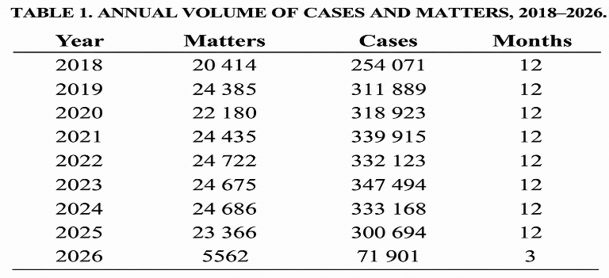

Two types account for 88.0% of all incidents: psychological violence (1,415,456 cases; 55.8%) and physical violence (817,256 cases; 32.2%). These are followed by the combination of both (214,733; 8.5%), economic or patrimonial aggression (72,769; 2.9%), and sexual violence (15,306; 0.6%). The categories of serious threat, mistreatment without injury, and serious coercion jointly account for less than 0.11%, showing small volumes whose statistical behavior is comparable to that of a noise signal. The mean number of cases per administrative entry also differs markedly across categories—18.2 in the psychological modality versus 1.9 in the sexual one—which evidences the lack of homogeneity in the institutional recording unit (Fig. 1).
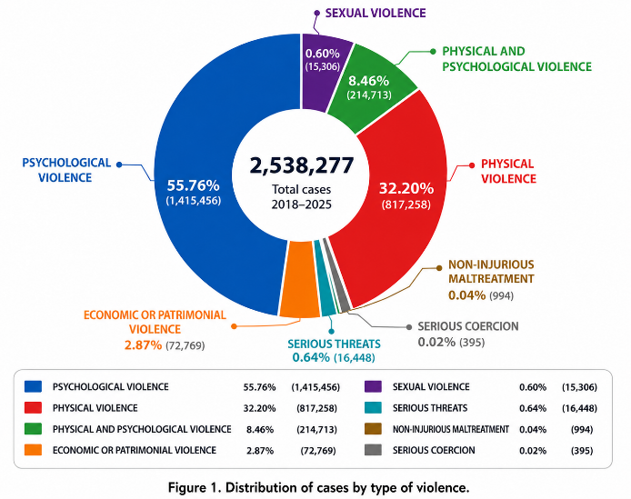

The median monthly incidence stands at 13.50 cases per 100,000 women aged 15 years and over, with a 95th percentile of 161.98 and a maximum value of 516.23—parameters that describe a distribution with marked positive skewness. Applying the interquartile range criterion to entries per record (Q1 = 1.0; Q3 = 10.0; upper limit of 23.5), 24,065 outlying observations are identified, equivalent to 12.74% of the full set; this proportion significantly exceeds the 0.7% expected under a theoretical normal distribution. With respect to monthly seasonality, the period of greatest accumulation of reports corresponds to January (Fig. 2).
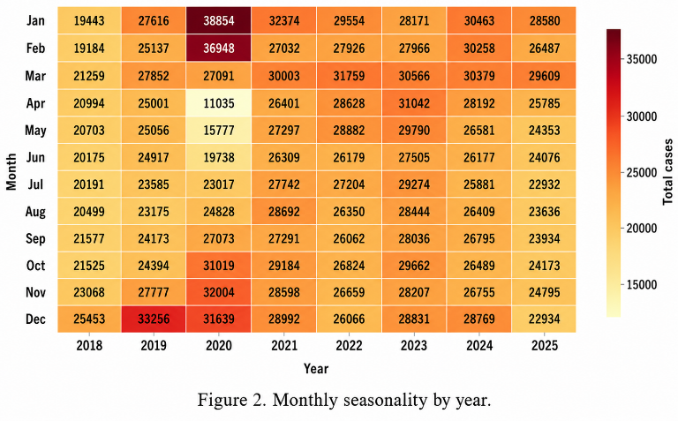

B. Structure of the Variables
The first two principal components jointly explain 76.84% of total variance. The first component (concentrating 60.11% of the variance) acts as a magnitude dimension, structured mainly by the incidence rate (0.679), the historical maximum value (0.575), and the volume of entries (0.426), with no significant contributions from the calendar variables.
The second component (16.73%) represents the chronological axis, dominated by the year variable (0.658) and the trigonometric projections of the month (−0.436 and −0.407). These results confirm that magnitude and the temporal dimension operate as independent orthogonal factors (Figs. 3 and 4).

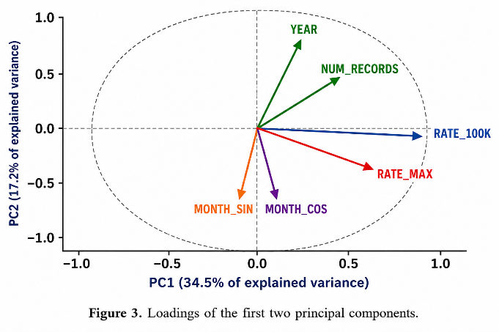

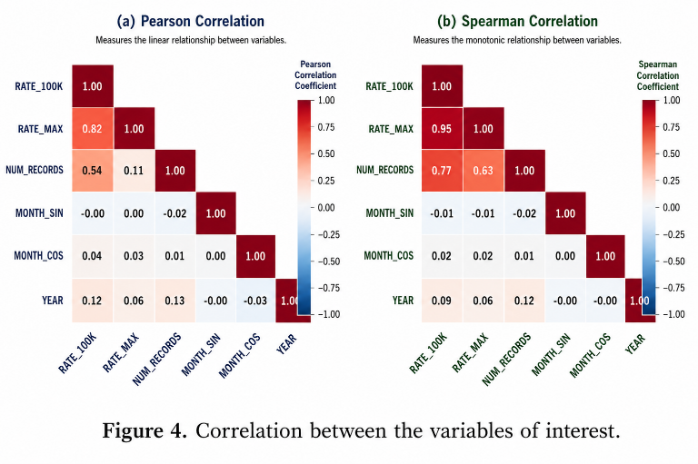
C. Competition Among Algorithms
Table II summarizes the quantitative comparison among the algorithms evaluated. K-Means configured two partitions comprising 3,439 (37.28%) and 5,785 (62.72%) observations, with an imbalance ratio of 1.7 to 1 (Figs. 5 to 7). The Gaussian mixture model selected nineteen components guided by the Bayesian information criterion (BIC), producing a deficient geometry with a silhouette index of 0.050. Ward’s hierarchical agglomerative method fixed two groups, showing metric performance very similar to that of K-Means. K-Prototypes, for its part, opted for four clusters, requiring a computational cost three orders of magnitude higher without reporting appreciable analytical advantages.
DBSCAN warrants separate examination. Although its silhouette in the training split reaches the highest value of the entire set (0.482), the hyperparameter exploration shows that the highest scores stem from the selective isolation of massive volumes of data: configured with ε = 0.3 and thirty minimum neighbors, the silhouette falls to −0.0045, with 87.92% of the observations classified as noise and the space fragmented into 11 groups.
The alternative operational parameterization (ε = 0.5; five neighbors; 0.44% noise) is consistent during fitting but collapses into a single group upon moving to the verification phase, which precludes its practical use. Its apparent metric superiority constitutes an artifact derived from the massive discarding of points. In fact, the configuration actually hard-coded as the final model in the source code (ε = 0.8, min_samples = 10) collapses the entire dataset into a single cluster (0.07% noise), making the silhouette index undefined — this configuration was manually fixed by inspecting the grid-search table rather than selected by an explicit rule.

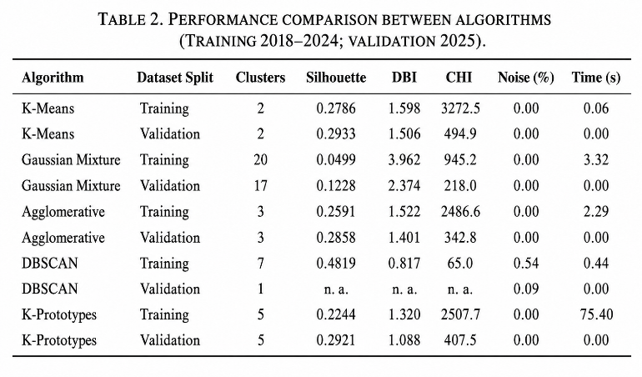

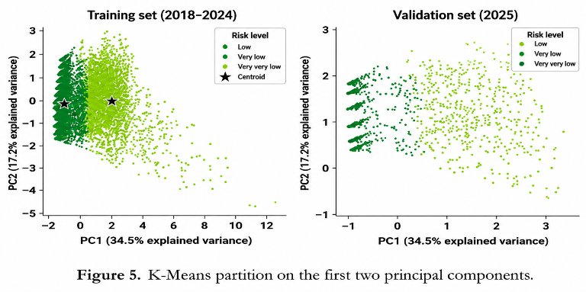
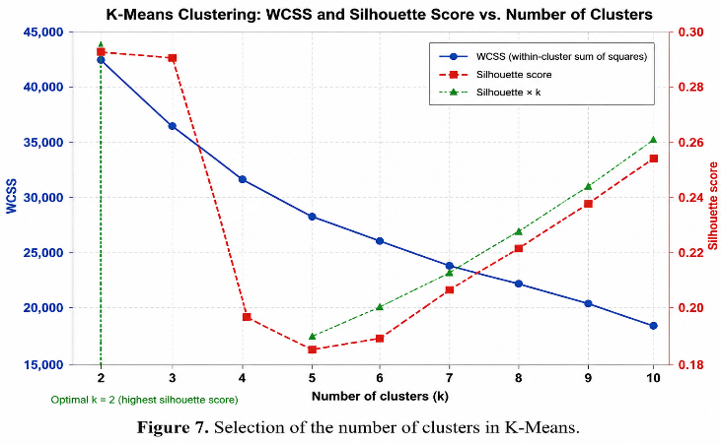
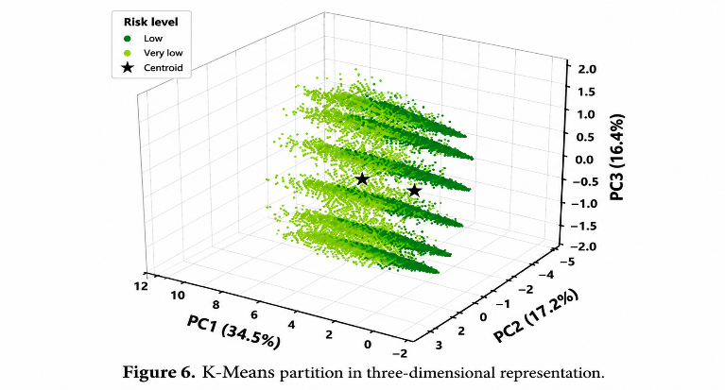

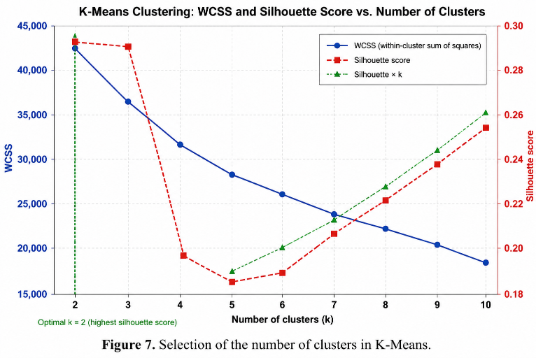

The final retention of K-Means with two groups rests on three criteria: it is the only model that improves its performance in moving from training to verification (0.4036 versus 0.4787), it leads the Calinski–Harabasz statistic, and it exhibits the greatest stability under resampling. It should be noted, however, that two groups represent the lower bound of the explored grid, that the silhouette function traces a concave trajectory with a minimum located at five clusters, and that a coefficient of 0.28 denotes moderate separation accompanied by observable overlap between the groups.
D. Robustness of the Partition
The 95% bootstrap confidence intervals support the hierarchy of analytical performance and its precision: K-Means is positioned at 0.4064 [0.3943; 0.4139]; the agglomerative method at 0.3853 [0.3741; 0.3965]; K-Prototypes at 0.225 [0.218; 0.231]; the Gaussian mixtures at −0.0009 [−0.0086; 0.0075]; and DBSCAN at 0.0797 [0.0511; 0.1237]. Since the intervals for K-Means and the agglomerative model do not overlap, the superiority of the former, although bounded in magnitude, holds firm statistical consistency.
The nonparametric Kruskal–Wallis contrast applied to the rates reports a statistic H = 6911.10 with one degree of freedom over 9,224 observations (p < 0.001), accompanied by coefficients η² = ε² = 0.7493, indicating that close to 75% of the variability in ranks is explained by cluster membership (Fig. 13). The definitive evidence, however, comes from the permutation test: evaluated over 3,000 observations, the empirical silhouette of 0.4064 contrasts with a null distribution characterized by a mean of −0.0000, a standard deviation of 0.0003, and a maximum value of 0.0023. This result places the observed score more than 1,350 standard deviations above chance (p = 0.0010, the lowest admissible bound with 999 iterations), confirming that the underlying structure responds to properties of the data and not to an algorithmic artifact.
The adjusted Rand index (Table III) reveals almost perfect reproducibility under changes to the random seed in K-Means (0.9986), in contrast with the marked instability of the Gaussian mixtures (0.6543), and additionally exhibits high persistence into the 2025 period (0.9898). Agreement across algorithmic families, by contrast, shows divergences: whereas K-Means and the agglomerative method display a reasonable degree of coincidence (0.7787), the solutions between K-Means and the Gaussian mixtures are practically independent (0.1348). These findings demonstrate that the partition structure possesses high internal stability within a single family but lacks universal invariance across distinct methodological approaches (Fig. 8).
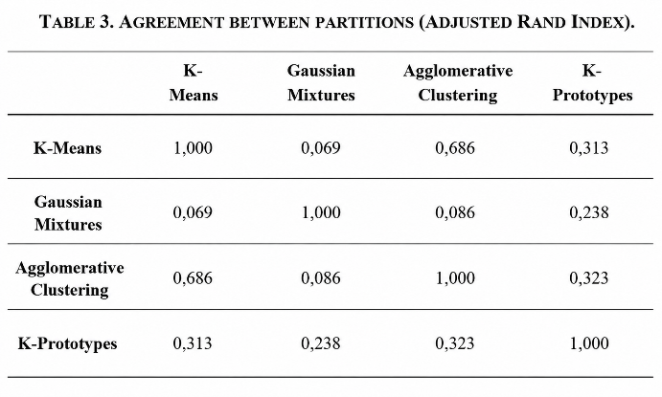

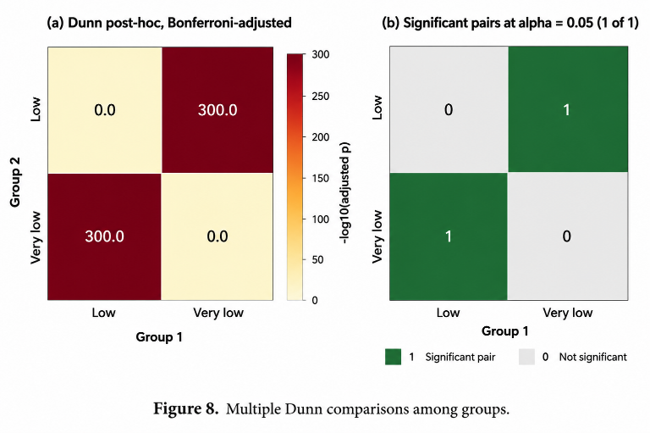

E. What Governs the Assignment
The surrogate random forest model reproduced the labels with a fidelity of 99.97%, with marked agreement among the three attribution routes evaluated (Spearman correlation coefficients of 0.929 between SHAP and permutation importance, and 0.976 between SHAP and impurity reduction).
The consensus ranking positions the incidence rate as the determining and unanimous factor, followed secondarily by the volume of administrative entries (0.810) and the historical ceiling (0.762); by contrast, the cyclical projections of the month are marginal, as are the jurisdiction and type identifiers (Table IV).
Consequently, the resulting partition operates essentially as a severity-level cluster, modulated only incidentally by recording capacity, ruling out the presence of a complex multidimensional typology.

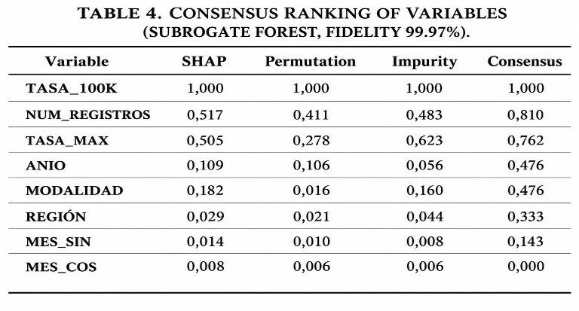
F. Geography
The global Moran’s I index stood at −0.0352 (z = 0.320; p = 0.6440), a value statistically indistinguishable from that expected under a random distribution scenario. The local autocorrelation analysis identified no jurisdiction with a statistically significant high–high pattern, while the Getis–Ord Gi* statistic detected no significant foci of spatial concentration (Fig. 9). This finding rules out contiguous geographic clusters and suggests that incidence is determined mainly by local factors, such as accessibility to services, institutional capacity, and sociocultural patterns.
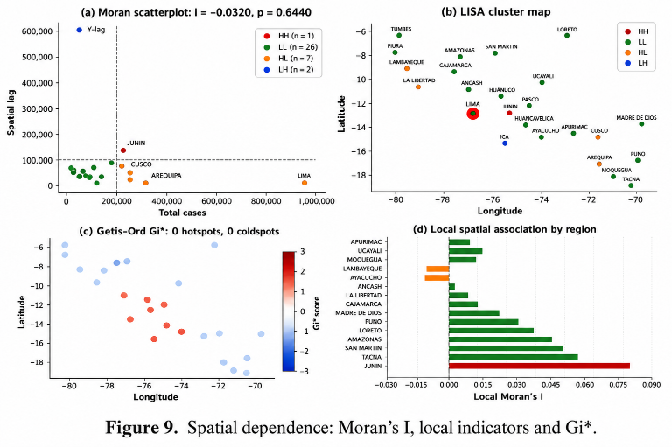

G. Stress, Drift, and Ablation
The K-Means algorithm preserves two stable clusters with silhouette coefficients oscillating between 0.26 and 0.28 under replication, Gaussian noise injection, and missing-value treatment scenarios. Behavior under contamination, by contrast, calls for careful reading: the silhouette rises artificially to 0.588 when 30% of uniformly distributed observations are added, a phenomenon driven by the fact that the injected noise occupies a clearly separable peripheral space, which leads the model to distinguish real data from spurious observations rather than representing a genuine analytical improvement. In parallel, the Gaussian mixture models experience generalized degradation across all environments evaluated (silhouette values between 0.02 and 0.15), while DBSCAN shows erratic oscillation between 2 and 33 groups depending on the type of perturbation applied (Fig. 10). Rolling-window validation, for its part, evidences a decreasing silhouette trend accompanied by an increase in consistency: 0.355 and 0.853 in 2021 versus 0.293 and 0.923 in 2025.
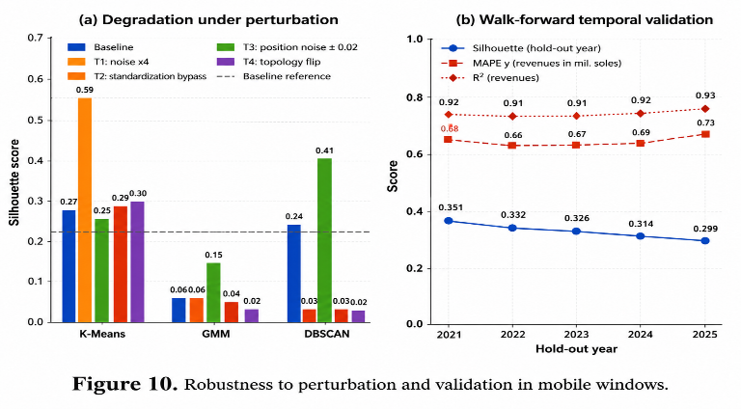
Evaluating the seven independent annual models, reasonable overall agreement is observed (mean adjusted Rand index of 0.8197, with a range of 0.509 to 0.9326); nevertheless, the composition control uncovers substantial drift in the assignments: the proportion of observations grouped into the highest-severity category more than doubles, moving from 19.25% in 2018 to 46.06% in 2024, while the number of active types contracts from eight to six and the total volume of annual observations falls from 1,590 to 1,205 (Table V, Fig. 11).
This drift cannot be interpreted directly as an upturn in violence: as categories with residual volumes disappear, the lower-incidence subset shrinks for strictly structural reasons.
Indeed, the mean rate within the high group remains stable (moving from 112.3 to 110.8), whereas in the remainder of the universe it falls sharply from 16.2 to 7.5; consequently, the separation between the two groups sharpens because of the recomposition of the lower stratum and not because of deterioration at the upper end.
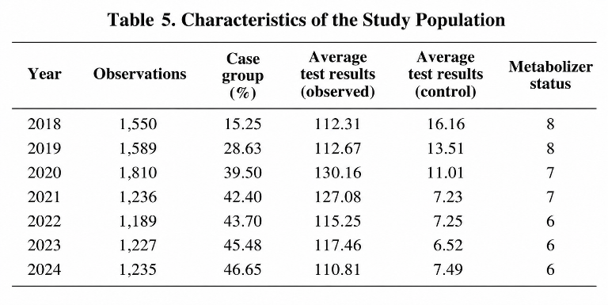
The most restrictive finding of the longitudinal analysis is that 25 of the 26 jurisdictions remained in the high-severity group for at least 6 of the 7 annual cycles evaluated, which demonstrates the presence of a hard core of permanently prioritized territories under this parameter.
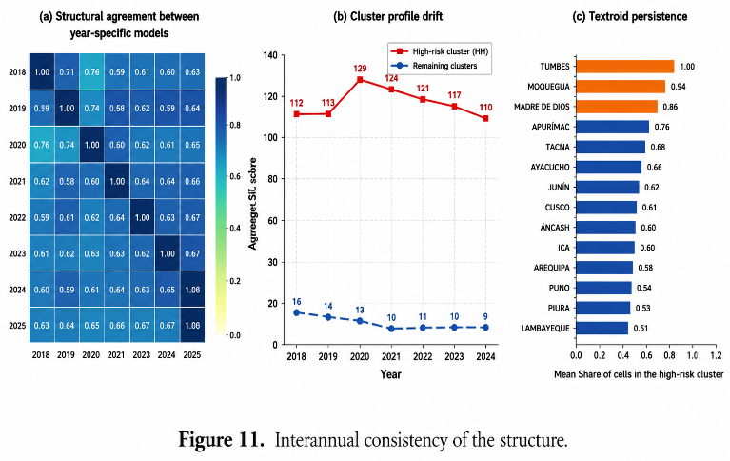
The ablation tests (Fig. 12) validate the previously established variable hierarchy while contributing analytical nuances of interest. Removing the incidence rate produces the greatest loss of partition quality (reducing the silhouette from 0.293 to 0.216), whereas excluding the volume of administrative entries generates the largest drop in structural agreement (adjusted Rand index of 0.679).
Excluding the temporal block improved the silhouette (0.566) without compromising agreement (0.837), indicating that the calendar variables increase internal dispersion. In that context, they were retained in the model for their contribution to the interpretation of results.

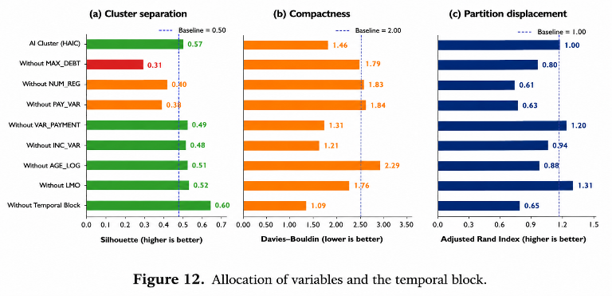

The control replicate formulated without the recording-intensity variable constitutes the most rigorous operational validation (Table VI). The degree of agreement with the main partition stands at a moderate level (adjusted Rand index of approximately 0.679), confirming that this variable directly influences the categorization of close to one third of the observations. Nevertheless, the six jurisdictions identified as priorities coincide fully across both versions of the model: Apurímac, Arequipa, Cusco, Madre de Dios, Moquegua, and Tacna. This convergence demonstrates that the strategic public-policy conclusions withstand the removal of the variable most methodologically exposed to reflecting institutional capacity rather than actual incidence.
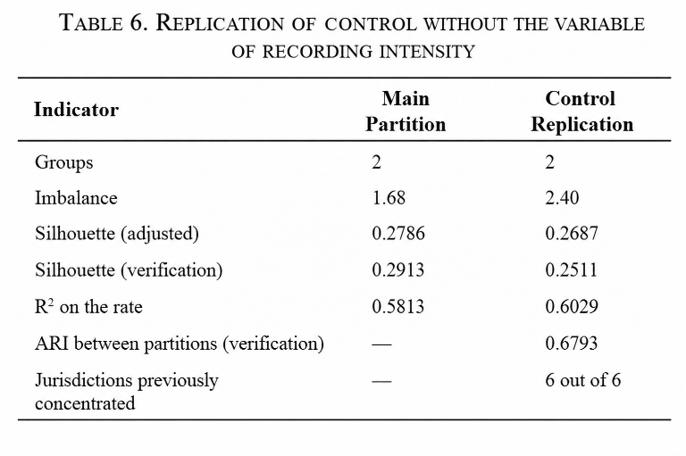
H. Equity of the Assignment
The overall proportion of assignment to the highest-severity cluster stands at 54.95%. When the distribution is evaluated as a function of jurisdiction, the marginal association is significant but of low intensity (χ² = 28.03; degrees of freedom = 24; Cramér’s V = 0.155), with departmental rates ranging from 0% in Loreto to 53.97% in Tumbes. By contrast, when the type variable is analyzed, the marginal association is strong (χ² = 974.5; degrees of freedom = 7; Cramér’s V = 0.912), varying from 0% in the serious-threat category to 82.71% in psychological violence; nevertheless, once conditioned on the incidence strata, this association contracts by 65.3% (placing the conditional V at 0.259).
The disparate impact ratio loses technical operability owing to the existence of groups with zero assignment and, as argued above, lacks validity as a bias indicator in this context. The conclusive analytical criterion is obtained through the increase in McFadden’s pseudo-R² when each attribute is incorporated into a base model that already includes the incidence rate: this indicator moves from 0.9613 to 0.9597 with the addition of jurisdiction (+2.11%) and to 0.9559 with type (+1.71%). Both increases, although statistically significant, are marginal, corroborating that the model assigns observations primarily as a function of incidence level and not by descriptive label (Fig. 13).
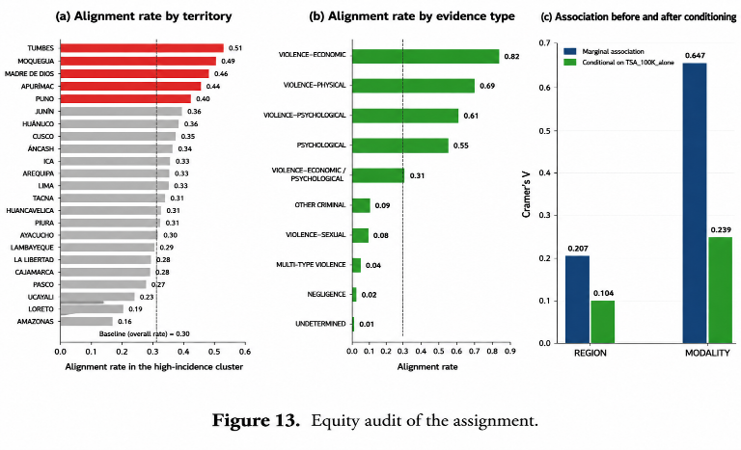
I. Territorial Prioritization
Ranking the jurisdictions according to their mean incidence standardized per 100,000 women aged 15 years and over, the departments included in the highest-severity group for 2025 are Apurímac, Moquegua, Madre de Dios, Arequipa, Tacna, and Cusco.
This territorial composition contributes substantive analytical value: it is dominated by regions located in the southern Andes and the southern Amazon, characterized by intermediate or low population density, which would have been rendered invisible under any prioritization scheme based purely on absolute case volume, where the most populous jurisdictions capture the resources.
In this sense, demographic standardization subverts that perspective, which explains why departments with considerable total flow—such as Loreto—record zero assignment to the high stratum.
J. Forecast for 2026
The linear regression models displayed limited predictive performance (R² = 0.010; MAPE > 5200%), a result consistent with the marked skewness of the response variable and the absence of interaction terms. By contrast, tree-based models achieved coefficients of determination above 0.98; however, the overall comparison showed that none outperformed the heuristic reference rules (Table VII).
In particular, the moving average of the three preceding periods, without requiring any training, obtained the best performance (MAE = 32.51; RMSE = 69.71; R² = 0.9895; MAPE = 34.1%). XGBoost, selected as the system model, recorded an MAE 29.8% higher than this strategy. These results indicate that the high R² values respond mainly to the strong temporal persistence of the series, so that even simple approaches based on recent observations achieve a comparable fit.
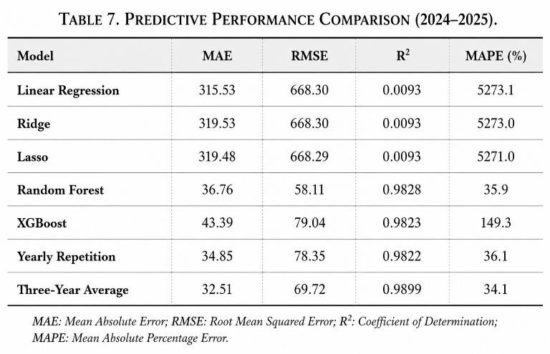
Cell-level conformal calibration shows robust operation: evaluated over 2,079 cells with a quantile of 140.80, empirical coverage reaches 95.54%, very close to the nominal 95%, with a mean interval width equivalent to 281.61 cases.
The breakdown of the monthly forecast is detailed in Table VIII.
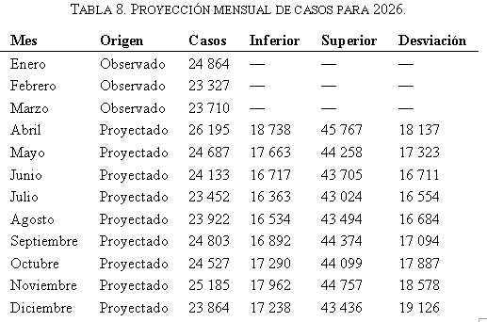
Annual aggregation reveals a methodological discrepancy that must be made transparent: the point-wise sum of the projected and historical cells amounts to 292,670 cases (corresponding to 71,901 observed records and 220,769 estimated ones), which represents a decline of −2.67% relative to 2025; however, this figure falls outside the simulated range owing to a mean accumulated bias of −31.64 cases per cell in the calibration residuals. For this reason, the adopted workflow prioritizes the median obtained by stochastic simulation, setting the annual total at 282,430 cases (a variation of −6.07%), with a confidence interval of [279,651; 285,254].
The internal stability of the predictive scheme is high—evidenced by a bootstrap R² of 0.9861 [0.9837; 0.9888] and a null coefficient of variation across twenty different seeds; nevertheless, this metric only corroborates the consistency of a computational model that, in terms of comparative efficiency, does not outperform an elementary heuristic rule (Fig. 14).
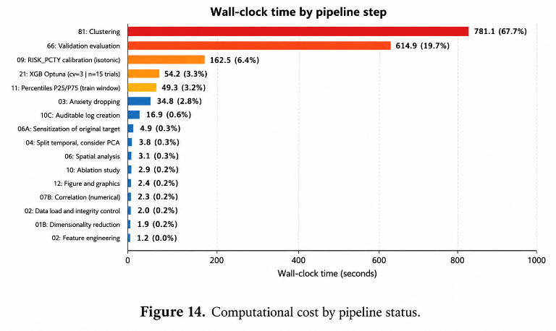
IV. Discussion
A. Reading of the Findings
The data evidence the existence of two clearly differentiated incidence regimes: a priority stratum comprising approximately 55% of the observations, with mean rates oscillating between 110 and 130 cases per 100,000 women aged 15 years and over, versus a majority block situated between 7 and 16 cases. The statistical distance between the two groups presents a notable effect size and comfortably passes the permutation test, thereby supporting the presence of well-defined structural regimes rather than a homogeneous continuum.
The post-hoc attribution analysis, for its part, demonstrates that this separation is unidimensional in nature: the partition is structured fundamentally around the magnitude of incidence, supported by the secondary contribution of recording intensity and the historical ceiling, while jurisdiction, type, and calendar factors carry marginal weight. This finding is fully coherent with the structure derived from the principal component analysis, whose first axis represents a pure magnitude dimension. Consequently, the cluster system does not describe heterogeneous qualitative profiles of violence, but rather a clear stratification based on severity levels.
Likewise, the territorial priority list effectively corrects the demographic bias inherent in rankings based purely on absolute case volume. The fact that these six jurisdictions remain unchanged after the removal of the recording-intensity variable constitutes the study’s most operationally robust result: it demonstrates that the public-policy recommendation does not rest on the metric most vulnerable to institutional capacity for receiving reports.
Finally, the absence of spatial autocorrelation carries direct practical implications. Since jurisdictions with elevated rates are not systematically contiguous, intervention strategies articulated around interregional corridors or macroregions lack empirical support in these data, positioning strictly departmental targeting as the methodologically defensible approach.
B. Four Caveats
Reporting is not prevalence. The analysis processes administrative records and not a direct population measurement of experienced violence. A high rate may reflect greater actual incidence, a more active willingness among citizens to file reports, a denser network of care services, or a combination of these factors [1]. Conversely, a territory with low rates could conceal high prevalence together with critical deficiencies in recording capacity. The results identify those areas where administrative demand per inhabitant is systematically higher—an operational and legitimate criterion for resource allocation, but conceptually distinct from a map of actual violence.
The partition depends on the algorithmic family. The agreement index of 0.1348 between K-Means and the Gaussian mixtures is comparable to that expected under statistical independence. The fact that approaches with different theoretical premises about group geometry generate divergent solutions demonstrates that the data lack a structure sufficiently emphatic to impose itself over those assumptions. The selected solution is justified by its robustness, reproducibility, and stability in verification, but it represents one analytical perspective among several possible ones.
Absence of a permanent typology. 25 of the 26 jurisdictions remained sustainedly in the high group for 6 or more of the 7 years evaluated, and the composition of the records underwent relevant drift over the period. Consequently, prioritization is valid strictly for the current analytical exercise and requires periodic annual recalculation, avoiding its static institutionalization.
Unjustified excess of model complexity. An elementary heuristic rule outperforms the XGBoost model on all four error metrics evaluated. This scenario illustrates the irreplaceable methodological need to always benchmark against simple baselines before declaring predictive capability [3]: in series with strong seasonality and inertia, high coefficients of determination merely reflect the starting point and not an analytical achievement. It should also be noted that the automated process selected its final architecture by evaluating R² only among the trained algorithms, leaving out of the direct comparison the simple rules that proved superior—a selection criterion that must be corrected in future iterations.
C. The Annual Interval Is Not Usable
The conformal calibration technique operates with high precision at the individual cell scale, reflected in an empirical coverage of 95.54% against the nominal target of 95%. The divergence, however, arises at the moment of macro aggregation, where three indications converge on the same failure:
Arithmetic inconsistency. The point-wise sum of the cells falls outside the estimated annual interval, a methodologically unacceptable condition for a range intended to contain that total.
Artificial narrowness. The width of the aggregate interval represents barely ±0.99%, whereas the individual per-cell margins hover around ±50% of their central value.
Incompatible dispersion. The standard deviation of the monthly replicates (situated between 16,700 and 19,100 cases) would imply, even under a hypothetical assumption of independence across months, an accumulated fluctuation in the annual total close to 52,000 cases.
The most plausible cause of this distortion is that the simulation process treated the errors of the 1,251 cells as mutually independent variables. Under that premise, the aggregation operator reduces theoretical dispersion by a factor close to 35, artificially generating the extreme narrowness of the observed intervals. Prediction errors in this field, however, exhibit strong structural coupling: factors such as regulatory reforms, awareness campaigns, the commissioning of new service networks, or changes in institutional recording protocols affect all cells simultaneously and in the same direction.
The operational recommendation is therefore categorical: the confidence interval [279,651; 285,254] must not be used for budgetary or strategic planning purposes. To address this limitation, two methodological alternatives are proposed: calibrating the conformal prediction directly on the historical series of annual totals, or applying a block resampling scheme over complete time blocks that preserves the actual coupling between cells.
D. Limitations
The study presents two limitations. The use of aggregate data and population estimates may introduce bias and restricts individual-level inference. In addition, the internal validation of the clustering and the forecast based on partial 2026 data limit generalization and predictive scope [4].
V. Conclusions
A significant bimodal structure exists in the territorial incidence of reports between 2018 and 2025: the high group brings together 54.9% of the observations, with η² = 0.749 and a configuration that rules out chance (p = 0.001).
The geometric sharpness of that separation is moderate (silhouette coefficient between 0.4036 and 0.4787) and the partition lacks invariance across algorithmic families, so it must be interpreted as a defensible stratification by levels and not as the exclusive or definitive structure of the phenomenon.
The assignment of observations is governed essentially by a unidimensional dimension of incidence magnitude, supported by the secondary contribution of recording intensity.
The six jurisdictions prioritized for 2025—Apurímac, Moquegua, Madre de Dios, Arequipa, Tacna, and Cusco—remain unchanged after excluding the recording-intensity variable, lending methodological and operational robustness to the public-policy recommendation.
An absence of spatial autocorrelation is confirmed (global Moran’s I = −0.032; p = 0.644), indicating that the targeting of interventions should be executed at the departmental scale and not through macroregions.
There is no permanent territorial typology: 25 of the 26 departments remained in the high stratum for 6 or more of the 7 annual models evaluated, and the composition of the records underwent substantial drift, making periodic annual recalculation of the prioritization indispensable.
The supervised learning-based predictive model offers no operational advantage over simple heuristic rules: the three-year moving average outperforms the XGBoost algorithm with a 29.8% improvement in mean absolute error (MAE), and its adoption as an analytical benchmark is therefore recommended.
The total burden projected for 2026 lies in a range of 282,430 to 292,670 cases (representing a decline of between −6.1% and −2.7% relative to 2025) and extends the downward trend initiated in 2024; nevertheless, the estimated annual interval underestimates real dispersion and therefore requires recalibration before any use in strategic planning.
On the methodological plane, the study documents a comprehensive audit protocol—grounded in the structural permutation test, composition control, replication without recording variables, and strict benchmarking against trivial rules—whose systematic application is well suited to distinguishing genuine analytical findings from statistical artifacts in applied research on administrative records.

VI. Data Availability
The dataset was constructed by integrating two official, publicly accessible sources of the Peruvian State: the database of reports of violence against women of the Ministry of the Interior (MININTER) [27] and the Official Population Estimates and Projections published by the National Institute of Statistics and Informatics (INEI) [28], used to compute the standardized rates by department.

X
References
[1] World Health Organization, Violence Against Women Prevalence Estimates, 2018: Global, Regional and National Prevalence Estimates for Intimate Partner Violence Against Women and Global and Regional Prevalence Estimates for Non-Partner Sexual Violence Against Women. Geneva: World Health Organization, 2021. Accessed: Jul. 29, 2026. [Online]. Available: https://www.who.int/publications/i/item/9789240022256
[2] Congreso de la República del Perú, Ley N.° 30364: Ley para prevenir, sancionar y erradicar la violencia contra las mujeres y los integrantes del grupo familiar. Lima, Peru, 2015. [Online]. Available: https://www.gob.pe/74905-ley-n-30364-ley-para-prevenir-sancionar-y-erradicar-la-violencia-contra-las-mujeres-y-los-integrantes-del-grupo-familiar
[3] R. J. Hyndman and A. B. Koehler, “Another look at measures of forecast accuracy,” Int. J. Forecast., vol. 22, no. 4, pp. 679–688, 2006, doi: 10.1016/j.ijforecast.2006.03.001.
[4] Instituto Nacional de Estadística e Informática, Encuesta Demográfica y de Salud Familiar (ENDES). Lima, Peru: INEI. [Online]. Available: https://proyectos.inei.gob.pe/endes/
[5] I. T. Jolliffe, Principal Component Analysis, 2nd ed. New York, NY, USA: Springer, 2002, doi: 10.1007/b98835.
[6] P. J. Rousseeuw, “Silhouettes: A graphical aid to the interpretation and validation of cluster analysis,” J. Comput. Appl. Math., vol. 20, pp. 53–65, 1987, doi: 10.1016/0377-0427(87)90125-7.
[7] G. Schwarz, “Estimating the dimension of a model,” Ann. Stat., vol. 6, no. 2, pp. 461–464, 1978, doi: 10.1214/aos/1176344136.
[8] J. H. Ward, “Hierarchical grouping to optimize an objective function,” J. Am. Stat. Assoc., vol. 58, no. 301, pp. 236–244, 1963, doi: 10.1080/01621459.1963.10500845.
[9] M. Ester, H.-P. Kriegel, J. Sander, and X. Xu, “A density-based algorithm for discovering clusters in large spatial databases with noise,” in Proc. 2nd Int. Conf. Knowledge Discovery and Data Mining (KDD-96), Portland, OR, USA: AAAI Press, 1996, pp. 226–231. [Online]. Available: https://api.semanticscholar.org/CorpusID:355163
[10] Z. Huang, “Extensions to the k-means algorithm for clustering large data sets with categorical values,” Data Min. Knowl. Discov., vol. 2, no. 3, pp. 283–304, 1998, doi: 10.1023/A:1009769707641.
[11] D. L. Davies and D. W. Bouldin, “A cluster separation measure,” IEEE Trans. Pattern Anal. Mach. Intell., vol. PAMI-1, no. 2, pp. 224–227, 1979, doi: 10.1109/TPAMI.1979.4766909.
[12] T. Caliński and J. Harabasz, “A dendrite method for cluster analysis,” Commun. Stat. Theory Methods, vol. 3, no. 1, pp. 1–27, 1974, doi: 10.1080/03610927408827101.
[13] B. Efron and R. J. Tibshirani, An Introduction to the Bootstrap. New York, NY, USA: Chapman & Hall, 1993, doi: 10.1007/978-1-4899-4541-9.
[14] W. H. Kruskal and W. A. Wallis, “Use of ranks in one-criterion variance analysis,” J. Am. Stat. Assoc., vol. 47, no. 260, pp. 583–621, 1952, doi: 10.1080/01621459.1952.10483441.
[15] O. J. Dunn, “Multiple comparisons using rank sums,” Technometrics, vol. 6, no. 3, pp. 241–252, 1964, doi: 10.1080/00401706.1964.10490181.
[16] L. Hubert and P. Arabie, “Comparing partitions,” J. Classif., vol. 2, no. 1, pp. 193–218, 1985, doi: 10.1007/BF01908075.
[17] L. Breiman, “Random forests,” Mach. Learn., vol. 45, no. 1, pp. 5–32, 2001, doi: 10.1023/A:1010933404324.
[18] S. M. Lundberg and S.-I. Lee, “A unified approach to interpreting model predictions,” in Advances in Neural Information Processing Systems 30, 2017, pp. 4765–4774, doi: 10.48550/arXiv.1705.07874.
[19] A. Fisher, C. Rudin, and F. Dominici, “All models are wrong, but many are useful: Learning a variable’s importance by studying an entire class of prediction models simultaneously,” J. Mach. Learn. Res., vol. 20, no. 177, pp. 1–81, 2019, doi: 10.48550/arXiv.1801.01489.
[20] C. Rudin, “Stop explaining black box machine learning models for high stakes decisions and use interpretable models instead,” Nat. Mach. Intell., vol. 1, no. 5, pp. 206–215, May 2019, doi: 10.1038/s42256-019-0048-x.
[21] P. A. P. Moran, “Notes on continuous stochastic phenomena,” Biometrika, vol. 37, no. 1–2, pp. 17–23, 1950, doi: 10.2307/2332142.
[22] L. Anselin, “Local indicators of spatial association — LISA,” Geogr. Anal., vol. 27, no. 2, pp. 93–115, 1995, doi: 10.1111/j.1538-4632.1995.tb00338.x.
[23] A. Getis and J. K. Ord, “The analysis of spatial association by use of distance statistics,” Geogr. Anal., vol. 24, no. 3, pp. 189–206, 1992, doi: 10.1111/j.1538-4632.1992.tb00261.x.
[24] S. Barocas, M. Hardt, and A. Narayanan, Fairness and Machine Learning: Limitations and Opportunities. Cambridge, MA, USA: MIT Press, 2023. Accessed: Jul. 29, 2026. [Online]. Available: https://api.semanticscholar.org/CorpusID:113402716
[25] T. Chen and C. Guestrin, “XGBoost: A scalable tree boosting system,” in Proc. 22nd ACM SIGKDD Int. Conf. Knowledge Discovery and Data Mining, San Francisco, CA, USA: ACM, Aug. 2016, pp. 785–794, doi: 10.1145/2939672.2939785.
[26] J. Lei, M. G’Sell, A. Rinaldo, R. J. Tibshirani, and L. Wasserman, “Distribution-free predictive inference for regression,” J. Am. Stat. Assoc., vol. 113, no. 523, pp. 1094–1111, Jul. 2018, doi: 10.1080/01621459.2017.1307116.
[27] Ministerio del Interior (MININTER), Base de datos de denuncias de violencia contra la mujer e integrantes del grupo familiar a marzo de 2026. Lima, Peru, 2026. [Online]. Available: https://www.gob.pe/institucion/mininter/informes-publicaciones/8041703-base-de-datos-de-denuncias-de-violencia-contra-la-mujer-e-integrantes-del-grupo-familiar-a-marzo-de-2026. Accessed: Jul. 30, 2026.
[28] Instituto Nacional de Estadística e Informática (INEI), Estimaciones y Proyecciones de Población: Población total estimada y proyectada al 30 de junio, por año, según sexo y grupo de edad, 2000–2026; y Población estimada al 30 de junio, por años calendario y sexo, según departamento, 2000–2026. Lima, Peru, 2026. [Online]. Available: https://m.inei.gob.pe/estadisticas/indice-tematico/population-estimates-and-projections/. Accessed: Jul. 30, 2026.

