**I.B.Tech – I Sem Idea Creation – Python Explore**

**“Edx”**

Under the Esteemed Guidance of

**Mr. E.Samuel Raju**

Asst. Professor, CSE

**Department of CSE - (AIML)**

By

B. Tarun Kumar-2311CS020112

B. Varsha Reddy-2311CS020114

B. Spoorthi -2311CS020111

CH. Revanth -2311CS020133

D. Manikanta -2311CS020178



**Malla Reddy University**

Maisammaguda, Kompally, Hyderabad- 500100,

Telangana State.

(

Telangana State Private Universities Act No. 13 of 2020 & G. O.

Ms. No. 14, Higher Education (UE) Department)



**Department of Artificial Intelligence and Machine Learning**

# CERTIFICATE

This is to certify that the Idea Creation report entitled “**Edx (in search of knowledge)**” by **B.TARUN KUMAR (2311CS020112),** **B.VARSHA REDDY (2311CS020114), B. SPOORTHI (2311CS020111),** **CH. REVANTH REDDY (2311CS020133), D. MANIKANTA (2311CS00178)** CSE - (AIML), Malla Reddy University, Hyderabad was submitted in partial fulfillment of the requirements for the completion of the course from during the academic year 2023-2024, is a bonafide record of work carried out under our guidance and supervision.

**Internal Guide**  **Idea Creation HOD**

*(Mr. E .Samuel Raju)* **Coordinator**

*(Mrs. Lakshmi T.K)*

*(Mr. K. Vikram)*

**External Examiner**

# Acknowledgment

We have been truly blessed to have a wonderful internal guide **Mr. E. Samuel Raju**, **Asst. Professor**, Department of CSE, Malla Reddy University for guiding us to explore the ramification of our work and we express our sincere gratitude towards him for leading me through the completion of Project.

We would like to say our sincere thanks to **Mr. K.Vikram**, **Asst.Professor**, Department of CSE, Idea Creation Coordinator, for providing seamless support and right suggestions are given in the development of the APP.

We would like to say our sincere thanks to **Mrs. Lakshmi. T.K**, **Incharge & Assistant Professor**, Department of CSE - (AIML) I. B.Tech, Malla Reddy University for providing seamless support and right suggestions are given in the development of the APP.

We wish to express our sincere thanks to **Dr.V.Dhanunjana Chari**, **Dean SOS & I B.Tech SOE**, Mallareddy University for providing us with the conducive environment for carrying through our academic schedules and Project with ease.

We wish to express our sincere thanks to **Vice Chancellor** sir and The Management of Mallareddy University for providing excellent infrastructure and their visionary thoughts to prepare ourselves industry ready by focusing on new technologies.

Finally, we would like to thank our family members and friends for their moral support and encouragement to achieve goals.

B.TarunKumar -2311CS020112

B.Varsha Reddy -2311CS020114

B. Spoorthi - 2311CS020111

Ch.Revanth -2311CS020133

D.Manikanta -2311CS020178

# ABSTRACT

Edx is a Python-based application designed to help students in interacting with studies with new techniques in a digitalized way. With its user-friendly interface and basic programming language requirements, Edx offers a range of features which helps the student in not getting deviated from studies.

Edx is a web application that helps students schedule their study plan. The app helps student in executing their plans without getting deviated. Reading habits, accessing resources, and material preferences change rapidly in a digital world. Students do plan, but frequently fail to implement their plans. Lack of concentration and external factors like friends ,works ,and others are the root cause for this failure. Simple techniques( Eg: Pomodoro techniques) can help students overcome this problem. Researches have shown that girls secure more marks than boys. Science exists everywhere. The reason for this is the ornaments that they ware. A student can do wonders if he have a control on his nervous system. Although it is not an easy task, we have techniques to achieve this.​

Indian tradition holds a bunch of scientific reasons. The casual things like bindi, ear rings, anklets, …. Are showing a significant impact on the control of mindset and activation of nerves. A very few people know that even hair can activate nervous system. People usually say that hair and nails are the useless parts of human body. Hair and nails play a major role in activating nervous system.​Taking Indian tradition as the source, ideas  can implement these in our day to day life in the way we live. It's not true that we should follow them in the previous ways. Life needs to be upgraded. A new way to study is the first and foremost concept of this presentation Edx.​

Introducing a platform for students where the learner enjoys the way of his studying. When the way of teaching influences the child, it's a fact that the way of learning also influences the student.​

# Table of Contents

|  |  |  |
| --- | --- | --- |
| **CHAPTER NO.** | **TITLE** | **PAGE NO.** |
|  | Introduction to APP  1.1 Summary of application  1.2 Background of application  Requirements of application  Design- algorithm or flow chart  3.1 Screen Shots of APP  Writing your App’s Code  4.1 Handling Errors  Conclusion  Future scope | 1  2  3  4  9  11  17  34  38  39 |

**LIST OF FIGURES**

|  |  |  |  |  |
| --- | --- | --- | --- | --- |
| **FIGURE NO** | **Description** | | **PAGE NO** | |
| Fig.1 | Data Flow diagrams for the project | | **9** | |
| Fig.2 | Data flow diagram of login page | | **10** | |
| Fig.3 | Screen shot for login page | | **12** | |
| Fig.4 | Screen shot for Home page | | **11** | |
| Fig.5 | Screen shot for Book Materials |  | **13** |
| Fig.6 | Screen shot for e-books page | | **14** |
| Fig.7 | Screen shot for Upload page | | **15** |
| Fig.8 | Architecture diagram | | **16** |
| Fig.9 | Data Flow diagram of Homepage | | **16** |
|  |

**Chapter - 1**

# Introduction To Edx

In the fast-paced digital era, students are continually seeking innovative ways to enhance their academic experience, foster connections with peers, and stay abreast of the latest updates from their educational institutions. Enter Edx, an all-encompassing application meticulously designed to cater to the diverse needs of students, providing them with a seamless platform for reading e-books, fostering communication with college mates, and staying informed about crucial updates.​

* Access to a comprehensive digital library of e-books.​
* User-friendly interface for easy navigation and annotation.​
* Robust communication platform for collaborative learning.​
* Instant updates and announcements from the college administration.​
* Secure and private space for students to interact and share insights.​
* It is a digital ecosystem that enriches the academic journey of students, providing them with the tools they need to succeed both inside and outside the classroom. Join the revolution in student connectivity and learning.​
* Taking the roots of Indian culture and tradition which holds a bunch of scientific reasons as the main concept of our web application development.
* This application helps a student in an efficient planning and execution.
* Short term goals and effective techniques like POMODORO Techniques are mainly focused.
* Deviation from studies to social-media can be reduced .At instants, it can also be avoided.

.

## Summary of Application

Edx is an educational platform offering online courses to the students with free of cost. Edx provides users with a seamless and efficient platform to find qualified teachers who can cater to their specific learning needs. Whether it's for academic subjects, extracurricular activities, or specialized skills, Edx offers a comprehensive solution to enhance the learning experience.

Users can access a wide range of subjects, from computer science to humanities, through video lectures, quizzes, course materials, assignments and forums. This platform aims to provide high-quality education to learners globally. Users can access this application where ever and whenever they want to use from their own place.

Edx application had a facility to download or stream course videos, organized by course sections. Even the users can upload the materials in the app and this application also provides materials for students who prepares for competitive exams. This application helps the users to improve their communication skills by interaction.

Edx facilitates direct communication between learners and teachers through the app, enabling seamless interaction. Learners can easily interact with the teachers to seek clarifications, or discuss any specific learning requirements. If the users cannot clarify their doubts by live interaction with teachers, they can approach a doubt box provided in the application.

In addition to empowering learners, Edx application also provides the puzzle games for mind relaxation while studying in this app. This application helps users to plan and schedule their time table .They can also set remainders at the their required particular time.

With its user-friendly interface and efficient search functionalities, Edx ensures a smooth and intuitive user experience. Navigating through the app is effortless, allowing learners to focus on finding the right teachers and engaging in meaningfull learning experience.

# 1.2 Background of App

The development of Edx stemmed from the recognition of the importance of quality education and the need for a platform that connects learners with qualified teachers in their local area. Education plays a vital role in personal growth and development, and finding the right teachers who can cater to individual learning needs is essential for academic success.

Extensive market research and analysis were conducted to understand the existing gaps in the education sector and the requirements of both learners and teachers. Insights from surveys, interviews, and educational experts helped shape the vision and features of Edx. The inspiration behind Edx came from personal experiences of struggling to find suitable teachers in a specific locality. This led to the realization that there was a need for a centralized platform that simplifies the process of finding and connecting with qualified teachers nearby.

A dedicated team of developers, designers, and educational experts collaborated to bring Edx to life. Their collective expertise and passion for education contributed to creating a user-friendly platform that caters to learners of all ages and educational backgrounds.

During the development process, user feedback and usability studies played a crucial role in refining the app's interface and features. The goal was to create an intuitive and accessible platform that makes it effortless for users to search for teachers, review profiles, and schedule lessons. Edx was designed to prioritize transparency and convenience for both learners and teachers. By empowering learners to make informed decisions based on comprehensive teacher profiles, Edx ensures that learners can find the right instructors who align with their educational goals and preferences.

Overall, Edx emerged from a deep understanding of the educational landscape and the desire to create a solution that simplifies the process of connecting learners with qualified teachers. Through extensive research, user-centered design, and a passion for education,

# Chapter - 2 Requirements of Application

**Operating System**: Any operating system compatible with Python.

**Processor**: Minimum 1 GHz or higher.

**RAM**: Minimum 2 GB or higher.

**Storage**: Sufficient disk space to accommodate the application and data. **Internet Connection**: Required for location services, database access, and communication features.

**Python**: Python 3.x installed on the system.

**Flask**: Flask is a popular web development framework for Python that allows developers to create web applications quickly and efficiently.

**Flask Installation:**

pip install Flask

**Steps to install the module:**

**Step 1**: Open a command prompt or terminal on your computer.

**Step 2**: Check if you have Python installed by running the command `python -version` or `**python3 --version**` (depending on your system). If Python is not installed, download and install the latest version from the official Python website.

**Step 3**: Install Flask using pip, the package installer for Python. Run the command `**pip install flask**` or `**pip3 install flask**` (depending on your system).

**Step 4**: Wait for the installation process to complete. Pip will automatically download and install the Flask module and its dependencies from the Python Package Index (PyPI).

**Step** 5**:** After the installation is finished, you can verify if Flask was installed correctly. Open a Python interpreter by running the command `python` or `**python3**` in your command prompt or terminal. Then, type `**import flask**` and press Enter. If there are no errors, Flask has been successfully installed.

That's it! You have now installed the Flask module on your system.

REFERENCES:

**Title**  :Indian Traditions and their Scientific Reasons.

**Author**  :Nilesh Agarwal Kumar

**Description** :

This book is printed on 70 GSM dust-free paper for a better reading experience. In this book, we will introduce you to some of the traditions which Hinduism has been following for many years. This thing may seem surprising, but these traditions are equally popular in every country outside India where Indians live.

Some of the scientific reasons mentioned are:

1. On the forehead, between the two eyebrows, is a spot that is considered as a major nerve point in human body since ancient times.
2. Application of mehndi can prevent too much stress because it cools the body and keeps the nerves from becoming tense.
3. piercing the ears helps in the development of intellect, power of thinking and decision making faculties. Talkativeness fritters away life energy. Ear piercing helps in speech-restraint. It helps to reduce impertinent behavior and the ear-channels become free from disorders.

**Title** :THE EDUCATIONAL HERITAGE OF ANCIENT INDIA

**Author**  : Sahana Singh

**Description** :

This book provides a comprehensive exploration of India’s rich educational traditions, delving into ancient philosophies, teaching methods, and the cultural foundations that shaped learning in the region. The book offers valuable insights into the historical roots of Indian education, making it a valuable resource for those interested in understanding the evolution of educational practices in the subcontinent.

The traditional method of teaching has immense scope for active learning. Students learn through personal interactions with their fellow students. This creates an active learning environment and helps them develop their communication skills.

Traditional learning develops the student’s mind and their social self. They build interpersonal relationships with their teachers and other students of their age group and, with them, learn the ways of the world.

In the traditional learning method, there is space for practical aspects of learning. For instance, chemistry, or biology experiments best happen within a traditional laboratory. Also, school playgrounds are best suited to enhance the mobility of children in a safe set-up.

**METHODLOGY:**

* EDX app follows a personalized learning approach that combines technology, extra content, and live classes.It typically involves...
* Materials : we provide lot of materials for each subject in different methods. User can upload the materials.
* Visual learning : This app provides materials and also videos, animations to explain concepts.
* Doubt box : The students who are not getting with materials and videos, They can approach doubt box.
* Live : EDX app provides live, to interact with educators( lecturers, professors, teachers, merit students etc....) to clarify their doubts.
* Remainders and scheduling : Assisting user in organizing their study schedules, setting remainders.
* Puzzles : Providing puzzle games for mind relaxation . Which can improve brain power.
* Communication skills : By attending the live interactions. Students can improve the communication skills.
* Free : EDX app is totally free. No need to take any type of subscriptions.

# Chapter - 3 Data Flow Diagram

**Fig. 01 Database diagram of Edx**

# Algorithm

Here's a algorithm for the **Edx application**:

1. Start the Edx application.
2. Display the login or registration page.
3. If the user is new, prompt them to register with their desired username and password.
4. If the user is already registered, prompt them to enter their login credentials.
5. Verify the user's credentials against the database or storage.
6. If the credentials are valid, redirect the user to their respective dashboard based on their user type (teacher or student).
7. If the credentials are invalid, display an error message and allow the user to retry or register again.

* Provide options to manage their courses, such as creating new courses, updating existing courses, or deleting courses.
* Allow teachers to view and manage student enrollments in their courses. - Allow teachers to communicate with their students through messages or notifications.

9. **Student Dashboard:**

* Display the student's profile information, including their name, contact details, and enrolled courses.
* Provide options to search for courses based on subject, teacher, or keywords.
* Allow students to enroll in courses of their choice.
* Provide access to course materials, assignments, and quizzes.
* Allow students to communicate with their teachers through messages or notifications.

## 3.1 Screenshots of Application

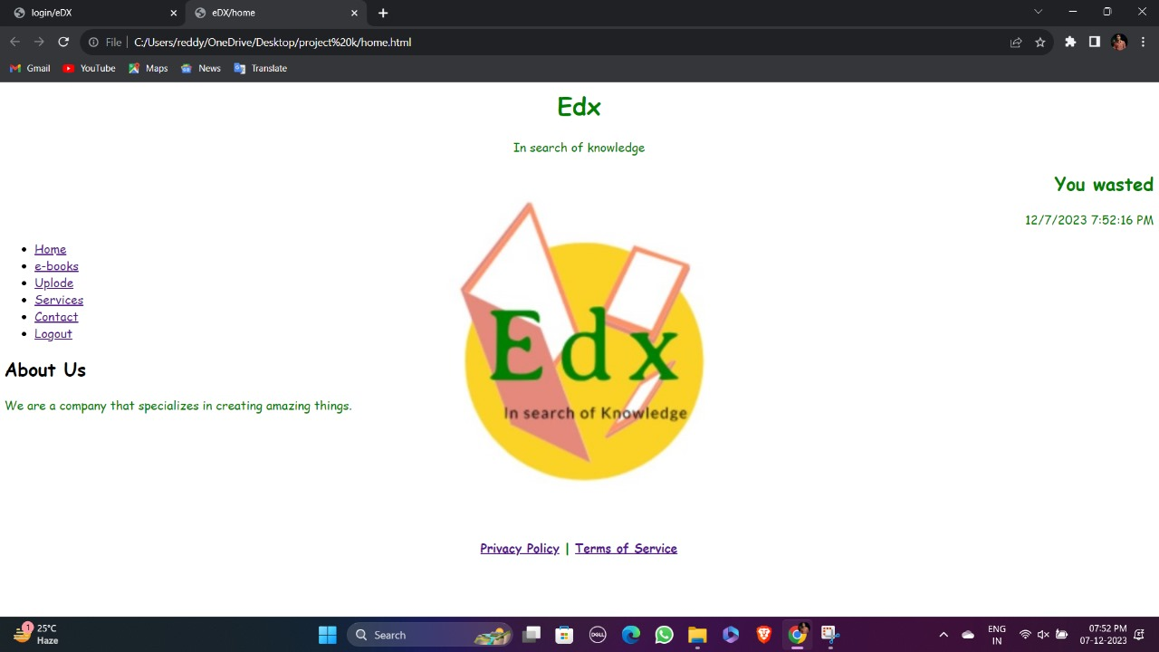

Fig. 1

2.The platform aims to connect teachers and students for seamless communication and learning.

3.Users are asked to select their role: "**Admin**" or "**Student**."

4.After selecting a role, users need to click the "**Next**" button to proceed.

5.The specific action or destination after clicking "**Next**" depends on the server-side implementation.

6.In summary, the page introduces the portal, asks users to choose their role, and prompts them to continue by clicking "**Next**."

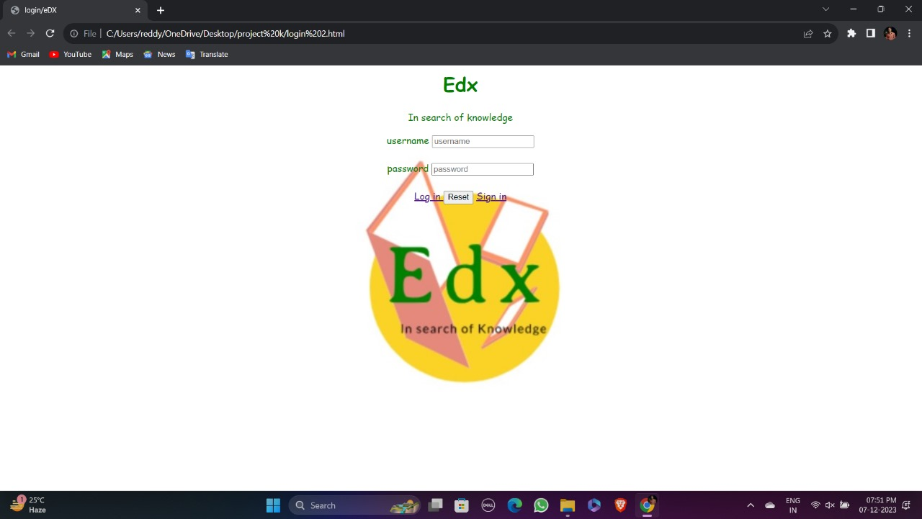

Fig. 2 Login Page

1.Users are required to fill in the following information:

2.**Name:** The teacher's name.

3.**Phone:** The teacher's phone number.

4.**Experience:** The teacher's experience.

5.**Teaching Place:** The place where the teacher teaches.

6.**Locality:** The locality or area where the teaching place is located.

7.**Classes:** The classes or subjects the teacher teaches.

8.All the fields in the form are marked as required, indicating that users must provide information in each field.

9.After filling in the details, users can submit the form by clicking the "Submit" button. In summary, the form collects essential information about teachers, such as their name, contact details, experience, teaching place, locality, and the classes they teach. Users are prompted to fill in the required information and submit the form using the "Submit" button.

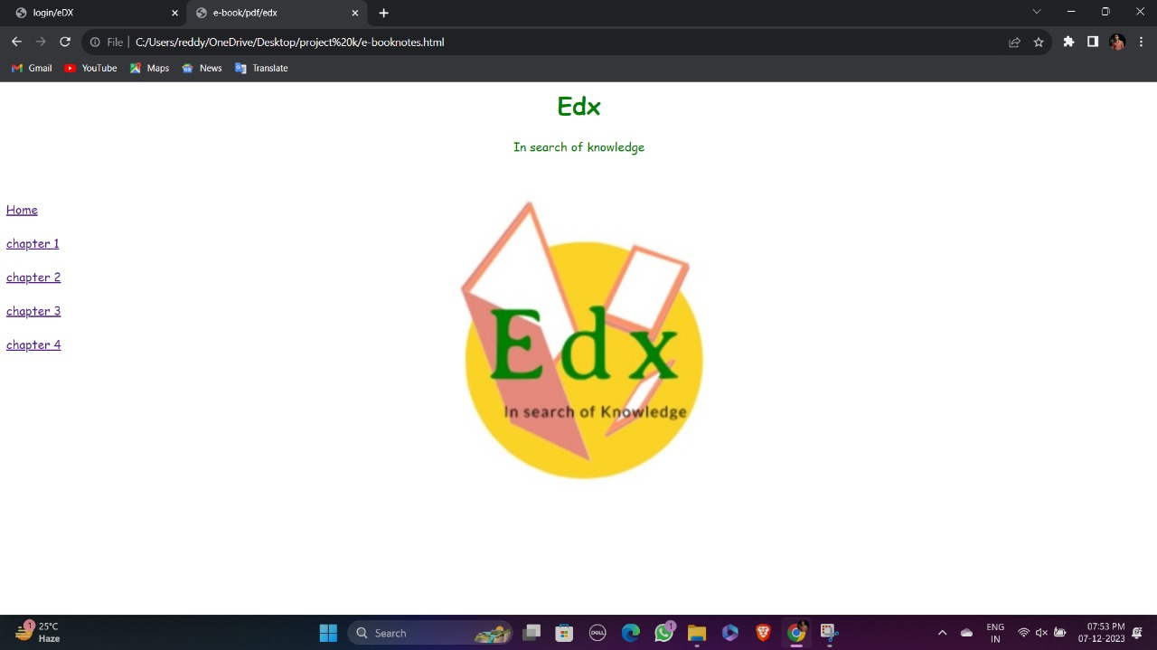

Fig. 3 Book Materials

1.After successfully submitting the teacher details, the user will typically see a message indicating that the submission was successful. This message serves to confirm that the teacher details have been received and processed.

2.The specific wording of the success message can vary depending on the implementation. However, a common message might be something like:

### 3."Teacher details submitted successfully!"

4.This message aims to provide reassurance to the user that their information has been successfully transmitted and recorded. It serves as a confirmation and signals that the submission process was completed without any issues.

5.Once the user receives this success message, they can proceed with any further actions or navigate to other sections of the website or application as desired.

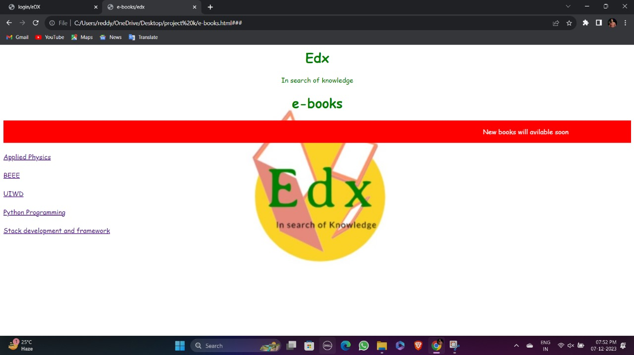

Fig. 4 E-books page

1.The form collects information about the student.

2.Users need to enter the following details:

3.**Student Name:** Enter the name of the student.

4.**Student Phone:** Enter the phone number of the student.

5.**Student Locality:** Enter the locality where the student resides.

6.**Teacher Name:** Enter the name of the teacher (optional).

7.**Student Class:** Enter the class or subject the student wants to study.

8.All fields in the form are required.

9.After filling in the details, users can click the "**Submit**" button to proceed.

10.The specific action or destination after submitting the form depends on the server-side implementation.

In summary, the form allows users to enter student details, including name, phone number, locality, teacher name (optional), and desired class. Users need to complete the required fields and submit the form to proceed.

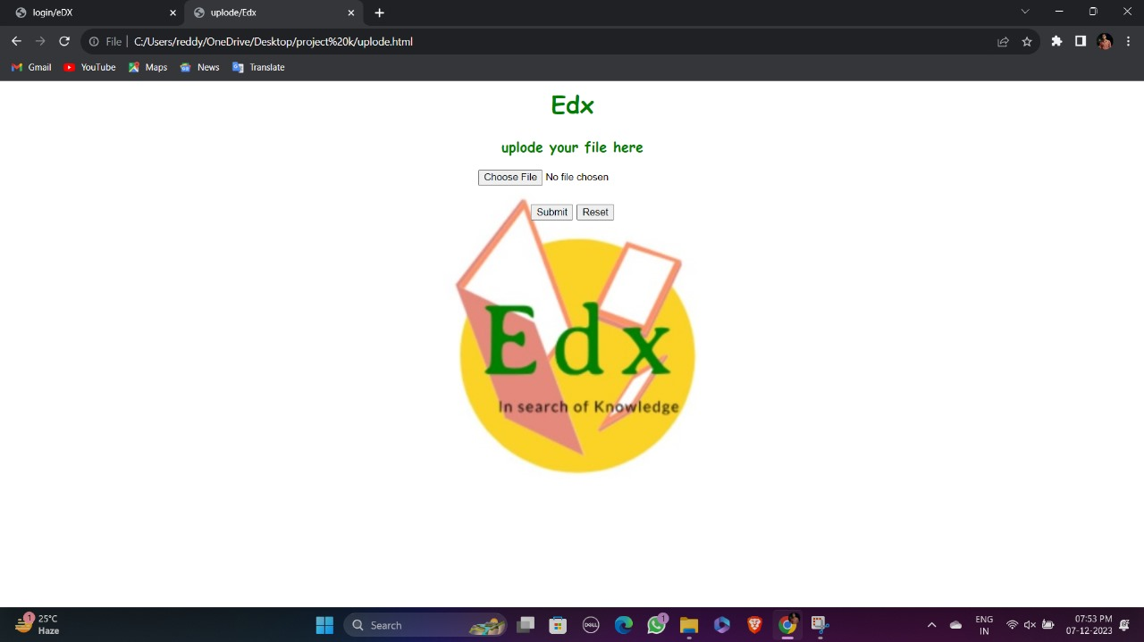

Fig. 5 Upload Page

If there are matching teachers (results), the code displays them in a list format.

For each teacher in the results, the following information is shown:

1.**Teacher Name:** Displayed as a heading 2 (<h2>) element.

2.**Phone:** Displayed as a paragraph (<p>) element, showing the teacher's phone number.

3.**Experience:** Displayed as a paragraph element, showing the teacher's experience.

4.**Teaching Place:** Displayed as a paragraph element, indicating the location where the teacher provides teaching.

5.**Locality:** Displayed as a paragraph element, indicating the locality associated with the teacher.

6.**Classes:** Displayed as a paragraph element, specifying the classes or subjects taught by the teacher.

If there are no matching teachers, the code displays a message stating :

**"No matching teachers found."**

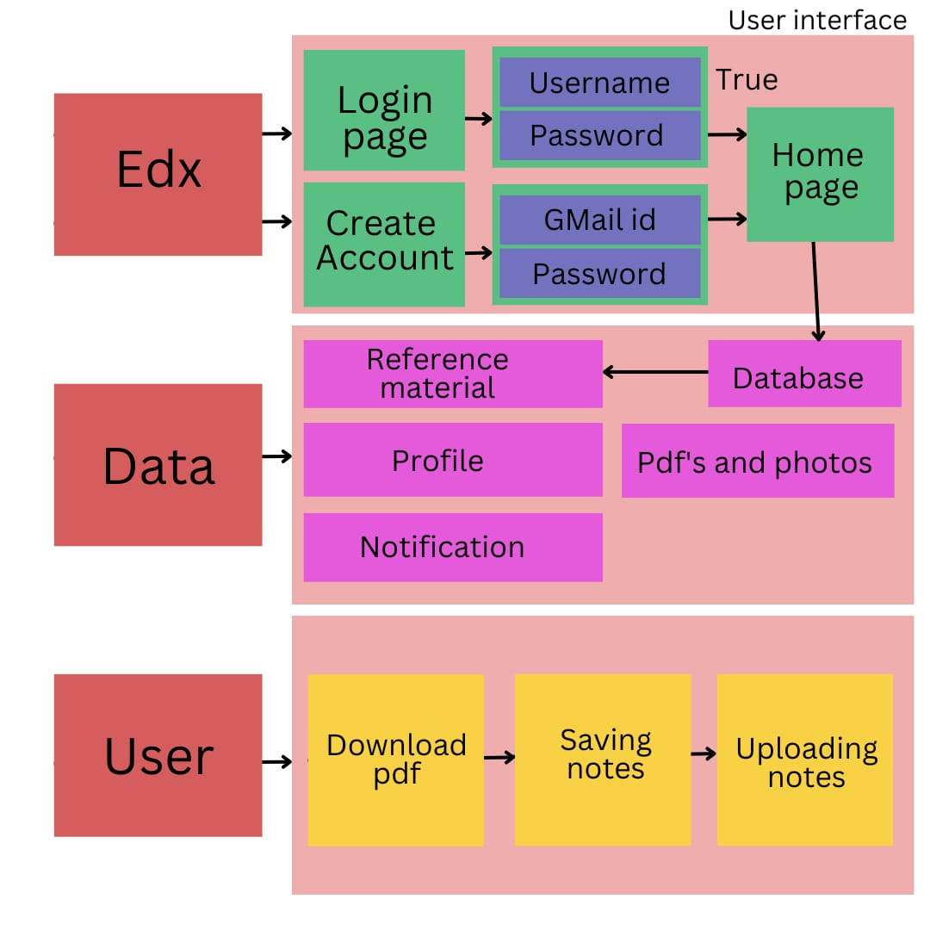**SYSTEM ARCHITECTURE:**

**Fig:** Architectur diagram

**DATA FLOW DIAGRAM:**

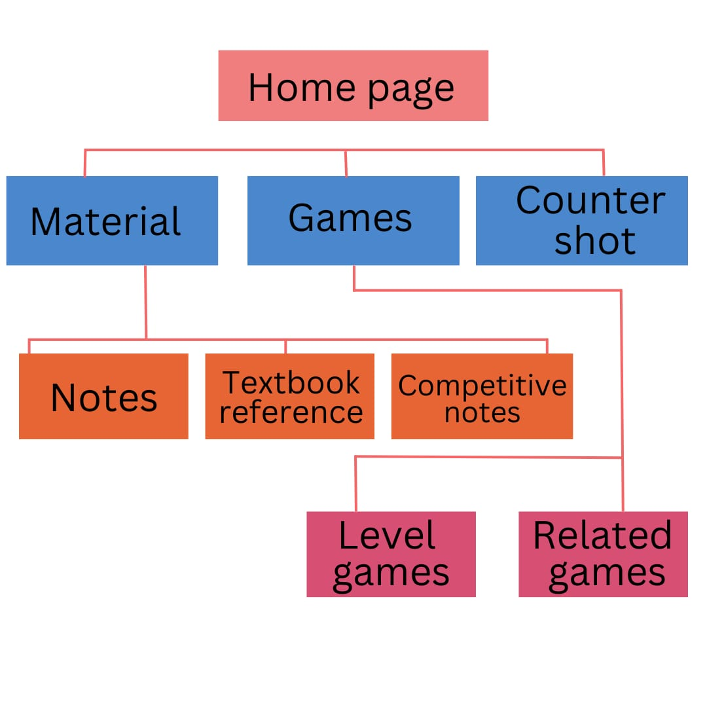

# Chapter - 4 Application Code

**Login page:**

<html>

<head>

<title> login/Edx </title>

<style>

body{

text-align:center;

background-color:white;

font-family:cursive;

}

summary

{

border-style: solid;

border-radius:50px;

border-height:100px;

width: 400px;

min-width: 400px;

flex-direction: column;

border: 1px solid rgba(255, 255, 255, 0.097);

display: flex;

align-items: center;

border-radius: 30px;

position: center;

background:rgb(255, 255, 237);

justify-content:center;

}

</style>

</head>

<body>

<header>

Edx </header>

<center>

<summary>

<h1 style="font-family:cursive" > Edx </h1>

<forms>

username <input type="username"

name="username"

accept="text"

placeholder="username"><br><br>

password <input type="password"

name="password"

accept="text, special characters, numbers"

placeholder="password"><br><br>

<input

type="submit"

name="submit"

<a herf="file:///C:/Users/reddy/OneDrive/Desktop/project%20k/home.html">

</a>

<input type="reset"

name="reset"><br><br>

</forms>

</summary>

</center>

</body>

</html>

**Code Explanation:**

**1. Routes:**

* The '/' route renders the home page.
* The '/submit' route handles the submission of user type (teacher or student) and redirects accordingly.
* The '/teacher' route handles the submission of teacher details and adds them to the list of teachers.
* The '/student' route handles the submission of student details, matches them with suitable teachers, and renders the results.

**2. Data Structures:**

- Two lists, 'teachers' and 'students', are used to store teacher and student data, respectively.

**3. Functionality:**

* The application allows users to choose between being a teacher or a student.
* Teachers can submit their details, which are then stored in the 'teachers' list. - Students can submit their details, and the application matches them with suitable teachers based on locality, class, and teacher name.
* The matched teachers' information is displayed in the results.

**4. Templates:**

- The application uses HTML templates, including 'index.html', 'teachers.html', 'students.html', and 'results.html', to render different pages and display the data.

**5. Running the Application:**

- The application can be run directly, and it runs in debug mode.

This Flask application provides a platform for teachers to submit their details and for students to find matching teachers based on their requirements.

[**<!DOCTYPE html>**](https://www.geeksforgeeks.org/html-doctypes/)**:** This is the document type declaration (not technically a tag). It declares a document as being an HTML document. The doctype declaration is not case-sensitive.

[**<html>**](https://www.geeksforgeeks.org/html-html-tag/)**:** This is called the HTML root element. All other elements are contained within it.

[**<head>**](https://www.geeksforgeeks.org/html-head-tag/#:~:text=The%20tag%20in%20HTML,head%3E%20element%20can%20be%20omitted.)**:** The head tag contains the “behind the scenes” elements for a webpage. Elements within the head aren’t visible on the front-end of a webpage. HTML elements used inside the <head> element include:

[**<style>**](https://www.geeksforgeeks.org/html-style-tag/)-This html tag allows us to insert styling into our webpages and make them appealing to look at with the help of CSS.

[**<title>**](https://www.geeksforgeeks.org/html-title-tag/)-The title is what is displayed on the top of your browser when you visit a website and contains the title of the webpage that you are viewing.

[**<base>**](https://www.geeksforgeeks.org/html-base-tag/)-It specifies the base URL for all relative URL’s in a document.

[**<noscript>**](https://www.geeksforgeeks.org/html-noscript-tag/)– Defines a section of HTML that is inserted when the scripting has been turned off in the users browser.

[**<script>**](https://www.geeksforgeeks.org/html-script-tag/)-This tag is used to add functionality in the website with the help of JavaScript.

[**<meta>**](https://www.geeksforgeeks.org/html-meta-tag/#:~:text=The%20tag%20in%20HTML,keywords%2C%20document%20author%2C%20etc.)-This tag encloses the meta data of the website that must be loaded every time the website is visited. For eg:- the metadata charset allows you to use the standard UTF-8 encoding in your website. This in turn allows the users to view your webpage in the language of their choice. It is a self closing tag.

[**<link>**](https://www.geeksforgeeks.org/html-link-tag/)– The ‘link’ tag is used to tie together HTML, CSS, and JavaScript. It is self closing.

[**<body>**](https://www.geeksforgeeks.org/html-body-tag/#:~:text=The%20tag%20in%20HTML,well%20as%20an%20ending%20tag.)**:** The body tag is used to enclose all the visible content of a webpage. In other words, the body content is what the browser will show on the front-end.

An HTML document can be created using any text editor. Save the text file using **.html** or **.htm**. Once saved as an HTML document, the file can be opened as a webpage in the browser.

**Title:** The **<title>** element sets the title of the HTML document, which will be displayed on the browser's title bar. In this case, it is "Teacher-Student Portal."

**CSS Link:** The **<link>** element references an external CSS file using the **href** attribute. The **href** attribute is populated dynamically using the **url_for** function. This allows the inclusion of a separate CSS file named "style.css" to apply custom styles to the form.

**Body Section:** The **<body>** tags contain the visible content of the web page. Within the body, we find the following elements:

**Container:** The outermost **<div>** element with the class "container" acts as a wrapper for the entire form, providing a visual container for its contents.

**Form Container:** Inside the container, there is another **<div>** element with the class "form-container". This element groups the form-related content together and provides specific styling.

**Form Header:** The **<h1>** heading tag represents the header of the form, displaying the text "Teacher Details" to provide a clear title for the form.

**Form Element:** The **<form>** element defines a form that will be submitted to a specified URL upon user interaction. The **action** attribute is populated dynamically using the **url_for** function, which directs the form submission to the "teacher" URL.

**Form Groups:** Inside the form, there are several **<div>** elements with the class "formgroup". Each form group represents a specific input field with its associated label and input element.

**Name:** The first form group represents the "Name" field. It consists of a **<label>** element with the "for" attribute pointing to the corresponding input field ID and an <input> element of type "text". The "required" attribute ensures the field must be filled out before submitting the form.

**Phone:** The second form group represents the "Phone" field. It is similar to the previous form group but uses an <input> element of type "tel" for phone number input.

**Experience**: The third form group represents the "Experience" field. It follows the same structure as the previous form groups, using an <input> element of type "text".

**Teaching Place**: The fourth form group represents the "Teaching Place" field. It is structured similarly to other form groups, allowing users to input the teacher's present teaching place.

**Locality**: The fifth form group represents the "Locality" field. It is similar to the previous form groups, enabling users to input the teacher's locality.

**Classes**: The sixth form group represents the "Classes" field. It is structured similarly to other form groups, allowing users to input the classes the teacher teaches.

**Submit Button**: The final **<div>** element with the class "form-group" contains a **<button>** element with the class "button". This button serves as the form submission trigger. When clicked, it will initiate the form submission process.

**Head Section:** Inside the `<head>` tags, we find the following elements:3.3 Result Header: The `<h1>` heading tag represents the header of the result page, displaying the text "Matching Teachers" to indicate the purpose of the page.

**Result Display:** The code uses template syntax and conditional statements to dynamically display the search results or a "No matching teachers found" message.

# Home Page:

<html>

<head>

<meta charset="UTF-8">

<title>Edx/home</title>

<style>

body

{font-family:cursive;

background-color:rgb(255, 255, 237);

}

</style>

</head>

<body>

<header>

<center><h1>Edx</h1></center>

<hr>

<nav>

<ul>

<li><a href="C:\Users\burra\OneDrive\Desktop\Tlogin.html"

target="self">Login</a></li>

<li><a href="C:\Users\burra\OneDrive\Desktop\home.html">Home</a></li>

<li><a href="C:\Users\burra\OneDrive\Desktop\e-books.html">e-books</a></li>

<li><a href="C:\Users\burra\OneDrive\Desktop\uplode.html">Uplode</a></li>

<li><a href="#">Services</a></li>

<li><a href="#">Contact</a></li>

</ul>

</nav>

</header>

<main>

<section>

<h2>About Us</h2>

<p>We are a company that specializes in creating amazing things.</p>

</section>

<section>

</section>

</main>

<aside>

</aside>

<footer>

<center><p&copy; 2023 My Website. All rights reserved.</p></center>

<center><p><a href="#">Privacy Policy</a> | <a href="#">Terms of

Service</a></p></center>

</footer>

</body>

</html>

**Code Explanation:**

[**<!DOCTYPE html>**](https://www.geeksforgeeks.org/html-doctypes/)**:** This is the document type declaration (not technically a tag). It declares a document as being an HTML document. The doctype declaration is not case-sensitive.

[**<html>**](https://www.geeksforgeeks.org/html-html-tag/)**:** This is called the HTML root element. All other elements are contained within it.

[**<head>**](https://www.geeksforgeeks.org/html-head-tag/#:~:text=The%20tag%20in%20HTML,head%3E%20element%20can%20be%20omitted.)**:** The head tag contains the “behind the scenes” elements for a webpage. Elements within the head aren’t visible on the front-end of a webpage. HTML elements used inside the <head> element include:

[**<style>**](https://www.geeksforgeeks.org/html-style-tag/)-This html tag allows us to insert styling into our webpages and make them appealing to look at with the help of CSS.

[**<title>**](https://www.geeksforgeeks.org/html-title-tag/)-The title is what is displayed on the top of your browser when you visit a website and contains the title of the webpage that you are viewing.

[**<base>**](https://www.geeksforgeeks.org/html-base-tag/)-It specifies the base URL for all relative URL’s in a document.

[**<noscript>**](https://www.geeksforgeeks.org/html-noscript-tag/)– Defines a section of HTML that is inserted when the scripting has been turned off in the users browser.

[**<script>**](https://www.geeksforgeeks.org/html-script-tag/)-This tag is used to add functionality in the website with the help of JavaScript.

[**<meta>**](https://www.geeksforgeeks.org/html-meta-tag/#:~:text=The%20tag%20in%20HTML,keywords%2C%20document%20author%2C%20etc.)-This tag encloses the meta data of the website that must be loaded every time the website is visited. For eg:- the metadata charset allows you to use the standard UTF-8 encoding in your website. This in turn allows the users to view your webpage in the language of their choice. It is a self closing tag.

[**<link>**](https://www.geeksforgeeks.org/html-link-tag/)– The ‘link’ tag is used to tie together HTML, CSS, and JavaScript. It is self closing.

[**<body>**](https://www.geeksforgeeks.org/html-body-tag/#:~:text=The%20tag%20in%20HTML,well%20as%20an%20ending%20tag.)**:** The body tag is used to enclose all the visible content of a webpage. In other words, the body content is what the browser will show on the front-end.

An HTML document can be created using any text editor. Save the text file using **.html** or **.htm**. Once saved as an HTML document, the file can be opened as a webpage in the browser.

**Title:** The **<title>** element sets the title of the HTML document, which will be displayed on the browser's title bar. In this case, it is "Teacher-Student Portal."

**CSS Link:** The **<link>** element references an external CSS file using the **href** attribute. The **href** attribute is populated dynamically using the **url_for** function. This allows the inclusion of a separate CSS file named "style.css" to apply custom styles to the form.

**Body Section:** The **<body>** tags contain the visible content of the web page. Within the body, we find the following elements:

**Container:** The outermost **<div>** element with the class "container" acts as a wrapper for the entire form, providing a visual container for its contents.

**Form Container:** Inside the container, there is another **<div>** element with the class "form-container". This element groups the form-related content together and provides specific styling.

**Form Header:** The **<h1>** heading tag represents the header of the form, displaying the text "Teacher Details" to provide a clear title for the form.

**Form Element:** The **<form>** element defines a form that will be submitted to a specified URL upon user interaction. The **action** attribute is populated dynamically using the **url_for** function, which directs the form submission to the "teacher" URL.

**Form Groups:** Inside the form, there are several **<div>** elements with the class "formgroup". Each form group represents a specific input field with its associated label and input element.

**Name:** The first form group represents the "Name" field. It consists of a **<label>** element with the "for" attribute pointing to the corresponding input field ID and an <input> element of type "text". The "required" attribute ensures the field must be filled out before submitting the form.

**Phone:** The second form group represents the "Phone" field. It is similar to the previous form group but uses an <input> element of type "tel" for phone number input.

**Experience**: The third form group represents the "Experience" field. It follows the same structure as the previous form groups, using an <input> element of type "text".

**Teaching Place**: The fourth form group represents the "Teaching Place" field. It is structured similarly to other form groups, allowing users to input the teacher's present teaching place.

**Locality**: The fifth form group represents the "Locality" field. It is similar to the previous form groups, enabling users to input the teacher's locality.

**Classes**: The sixth form group represents the "Classes" field. It is structured similarly to other form groups, allowing users to input the classes the teacher teaches.

**Submit Button**: The final **<div>** element with the class "form-group" contains a **<button>** element with the class "button". This button serves as the form submission trigger. When clicked, it will initiate the form submission process.

**Head Section:** Inside the `<head>` tags, we find the following elements:3.3 Result Header: The `<h1>` heading tag represents the header of the result page, displaying the text "Matching Teachers" to indicate the purpose of the page.

**Result Display:** The code uses template syntax and conditional statements to dynamically display the search results or a "No matching teachers found" message.

**E-Books:**

<html>

<head>

<title> e-books/Edx </title>

<style>

body

{

text-align:center;

font-family:cursive;

background-color:"YELLOW";

}

</style>

</head>

<body>

<header>

<h1>e-books</h1>

<marquee style="background-color:green";><p> New books will avilable soon </p></marquee>

<hr>

</header>

<nav><a href="">

<aside>

SUBJECT 1

</a>

</nav><br>

<nav>

<a href="###">

SUBJECT 2

</a> </nav><br>

<nav>

<a href="###">

SUBJECT 3

</aside>

</a>

</nav><br>

</body>

</html>

**Code Explanation:**

[**<!DOCTYPE html>**](https://www.geeksforgeeks.org/html-doctypes/)**:** This is the document type declaration (not technically a tag). It declares a document as being an HTML document. The doctype declaration is not case-sensitive.

[**<html>**](https://www.geeksforgeeks.org/html-html-tag/)**:** This is called the HTML root element. All other elements are contained within it.

[**<head>**](https://www.geeksforgeeks.org/html-head-tag/#:~:text=The%20tag%20in%20HTML,head%3E%20element%20can%20be%20omitted.)**:** The head tag contains the “behind the scenes” elements for a webpage. Elements within the head aren’t visible on the front-end of a webpage. HTML elements used inside the <head> element include:

[**<style>**](https://www.geeksforgeeks.org/html-style-tag/)-This html tag allows us to insert styling into our webpages and make them appealing to look at with the help of CSS.

[**<title>**](https://www.geeksforgeeks.org/html-title-tag/)-The title is what is displayed on the top of your browser when you visit a website and contains the title of the webpage that you are viewing.

[**<base>**](https://www.geeksforgeeks.org/html-base-tag/)-It specifies the base URL for all relative URL’s in a document.

[**<noscript>**](https://www.geeksforgeeks.org/html-noscript-tag/)– Defines a section of HTML that is inserted when the scripting has been turned off in the users browser.

[**<script>**](https://www.geeksforgeeks.org/html-script-tag/)-This tag is used to add functionality in the website with the help of JavaScript.

[**<meta>**](https://www.geeksforgeeks.org/html-meta-tag/#:~:text=The%20tag%20in%20HTML,keywords%2C%20document%20author%2C%20etc.)-This tag encloses the meta data of the website that must be loaded every time the website is visited. For eg:- the metadata charset allows you to use the standard UTF-8 encoding in your website. This in turn allows the users to view your webpage in the language of their choice. It is a self closing tag.

[**<link>**](https://www.geeksforgeeks.org/html-link-tag/)– The ‘link’ tag is used to tie together HTML, CSS, and JavaScript. It is self closing.

[**<body>**](https://www.geeksforgeeks.org/html-body-tag/#:~:text=The%20tag%20in%20HTML,well%20as%20an%20ending%20tag.)**:** The body tag is used to enclose all the visible content of a webpage. In other words, the body content is what the browser will show on the front-end.

An HTML document can be created using any text editor. Save the text file using **.html** or **.htm**. Once saved as an HTML document, the file can be opened as a webpage in the browser.

**Title:** The **<title>** element sets the title of the HTML document, which will be displayed on the browser's title bar. In this case, it is "Teacher-Student Portal."

**CSS Link:** The **<link>** element references an external CSS file using the **href** attribute. The **href** attribute is populated dynamically using the **url_for** function. This allows the inclusion of a separate CSS file named "style.css" to apply custom styles to the form.

**Body Section:** The **<body>** tags contain the visible content of the web page. Within the body, we find the following elements:

**Container:** The outermost **<div>** element with the class "container" acts as a wrapper for the entire form, providing a visual container for its contents.

**Form Container:** Inside the container, there is another **<div>** element with the class "form-container". This element groups the form-related content together and provides specific styling.

**Form Header:** The **<h1>** heading tag represents the header of the form, displaying the text "Teacher Details" to provide a clear title for the form.

**Form Element:** The **<form>** element defines a form that will be submitted to a specified URL upon user interaction. The **action** attribute is populated dynamically using the **url_for** function, which directs the form submission to the "teacher" URL.

**Form Groups:** Inside the form, there are several **<div>** elements with the class "formgroup". Each form group represents a specific input field with its associated label and input element.

**Name:** The first form group represents the "Name" field. It consists of a **<label>** element with the "for" attribute pointing to the corresponding input field ID and an <input> element of type "text". The "required" attribute ensures the field must be filled out before submitting the form.

**Phone:** The second form group represents the "Phone" field. It is similar to the previous form group but uses an <input> element of type "tel" for phone number input.

**Experience**: The third form group represents the "Experience" field. It follows the same structure as the previous form groups, using an <input> element of type "text".

**Teaching Place**: The fourth form group represents the "Teaching Place" field. It is structured similarly to other form groups, allowing users to input the teacher's present teaching place.

**Locality**: The fifth form group represents the "Locality" field. It is similar to the previous form groups, enabling users to input the teacher's locality.

**Classes**: The sixth form group represents the "Classes" field. It is structured similarly to other form groups, allowing users to input the classes the teacher teaches.

**Submit Button**: The final **<div>** element with the class "form-group" contains a **<button>** element with the class "button". This button serves as the form submission trigger. When clicked, it will initiate the form submission process.

**Head Section:** Inside the `<head>` tags, we find the following elements:3.3 Result Header: The `<h1>` heading tag represents the header of the result page, displaying the text "Matching Teachers" to indicate the purpose of the page.

**Result Display:** The code uses template syntax and conditional statements to dynamically display the search results or a "No matching teachers found" message.

upload:

<html>

<head>

<title>

uplode/Edx

</title>

<style>

body

{font-family:cursive;

background-color:rgb(255, 255, 237);

text-align:center;

}

</style>

</head>

<body>

<header>

<h1>Edx</h1>

<h3> uplode your file here </h3>

</header>

<input type="file" id="filenput" accept=".pdf"/>

</body>

</html>

**Code Explanation:**

[**<!DOCTYPE html>**](https://www.geeksforgeeks.org/html-doctypes/)**:** This is the document type declaration (not technically a tag). It declares a document as being an HTML document. The doctype declaration is not case-sensitive.

[**<html>**](https://www.geeksforgeeks.org/html-html-tag/)**:** This is called the HTML root element. All other elements are contained within it.

[**<head>**](https://www.geeksforgeeks.org/html-head-tag/#:~:text=The%20tag%20in%20HTML,head%3E%20element%20can%20be%20omitted.)**:** The head tag contains the “behind the scenes” elements for a webpage. Elements within the head aren’t visible on the front-end of a webpage. HTML elements used inside the <head> element include:

[**<style>**](https://www.geeksforgeeks.org/html-style-tag/)-This html tag allows us to insert styling into our webpages and make them appealing to look at with the help of CSS.

[**<title>**](https://www.geeksforgeeks.org/html-title-tag/)-The title is what is displayed on the top of your browser when you visit a website and contains the title of the webpage that you are viewing.

[**<base>**](https://www.geeksforgeeks.org/html-base-tag/)-It specifies the base URL for all relative URL’s in a document.

[**<noscript>**](https://www.geeksforgeeks.org/html-noscript-tag/)– Defines a section of HTML that is inserted when the scripting has been turned off in the users browser.

[**<script>**](https://www.geeksforgeeks.org/html-script-tag/)-This tag is used to add functionality in the website with the help of JavaScript.

[**<meta>**](https://www.geeksforgeeks.org/html-meta-tag/#:~:text=The%20tag%20in%20HTML,keywords%2C%20document%20author%2C%20etc.)-This tag encloses the meta data of the website that must be loaded every time the website is visited. For eg:- the metadata charset allows you to use the standard UTF-8 encoding in your website. This in turn allows the users to view your webpage in the language of their choice. It is a self closing tag.

[**<link>**](https://www.geeksforgeeks.org/html-link-tag/)– The ‘link’ tag is used to tie together HTML, CSS, and JavaScript. It is self closing.

[**<body>**](https://www.geeksforgeeks.org/html-body-tag/#:~:text=The%20tag%20in%20HTML,well%20as%20an%20ending%20tag.)**:** The body tag is used to enclose all the visible content of a webpage. In other words, the body content is what the browser will show on the front-end.

An HTML document can be created using any text editor. Save the text file using **.html** or **.htm**. Once saved as an HTML document, the file can be opened as a webpage in the browser.

**Title:** The **<title>** element sets the title of the HTML document, which will be displayed on the browser's title bar. In this case, it is "Teacher-Student Portal."

**CSS Link:** The **<link>** element references an external CSS file using the **href** attribute. The **href** attribute is populated dynamically using the **url_for** function. This allows the inclusion of a separate CSS file named "style.css" to apply custom styles to the form.

**Body Section:** The **<body>** tags contain the visible content of the web page. Within the body, we find the following elements:

**Container:** The outermost **<div>** element with the class "container" acts as a wrapper for the entire form, providing a visual container for its contents.

**Form Container:** Inside the container, there is another **<div>** element with the class "form-container". This element groups the form-related content together and provides specific styling.

**Form Header:** The **<h1>** heading tag represents the header of the form, displaying the text "Teacher Details" to provide a clear title for the form.

**Form Element:** The **<form>** element defines a form that will be submitted to a specified URL upon user interaction. The **action** attribute is populated dynamically using the **url_for** function, which directs the form submission to the "teacher" URL.

**Form Groups:** Inside the form, there are several **<div>** elements with the class "formgroup". Each form group represents a specific input field with its associated label and input element.

**Name:** The first form group represents the "Name" field. It consists of a **<label>** element with the "for" attribute pointing to the corresponding input field ID and an <input> element of type "text". The "required" attribute ensures the field must be filled out before submitting the form.

**Phone:** The second form group represents the "Phone" field. It is similar to the previous form group but uses an <input> element of type "tel" for phone number input.

**Experience**: The third form group represents the "Experience" field. It follows the same structure as the previous form groups, using an <input> element of type "text".

**Teaching Place**: The fourth form group represents the "Teaching Place" field. It is structured similarly to other form groups, allowing users to input the teacher's present teaching place.

**Locality**: The fifth form group represents the "Locality" field. It is similar to the previous form groups, enabling users to input the teacher's locality.

**Classes**: The sixth form group represents the "Classes" field. It is structured similarly to other form groups, allowing users to input the classes the teacher teaches.

**Submit Button**: The final **<div>** element with the class "form-group" contains a **<button>** element with the class "button". This button serves as the form submission trigger. When clicked, it will initiate the form submission process.

**Head Section:** Inside the `<head>` tags, we find the following elements:3.3 Result Header: The `<h1>` heading tag represents the header of the result page, displaying the text "Matching Teachers" to indicate the purpose of the page.

**Result Display:** The code uses template syntax and conditional statements to dynamically display the search results or a "No matching teachers found" message.

**Conditional Statement:** The `{% if results %}` statement checks if there are any search results available. If results exist, the following content will be displayed; otherwise, the "No matching teachers found" message will be shown.

**Result List:** Inside the `<ul>` tags, a `{% for teacher in results %}` loop iterates over the list of matching teachers. Each teacher's details are displayed in a separate `<li>` element.

## 4.1 Handling Errors

Here are the steps to handle errors effectively in your code:

1.**Identify Potential Error Points**: Review your code and identify areas where errors could occur. These can include user input, file operations, database interactions, network requests, etc.

2.**Implement Error Handling Mechanisms**: Use try-except blocks to catch and handle specific types of exceptions that may occur. For example:

*try:*

*# Code that may raise an exception except ExceptionType:*

*# Handle the specific exception*

1.**Display Meaningful Error Messages**: When an exception is caught, display an informative error message to the user. Include details about the error and possible solutions.

For example: *try:*

*# Code that may raise an exception except ValueError: print("Invalid input! Please enter a valid value.")*

1.**Logging**: Implement logging mechanisms to record errors and exceptions. Use a logging library to write error logs to a file or a log management system. Include relevant information like the error message, timestamp, and any relevant context details.

*import logging logging.basicConfig(filename='error.log', level=logging.ERROR)*

*try: # Code that may raise an exception except Exception as e: logging.error(str(e))*

**BRIEF EXPLANATION OF THE APPLICATION:**

**OBJECTIVE:**

Online education is the newly evolved form of education where students study from their homes with the help of computers and the internet. At present COVID-19 still have an impact on our lives where we are not able to move out freely in public areas. ​

Students now day preferring e-booking in place of traditional book made of paper. The e-books playing a crucial role online education.​

Online education playing a vital role in present education system. And there is no exaggeration telling that online education will replace the traditional education system.​

And mostly we will be the last generation to experience the traditional education system**.​**

**ABSTRACT:**

In a relatively short period of time, higher education has been transformed by digital technologies such as the internet, laptop computers, mobile phones and, most recently, electronic books or e-books. E-books are regarded as “a radical innovation” for university students, transforming their academic life and reading habits. This study tried to determine the preferences of Dhaka University students on reading printed books or e-books and the reasons for these preferences. This study was conducted using screening technique which is a descriptive research model. To compare the quantitative data with the relationship between two groups, chi-square test was used. While the current generation of Dhaka university students is comfortable with digital information and communication devices, surveys often indicate a strong preference for printed books.​

Reading habits, accessing resources, and material preferences change rapidly in a digital world. Students do plan, but frequently fail to implement their plans. Lack of concentration and external factors like friends ,works ,and others are the root cause for this failure. Simple techniques( Eg: Pomodoro techniques) can help students overcome this problem. Researches have shown that girls secure more marks than boys. Science exists everywhere. The reason for this is the ornaments that they ware. A student can do wonders if he have a control on his nervous system. Although it is not an easy task, we have techniques to achieve this.​

Indian tradition holds a bunch of scientific reasons. The casual things like bindi, ear rings, anklets, …. Are showing a significant impact on the control of mindset and activation of nerves. A very few people know that even hair can activate nervous system. People usually say that hair and nails are the useless parts of human body. Hair and nails play a major role in activating nervous system.​

Taking Indian tradition as the source, ideas  can implement these in our day to day life in the way we live. It's not true that we should follow them in the previous ways. Life needs to be upgraded. A new way to study is the first and foremost concept of this presentation EdX.​

Introducing a platform for students where the learner enjoys the way of his studying. When the way of teaching influences the child, it's a fact that the way of learning also influences the student.​

## Implementation:

A **digital textbook** is a digital book or [e-book](https://en.wikipedia.org/wiki/E-book) intended to serve as the text for a class. Digital textbooks may also be known as **e-textbooks** or **e-texts**. Digital textbooks are a major component of technology-based education reform. They may serve as the texts for a traditional face-to-face class, an online course or degree, or [massive open online courses (MOOCs)](https://en.wikipedia.org/wiki/Massive_open_online_courses). As with physical textbooks, digital textbooks can be either rented for a term or purchased for lifetime access. While accessible, digital textbooks can be downloaded, printed, or accessed online via a compatible device. To access content online, users must often use a 3rd party hosting provider or "digital bookshelf" through which digital textbooks can be served.

There are many potential advantages to digital textbooks. They may offer lower costs, make it easier to monitor student progress, and are easier and cheaper to update when needed. [Open source](https://en.wikipedia.org/wiki/Open-source_model) e-textbooks may offer the opportunity to create free, modifiable textbooks for basic subjects, or give individual teachers the opportunity to create e-texts for their own classrooms. They may offer better access to quality texts in the developing world. For this reason, many schools and colleges around the world have made the implementation of digital textbooks a central component of education policy. For example, in South Korea, reading materials in all public schools will be digitized by 2015. In the United States, the [Federal Communications Commission](https://en.wikipedia.org/wiki/Federal_Communications_Commission) aims for every student to be able to access e-texts by 2017.

However, the transition to e-textbooks is costly, complex and controversial. Students express a strong preference for printed materials in many surveys and across cultures Many interconnected factors, from device access, to [digital literacy](https://en.wikipedia.org/wiki/Digital_literacy), to teaching methods affect the implementation of digital textbooks in the classroom. Issues of overall value, book quality, privacy, and intellectual property have yet to be resolved. An early 2009 study by Cleantech Group LLC also found that the emissions used to create an eBook were equivalent to 22.5 physical books, representing a significant improvement in environmental sustainability. As of 2021, the largest supplier of digital textbooks is VitalSource, with over 1 million titles in its catalog

**Chapter - 5**

## Conclusion

The rise of online education has transformed the education sector, creating new opportunities and challenges for traditional learning institutions. Online education has democratized access to education, making it more accessible, flexible, and affordable. The emergence of new learning platforms and delivery methods has created new competition and opportunities for learning institutions. Traditional learning institutions have had to adapt to the new digital landscape of education, investing in new technologies and infrastructure, and innovating to remain competitive. Online education has created new challenges in terms of quality control and accreditation, but also new opportunities for institutions to expand their reach and impact. Overall, online education has had a profound impact on traditional learning institutions, and its influence will continue to grow in the coming years.

Some of the methods that we have been inspired to achieve our aspirations are:

1. Pomodoro Techniques: short term goals with small break
2. Eat That Frog Technique: Best for: Tackling important or difficult tasks
3. SMART goal system: specific, measurable, attainable, relevant, time-bound
4. Reserve day :extra time pre-scheduled and applied
5. The Big Picture Technique – Learn from the General to the Specific
6. Chocolate chewing Technique: Flavour rememberence.

**Chapter - 6**

## Future Scope

The Edx platform has a promising future with several potential areas for expansion and improvement. Here are some possible future enhancements that can further enhance the platform's functionality and user experience:

*** Study apps provide a convenient platform for learning on-the-go. They offer diverse resources, including interactive quizzes and video lectures. Users can customize study schedules to fit their pace and preferences. Many apps incorporate gamification elements, enhancing engagement and motivation. Overall, study apps are valuable tools for fostering effective and personalized learning experiences.

1. **Posts**: The posts could serve as a valuable resource for students by providing relevant information, aiding in the gathering of knowledge, and facilitating collaborative learning within the study app. The posts can assist students by offering educational content, explanations, and resources, enhancing their understanding and supporting their academic progress within the study app.
2. **Chat interface or messaging panel**: The chat option will enable students to raise and address their doubts effectively, fostering a direct and interactive way for them to seek clarification within the study app. The chat option will enable students to raise and address their doubts effectively, fostering a direct and interactive way for them to seek clarification within the study app.

Real-time Interaction: The chat option facilitates immediate communication, allowing students to address their doubts promptly.

Clarification: Students can seek clarification specific concepts or questions, promoting a better understanding of the study material.

Personalized Assistance: It offers a personalized approach, enabling tailored responses to individual doubts and providing a more targeted learning experience.

Collaborative Learning: Students can engage in discussions, encouraging collaborative learning where peers can also contribute to addressing doubts.

Accessible Support: The chat option ensures that support vailable, creating a user-friendly environment where students feel encouraged to actively participate and learn.

1. **Relaxation purpose:** The study app enriches user experience by integrating miniature games and animation videos designed for relaxation. These elements serve as engaging breaks, offering users a brief respite from intense study sessions. Miniature games provide a playful diversion, promoting mental refreshment, while animation videos contribute to a visually stimulating and calming atmosphere. By incorporating these features, the study app recognizes the importance of balancing focused learning with moments relaxation, ultimately enhancing user satisfaction and overall well-being during study sessions.
2. **Uploading material**: The feature allows any user to upload new study materials, promoting a collaborative and dynamic learning environment. This inclusivity empowers not only educators but also students contribute relevant content, fostering a diverse range of perspectives. It enhances the study app's repository with up-to-date information and varied resources, ensuring a continuous flow offers and relevant material. This democratization of content creation encourages a community-driven approach to knowledge sharing. Proper moderation and verification mechanisms should be in place to maintain the quality and accuracy of the uploaded materials
3. **Usable**: A versatile study app caters not only to students but extends its utility to individuals seeking effective work management. It allows users to create customized schedules, aiding in organizing tasks and maximizing productivity.The app's features, such as task reminders and progress tracking, benefit professionals managing work projects and deadlines.By offering a seamless interface for scheduling and prioritizing tasks, it becomes a valuable tool for anyone with work-related responsibilities.