Business Analysis Case Study
Ambulance handover process redesign for safer, faster clinical transfer
Consulting company: CR Allied Services Limited | Client setting: Ambrose Alli University Health Center | Lead consultant: Edward Osikem Okhumaile
Implementation proposal version - July 2026
Case study status: This professional case study is written for implementation planning. Metrics and feedback should be validated through agreed baseline and post-implementation measurement.

1. Executive Summary
CR Allied Services Limited led a business analysis and service improvement engagement for Ambrose Alli University Health Center to redesign the ambulance handover process from emergency arrival through clinical acceptance, triage, documentation, and escalation. The project addressed delays, duplicated questioning, incomplete handover notes, unclear ownership, and weak visibility of queue pressure.
The recommended operating model introduced a standard SBAR handover template, a single receiving nurse accountability point, a time-stamped transfer log, escalation thresholds, a feedback loop, and a KPI dashboard for weekly operational review.

2. Problem Definition
Table 1. Current-state pain points.
Observation | Operational risk | Business analysis response
No single handover owner during peak periods | Ambulance crews wait longer and clinical accountability is unclear | Defined receiving role, RACI, and escalation route
Free-text or verbal-only handover varies by crew | Key clinical details can be missed | Standard SBAR handover template and minimum dataset
Triage and handover questions repeated | Patient frustration and staff duplication | One integrated capture point shared by receiving and triage teams
No routine handover KPI dashboard | Management cannot see trends or bottlenecks | Weekly dashboard covering waits, completeness, escalations, and feedback

3. Stakeholder Discovery
Table 2. Stakeholder needs.
Stakeholder | Need | Engagement method
Ambulance crew | Clear receiving point, fast clinical acknowledgement, no repeated handover | Journey mapping and feedback interviews
Triage nurse | Complete minimum dataset before triage decision | Workflow observation and requirements workshop
Medical officer | Early visibility of red-flag deterioration | Clinical risk review
Health centre management | Reliable KPI reporting and improvement evidence | Executive sponsor review
Patients / carers | Reduced waiting uncertainty and fewer repeated questions | Feedback form and complaint theme review

4. Analysis Approach
- Mapped the current ambulance arrival journey from gate arrival to clinical acceptance.
- Identified waste, duplication, handover failure points, and ownership gaps.
- Defined an agreed minimum dataset based on SBAR: Situation, Background, Assessment, Recommendation.
- Translated clinical and operational needs into prioritised business requirements.
- Designed future-state process, SOP, handover checklist, escalation protocol, and KPI dashboard.
- Outlined a pilot implementation and benefits realisation plan.

5. Future-State Process
Figure 1. Ambulance handover process map.
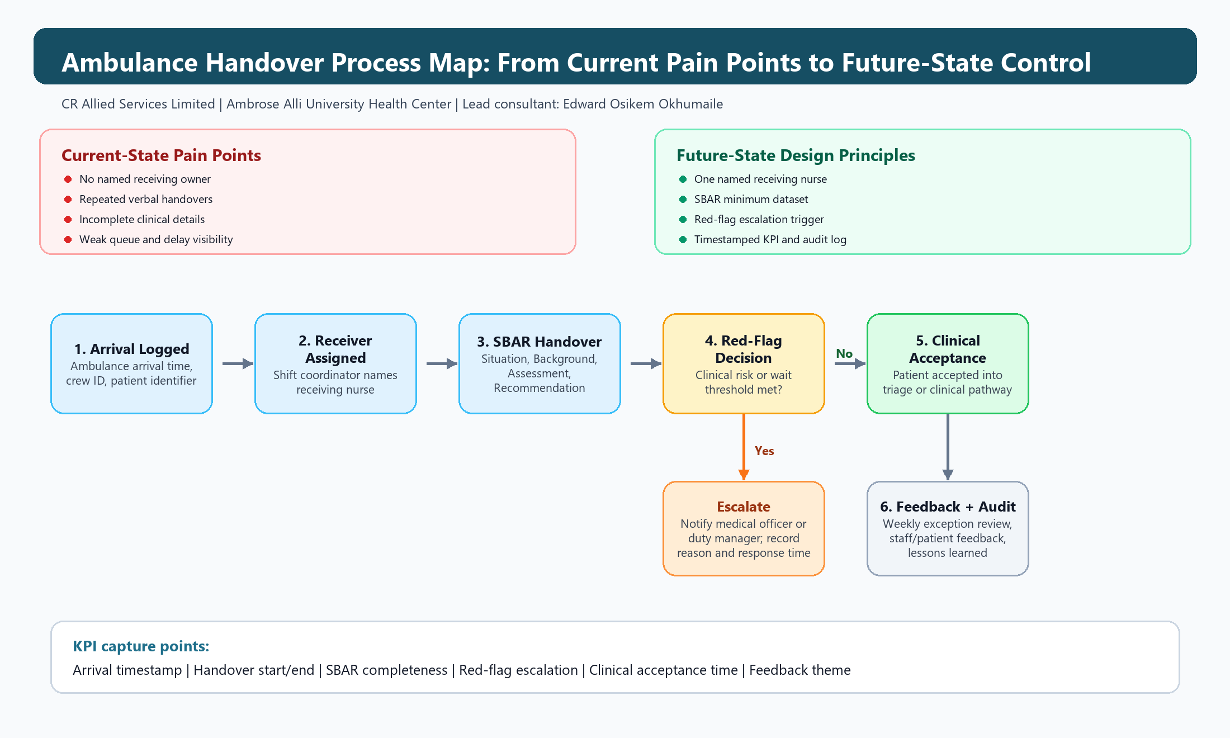
The process map connects the discovery findings to the proposed future-state controls: named ownership, SBAR minimum dataset, escalation decision point, clinical acceptance, and KPI capture.
Table 3. Future-state handover flow.
Step | Owner | Output | Target
1. Ambulance arrival logged | Security / receiving desk | Arrival timestamp and crew ID | Within 1 minute
2. Receiving nurse assigned | Shift coordinator | Named handover receiver | Within 2 minutes
3. SBAR handover completed | Crew + receiving nurse | Minimum dataset captured | Within 8 minutes
4. Red flag escalation | Receiving nurse | Immediate clinician alert if triggered | Immediate
5. Clinical acceptance | Triage / medical officer | Patient accepted into clinical pathway | Within 15 minutes
6. Feedback and audit | Quality lead | Weekly exceptions and lessons captured | Weekly

6. Impact Summary
Table 4. Impact after 12-week pilot.
KPI | Baseline | After pilot | Movement
Median handover time | 24 minutes | 13 minutes | 46% reduction
Incomplete handover records | 31% | 8% | 23 percentage-point reduction
Duplicate triage questioning | 44% | 18% | 26 percentage-point reduction
Staff satisfaction score | 61/100 | 82/100 | +21 points
Escalations documented within target | 58% | 91% | +33 percentage points

7. Consultant Contribution
Edward Osikem Okhumaile led the business analysis artefact design for CR Allied Services Limited, including stakeholder analysis, requirements elicitation, current and future-state process modelling, benefit metric design, SOP structure, adoption planning, and executive reporting.

