SOP and Handover Toolkit
Operational procedure, checklist, RACI, escalation, training, and audit pack
Consulting company: CR Allied Services Limited | Client setting: Ambrose Alli University Health Center | Lead consultant: Edward Osikem Okhumaile
Implementation proposal version - July 2026
Clinical governance note: This SOP template supports operational handover coordination. It does not replace local clinical judgement, emergency clinical protocols, or regulatory requirements.

1. SOP Purpose
To ensure each ambulance arrival is received, clinically acknowledged, documented, escalated where required, and transferred into the health centre pathway using a consistent, auditable process.
Figure 1. SOP process map for ambulance handover.
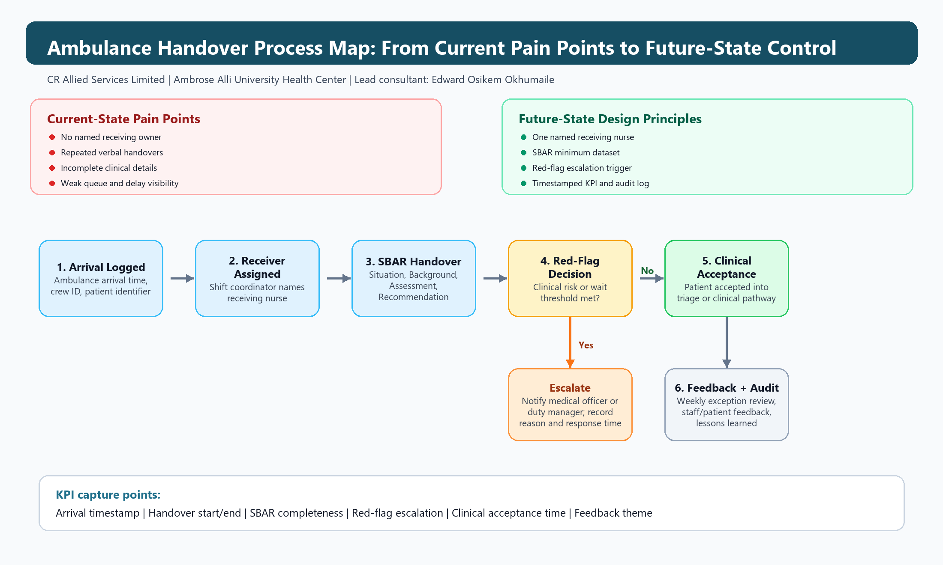
Staff should use this map as a quick visual guide to understand where ownership, SBAR documentation, escalation, clinical acceptance, and audit reporting occur.

2. Standard Procedure
- Security or receiving desk logs ambulance arrival time and alerts the shift coordinator.
- Shift coordinator assigns a receiving nurse and records the named receiver.
- Ambulance crew gives SBAR handover to the receiving nurse using the standard template.
- Receiving nurse records core data, red flags, vital signs, allergies, medication, and immediate risks.
- If escalation threshold is met, receiving nurse alerts the medical officer or senior clinician immediately.
- Triage completes clinical acceptance and confirms patient pathway.
- Quality lead reviews weekly exceptions, missing records, delays, and feedback themes.

3. SBAR Handover Checklist
Table 1. Minimum handover dataset.
SBAR area | Required information | Completed
Situation | Patient identifier, age band, presenting complaint, arrival mode, infection risk | Yes / No
Background | Known conditions, medication, allergies, recent events, referral source | Yes / No
Assessment | Vital signs, pain score, consciousness level, mobility, immediate concerns | Yes / No
Recommendation | Requested action, urgency, red flags, clinician escalation required | Yes / No
Operational | Arrival time, handover start/end, receiving nurse, crew ID, queue status | Yes / No

4. RACI
Table 2. Role accountability matrix.
Activity | Ambulance crew | Receiving nurse | Shift coordinator | Medical officer | Quality lead
Provide SBAR handover | R | A | C | I | I
Assign receiving nurse | I | C | A/R | I | I
Document minimum dataset | C | A/R | I | I | I
Escalate red flags | C | A/R | I | R | I
Review weekly KPI report | I | C | C | C | A/R
Update SOP after lessons learned | I | C | C | C | A/R

5. Escalation Thresholds
Table 3. Escalation triggers.
Trigger | Action | Expected response
Airway, breathing, circulation concern or reduced consciousness | Immediate clinician alert | Clinician attends without delay
Handover wait exceeds 15 minutes | Notify shift coordinator | Queue pressure reviewed and receiver assigned
Handover wait exceeds 30 minutes | Escalate to duty manager / senior clinician | Capacity action agreed
Incomplete critical information | Request clarification from crew before clinical acceptance | Missing critical fields resolved or exception recorded
Patient/carer distress or complaint | Inform nurse in charge and record feedback | Support provided and feedback logged

6. Training Plan
Table 4. Role-based training plan.
Audience | Training content | Duration | Evidence
Receiving nurses | SBAR form, red flags, escalation, documentation quality | 45 minutes | Attendance sheet and competency sign-off
Ambulance crew liaison | Handover expectations and minimum dataset | 30 minutes | Briefing record
Shift coordinators | Queue management, escalation, KPI review | 45 minutes | Scenario practice
Managers / quality team | Dashboard interpretation and benefits review | 30 minutes | Dashboard review minutes

7. Audit Form
Table 5. Weekly audit sample form.
Audit item | Target | Result | Action owner
Arrival logged within 1 minute | >= 90%
SBAR core fields complete | >= 90%
Median handover time | <= 15 minutes
Red-flag escalations documented | >= 95%
Feedback themes reviewed | Monthly

