Stakeholder Team Meeting Transcript
Discovery meeting that initiated the Ambulance Handover Process Improvement project
Consulting company: CR Allied Services Limited | Client setting: Ambrose Alli University Health Center | Lead consultant: Edward Osikem Okhumaile
Implementation proposal version - July 2026
Evidence integrity note: This stakeholder record should be verified against approved meeting minutes and project communication records before external circulation.

1. Meeting Overview
Table 1. Meeting metadata.
Item | Details
Meeting title | Ambulance Handover Process Improvement - Stakeholder Discovery
Date / time | 8 July 2026, 09:00-09:45
Facilitator | Edward Osikem Okhumaile, Business Analyst, CR Allied Services Limited
Client setting | Ambrose Alli University Health Center
Purpose | Agree the operational problem, capture stakeholder pain points, define project scope, and confirm pilot deliverables.
Meeting outcome | Stakeholders agreed to proceed with a 12-week pilot supported by BRD, SOP, RACI, escalation rules, audit form, and KPI dashboard.

2. Attendees and Roles
Table 2. Stakeholder attendees.
Name | Role | Contribution
Dr. Miriam Aigbe | Medical Officer / Clinical Lead | Clinical risk, red-flag escalation, urgent decision making
Nurse Grace Okon | Triage Nurse Lead | Triage workflow, handover completeness, nursing adoption
Mr. Paul Ekhator | Ambulance Liaison Officer | Crew waiting time, repeated handover, ambulance release
Mrs. Ifeoma Nwosu | Operations Manager | Operational ownership, pilot approval, management reporting
Mr. Tunde Bello | Quality and Patient Safety Officer | Audit, safety evidence, governance review
Ms. Amaka Obi | Health Records / Data Analyst | Dashboard data fields and reporting definitions
Mrs. Helen Musa | Patient Services Representative | Patient/carer experience and communication
Edward Osikem Okhumaile | Business Analyst | Facilitated discovery, documented requirements, translated issues into project artefacts

3. Meeting Transcript
Table 3. Transcript extract - opening problem definition.
Time | Speaker | Transcript
9:02 AM | Mrs. Ifeoma Nwosu | Good morning everyone. Thank you for joining. We need to agree whether the ambulance handover delays are a process problem, a staffing problem, or both.
9:03 AM | Edward Osikem Okhumaile | Thanks. I will facilitate today as discovery. I am listening for pain points, decision rules, missing data, and where ownership becomes unclear.
9:05 AM | Mr. Paul Ekhator | From the ambulance side, the biggest issue is not knowing who is formally receiving the patient. Sometimes crews repeat the same handover to two or three people.
9:06 AM | Nurse Grace Okon | That happens because triage is also trying to identify risk quickly. If the first handover is incomplete, we ask again to protect the patient.
9:08 AM | Dr. Miriam Aigbe | The clinical risk is missing red flags. We need a short SBAR structure, not a long form that delays urgent cases.
9:10 AM | Edward Osikem Okhumaile | So I am hearing: named receiver, short SBAR minimum dataset, red-flag escalation, and a single timestamped log. Is that a fair starting point?
9:11 AM | Mr. Tunde Bello | Yes. And we need a weekly audit. At the moment we only hear about delays when there is a complaint.

Table 4. Transcript extract - requirements and patient experience.
Time | Speaker | Transcript
9:18 AM | Ms. Amaka Obi | For dashboard reporting, we can capture arrival time, handover start, handover end, receiver, escalation reason, and whether the SBAR fields were complete.
9:20 AM | Mrs. Helen Musa | Patients and relatives mainly complain about uncertainty. They do not know whether they have been accepted or are still waiting for handover.
9:22 AM | Nurse Grace Okon | A patient communication prompt would help. Once handover is complete, someone should explain the next step to relatives if appropriate.
9:24 AM | Edward Osikem Okhumaile | I will add that to the future-state process: clinical acceptance plus patient/carer communication prompt. It supports experience as well as safety.
9:26 AM | Mrs. Ifeoma Nwosu | Can we pilot this for 12 weeks before making it permanent? I want data before we ask for wider changes.
9:27 AM | Edward Osikem Okhumaile | Agreed. I will produce the BRD, SOP, RACI, escalation rules, audit form, and dashboard structure for pilot approval.
9:29 AM | Dr. Miriam Aigbe | Please make sure the SOP says this supports clinical judgement. It must not replace urgent clinical decisions.

Table 5. Transcript extract - pilot decision and actions.
Time | Speaker | Transcript
9:34 AM | Mr. Tunde Bello | Decision summary: we proceed with a pilot. Success measures should include median handover time, incomplete records, duplicate questioning, escalation within target, and satisfaction.
9:35 AM | Mr. Paul Ekhator | Please include ambulance crew release time. If we reduce repeated handovers, crews can return to service sooner.
9:37 AM | Nurse Grace Okon | Training must be short. Staff will not attend a half-day session for a form.
9:38 AM | Edward Osikem Okhumaile | Noted. I will propose role-based 30-45 minute sessions and a one-page checklist for shift use.
9:40 AM | Ms. Amaka Obi | I can help validate the data fields and dashboard definitions.
9:42 AM | Mrs. Ifeoma Nwosu | Good. Edward, please circulate the process map and requirements by Friday. We will review next week.
9:43 AM | Edward Osikem Okhumaile | Thank you. I will circulate the project artefacts with assumptions, open questions, and the pilot evidence plan.

4. Decisions and Actions
Table 6. Decision and action log.
Decision / action | Owner | Due | Evidence output
Proceed with ambulance handover pilot | Operations Manager | Next governance meeting | Implementation proposal index and case study
Create SBAR handover minimum dataset | Edward Osikem Okhumaile | Friday after meeting | BRD and SOP toolkit
Define red-flag and waiting-time escalation thresholds | Clinical Lead + Business Analyst | Pilot design review | SOP escalation section
Confirm dashboard data fields and KPI definitions | Data Analyst + Business Analyst | Before pilot launch | Impact dashboard workbook
Prepare staff training approach | Triage Lead + Quality Officer | Go-live readiness | Training plan and audit form
Review patient/carer communication prompt | Patient Services Representative | SOP review | SOP and feedback report

5. Teams Conversation Screenshots
The screenshots below summarise stakeholder alignment, decision-making, and business analysis facilitation for the project record.

Figure 1. Teams conversation screenshot 1.
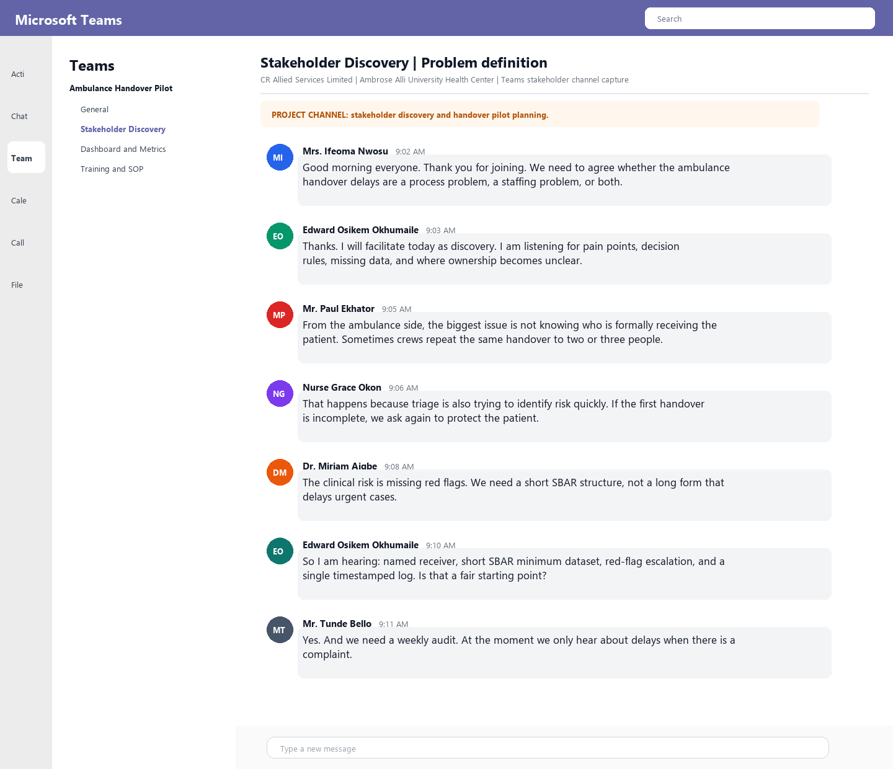

Figure 2. Teams conversation screenshot 2.
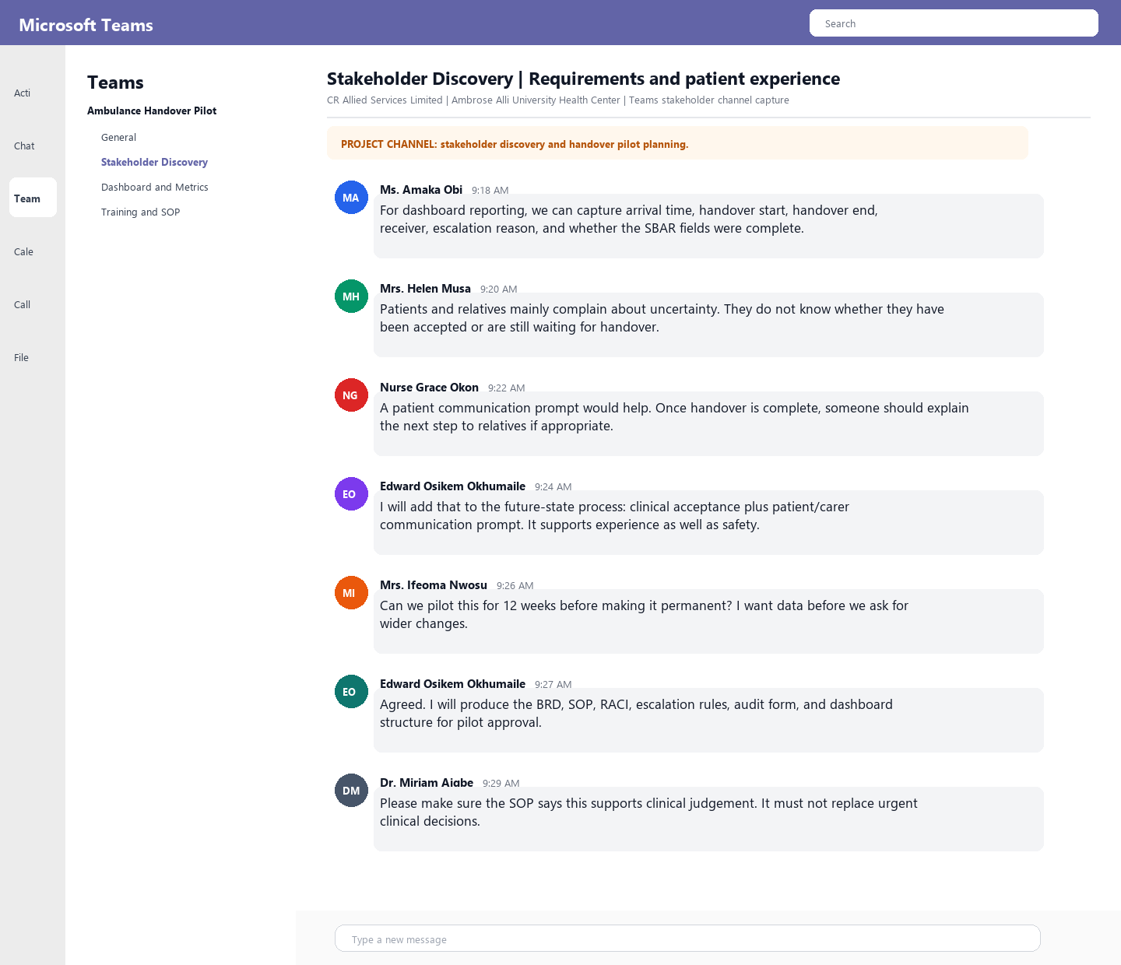

Figure 3. Teams conversation screenshot 3.
