Machine Learning Classification of COVID-19 Test Outcomes Using Symptom and Testing-Context Features
A comparative and temporal-validation study using COVID-19 testing records
Edward Osikem Okhumaile
GitHub: Edy-King | July 2026

Abstract
Background: Symptom and testing-context data may support population-level COVID-19 screening research, but prediction models can look stronger than they are when validation is weak or when test sets are reused. Objective: To compare seven supervised learning algorithms and examine whether apparent performance is maintained over time. Methods: The original model comparison used the first 1,000,000 records from a public 2020-2021 dataset. A corrected secondary analysis used all 5,861,480 records with whole-date partitions: development through 3 March 2021, validation from 4 March to 7 August 2021, and an untouched temporal holdout from 8 August to 11 October 2021. Calibration and threshold selection were restricted to validation data. Results: In the original comparison, tuned LightGBM achieved ROC-AUC 0.743, precision 0.629 and recall 0.381, with no meaningful advantage over the other tree ensembles. The exactly reproduced random forest had average precision 0.397 and bootstrap ROC-AUC 95% CI 0.739-0.747. In the corrected temporal analysis, random-forest ROC-AUC fell from 0.831 in validation to 0.694 in the untouched holdout; average precision was 0.331, precision 0.136, recall 0.701 and F1-score 0.227. Conclusion: The random-split result did not transport reliably to a later period. The work supports a reproducible research workflow, but it does not establish clinical utility. True external validation in an independent population remains necessary.
Keywords: COVID-19; machine learning; symptom screening; temporal validation; LightGBM; random forest; imbalanced classification; clinical prediction modelling

1. Introduction
Laboratory testing remains the diagnostic standard for COVID-19, but routinely collected symptom and testing-context data can be investigated as signals for triage, surveillance and retrospective population analysis. Early studies showed that combinations of symptoms and demographic information could contribute to prediction of infection status, while also illustrating how performance depends on population, prevalence, data collection and validation design (Menni et al., 2020; Zoabi et al., 2021).
The rapid growth of COVID-19 prediction research also produced substantial methodological concern. A systematic review found that many diagnostic and prognostic models were at high risk of bias because of small or non-representative samples, unclear handling of participants and predictors, and inadequate validation (Wynants et al., 2020). The TRIPOD+AI statement consequently emphasises transparent reporting of data sources, participant selection, preprocessing, model development, performance measures and validation for regression- and machine-learning-based prediction models (Collins et al., 2024).
This study asks how well seven common supervised learning methods classify COVID-19 test outcomes using five symptom indicators and a small group of testing-context variables. Its contribution is a transparent, reproducible modelling workflow on a large structured dataset, including a corrected temporal holdout analysis, rather than a claim that the model is ready for clinical use. The study also examines whether more complex ensemble methods provide meaningful gains over simpler alternatives and interprets performance against the observed class distribution.

2. Data and Methods

2.1 Data source and study population
The analysis used the public COVID-19 Dataset for Year 2020 hosted on Kaggle and described by the distributor as being derived from Israeli Ministry of Health records. The original comparison analysed the first 1,000,000 testing records. The corrected temporal-validation analysis used all 5,861,480 available records. The term testing records is used throughout because the supplied materials do not establish that every row represents a unique patient. The original data are not redistributed with this manuscript.
The outcome was corona_result, encoded as negative (0) or positive (1). The supplied dataset contained no missing values in the analysed fields; consequently, no missing-value imputation was required or performed.
Table 1. Dataset and modelling design summary
Item | Specification
Records analysed | Original comparison: first 1,000,000 testing records; corrected temporal validation: all 5,861,480 records
Outcome | corona_result: negative=0; positive=1
Symptom predictors | cough, fever, sore_throat, shortness_of_breath, head_ache
Context predictors | test_date, age_60_and_above, gender, test_indication
Engineered predictors | symptom count; any/multiple-symptom flags; encoded context; month; weekday
Missing values | None in the supplied dataset; no imputation performed
Evaluation split | Original comparison: stratified 80:20 split; corrected temporal validation: development, validation and untouched later-period holdout
Primary comparison | ROC-AUC, average precision, calibration, threshold performance and temporal transportability

2.2 Preprocessing and feature engineering
Symptom indicators were converted to numerical values, clipped to the binary range and cast to integer type. Gender and test indication were one-hot encoded. Test date was used to derive month and weekday, and symptom count, any-symptom and multiple-symptom indicators were derived from the five symptom fields. Feature construction used row-wise, non-fitted transformations before splitting; scaling and PCA for the linear SVM were contained within a fitted pipeline.

2.3 Model development and evaluation
The compared model families were logistic regression, random forest, extra trees, principal component analysis followed by a linear support vector machine (PCA + linear SVM), XGBoost, LightGBM and CatBoost. Class weighting was reported as the imbalance strategy; no over- or undersampling was described. GPU acceleration was attempted for XGBoost, LightGBM and CatBoost where available, with CPU fallback.
A stratified 80:20 split with random_state=42 produced a test set of 200,000 records: 181,793 negative and 18,207 positive. Accuracy, precision, recall (sensitivity), F1-score, ROC-AUC and confusion matrices were reported. Specificity, negative predictive value, balanced accuracy, prevalence and the majority-class accuracy benchmark in this revision were calculated directly from the published LightGBM confusion matrix. Wilson 95% confidence intervals were calculated for binomial proportion metrics; these intervals quantify sampling precision conditional on the test set but do not address dataset shift or model-selection uncertainty.
Repository verification established random_state=42, three-fold shuffled stratified cross-validation, a maximum of 10 randomized-search candidates per selected model and explicit model-specific tuning spaces. The original dependency file named the required packages but did not pin package versions; the corrected temporal workflow therefore includes a pinned dependency file. Baseline test-set ROC-AUC and F1-score were used to select the three models for tuning, so the original test set was not fully independent of model selection.

2.4 Extended reproducibility analyses
The uploaded Kaggle archive was used to reconstruct the repository workflow. Logistic regression, random forest and extra trees were retrained with the repository configurations, and their saved metrics and confusion matrices were reproduced exactly to the reported precision. Random forest was then used for the extended probability-based analyses because its repository result was exactly reproducible and record-level probabilities were available. These probabilities supported average precision, Brier score, calibration, threshold analysis and 200 stratified bootstrap resamples. Model agreement was assessed using raw classification agreement and Cohen's kappa. Permutation importance was calculated on a deterministic 50,000-record test subset with five repeats and average precision as the scoring measure.
A corrected temporal design used all 5,861,480 records. The repository-configured random forest was fitted on 4,386,596 development records dated 20 March 2020 to 3 March 2021. Isotonic calibration and selection of the threshold that maximised F1 used only 592,575 validation records dated 4 March to 7 August 2021. The selected calibrated threshold (0.3180) was frozen before a single evaluation on 882,309 untouched records dated 8 August to 11 October 2021. Whole dates were kept within one partition. The temporal script also writes compressed validation and holdout prediction files containing raw probabilities, calibrated probabilities and frozen-threshold classifications. This is temporal validation within the same data source, not external validation.

3. Results

3.1 Baseline comparison
Table 2. Baseline model comparison on the held-out test set
Model | Accuracy | Precision | Recall | F1 | ROC-AUC
Logistic regression | 0.923 | 0.626 | 0.381 | 0.474 | 0.711
Random forest | 0.923 | 0.630 | 0.380 | 0.474 | 0.743
Extra trees | 0.923 | 0.630 | 0.380 | 0.474 | 0.743
PCA + linear SVM | 0.923 | 0.625 | 0.378 | 0.472 | 0.711
XGBoost | 0.923 | 0.630 | 0.381 | 0.474 | 0.743
LightGBM | 0.923 | 0.630 | 0.380 | 0.474 | 0.743
CatBoost | 0.923 | 0.630 | 0.380 | 0.474 | 0.743

The tree-based ensemble models were indistinguishable at the displayed precision, with ROC-AUC 0.743 and nearly identical threshold-dependent metrics. Logistic regression and PCA + linear SVM had lower ROC-AUC (0.711). Because the values are rounded to three decimals and no paired confidence intervals or prediction-agreement analysis were available, superiority among the tree-based models cannot be established.

3.2 Tuned models and selected model
Table 3. Reported tuned-model comparison
Model | Accuracy | Precision | Recall | F1 | ROC-AUC
XGBoost | 0.923 | 0.630 | 0.381 | 0.474 | 0.743
LightGBM | 0.923 | 0.629 | 0.381 | 0.474 | 0.743
CatBoost | 0.923 | 0.630 | 0.380 | 0.474 | 0.743

LightGBM was retained in the original workflow, although it did not show a statistically or practically meaningful advantage over XGBoost or CatBoost in the reported results. Its reported parameters were subsample=0.85, num_leaves=31, n_estimators=300, min_child_samples=100, learning_rate=0.08 and colsample_bytree=0.8. Because LightGBM record-level probabilities were not available for the extended analyses, the corrected temporal validation was performed with the exactly reproduced random forest rather than presented as a LightGBM holdout result.

3.3 Confusion-matrix analysis
The LightGBM confusion matrix was [[177,702, 4,091], [11,274, 6,933]], using the order [[true negatives, false positives], [false negatives, true positives]]. The test-set positive prevalence was 9.10%. A classifier that predicted every record as negative would therefore achieve 90.90% accuracy; the model’s 92.32% accuracy was an absolute improvement of 1.42 percentage points.
Table 4. Derived LightGBM performance measures
Measure | Estimate | 95% CI / comparator
Accuracy | 0.9232 | 0.9220–0.9243
Precision / PPV | 0.6289 | 0.6198–0.6379
Recall / sensitivity | 0.3808 | 0.3738–0.3879
Specificity | 0.9775 | 0.9768–0.9782
Negative predictive value | 0.9403 | 0.9393–0.9414
Balanced accuracy | 0.6791 | Derived mean of sensitivity and specificity
Majority-class accuracy | 0.9090 | All-negative benchmark

Confidence intervals are Wilson intervals derived from the reported counts. ROC-AUC confidence intervals, PR-AUC, calibration measures and threshold curves cannot be recovered from a single confusion matrix and require record-level probabilities. These quantities were therefore reconstructed for random forest, not for LightGBM.

3.4 Extended random-forest evaluation
The reconstructed random forest exactly reproduced the repository result (ROC-AUC 0.74274; confusion matrix [[177,725, 4,068], [11,281, 6,926]]). Average precision was 0.397, compared with positive prevalence 0.091. The Brier score was 0.170 and the calibration curve showed substantial overprediction of observed risk, which is consistent with treating class-weighted training scores as uncalibrated probabilities.
Table 5. Reproduced random-forest metrics with stratified bootstrap intervals
Measure | Estimate | Bootstrap 95% CI
ROC-AUC | 0.7427 | 0.7389–0.7467
Average precision | 0.3971 | 0.3913–0.4043
Accuracy | 0.9233 | 0.9224–0.9242
Precision | 0.6300 | 0.6212–0.6384
Recall | 0.3804 | 0.3739–0.3883
F1-score | 0.4744 | 0.4684–0.4821
Balanced accuracy | 0.6790 | 0.6759–0.6829
Brier score | 0.1704 | 0.1699–0.1710

Figure 1. Random-forest discrimination, precision–recall and calibration
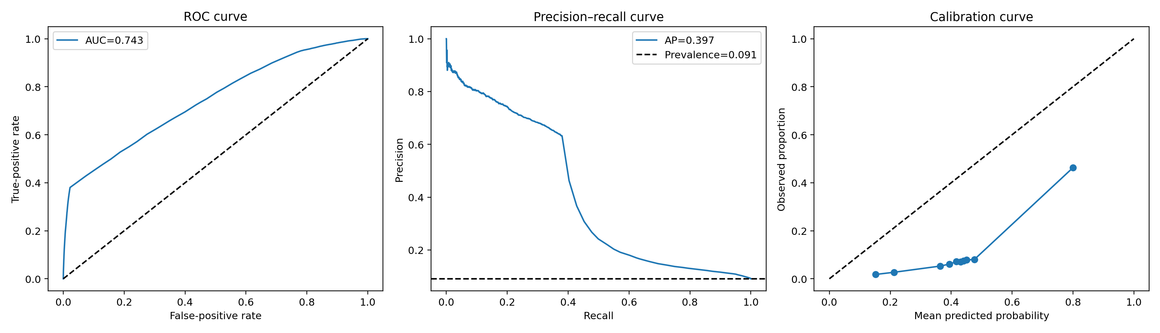
At threshold 0.5, random forest and extra trees agreed on 99.9965% of classifications (Cohen’s κ=0.9997). Logistic regression and random forest agreed on 99.943% (κ=0.9945). These results show that the near-identical threshold metrics reflected nearly identical classifications, although the models’ ranking performance differed.
Figure 2. Random-forest permutation importance measured by decrease in average precision
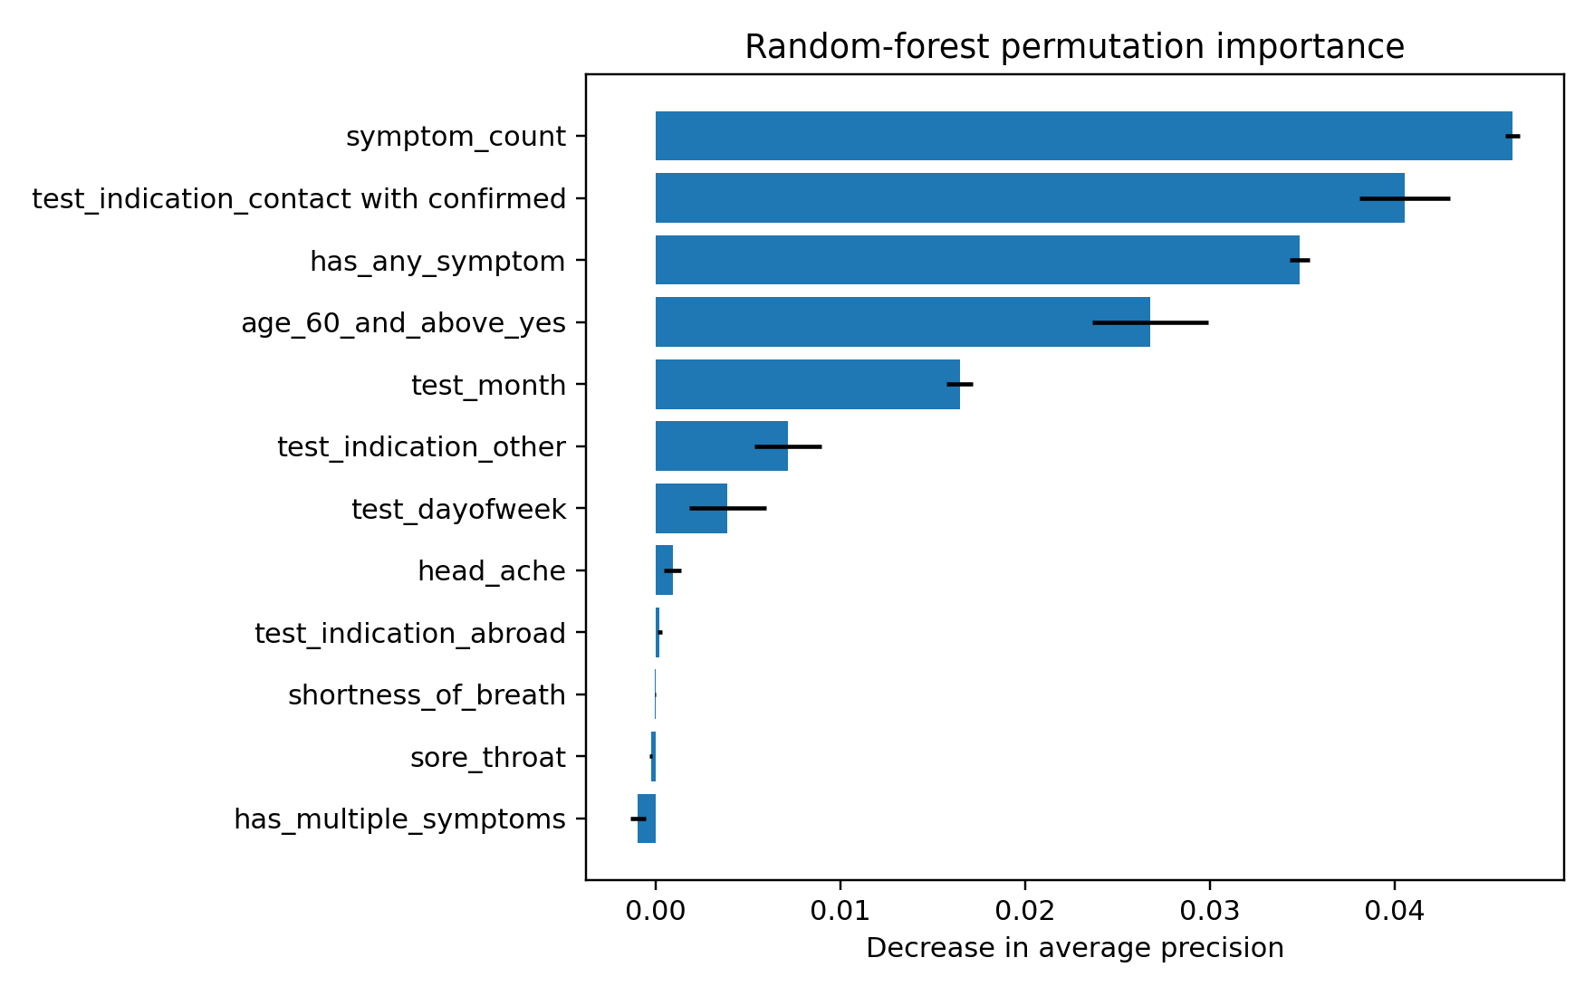
Symptom count, confirmed-contact test indication, any-symptom status, age over 60 and test month were the leading permutation-importance signals. Negative or near-zero values for individual symptoms should not be interpreted as protective effects because the engineered symptom aggregates are strongly redundant with their component indicators.

3.5 Untouched temporal holdout
Table 6. Validation and untouched temporal-holdout performance
Measure | Validation | Untouched holdout
Records | 592,575 | 882,309
Positive prevalence | 0.0390 | 0.0972
ROC-AUC | 0.8313 | 0.6938
Average precision | 0.3517 | 0.3306
Accuracy | 0.9569 | 0.5367
Precision | 0.4635 | 0.1357
Recall | 0.6556 | 0.7015
Specificity | 0.9692 | 0.5190
F1-score | 0.5430 | 0.2274
Balanced accuracy | 0.8124 | 0.6102
Brier score | 0.0268 | 0.1069

Figure 3. Random-forest performance on the untouched temporal holdout
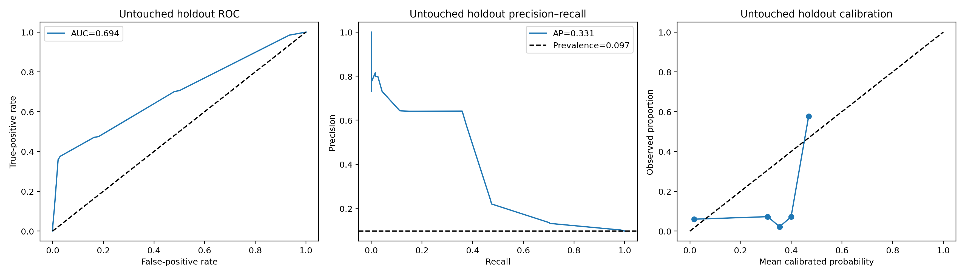
The untouched holdout showed marked temporal degradation. ROC-AUC fell by 0.138 relative to validation, and the validation-selected threshold produced 383,146 false positives and 25,607 false negatives. Recall was 0.701, but precision fell to 0.136. The shift in prevalence, discrimination and calibration shows that neither the random-split estimate nor the validation-period threshold performance transferred reliably to the latest period.

4. Discussion

4.1 Principal findings
The leading tree-based models achieved moderate discrimination on the original random split (ROC-AUC approximately 0.74), but their classifications at the reported threshold were dominated by high specificity and low sensitivity. Approximately 62% of positive cases were missed. In a screening setting, that false-negative rate would be unacceptable unless the model were used only as one component of a broader pathway and the decision threshold were chosen according to explicit clinical costs.
The modest improvement over the majority-class accuracy benchmark illustrates why accuracy alone can be misleading in an imbalanced dataset. Balanced accuracy of 0.679 provides a more cautious summary of threshold performance. The similarity of the ensemble models suggests that the feature set, rather than algorithm choice, constrained discrimination. LightGBM should therefore be described as the retained implementation from the original workflow, not as a clearly superior model.

4.2 Relation to previous work
Previous symptom-based studies reported that combinations of symptoms and participant characteristics could predict COVID-19 infection, but their settings, recruitment mechanisms and predictor definitions differed substantially (Menni et al., 2020; Zoabi et al., 2021). Direct numerical comparison is therefore inappropriate. More broadly, methodological reviews of COVID-19 prediction studies identified high risks of bias and emphasised the need for representative data, transparent preprocessing and external validation (Wynants et al., 2020, 2022). The present findings reinforce the distinction between apparent performance on a random split and evidence of transportability to new time periods, policies or populations.

4.3 Model selection, thresholding and clinical interpretation
ROC-AUC evaluates ranking across thresholds, whereas recall, specificity and predictive values depend on the selected operating threshold and, for predictive values, on prevalence. A lower threshold can raise sensitivity but will increase false positives. Selection of an operating point should occur on validation data using pre-specified clinical or operational consequences, followed by one evaluation on untouched test data. Precision-recall curves are particularly important here because positive cases represented only 9.1% of the original test sample and 9.7% of the final temporal holdout.
No claim of clinical utility can be made from the current evidence. Calibration, decision-curve analysis and comparison with an appropriate clinical baseline would be needed before predicted probabilities could support decisions. Feature-attribution analysis is also needed to clarify whether the model relies mainly on symptoms or on contextual proxies such as month and test indication.
The reconstructed analyses sharpen this interpretation. Random-forest scores from the original split were poorly calibrated, so they should not be presented as individual risks. Permutation importance showed that symptom burden and testing context both contributed to performance; confirmed-contact indication and month were prominent signals. Even after validation-only isotonic calibration and threshold selection, discrimination and calibration deteriorated in the untouched latest period. This indicates temporal dataset shift and shows why both ranking performance and operating characteristics must be re-evaluated when time, testing policy and prevalence change.
The extensive repetition of identical observed rows further limits inference. Because the dataset contains no patient identifier, exact duplicate rows may represent different people with the same recorded profile, repeat tests, duplicated records or a combination of these. Random splitting does not separate these possibilities and allows identical profiles to occur in development and test data. Patient-level splitting is therefore recommended if identifiers become available.

5. Limitations
- The compact feature set excludes laboratory measurements, comorbidities, vaccination status, viral variants and longitudinal history.
- The original random stratified split may place temporally adjacent records under similar testing policies in both training and test sets. This can overstate generalisation compared with a later-period temporal holdout.
- The materials do not establish whether rows are unique patients; patient-level clustering or repeated tests could lead to information dependence across the split.
- The code uses test-set results to select the three baseline models for tuning and again to select the final tuned model. This test-set reuse makes the final estimate selection-informed and potentially optimistic.
- The nearly identical tree-model results require verification using unrounded metrics, paired resampling and prediction-agreement checks.
- The first million rows contain 987,175 exact full-row duplicates and only 12,825 unique full-row combinations. Without patient identifiers, repeated tests and repeated patients cannot be distinguished, and random splitting permits identical observed profiles in both sets.
- PR-AUC, calibration and threshold analyses were reconstructed for random forest, not for the originally retained LightGBM model, because saved LightGBM record-level probabilities were unavailable.
- Decision-curve analysis was not performed because no defensible clinical decision context or relative harm specification was supplied.
- The Wilson intervals reported here reflect binomial sampling variation only and do not account for model-development uncertainty, temporal change or external dataset shift.
- Temporal validation was completed within the same data source, but true external validation in a distinct population, institution or collection system remains absent. The model should not be used for diagnosis or clinical decision-making.

6. Reproducibility and Availability
The public code repository is available at https://github.com/Edy-King/covid-19-ml-workflow and the data source at https://www.kaggle.com/datasets/mykeysid10/covid19-dataset-for-year-2020. Repository inspection confirmed executed notebooks, result tables, a saved LightGBM model and metadata. The corrected temporal workflow used a pinned environment: pandas 2.2.3, NumPy 2.3.5, scikit-learn 1.8.0, matplotlib 3.10.8, seaborn 0.13.2 and joblib 1.5.3. The repository update includes the corrected temporal script, requirements_temporal_lock.txt, fixed partition dates and locally generated validation and holdout prediction files when the script is run with the Kaggle CSV. The source dataset is not redistributed because of its size and distribution terms.

7. Conclusion
Seven supervised learning algorithms were initially compared on one million records, with LightGBM retained despite showing no meaningful advantage over the other tree ensembles. A corrected analysis used all 5,861,480 records with separate development, validation and untouched temporal-holdout periods. Despite validation-only calibration and threshold selection, final holdout ROC-AUC fell to 0.694 and precision to 0.136, demonstrating substantial temporal degradation. This temporal holdout is stronger evidence than the original random split, but it does not support clinical use. Test-set reuse in the original comparison, repeated row profiles, lack of patient identifiers and absence of true external validation remain important limitations. Future work should validate the locked workflow in a distinct population and preserve patient-level separation where identifiers exist.

Declarations
Data availability: The dataset is publicly available from Kaggle at the address listed above. The source data are not redistributed with this manuscript.
Code availability: The executed notebooks, notebook-generation script, result tables, trained model, metadata and corrected temporal-validation workflow are publicly available at https://github.com/Edy-King/covid-19-ml-workflow.
Ethics statement: This secondary analysis used an existing public dataset and did not involve participant recruitment, intervention or collection of new personal data. Before submission, the dataset licence, de-identification statement and any applicable institutional exemption should be confirmed against the journal's requirements.
Competing interests: The author declares no competing interests.
Funding: No external funding was received.
Author contributions: Edward Osikem Okhumaile conceived the study, developed the analysis workflow, conducted the modelling, interpreted the findings and prepared the manuscript.

References
1. Chen T, Guestrin C. XGBoost: A scalable tree boosting system. Proceedings of the 22nd ACM SIGKDD International Conference on Knowledge Discovery and Data Mining. 2016:785–794. doi:10.1145/2939672.2939785.
2. Collins GS, Moons KGM, Dhiman P, et al. TRIPOD+AI statement: updated guidance for reporting clinical prediction models that use regression or machine learning methods. BMJ. 2024;385:e078378. doi:10.1136/bmj-2023-078378.
3. Ke G, Meng Q, Finley T, et al. LightGBM: A highly efficient gradient boosting decision tree. Advances in Neural Information Processing Systems. 2017;30.
4. Menni C, Valdes AM, Freidin MB, et al. Real-time tracking of self-reported symptoms to predict potential COVID-19. Nature Medicine. 2020;26:1037–1040. doi:10.1038/s41591-020-0916-2.
5. Pedregosa F, Varoquaux G, Gramfort A, et al. Scikit-learn: Machine learning in Python. Journal of Machine Learning Research. 2011;12:2825–2830.
6. Prokhorenkova L, Gusev G, Vorobev A, Dorogush AV, Gulin A. CatBoost: unbiased boosting with categorical features. Advances in Neural Information Processing Systems. 2018;31.
7. Wynants L, Van Calster B, Collins GS, et al. Prediction models for diagnosis and prognosis of COVID-19: systematic review and critical appraisal. BMJ. 2020;369:m1328. doi:10.1136/bmj.m1328.
8. Wynants L, Van Calster B, Collins GS, et al. Update to living systematic review on prediction models for diagnosis and prognosis of COVID-19. BMJ. 2022;378:o2009. doi:10.1136/bmj.o2009.
9. Zoabi Y, Deri-Rozov S, Shomron N. Machine learning-based prediction of COVID-19 diagnosis based on symptoms. npj Digital Medicine. 2021;4:3. doi:10.1038/s41746-020-00372-6.

