Aquarium Led control

LED lamp driving using an ESP8266.

Preface.
An ESP8266 is used to drive 2 aquarium lamps (LED) with PWM. I used 2 Superfish Led Combi 45 cm lamps, one with white LEDs and one with colored LEDs. The lamps should be powered by a 10 Volt adapter, but in my case the light was too intens.

The ESP8266 software contains a 24 hour program to power the lamps. There is also a way to overrule the programmed settings.

Schematics.
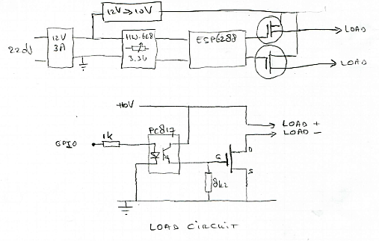
The FETs are IRF540 N channel FETs. Optocouplers are used to protect the ESP8266 I/O pins from the 10 Volt rail.
The 12V-3A powersupply is an external adaptor.

Software.
The software is written for a Wemos D1 board. PaltformIO is used for development.
At start-up, the intensity table will be read from EEPROM. A NTP server is used to synchronize the internal real time clock. Depending on the current time of day, the corresponding entry in the intensity table is used to power the lamps.
The software uses CET/CEST time zone, but this can be change easily in the progrm (near line 44):

// Central European Time (Amsterdam, Frankfurt, Paris)
TimeChangeRule CEST = { "CEST", Last, Sun, Mar, 2, 120 } ; // Central European Summer Time
TimeChangeRule CET = { "CET ", Last, Sun, Oct, 3, 60 } ; // Central European Standard Time

Pin usage.
Pins D5 and D6 are used to control the output PWM signals.

Web interface.
A web interface is available for the configuration of the 24 hour timing and the overrule function. There are extra pages for examining the logging and for some info about the project.

Home page.
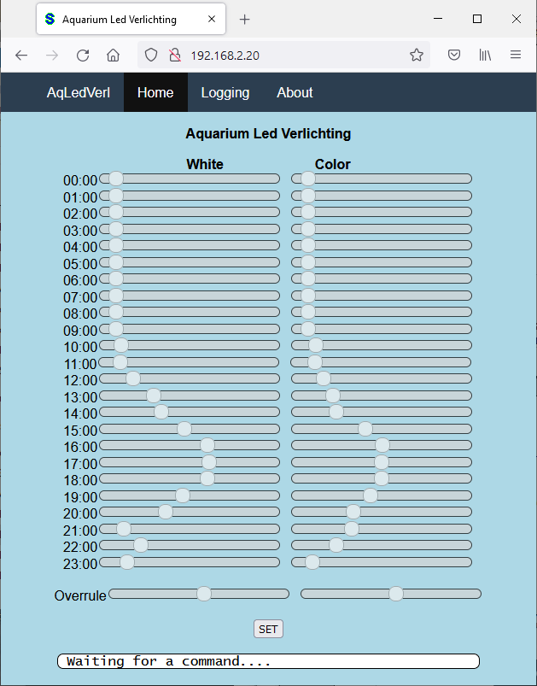
The page looks like this:
In this page you can program the intensity for both lamps during the day (24 hours) by setting the sliders. Sliders can be set to any value between 0 and 100 percent. If the “SET”button is pushed, the setting will be transferred to the ESP8266, the table will be saved in EEPROM and the table is activated.

By setting the 2 “overrule” sliders, you may overrule the programmed settings. The text (and the function) of the button will change to “OVERRULE”. The overrule function ends when you shift one or both overrule sliders to the leftmost position (-1) and push the “SET” button.

Pictures.
The controller looks like this:
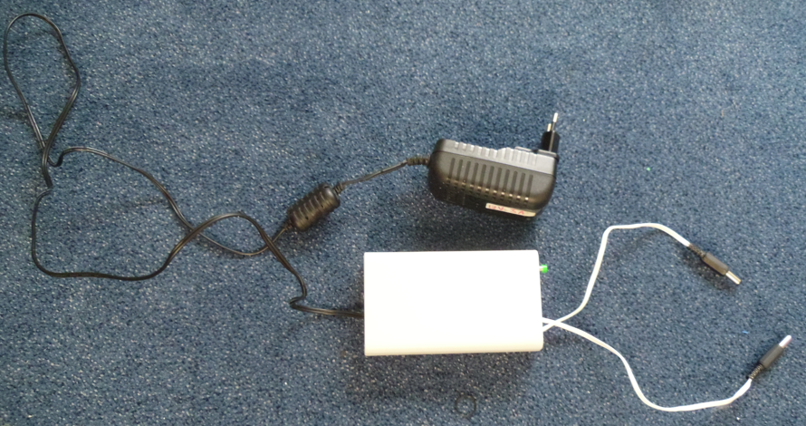
The box contains:
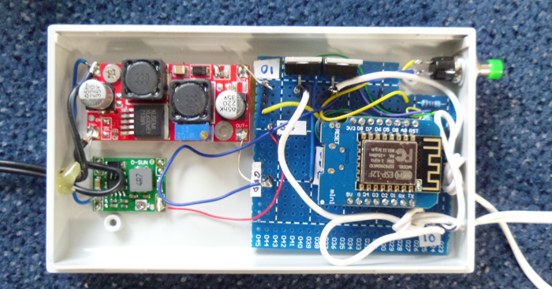
The push button is connected to the RST of the ESP8266.

