4PDP8-ES, an ESP32 pdp8 simulator

Introduction.
This document describes a pdp8 simulator that runs on an ESP32 SOC. The emulator simulates the pdp8 and some peripherals like an RK8E disk and a TU56 dectape drive capable of running the OS/8 operating system.
The pdp8 is a well known minicomputer from the sixties. OS/8 is developed in the seventies.
On the internet there is plenty of information available about this remarkable machine.
The software is developed using the Espressif esp-idf toolchain. The speed of the simulated pdp8 is about as fast as an original pdp8/e machine, but disk/tape I/O is much faster. The simulator will emulate a pdp8 like this:

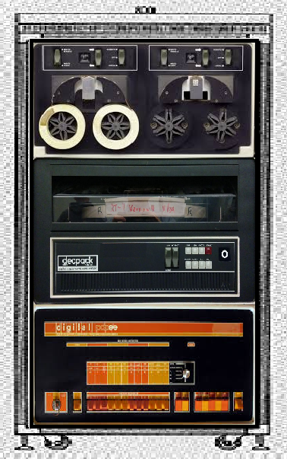

Four RK8E drives are simulated in the 16MB flash version.

Hardware.

Minimal version.
The original hardware used for the simulator is an ESP32 development board with 4 MB flash. An SD-card can be connected to the VSPI bus of the ESP32 (pins 18,19,23) for storage of several OS/8 compatible images. The CS pin used for the SD card can be defined with “make menuconfig” in the esp-idf. The simulator can be used without the SD card. The console terminal is connected through a TELNET connecting using the WiFi capabilities of the ESP32. It is also possible to use a serial connection. A minimal configuration could look like this:

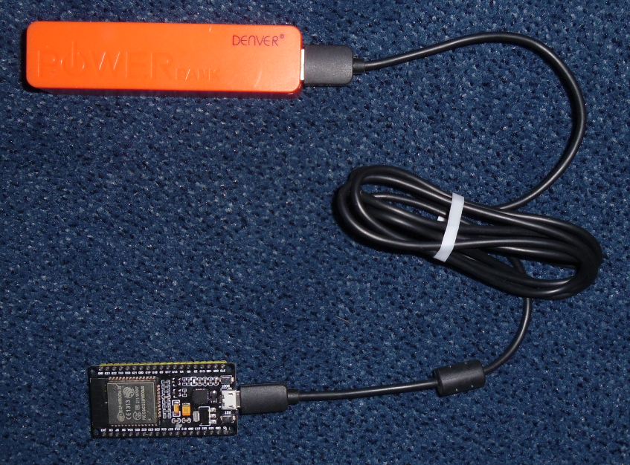

SD Card (optional).
This is how an SD card can be connected:
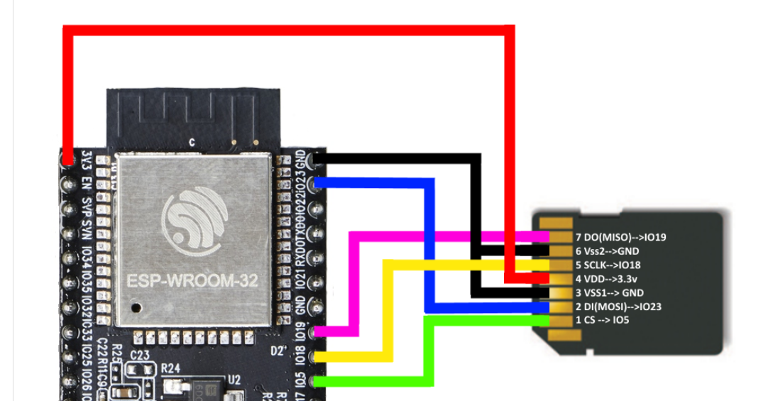

Without the SD card the simulator can download an image of the OS/8 operating system from the Internet. OS/8 will be saved in the flash memory of the ESP32 and can be booted afterwards.

Version with OLED and SD Card.
This version results in a very small PDP8. I call it the PDP8-ES. “ES” stands for “Extra Small”, “ESp32” and “Ed Smallenburg”. For this PDP8-ES I used a development board from Aliexpress “16 Mt bytes Pro ESP32 OLED V2.0 TTGO”. This module has a build-ind OLED screen that is used to display the famous console lights of the PDP8 in “real time”. It also has 128 Mbit flash instead of the standard 64 Mbit. This extra space is used to simulate more peripheral devices.

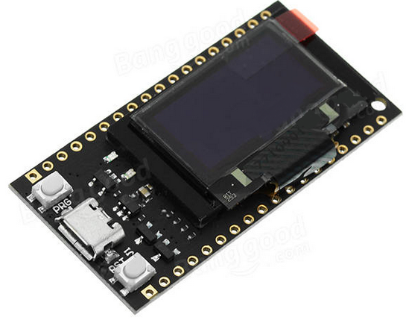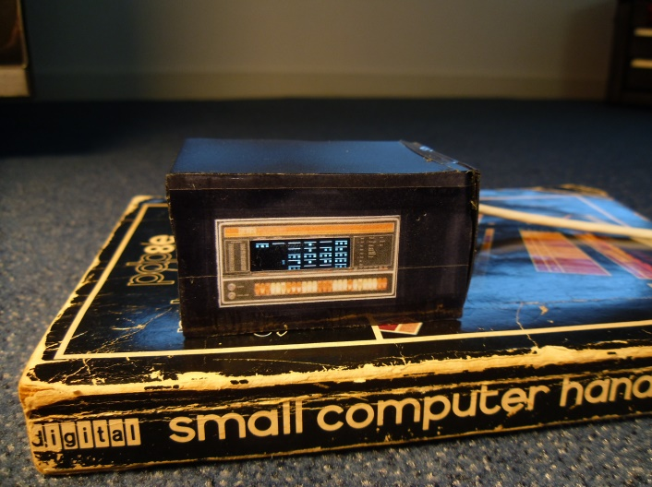

The result is a very small PDP8 (see picture). A small demo video can be seen at http://smallenburg.nl/pdp8/PDP8-ES.MP4.
The module has a build-in interface for a LiPo battery, so you can run your PDP8-ES completely wireless (for a limited time).

Another ESP module for this project may be this one:
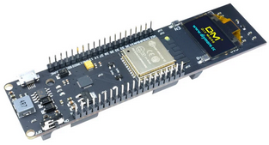
It also has an OLED, but memory space is limited to 4MB.

For boards without a display, an external OLED can be used, like this one:

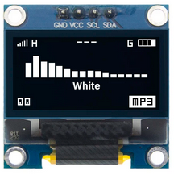
The driver is SSD1306

Partitioning.
The OS/8 block devices like RKA0:, RKB0:, DTA0: are emulated as partitions in the
ESP32 module with 16 MB (128 Mbit) flash the partition table is:

# Name, Type, SubType, Offset, Size, Flags
nvs, data, nvs, 0x0009000, 0x004000,
otadata, data, ota, 0x000D000, 0x002000,
phy_init, data, phy, 0x000F000, 0x001000,
factory, app, factory, 0x0010000, 0x100000,
ota_0, app, ota_0, 0x0110000, 0x100000,
ota_1, app, ota_1, 0x0210000, 0x100000,
RKA0, data, 0x80, 0x0310000, 0x140000,
RKB0, data, 0x80, 0x0450000, 0x140000,
RKA1, data, 0x80, 0x0590000, 0x140000,
RKB1, data, 0x80, 0x06D0000, 0x140000,
RKA2, data, 0x80, 0x0810000, 0x140000,
RKB2, data, 0x80, 0x0950000, 0x140000,
DTA0, data, 0x81, 0x0A90000, 0x04C000,
DTA1, data, 0x81, 0x0ADC000, 0x04C000,
#Free 0x0B28000
#End+1 0x1000000

For a 4MB (32 Mbits) ESP32, the partition table is like this:

# Name, Type, SubType, Offset, Size, Flags
nvs, data, nvs, 0x009000, 0x004000,
otadata, data, ota, 0x00D000, 0x002000,
phy_init, data, phy, 0x00F000, 0x001000,
factory, app, factory, 0x010000, 0x0E0000,
RKA0, data, 0x80, 0x0F0000, 0x140000,
RKB0, data, 0x80, 0x230000, 0x140000,
DTA0, data, 0x81, 0x370000, 0x04C000,
RXA0, data, 0x82, 0x3BC000, 0x034000,
coredump, data, coredump, 0x3F0000, 0x010000,
# 0x400000

A sector (1000 hexadecimal bytes = 4kB) in the flash memory can hold 21 PDP8 pages of 128 packed words. A sector in flash can only be written to as a whole block of 4 kB. To minimize the number of writes (and reads), a cache of at least 16 sectors are buffered in the simulator. The dirty cache buffers (caused by write operations) will be saved in flash every 5 minutes or by using the “FL” or “PO” command in the console.

At least the RKA0 partition must be filled by a proper image in order to run OS/8 on the simulator. The image can be downloaded from the Internet through the build-in http client or loaded from an SD card.

A fully patch RKA0/RKB0 image will be available at http://smallenburg.nl/pdp8/os8patched.rk05, ready to be transferred to an SD card. The same image is used for direct download onto the RKA0/RKB0 drives.

Managing the simulator.

TELNET client.
On (re)start of the ESP32, the simulator does not start automatically. The user must make a TELNET connection to the ESP32. A good TELNET client for this purpose is “PuTTY” (see http://putty.org).
The last digit of the IP address will be displayed in the MQ register of the console in octal form. I my case it was 10 (octal), so the address is 192.168.2.8.
Assuming an IP address of 192.168.2.8, the settings for a connection are:

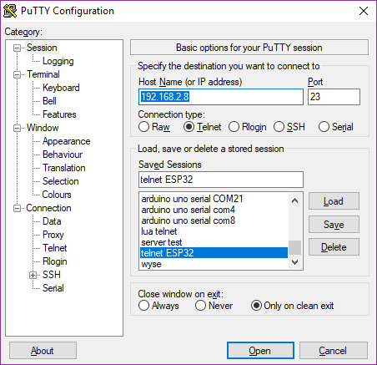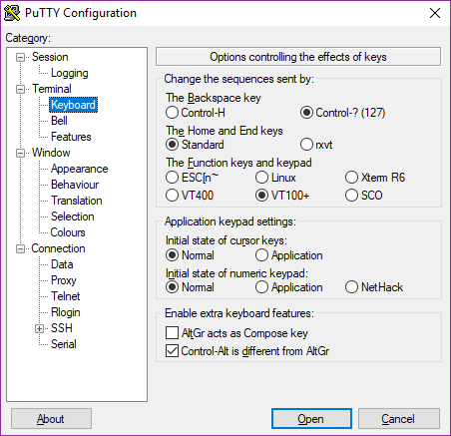

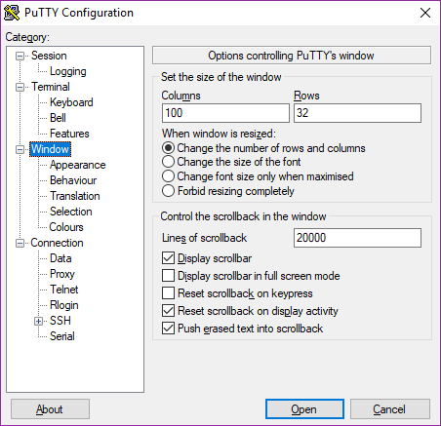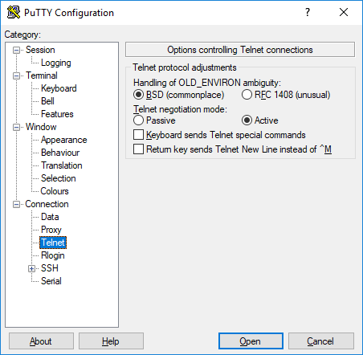

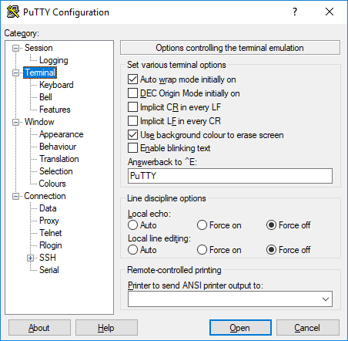
If you want to use the serial connection instead of TelNet, you have to select Serial and the right COM port:

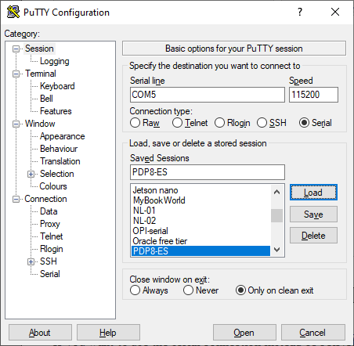
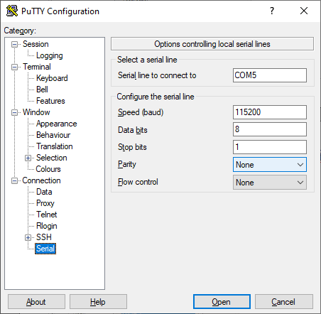
Also set the flow control to “None”.

You may save the settings for convenience.

The serial monitor of PlatformIO can also be used, but note that Ctrl-C stops the serial monitor and not the PDP8 program.

Control Console.
Connect to the simulator through the build-in Control Console (TelNet or Serial)./res

Once connected, you will see a screen like this:

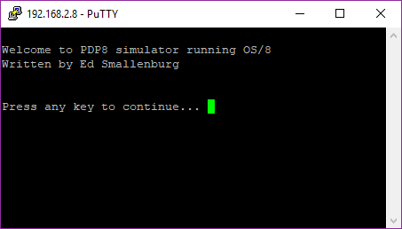

For a serial connection, pressing Ctrl-A is required to start this screen.

An extra line is added if an SD card is connected.

After pressing a key, the simulator console will be shown:

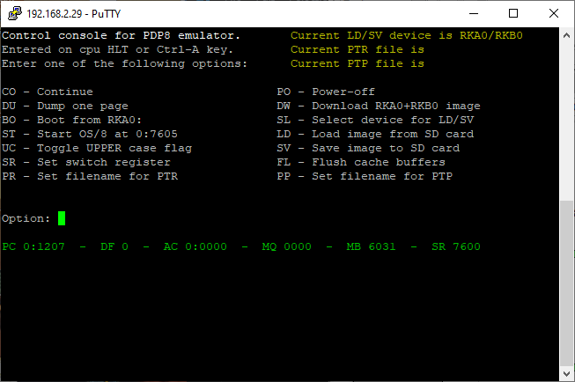

This screen can be activated any time by pressing Ctrl-A on the keyboard. A HLT instruction or an illegal IOT will also bring up this screen.
You may adjust the size of the console screen if filenames are too long to fit the screen.

The most obvious command is “BO”, but for the first time you have to configure your PDP8. Possible commands are listed below. Command can have one or two parameters.
- CO – This will continue the PDP8 after a Ctrl-A interrupt.
- DU – This will dump the contents of one PDP8 page on the screen. Parameters may be the data field and the start address of the dump. If no parameters are supplied, the next page will be dumped.
Examples: “DU 3 200”, “DU 1000”, “DU”.
- BO – This will boot the RKA0: disk and start OS/8.
- ST – This will start OS/8 at 07605 after a Ctrl-A interrupt. Parameters may be field and address of a different start point.
Examples: “ST”, “ST 0 7600”, “ST 0200”.
- UC – This will toggle the Uppercase flag. Some versions of OS/8 expect only uppercase characters. This function may be handy for this situation.
- SR – Will set the pdp8 switch register according the parameter. The “LAS” instruction will read this number in the accumulator.
Example: “SR 7600”
- PR – Set the input file (on SD card) for the simulated paper tape reader. The current input file will be visible at the top of the screen.
- PO – Power off. This will write cached data to the simulated drives and the ESP32 is set to sleep. Wake up by the RESET or BOOT button of the development module. Not that disconnecting the power without this command does not write the cache to the simulated disks/tapes, and may therefore cause file inconsistency.
- DW – This will download a more or less working OS/8 system from the internet. You may also supply a different URL as a parameter for this command, for example: ”www.pdp8online.com/ftp/images/os8/diag-games-kermit.rk05”. Other images can be stored on an SD card (if connected). See the “LD” command.
- SL – This will select a pdp8 device for the LD and SV commands. If no parameter is supplied, a list of the available devices will be shown.
- LD – This will copy an image from the SD-card to the selected pdp8 device. For RKA0/RKB0, the image is usually the size of one or two disks. The reason is that the disk was divided into 2 “sides” as the whole disk was too big to be addressed as one device (more than 4096 blocks). Without a parameter, the console will show all the matching (see SL command) images on the SD card like this:
os8.rk05
diag-games-kermit.rk05
To load an image, select the right input file according to the directory listing.
Example: “LD os8.rk05”. The extension of the file will be forced to the standard extension, like “.rk05” for a RKA0/RKB0 image.
Note: a load from existing .rx01 files does not work yet. However, you may save an rx01 image and read it back using LD.
- SV – Save the image of the selected device to the SD card. This is the reverse of “LD”. You have to specify a filename. The extension will be forced to a standard extension.
- FL – This will flush the cached data to the pdp8 devices. Never turn the power off without a flush! You may also use the “PO” command.
- PP – Set the output file (on SD card) for the simulated paper tape punch. Specify the filename in the parameter. The current output file is visible at the top of the screen.

Running OS/8.

Unpatched OS/8 images.
An unpatched RK8E OS/8 image will run on the simulator. But only RKA0 is available in this case. You can make RKB0 accessible by making a simple patch. This is the procedure:
- Find out what the device number is for RKB0. Use RESORC.SV for this purpose:
.RESORC /E
This will show a table like:
# NAME TYPE MODE SIZ BLK KIND U V ENT USER
01 SYS RK8E RWF 3248 SYS 0 C 07
02 DSK RK8E RWF 3248 SYS 0 C 07
03 RKA0 RK8E RWF 3248 16 RK05 0 A 20
04 RKB0 RK8E RWF 3248 16 RK05 0 A 21
05 RKA1 RK8E RWF 3248 16 RK05 1 A 22
06 RKB1 RK8E RWF 3248 16 RK05 1 A 23
07 RXA0 RX8E RWF 494 17 E 30
- Look at the device number (column 1) for device RKB0. In this example it is 4.
- Start ODT and open location 17646 + DEVNR, in this example 17652 and change its contents to 7613. Exit ODT afterwards by pressing Ctrl-C:
. ODT
17652/0000 7613
.^C
.
- Now RKB0 is also accessible.
- Optional, you can make DTA0 accessible by 17652/putting the number 7617 into 17646+(devnr of DTA0).

Patched OS/8 images.
In the data directory is a fully patched OS/8 image available (os8patched.rk05). Copy this to your SD card if you want to use it.

Some handy commands:
- SET TTY WIDTH 80
This prevents extra new lines to be printed if lines are longer than 72 characters.
- SET TTY NO PAUSE
This will prevent pauses if text scrolls over the screen. Will not work with all OS/8 versions.
- DIR
This will give you a directory listing. Also “DIR DTA0:” or “DIR RKB0:” Note that device names end with a semicolon to distinguish it from a filename.
- HELP
This will give you some help texts.

OS/8 programs incompatibility.
Some programs will not run on this simulator. Specially programs that uses I/O directly. Direct I/O for extended memory handling, papertape and teletype I/O are emulated, but if a program tries to execute IOTs for disk or dectape access directly, the simulator will stop with information about the failed instruction.
So for example DTCOPY.SV will not work. Programs that use the interrupt facility will also not work.
A PATCH.PA program is supplied in the tools directory that will patch CCL, DIRECT, RESORC and PIP for this simulator.

CCL.SV.
The OS/8 date was originally designed to run from 1-JAN-70 to 31-DEC-77. This limit was caused by having just 3 bits to store the year. Here the year offset was 1970. Later on, the limit of the year was extended to 1999 by using 2 additional bits at location 07777, bits 3 and 4. The simulator tries to set the date automatically on boot, at location 17666 and 07777. For 2017, this will result in something like Sunday August 23, 1987.
So we have to change the offset for the year from 1970 to 2000. I patched CCL.SV for this purpose. Now, since a long time, it prints the correct date:

.DATE
Wednesday August 23, 2017

Note that setting the date is no longer necessary and maybe impossible.
I also patched DIRECT.SV so it will print the right date:

.DIR

17-Jan-18

K12DEC.SV 5 RXCOPY.SV 9 04-Jan-11 LOAD .LS 8
K12MIT.SV 33 FLOP .HN 3 04-Jan-11 TEST .SV 2 12-Jan-18
K12DJG.SV 33 LCSYS .BI 3 PASCAL.BN 63 03-Jan-18
K12DEB.SV 4 UCSYS .BI 3 TEST .PA 2 12-Jan-18
K12ENB.SV 4 BASIC .WS 11 TEST .BN 1 12-Jan-18
BRTS .SV 15 01-Dec-13 SET .SV 20 04-Jan-11 FAKE .PA 7 16-Jan-18
F4 .SV 20 21-Jul-15 RTFLOP.SV 15 04-Jan-11 FAKE .BN 1 16-Jan-18
FRTS .SV 26 04-Oct-17 WPFLOP.SV 14 04-Jan-11 PATCH .PA 5 16-Jan-18
PASS2 .SV 20 21-Jul-15 RESORC.SV 14 04-Jan-11 PATCH .BN 2 16-Jan-18
PASS2O.SV 5 21-Jul-15 DECX8 .SV 43 24-Mar-17 X .DI 15 16-Jan-18

171 Files in 2746 Blocks - 446 Free blocks

F4.SV / FRTS.SV.
The Fortran compiler seems to work. However I was not able to run the famous ADVENTURE program. Compiling the source code succeeded, but there was an error on running the program.

BASIC.SV
The RUN command in basic does not work. But you may run your basic programs by:
.COMPILE SPACWR.BA

Programs that run normally.
PAL8.SV | ABSLDR.SV | TECO.SV
EDIT.SV | FUTIL.SV | FORT.SV
SABR.SV | LOADER.SV | PIP.SV
CCL.SV | BITMAP.SV | BUILD.SV

Fake device handlers.

Block drivers.
The OS/8 block drivers for the simulated devices like RK8E, DTA0,…. are not emulated by their IOTs. Instead their functions (read and write) are simulated. The IOTs 6770, 6771, 6772, 6773, 6774 and 6775 are used for this purpose. A special device handler has been made that can be used in “BUILD”. It forms a “fake” handler for devices like: SYS, RKA0, RKB0, DTA0 and DTA1. Below is the listing of the source code of this handler.

/ FAKE.PA
/
/ FAKE HANDLER FOR PDP8 SIMULATOR
/ ED SMALLENBURG, 16-JAN-2018
/
VERSION="C&77
*0

DECIMAL;RKLEN=3248;OCTAL
DECIMAL;DTALEN=737;OCTAL

-11 /9 HANDLERS: SYS,RKA0,RKB0,RKA1,RKB1,RKA2,RKB2,DTA0,DTA1
DEVICE FAKE;DEVICE SYS ;4231;2007;0;RKLEN
DEVICE FAKE;DEVICE RKA0;4231;1007;0;RKLEN
DEVICE FAKE;DEVICE RKB0;4231;RKB0H&177+1000;0;RKLEN
DEVICE FAKE;DEVICE RKA1;4231;RKA1H&177+1000;0;RKLEN
DEVICE FAKE;DEVICE RKB1;4231;RKB1H&177+1000;0;RKLEN
DEVICE FAKE;DEVICE RKA2;4231;RKA2H&177+1000;0;RKLEN
DEVICE FAKE;DEVICE RKB2;4231;RKB2H&177+1000;0;RKLEN
DEVICE FAKE;DEVICE DTA0;4161;DTA0H&177+1000;0;DTALEN
DEVICE FAKE;DEVICE DTA1;4161;DTA1H&177+1000;0;DTALEN
BOOT-BLAST
RELOC 0

BOOT, TAD I BOOTX1
DCA I BOOTX2
TAD I BOOTX3
CDF 10
DCA I BOOTX4
CDF 0
TAD BOOTX2
SZA CLA
JMP BOOT
JMP I B7605
BOOTX1, 177
BOOTX2, 7577
BOOTX3, 46
BOOTX4, 7646
ZBLOCK 30-.
B7605, 7605
BLAST, RELOC

*200
RELOC 7600

ZBLOCK 7
SHNDLR, VERSION /SYSTEM AND RKA0: ENTRYPOINT
CLA CLL /GUARD AGAINST NON-ZERO AC
TAD SHNDLR /POINTER TO PARAMETERS
6770 /SIMULATES RKA0: READ/WRITE
/NO RETURN HERE, SIMULATOR WILL RETURN TO CALLERS RETURN ADDRESS

RKB0H, VERSION /RKB0: ENTRYPOINT
CLA CLL /GUARD AGAINST NON-ZERO AC
TAD RKB0H /POINTER TO PARAMETERS
6771 /SIMULATES RKB0: READ/WRITE
/NO RETURN HERE

RKA1H, VERSION /RKA1: ENTRYPOINT
CLA CLL /GUARD AGAINST NON-ZERO AC
TAD RKA1H /POINTER TO PARAMETERS
6772 /SIMULATES RKA1: READ/WRITE
/NO RETURN HERE

RKB1H, VERSION /RKB1: ENTRYPOINT
CLA CLL /GUARD AGAINST NON-ZERO AC
TAD RKB1H /POINTER TO PARAMETERS
6773 /SIMULATES RKB1: READ/WRITE
/NO RETURN HERE

RKA2H, VERSION /RKA2: ENTRYPOINT
CLA CLL /GUARD AGAINST NON-ZERO AC
TAD RKA2H /POINTER TO PARAMETERS
6774 /SIMULATES RKA2: READ/WRITE
/NO RETURN HERE
RKB2H, VERSION /RKB2: ENTRYPOINT
CLA CLL /GUARD AGAINST NON-ZERO AC
TAD RKB2H /POINTER TO PARAMETERS
6775 /SIMULATES RKB2: READ/WRITE
/NO RETURN HERE

DTA0H, VERSION /DTA0: ENTRYPOINT
CLA CLL /GUARD AGAINST NON-ZERO AC
TAD DTA0H /POINTER TO PARAMETERS
6776 /SIMULATES DTA0: READ/WRITE
/NO RETURN HERE

DTA1H, VERSION /DTA1: ENTRYPOINT
CLA CLL /GUARD AGAINST NON-ZERO AC
TAD DTA1H /POINTER TO PARAMETERS
6777 /SIMULATES DTA1: READ/WRITE
/NO RETURN HERE

RELOC
$
The configuration after “BUILD” looks like this:

.RESORC /E

171 FILES IN 2746 BLOCKS USING 5 SEGMENTS
446 FREE BLOCKS (5 EMPTIES)

# NAME TYPE MODE SIZ BLK KIND U V ENT USER
01 SYS RK8E RWF 3248 SYS 0 C 07
02 DSK RK8E RWF 3248 SYS 0 C 07
03 TTY TTY RW 16+ KL8E E 176
04 PTP PTP W 17 PT8E A 00
05 PTR PTR R 17 PT8E A 112
06 RKA0 RK8E RWF 3248 SYS 0 C 07
07 RKB0 RK8E RWF 3248 SYS 1 C 13
10 RKA1 RK8E RWF 3248 SYS 1 C 17
11 RKB1 RK8E RWF 3248 SYS 1 C 23
12 RKA2 RK8E RWF 3248 SYS 1 C 27
13 RKB2 RK8E RWF 3248 SYS 1 C 33
14 DTA0 TC08 RWF 737 SYS 1 C 37
15 DTA1 TC08 RWF 737 SYS 1 C 43

FREE DEVICE SLOTS: 02, FREE BLOCK SLOTS: 06
OS/8 V3T
.

Fake PTR.
A paper tape reader (PTR) can be very handy to load source code to a pdp8 file. Also binary files (with the “.bn” extension) can be read from paper tape.
The simulator has the possibility to connect a file on SD card to the virtual paper tape reader. The IOTs for the paper tape reader can read from this file. At end of file, a Ctrl-Z character will be the result of the RRB instruction.
The filename for the simulated PTR can be supplied in the PR command. If the filename is omitted, the directory of the SD card is presented.
In the simulator a file can be read, for example, like:

.R PIP
*XXX.PA<PTR:

Fake PTP.
The PTP: handler is simulated to redirect the output to a SD card file. The name for the file must be specified in the control console. This makes it possible to get source files (or binaries) out of the simulator.
Output to paper can be initiated like this:

.R PIP
*PTP:<XXX.PA

More information.
The best website for software and manuals was http://www.vandermark.ch/pdp8, but it seems thate the website is no longer accesable.

OS/8 handbook.
http://bitsavers.trailing-edge.com/pdf/dec/pdp8/os8/OS8_Handbook_Apr1974.pdf

pdp8 online home page.
http://www.pdp8online.com

Quick start.
The quickest way to get the system to work:
- Download the zipfile of the project to any directory on your hard disk.
- Unzip the file.
- Go to the unzipped directory.
- Double click on the “pdp8.code-workspace” to open PlatformIO and upload the project to your ESP32.
- Use a telnet session to connect tot the IP-address of the ESP32.
- Run the “DW” command in the pdp8 control console to download a patched OS/8 to RKA0:/RKB0:.
- Run the “BO” command to bootstrap the pdp8.
- You are now in OS/8 mode. Type the command “DIR” to show the RKA0: directory.

Logging during start-up.
This will be logged on the serial output during start-up. This may vary according the debugging level set in the configuration.

D: Starting PDP8 simulator on ESP32...
D: Flash size is 16 MB
D: Failed to mount SD card!
D: Connecting to WiFi Nokia-basis-11..
D: Reconnect
D: Connected to WiFi, IP is 192.168.1.77
D: 0 - RKA0 mounted, size 13A000 bytes (3297 OS/8 blocks) 3248 blocks used
D: 1 - RKB0 mounted, size 13A000 bytes (3297 OS/8 blocks) 3248 blocks used
D: 2 - RKA1 mounted, size 13A000 bytes (3297 OS/8 blocks) 3248 blocks used
D: 3 - RKB1 mounted, size 13A000 bytes (3297 OS/8 blocks) 3248 blocks used
D: 4 - RKA2 mounted, size 13A000 bytes (3297 OS/8 blocks) 3248 blocks used
D: 5 - RKB2 mounted, size 13A000 bytes (3297 OS/8 blocks) 3248 blocks used
D: 6 - DTA0 mounted, size 048000 bytes ( 756 OS/8 blocks) 737 blocks used
D: 7 - DTA1 mounted, size 048000 bytes ( 756 OS/8 blocks) 737 blocks used
D: Starting PDP8 Emulator task and telnet server
D: End of setup()
D: Scan I2C bus..
D: Found I2C address 0x3C
D: Free stack of loopTask is 6292, run count is 1
D: Free stack of telnetTask is 1640, run count is 0
D: Free stack of PDP8Task is 1696, run count is 0
D: Free stack of consoleTask is 740, run count is 0
D: Free heap space is 29464 bytes
D: Menu state is 0, run state is 0
D: Reconnect to WiFi..
D: Initializing SNTP
D: Waiting for system time to be set... (1/10)
D: telnetTask started
D: Telnet is listening..
14:49:58 - Time is set to 16-11-2023 - 14:49:58

