
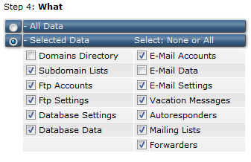
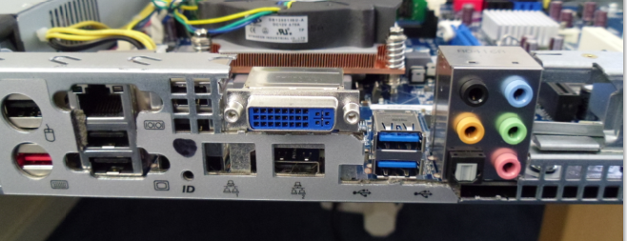
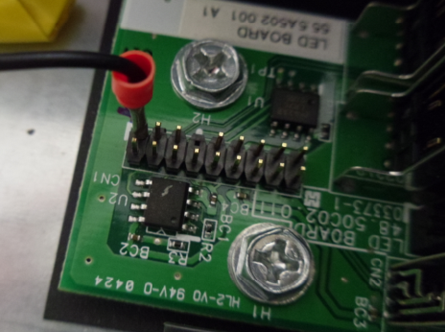
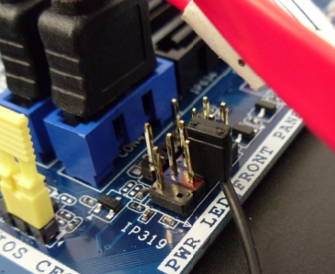
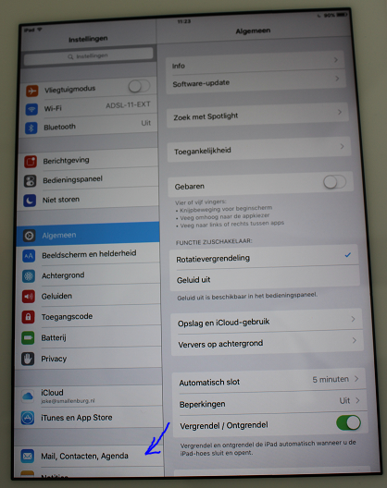
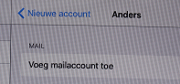
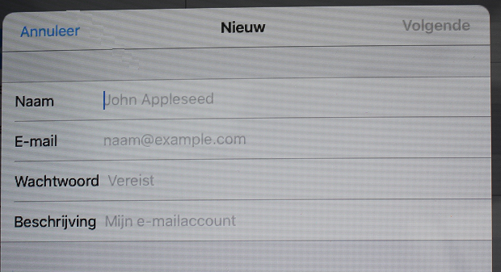
ESP32-radio V2.0

This document describes the realization of an Internet radio based on an ESP32 WiFi module.
For the ESP32 an Internet radio was build in 1917 using a VS1053 mp3 decoder. Now the software is updated to support I2S output as well. A 1.8 TFT color display to give some information about the radio station that’s playing. Other types of display are also supported, including NEXTION.

Features:
- Can connect to thousands of Internet radio stations that broadcast MP3 or AAC audio streams.
- mp3 playlists supported.
- Uses a minimal number of components.
- Has a preset list of a maximum of 100 favorite radio stations as preferences in flash.
- Can be controlled by a tablet or other device through the built-in webserver.
- Can be controlled by MQTT commands. Status info is published by using MQTT.
- Can be controlled by commands on the serial input.
- Can be controlled by IR.
- Can be controlled by rotary switch encoder.
- Up to 14 input ports can be configured as control buttons like volume, skip to the next/previous/first/favorite preset station.
- I/O pins for TFT, VS1053, IR and rotary encoder can be configured in preferences.
- The strongest available WiFi network is automatically selected. Passwords are kept as preferences in flash. Heavily commented source code, easy to add extra functionality.
- Debug information through serial output.
- 2nd processor is used for smooth playback.
- Update of software over WiFi (OTA) through Arduino IDE or remote server.
- Parameters like WiFi information and presets can be edited in the web interface.
- Preset, volume, bass and treble settings are saved in preferences.
- Displays time of day on TFT.
- Optional displays remaining battery charge.
- Bit-rates up to 320 kbps.
- Control of TFT back-light.
- PCB available.
- 3D printable box available.

Software:
The software for the radio is supplied as a PlatformIO project using the Arduino platform.
The following libraries are used:
- Wire
- SD(esp32) @^1.0.5
- knolleary/PubSubClient@^2.8
- adafruit/Adafruit ST7735 and ST7789 Library@^1.6.0
- adafruit/Adafruit BusIO@^1.9.3
- adafruit/Adafruit GFX Library@^1.10.4
- adafruit/Adafruit ILI9341 @ ^1.5.9
- djuseeq/Ch376msc @ ^1.4.4
- ESP Async WebServer@^1.2.3
- AsyncTCP@^1.1.1WiFi – for establishing the communication with WiFI, part of ESP32 core library

The data directory of the project contains the files for the web interface: index.html, favicon.ico, style.css, search.html, config.html, defaultprefs.txt, and about.html.

Preferences
Preferences for ESP32-Radio are kept in Flash memory (NVS).
You may change the contents of NVS with the “Config”-button in the web interface. An example of the contents is:

bat0 = 2178 # ADC for 0% battery capacity left
bat100 = 3256 # ACD for 100% battery capacity
#
clk_dst = 1
clk_offset = -1
clk_server = pool.ntp.org
#
gpio_00 = uppreset = 1
gpio_12 = upvolume = 2
gpio_13 = downvolume = 2
#
ir_40BF = upvolume = 2
ir_C03F = downvolume = 2
#
mqttbroker = none
mqttpasswd = none
mqttport = 1883
mqttuser = carol
#
pin_enc_clk = 25 # GPIO rotary encoder CLK
pin_enc_dt = 26 # GPIO rotary encoder DT
pin_enc_sw = 27 # GPIO rotary encoder SW
pin_ir = 35 # GPIO IR receiver VS1838B
pin_tft_cs = 15 # GPIO TFT CS
pin_tft_dc = 2 # GPIO TFT DC
pin_vs_cs = 5 # GPIO VS1053 CS
pin_vs_dcs = 16 # GPIO VS1053 DCS
pin_vs_dreq = 4 # GPIO VS1053 DREQ
#
preset = 5
preset_000 = 109.206.96.34:8100 # 0 - NAXI LOVE RADIO, Belgrade, Serbia
preset_001 = airspectrum.cdnstream1.com:8114/1648_128 # 1 - Easy Hits Florida
preset_002 = streamer.radio.co/sa7bf61271/listen # 2 - JB's Rock N Roll
preset_003 = airspectrum.cdnstream1.com:8000/1261_192 # 3 - Magic Oldies Florida
preset_004 = stream.laut.fm/kinderlieder-123 # 4 - Kinderlieder
preset_005 = icecast.omroep.nl:80/radio1-bb-mp3 # 5 - Radio 1, NL
preset_006 = icecast.omroep.nl:80/radio5-bb-mp3 # 6 - Radio 5, NL
preset_007 = icecast.omroep.nl:80/radio2-bb-mp3 # 7 - Radio 2, NL#
#
toneha = 0
tonehf = 0
tonela = 0
tonelf = 0
#
volume = 72
#
wifi_00 = ADSL-11_plus/xxxxxx
wifi_01 = NETGEAR-11/xxxxxx
wifi_02 = ADSL-11/xxxxxx

Note that the size of the NVS is limited to 20 kB.
Lines starting with “#” are comment lines and are ignored. Comments per line (after “#”) will also be ignored, except for the “preset_” lines. The comments on the “preset_” lines are used to identify the presets in the web interface.
The maximum line length is 150 characters.
Note that the preset numbers ranges from 000 to 199. The range can be extended by the definition of MAXPRESETS. Note that there is also a limit on the NVS space. If the highest numbered station is reached, the next station will be 00 again. URLs with mp3 files or mp3 playlists (.m3u) are allowed.

Preferences like "pin_ir", " pin_enc_clk", " pin_enc_dt", " pin_enc_sw", " pin_tft_cs", " pin_tft_dc", "pin_vs_cs", "pin_vs_dcs" and " pin_vs_dreq" specify the GPIO pins that are wired to the various devices. For a FEATERBOARD you have to change some settings, especially for the display. The pins for SPI default to SCK=18, MISO=19 and MOSI=23, but they may be configured by “pin_spi_sck”, “pin_spi_miso” and “pin_spi_mosi” respectively.
For an I2C display (OLED, LCD1602, LCD2004) there must be definitions for " pin_tft_scl" and " pin_tft_sda".
Remove the lines if a device is not connected.

“pin_shutdown” is the pin that will be set if the radio is not playing or the volume is set to zero. This output-pin can be used to shut down the amplifier.
“pin_shutdownx” has the same function. The output signal is inversed: the pin will be LOW to shut down the
amplifier.

"pin_tft_bl" is the pin that controls the back light of a TFT display. The BL is disbled after some time if there is no activity. This helps to reduce power when running on batteries.
"pin_tft_blx" has the same function. The output signal is inversed (LOW to enable the BL pin).

The "gpio_" lines specify input pins and the command that is executed if the input pin goes from HIGH to LOW.

The "touch_" lines specify the GPIO input pins for this signal and the command that is executed if the input pin is activated.

The "ir_XXXX" lines specify IR-codes and the command that is executed if the IR-code is received. The code part is a hexadecimal number in upper-case characters.

The "clk_" lines are used for the display of the current time on the TFT. Please change the values for your timezone. The values in the example are valid for the Netherlands.

The “bat0” and “bat100” lines are for displaying the remaining battery capacity on the display. See the details at the paragraph with optional features.

The preferences can be edited in the web interface. Changes will in some cases be effective after restart of the Esp-radio. If the list of preferences is empty (first start), you may use the default button. The list will show some default values which can be edited.

Using Winamp to find out the correct preset line for a station.

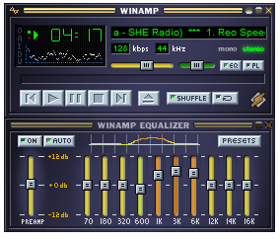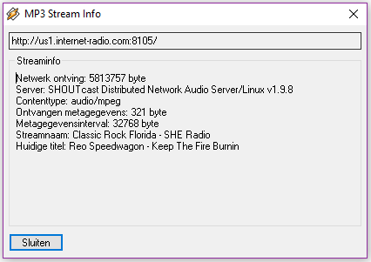
Press Alt-3 in the main window (left picture). You will see info for the playing station (right picture).
The top line (with “http”) will contain the information for the preset, in this example:
“us1.internet-radio.com:8105”. The complete line for this station in the preferences would be:
preset_05 = us1.internet-radio.com:8105 # 5 - Classic Rock Florida - SHE Radio

Optional features:

Digital control through input pins:
Normally the radio is controlled by the web interface. However, free digital inputs (GPIO) may be connected to buttons to control the radio. Their function can be programmed using the web interface.
You can assign commands to the digital inputs by adding lines in the configuration (Webinterface, "Config" page). Examples:

gpio_00 = uppreset = 1
gpio_12 = upvolume = 2
gpio_13 = downvolume = 2
gpio_14 = stop
gpio_17 = resume
gpio_21 = station = icecast.omroep.nl:80/radio1-bb-mp3
In this example the ESP32-Radio will execute the command "uppreset=1" if GPIO0 will go from HIGH to LOW. The commands are equal to the commands that are handled by the serial input or by the MQTT interface.
The same format can be used for the touch-inputs:
touch_04 = uppreset = 1
touch_13 = upvolume = 2

In this example the ESP32-Radio will execute the command "uppreset=1" if TOUCH0 (GPIO04) will be activated. The commands are equal to the commands that are handled by the serial input or by the MQTT interface.

IR Interface.
The radio can be controlled by an IR remote control like this:
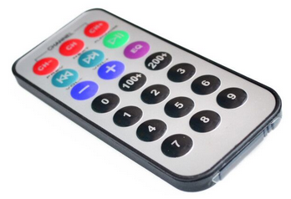
To use this interface, the "out" pin of a VS1838B receiver must be connected to a GPIO pin of the ESP32:
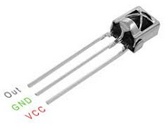
Add the assigned GPIO pin to the preferences through the config page in the web interface. Example:
pin_ir = 35 # GPIO Pin number for IR receiver VS1838B

VCC is connected to 3.3 Volt. A 220 µF capacitor should be connected between VCC and GND.
The software will read the raw code of the IR transmitter, making it possible to use virtually any remote control to be used. I tested it with the 21 button remote as well as with an LG TV remote.
To assign functions to the buttons, watch the debug log output while pressing a button. For example, press the +volume button. You will see something like:
D: IR code 807F received, but not found in preferences!
Now add the command:
ir_807F = upvolume = 2
to the preferences in the config page of the web interface. Likewise you can assign functions to all buttons, for example:
ir_8A31 = uppreset = 1
ir_719A = station = us1.internet-radio.com:8105
ir_1F6B = mute

Display remaining battery capacity:
The remaining battery capacity is computed by measuring the battery voltage on ping GPIO36 (ADC0).
The battery voltage must be supplied to ADC0 through a resistor voltage divider. The maximum voltage fort his input is 1.0 volt. I used 100 kΩ and 22 kΩ fort his purpose.
Furthermore you need to specify ADC value for both the full and the empty voltages. These values must be in the preferences like:
bat0 = 2178 # ADC for 0% battery capacity left
bat100 = 2690 # ACD for 100% battery capacity

To calibrate the settings you may use the “TEST” command in the serial monitor. This will display the current reading of the ADC0 pin. Do this for a fully charge battery and for an (almost) empty one.
Note that it will take about 6 seconds before the reading is stable. This is a result of a filter in the measurement of the ADC.

The remaining capacity is displayed as a green/red bar near the top of the display.

Hardware:
The radio is built with the following widely available hardware:
- An ESP-32 module. This is basically an ESP32 on a small print. I used a DOIT ESP32 Development Board. See figure 1 below. The ESP32 is running on 160 MHz. On Aliexpress: this.
- An optional VS1053 module. See figure 2.
- An optional PCM5102 I2S to analog module. See figure 14.
- A 1.8 inch color TFT display 160x128. Optional, see figure 3 and 4. On Aliexpress: this or this.
- A 1.44 inch color TFT display 128x128. Optional, see figure 9. On Aliexpress: this.
- An OLED 128x64 display. Optional, see figure 7. On Aliexpress: this.
- An 1602 LCD display with I2C backpack. Optional, see figure 8.
- An 2004 LCD display with I2C backpack. Optional, see figure 13.
- A NEXTION display. Optional, see figure 10. Tested with a NX3224T024_011.
- Two small speakers.
- A Class D stereo amplifier to drive the speakers. Best quality if powered by a separate power source.
- A rotary encoder switch. Optional, see figure 4.
- A IR receiver. Optional, see figure 6.
- Two audio transformers. Optional, see figure 11.
- Optional CH376 drive for USB stick, see figure 12.
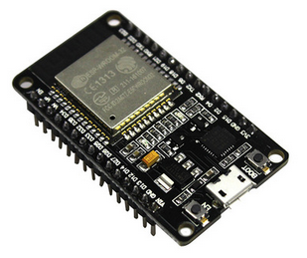  Fig. 1 | 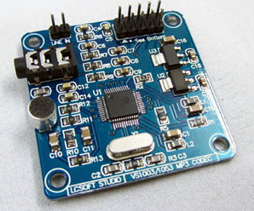  Fig. 2 | 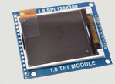  Fig. 3
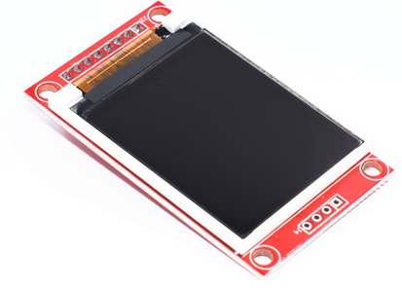  Fig. 4 | 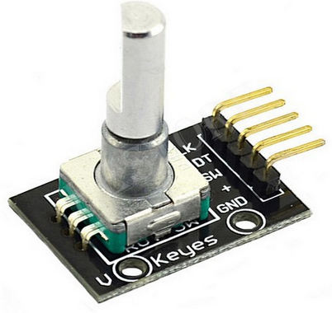  Fig. 5 | Fig. 6
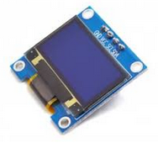  Fig. 7 | 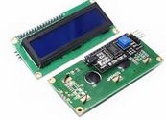Ffig. 8 | 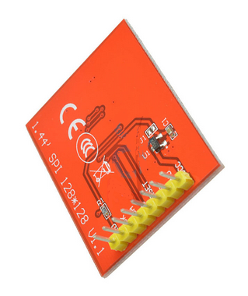  Fig. 9
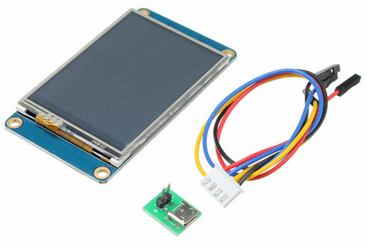  Fig. 10 | 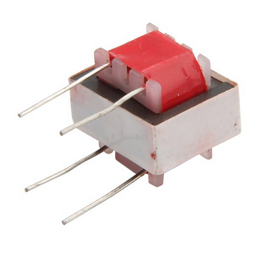  Fig. 11 | 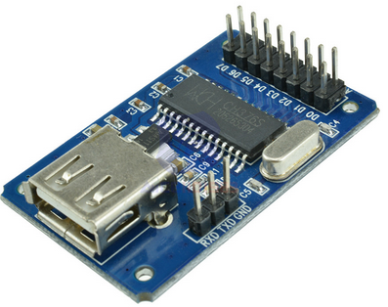Fig. 12
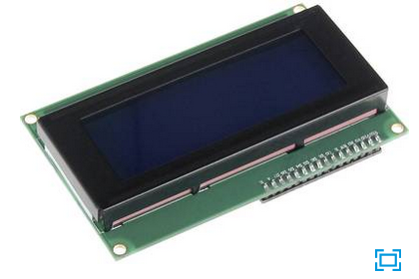  Fig. 13 | 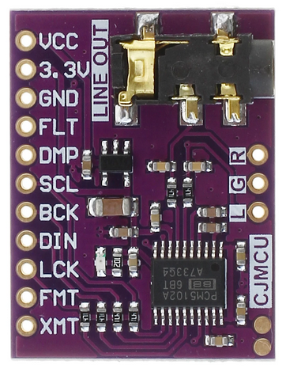  Fig. 14

Here is a picture of the radio in a test configuration with software MP3 decoding. Only the PCM5102 is connected.

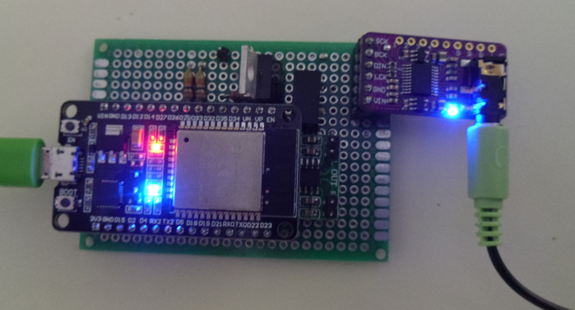

PCB.
Harm Verbeek, see https://github.com/Edzelf/ESP32-Radio/issues/198, designed a PCB for this radio. I have built the radio on this PCB:

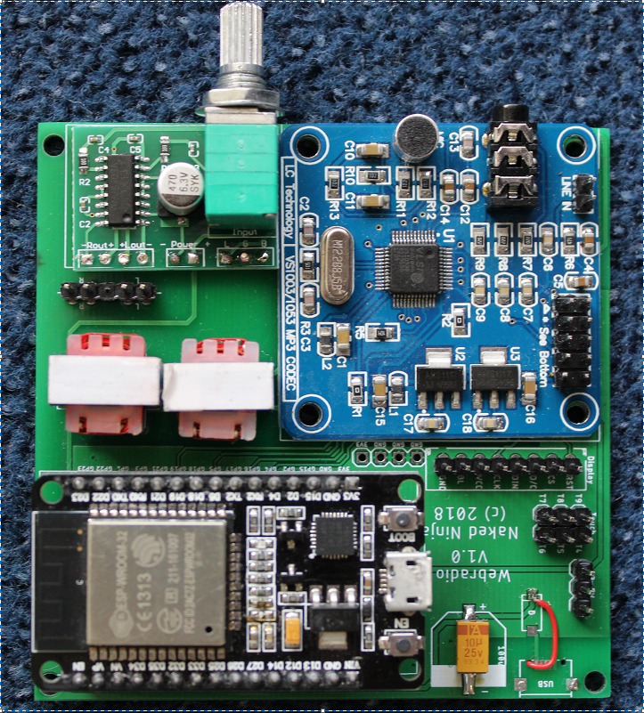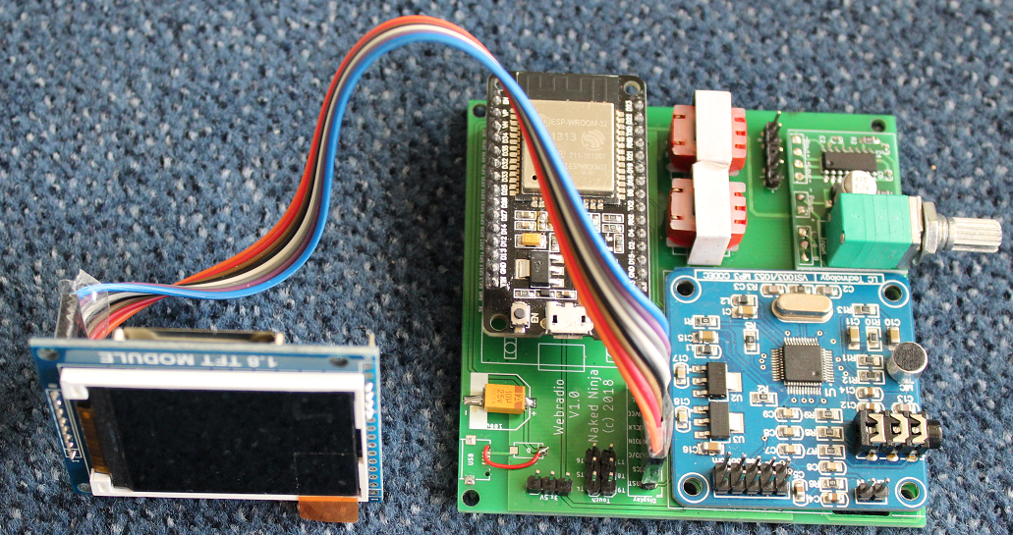

There is another PCB version available, see https://github.com/Edzelf/ESP32-Radio/issues/165.

Hans Vink designed a #D printable case for this radio. Mounted in tis case is looks like this:

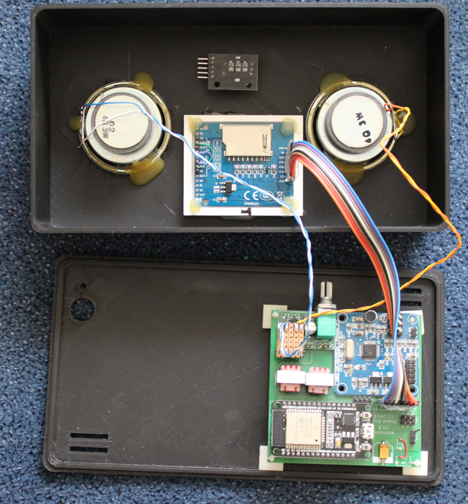
See https://www.thingiverse.com/thing:3346460
Note that power supply and rotary switched are not connected here.

And playing:

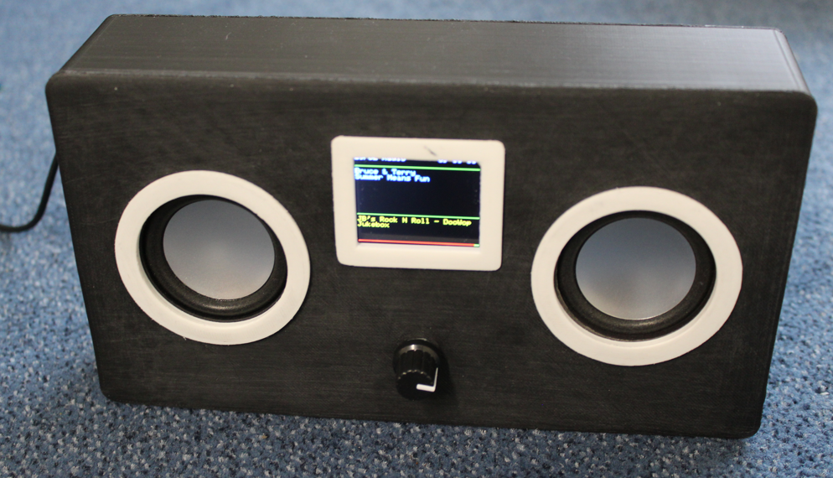

Wiring:
The logic wiring in the table below. The analog amplifier and the speakers are not included.
Note that the GPIO pins are just an example. The assignment of GPIO pins is defined in the preferences that can be edited in the "config" page of the web interface.
ESP32dev Signal Wired to LCD Wired to VS1053 Wired to the rest
-------- ------ -------------- ------------------- ---------------
GPIO16 - pin 1 XDCS -
GPIO5 - pin 2 XCS -
GPIO4 - pin 4 DREQ -
GPIO2 pin 3 D/C or A0 - -
GPIO22 - - -
GPIO21 RXD2 - - TX of NEXTION (if in use)
GPIO17 TXD2 - - RX of NEXTION (if in use)
GPIO18 SCK pin 5 CLK or SCK pin 5 SCK -
GPIO19 MISO - pin 7 MISO -
GPIO23 MOSI pin 4 DIN or SDA pin 6 MOSI -
GPIO15 pin 2 CS - -
GPI03 RXD0 - - Reserved serial input
GPIO1 TXD0 - - Reserved serial output
GPIO34 - - - Optional pull-up resistor
GPIO35 - - - Infrared receiver VS1838B
GPIO25 - - - Rotary encoder CLK
GPIO26 - - - Rotary encoder DT
GPIO27 - - - Rotary encoder SW
------- ------ --------------- ------------------- ----------------
GND - pin 8 GND pin 8 GND Power supply GND
VCC 5 V - pin 7 BL - Power supply
VCC 5 V - pin 6 VCC pin 9 5V Power supply
EN - pin 1 RST pin 3 XRST -

The wiring of the 1.8 inch TFT module is on the right side of the board.

Amplifier and power circuit (VS1053 version).
The amplifier is a class D stereo amplifier. If the power is shared with the power supply of the radio, you will hear much noise. So I used a separate LiPo battery (Batt 2) for the amplifier.
During operation only Batt 1 will be charged. If the radio is switched off, both batteries will be recharged by the LiPo charger. S1a, S1b and S1c is a triple On-On switch.
Note that there may be high currents in the “off”-position if one of the batteries fully discharged. Use protected batteries only!
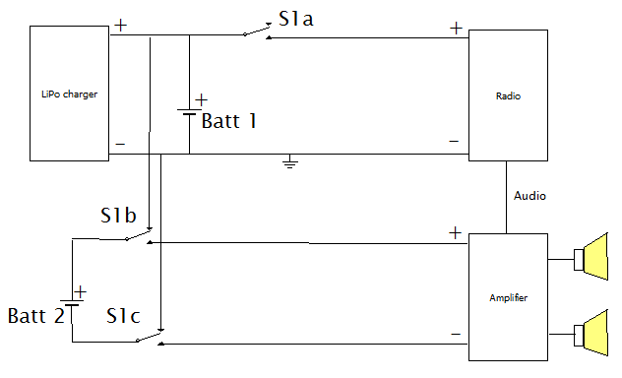

A better approach is to use 2 small audio transformers to isolate the output of the VS1053 from the power circuit. This is used on the PCB made by Harm Verbeek.

Backlight control circuit.
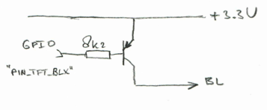

Web interface.
The web interface is simple and can be adapted to your needs. The basic idea is to have a html page with embedded javascript that displays an interface to the radio. Command to the radio can be sent to the http server on the ESP32. The IP address of the webserver will be displayed on the TFT during startup. The webpages are defined in the data directory.

Capabilities of the webserver:
Let’s assume that the IP of the ESP32-radio is 192.168.2.12. From your browser you can show a simple root page by entering the following URL: http://192.168.2.12. This will display the index.html page from the ESP32 as well as favicon.ico.
If your computer is configured for mDNS, you can also use http://ESP32Radio.local in your browser.
The following simple web interface will be displayed (I2S version):

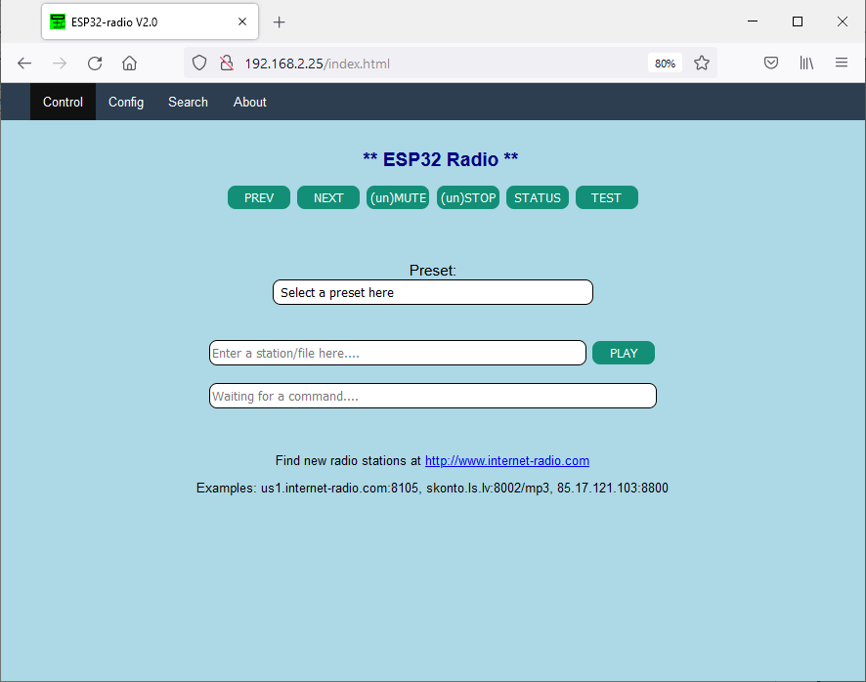
Clicking on one of the available buttons will control the ESP32-radio. The reply of the webserver will be visible in the status box below the buttons. A click will be translated into a command to the ESP32-radio in the form:
http://192.168.2.12/?<parameter>=<value>
For example: http://192.168.2.12/?upvolume=2

The “STATUS” and “TEST” buttons give some info about the playing stream/file. The “Search” menu option can be used to discover stations. The list of stations is maintained by Community Radio Browser. See https://www.radio-browser.info.
Not all functions are available as buttons in the web interface shown above. Commands may also come from MQTT or serial input. Not all commands are meaningful on MQTT or serial input. Working commands are:

preset = 12 Select start preset to connect to
preset_00 = <mp3 stream> Specify station for a preset 00-max *)
volume = 95 Percentage between 0 and 100
upvolume = 2 Add percentage to current volume
downvolume = 2 Subtract percentage from current volume
toneha = <0..15> Setting treble gain
tonehf = <0..15> Setting treble frequency
tonela = <0..15> Setting bass gain
tonelf = <0..15> Setting treble frequency
station = <mp3 stream> Select new station (will not be saved)
station = <URL>.mp3 Play standalone .mp3 file (not saved)
station = <URL>.m3u Select playlist (will not be saved)
stop Stop playing
resume Resume playing
mute Mute/unmute the music (toggle)
wifi_00 = mySSID/mypassword Set WiFi SSID and password *)
mqttbroker = mybroker.com Set MQTT broker to use *)
mqttprefix = XP93g Set MQTT broker to use
mqttport = 1883 Set MQTT port to use, default 1883 *)
mqttuser = myuser Set MQTT user for authentication *)
mqttpasswd = mypassword Set MQTT password for authentication *)
clk_server = pool.ntp.org Time server to be used *)
clk_offset = <-11..+14> Offset with respect to UTC in hours *)
clk_dst = <1..2> Offset during dst in hours *)
settings Returns setting like presets and tone
status Show current URL to play
test For test purposes
debug = 0 or 1 Switch debugging on or off
reset Restart the ESP32
bat0 = 2318 ADC value for an empty battery
bat100 = 2916 ADC value for a fully charged battery

Commands marked with "*)" are sensible during power-up only.

Station may also be of the form “skonto.ls.lv:8002/mp3”. The default port is 80.
Station may also point to an mp3 playlist. Example: “www.rockantenne.de/webradio/rockantenne.m3u”.
Station may be an .mp3-file on a remote server. Example: "www.stephaniequinn.com/Music/Rondeau.mp3".
It is allowed to have multiple (max 100) “preset_” lines. The number after the “_” will be used as the preset number. The comment part (after the “#”) will be shown in the web interface.
It is also allowed to have multiple “wifi_” lines. The strongest Wifi access point will be used.

Configuration
The "Config" button will bring up a second screen. Here you can edit the preferences. The available Wifi networks are listed as well. The config screen will be shown automatically if the ESP32 cannot connect to one of the WiFi stations specified in the preferences. In that case the ESP32 will act as an accesspoint with the name “ESP32Radio”. You have to connect to this AP with password “ESP32Radio”. Then the ESP32-radio can be reached at http:// 192.168.4.1.
The configuration screen will be displayed and you have the opportunity to edit the preferences. A "default" button is available to fill the editbox with some example data. For a quick start, just fill in you WiFi network name and password and click "Save". Restart the radio afterwards.
Note that passwords are hidden in this screen to give some protection against abuses. You may however change them here. If unchanged, the original values are preserved.
After changing the contents of this page, it must be saved to the preferences by clicking the “Save” button. Changes will have effect on the next restart of the ESP-radio, so click the “Restart” button.

The “Update”-button can be used to get the latest version of the software by downloading it from http:smallenburg.nl/Arduino/ Esp32_radio.ino.bin.

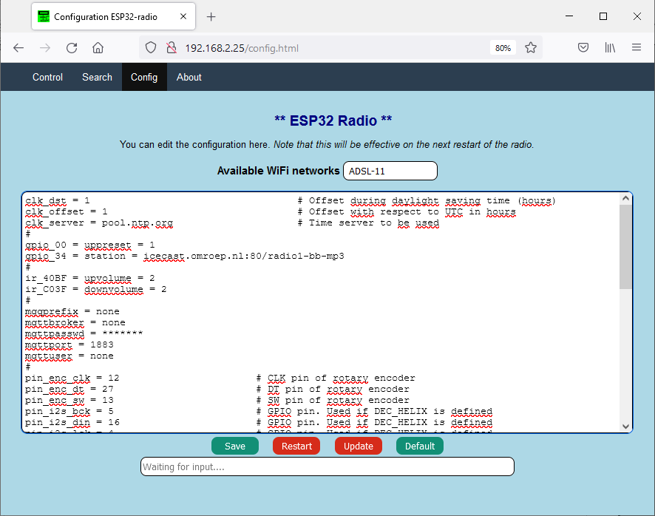

It may take some time to fill this screen.

Rotary encoder interface.
The rotary encoder switch can control some essential functions of the ESP32-radio. The "GND"- and "+"-pins must be connected to ground and 3.3 Volt pins of the ESP32 DEV module.
The default function is volume control. Turning the knob will result in lower or higher volume. Pressing the knob will mute/unmute the signal. The text “Mute” or “Unmute” will be shown on the TFT during 4 seconds.
A double click selects the preset-mode. Rotation of the switch will select one of the preset stations. The preset will be shown on the TFT. Once a preset is selected, you can activate this preset by a single click.
Without rotation, the next preset is selected.
After an inactivity of 4 seconds the rotary encoder will return to its default function (VOLUME).

Supported displays.
The preferred display is a 1.8 inch TFT with 160x128 pixels. Other displays may also be used:
- No display. Edit the sketch (around line 123), so that “DUMMYTFT” is defined and all other display types are commented out.
- The preferred display 160x128 pixels. Define “BLUETFT” and comment out the other types.
- An ILI9341 display, default 320x240 pixels. Define “ILI9341” and comment out the other types.
- A 128x128 1.44 inch display. Edit bluetft.h (around line 58), use “INITR_144GREENTAB” and set dsp_getwidth() to 128.
- A 128x64 OLED. Define “”OLED” and comment out the other types.
- AN LCD 1602 display with I2C backpack. Define “LCD1602I2C” and comment out the other types. Note that this display is limited as it has only 32 characters.
- AN LCD 2004 display with I2C backpack. Define “LCD2004I2C” and comment out the other types. Note that this display is limited as it has only 80 characters.
- A NEXTON model NX#@@$T024_11 display connected to GPIO 16 and 17.

The OLED, 2004 and 1602 displays use the serial I2C bus. There must be definitions for this in the preferences, for example:

pin_tft_scl = 13 # GPIO Pin number for SCL
pin_tft_sda = 14 # GPIO Pin number for SDA

Th I2C address of the 2004 and 1602 displays is defined in the corresponding module.

MQTT interface.
The MQTT interface can handle the same commands as the web interface.
As publish command on a Linux system may look like:
$ mosquitto_pub -h broker.hivemq.com -t espradio -m volume=80
Note that broker.hivemq.com is heavily used, this may cause some delay. If you use your own broker the reaction on commands will be much better.
Remove the lines starting with “mqtt” if no MQTT is required or set mqttbroker to "none".
You can use an MQTT client like https://kamilfb.github.io/mqtt-spy/ to view the MQTT interface.
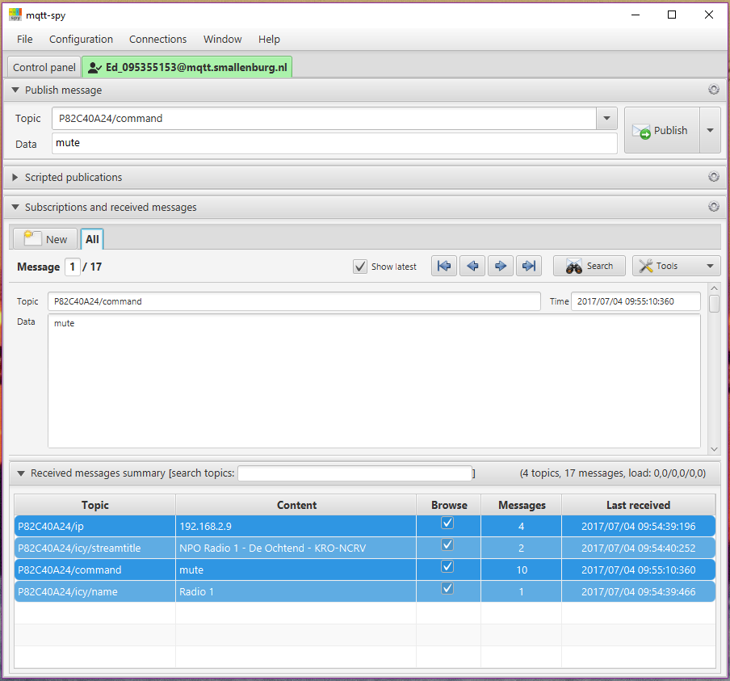
Subscribe to “P82C40A24/ip” and you will see the IP-address of your radio. You will see the IP address of your radio or the IP address of a different user. So be sure to use unique names for your topics. This can be accomplished by specifying a unique prefix in the preferences, see below.
The parameters in preferences for this example are:
# MQTT broker, credentials and topic to subscribe
mqttbroker = broker.hivemq.com # Broker to connect with
mqttprefix = P82C40A24 # Prefix for pub/sub. Default is part of MAC-address.
mqttport = 1883 # Portnumber (1883 is default)
mqttuser = none # (No) username for broker
mqttpasswd = none # (No) password for broker
#

In this example I published the command “mute” to the radio. The radio published the IP-address 192.168.2.8 to the broker (once every 10 minutes).

MQTT PUB topics.
In this version 7 topics will be published to MQTT and can be subscribed to by an MQTT client:
prefix/ip | The IP-address of the ESP32-Radio
prefix/icy/name | The name of the station
prefix/icy/streamtitle | The name of the stream
prefix/nowplaying | Track information
prefix/preset | Preset currently plaing
prefix/volume | Current volume setting
prefix/playing | 1 if playing, 0 if stopped

Command to control the ESP32-Radio can be published to "prefix/command".

Alternative way of configuration.
An extra sketch "Esp32_radio_init" is supplied as an alternative to initialize the preferences (in Non-Voltile Storage of the ESP32). Just change lines 39 and 40 (the specs for WiFi networks) to match your network(s).
Upload and run the sketch once and then load the ESP32-Radio.

OTA update through remote server.
The software can be update by uploading the compiled project to the ESP32. There is also a build-in feature to load the latest version of the software from a remote server. The software for the NEXTION (if in use) will also be updated.

The update can be initiated by the “update”-command through the serial interface or the webinterface.

The update will fail if there is no new version available or if no connection can be made to the server.
The radio connects to the host “smallenburg.nl” and download the file “/Arduino/Esp32_radio/firmware.bin” and “/Arduino/ESP32-Radio.tft”. The binary file is flashed to the ESP32 and the NEXTION and will start the new version. The process may take some 2 to 3 minutes.

Compiler/upload output.

Software upload.
> Executing task in folder ESP32-Radio: C:\Users\hp\.platformio\penv\Scripts\platformio.exe run --target upload <

Processing esp32doit-devkit-v1 (platform: espressif32; board: esp32doit-devkit-v1; framework: arduino)
-------------------------------------------------------------------------------------------------------Verbose mode can be enabled via `-v, --verbose` option
CONFIGURATION: https://docs.platformio.org/page/boards/espressif32/esp32doit-devkit-v1.html
PLATFORM: Espressif 32 (3.3.2) > DOIT ESP32 DEVKIT V1
HARDWARE: ESP32 240MHz, 320KB RAM, 4MB Flash
DEBUG: Current (esp-prog) External (esp-prog, iot-bus-jtag, jlink, minimodule, olimex-arm-usb-ocd, olimex-arm-usb-ocd-h, olimex-arm-usb-tiny-h, olimex-jtag-tiny, tumpa)
PACKAGES:
- framework-arduinoespressif32 3.10006.210326 (1.0.6)
- tool-esptoolpy 1.30100.210531 (3.1.0)
- tool-mkspiffs 2.230.0 (2.30)
- toolchain-xtensa32 2.50200.97 (5.2.0)
LDF: Library Dependency Finder -> http://bit.ly/configure-pio-ldf
LDF Modes: Finder ~ chain, Compatibility ~ soft
Found 47 compatible libraries
Scanning dependencies...
Dependency Graph
|-- <Wire> 1.0.1
|-- <SD(esp32)> 1.0.5
| |-- <FS> 1.0
| |-- <SPI> 1.0
|-- <PubSubClient> 2.8.0
|-- <Adafruit ST7735 and ST7789 Library> 1.7.4
| |-- <Adafruit GFX Library> 1.10.12
| | |-- <SPI> 1.0
| | |-- <Adafruit BusIO> 1.9.3
| | | |-- <Wire> 1.0.1
| | | |-- <SPI> 1.0
| | |-- <Wire> 1.0.1
| |-- <SPI> 1.0
|-- <Adafruit BusIO> 1.9.3
| |-- <Wire> 1.0.1
| |-- <SPI> 1.0
|-- <Adafruit GFX Library> 1.10.12
| |-- <SPI> 1.0
| |-- <Adafruit BusIO> 1.9.3
| | |-- <Wire> 1.0.1
| | |-- <SPI> 1.0
| |-- <Wire> 1.0.1
|-- <Adafruit ILI9341> 1.5.9
| |-- <Adafruit GFX Library> 1.10.12
| | |-- <SPI> 1.0
| | |-- <Adafruit BusIO> 1.9.3
| | | |-- <Wire> 1.0.1
| | | |-- <SPI> 1.0
| | |-- <Wire> 1.0.1
| |-- <SPI> 1.0
|-- <Ch376msc> 1.4.5
| |-- <SPI> 1.0
|-- <ESP Async WebServer> 1.2.3
| |-- <AsyncTCP> 1.1.1
| |-- <FS> 1.0
| |-- <WiFi> 1.0
|-- <AsyncTCP> 1.1.1
|-- <codecs>
| |-- <SPI> 1.0
|-- <bluetft>
| |-- <Adafruit ST7735 and ST7789 Library> 1.7.4
| | |-- <Adafruit GFX Library> 1.10.12
| | | |-- <SPI> 1.0
| | | |-- <Adafruit BusIO> 1.9.3
| | | | |-- <Wire> 1.0.1
| | | | |-- <SPI> 1.0
| | | |-- <Wire> 1.0.1
| | |-- <SPI> 1.0
|-- <dummytft>
|-- <ILI9341>
| |-- <Adafruit ILI9341> 1.5.9
| | |-- <Adafruit GFX Library> 1.10.12
| | | |-- <SPI> 1.0
| | | |-- <Adafruit BusIO> 1.9.3
| | | | |-- <Wire> 1.0.1
| | | | |-- <SPI> 1.0
| | | |-- <Wire> 1.0.1
| | |-- <SPI> 1.0
|-- <LCD1602>
|-- <LCD2004>
|-- <NEXTION>
|-- <ArduinoOTA> 1.0
| |-- <Update> 1.0
| |-- <WiFi> 1.0
| |-- <ESPmDNS> 1.0
| | |-- <WiFi> 1.0
|-- <ESPmDNS> 1.0
| |-- <WiFi> 1.0
|-- <SPI> 1.0
|-- <SPIFFS> 1.0
| |-- <FS> 1.0
|-- <WiFi> 1.0
Building in release mode
Compiling .pio\build\esp32doit-devkit-v1\src\main.cpp.o
Linking .pio\build\esp32doit-devkit-v1\firmware.elf
Retrieving maximum program size .pio\build\esp32doit-devkit-v1\firmware.elf
Checking size .pio\build\esp32doit-devkit-v1\firmware.elf
Advanced Memory Usage is available via "PlatformIO Home > Project Inspect"
RAM: [== ] 21.4% (used 69996 bytes from 327680 bytes)
Flash: [========= ] 93.8% (used 1229766 bytes from 1310720 bytes)
Building .pio\build\esp32doit-devkit-v1\firmware.bin
esptool.py v3.1
Merged 1 ELF section
Configuring upload protocol...
AVAILABLE: esp-prog, espota, esptool, iot-bus-jtag, jlink, minimodule, olimex-arm-usb-ocd, olimex-arm-usb-ocd-h, olimex-arm-usb-tiny-h, olimex-jtag-tiny, tumpa
CURRENT: upload_protocol = esptool
Looking for upload port...
Use manually specified: COM4
Uploading .pio\build\esp32doit-devkit-v1\firmware.bin
esptool.py v3.1
Serial port COM4
Connecting.....
Chip is ESP32-D0WDQ6 (revision 1)
Features: WiFi, BT, Dual Core, 240MHz, VRef calibration in efuse, Coding Scheme None
WARNING: Detected crystal freq 41.01MHz is quite different to normalized freq 40MHz. Unsupported crystal in use?
Crystal is 40MHz
MAC: 24:6f:28:b0:7b:e0
Uploading stub...
Running stub...
Stub running...
Changing baud rate to 460800
Changed.
Configuring flash size...
Auto-detected Flash size: 4MB
Flash will be erased from 0x00001000 to 0x00005fff...
Flash will be erased from 0x00008000 to 0x00008fff...
Flash will be erased from 0x0000e000 to 0x0000ffff...
Flash will be erased from 0x00010000 to 0x0013cfff...
Compressed 17104 bytes to 11191...
Writing at 0x00001000... (100 %)
Wrote 17104 bytes (11191 compressed) at 0x00001000 in 0.6 seconds (effective 231.3 kbit/s)...
Hash of data verified.
Compressed 3072 bytes to 128...
Writing at 0x00008000... (100 %)
Wrote 3072 bytes (128 compressed) at 0x00008000 in 0.1 seconds (effective 315.3 kbit/s)...
Hash of data verified.
Compressed 8192 bytes to 47...
Writing at 0x0000e000... (100 %)
Wrote 8192 bytes (47 compressed) at 0x0000e000 in 0.1 seconds (effective 462.3 kbit/s)...
Hash of data verified.
Compressed 1229872 bytes to 723457...
Writing at 0x00010000... (2 %)
Writing at 0x00017038... (4 %)
Writing at 0x0001c057... (6 %)
.
.
Writing at 0x001354dc... (97 %)
Writing at 0x0013b13c... (100 %)
Wrote 1229872 bytes (723457 compressed) at 0x00010000 in 17.5 seconds (effective 561.2 kbit/s)...
Hash of data verified.

Leaving...
Hard resetting via RTS pin...

Filesystem upload.
PS D:\docs\PlatformIO\Projects\ESP32-Radio> pio run -t uploadfs
Processing esp32doit-devkit-v1 (platform: espressif32; board: esp32doit-devkit-v1; framework: arduino)
-----------------------------------------------------------------------------------------------------------------------------Verbose mode can be enabled via `-v, --verbose` option
CONFIGURATION: https://docs.platformio.org/page/boards/espressif32/esp32doit-devkit-v1.html
PLATFORM: Espressif 32 (3.3.2) > DOIT ESP32 DEVKIT V1
HARDWARE: ESP32 240MHz, 320KB RAM, 4MB Flash
DEBUG: Current (esp-prog) External (esp-prog, iot-bus-jtag, jlink, minimodule, olimex-arm-usb-ocd, olimex-arm-usb-ocd-h, olimex-arm-usb-tiny-h, olimex-jtag-tiny, tumpa)
PACKAGES:
- framework-arduinoespressif32 3.10006.210326 (1.0.6)
- tool-esptoolpy 1.30100.210531 (3.1.0)
- tool-mkspiffs 2.230.0 (2.30)
- toolchain-xtensa32 2.50200.97 (5.2.0)
LDF: Library Dependency Finder -> http://bit.ly/configure-pio-ldf
LDF Modes: Finder ~ chain, Compatibility ~ soft
Found 47 compatible libraries
Scanning dependencies...
Dependency Graph
|-- <Wire> 1.0.1
|-- <SD(esp32)> 1.0.5
| |-- <FS> 1.0
| |-- <SPI> 1.0
|-- <PubSubClient> 2.8.0
|-- <Adafruit ST7735 and ST7789 Library> 1.7.4
| |-- <Adafruit GFX Library> 1.10.12
| | |-- <SPI> 1.0
| | |-- <Adafruit BusIO> 1.9.3
| | | |-- <Wire> 1.0.1
| | | |-- <SPI> 1.0
| | |-- <Wire> 1.0.1
| |-- <SPI> 1.0
|-- <Adafruit BusIO> 1.9.3
| |-- <Wire> 1.0.1
| |-- <SPI> 1.0
|-- <Adafruit GFX Library> 1.10.12
| |-- <SPI> 1.0
| |-- <Adafruit BusIO> 1.9.3
| | |-- <Wire> 1.0.1
| | |-- <SPI> 1.0
| |-- <Wire> 1.0.1
|-- <Adafruit ILI9341> 1.5.9
| |-- <Adafruit GFX Library> 1.10.12
| | |-- <SPI> 1.0
| | |-- <Adafruit BusIO> 1.9.3
| | | |-- <Wire> 1.0.1
| | | |-- <SPI> 1.0
| | |-- <Wire> 1.0.1
| |-- <SPI> 1.0
|-- <Ch376msc> 1.4.5
| |-- <SPI> 1.0
|-- <ESP Async WebServer> 1.2.3
| |-- <AsyncTCP> 1.1.1
| |-- <FS> 1.0
| |-- <WiFi> 1.0
|-- <AsyncTCP> 1.1.1
|-- <codecs>
| |-- <SPI> 1.0
|-- <bluetft>
| |-- <Adafruit ST7735 and ST7789 Library> 1.7.4
| | |-- <Adafruit GFX Library> 1.10.12
| | | |-- <SPI> 1.0
| | | |-- <Adafruit BusIO> 1.9.3
| | | | |-- <Wire> 1.0.1
| | | | |-- <SPI> 1.0
| | | |-- <Wire> 1.0.1
| | |-- <SPI> 1.0
|-- <dummytft>
|-- <ILI9341>
| |-- <Adafruit ILI9341> 1.5.9
| | |-- <Adafruit GFX Library> 1.10.12
| | | |-- <SPI> 1.0
| | | |-- <Adafruit BusIO> 1.9.3
| | | | |-- <Wire> 1.0.1
| | | | |-- <SPI> 1.0
| | | |-- <Wire> 1.0.1
| | |-- <SPI> 1.0
|-- <LCD1602>
|-- <LCD2004>
|-- <NEXTION>
|-- <ArduinoOTA> 1.0
| |-- <Update> 1.0
| |-- <WiFi> 1.0
| |-- <ESPmDNS> 1.0
| | |-- <WiFi> 1.0
|-- <ESPmDNS> 1.0
| |-- <WiFi> 1.0
|-- <SPI> 1.0
|-- <SPIFFS> 1.0
| |-- <FS> 1.0
|-- <WiFi> 1.0
Building in release mode
Building SPIFFS image from 'data' directory to .pio\build\esp32doit-devkit-v1\spiffs.bin
/about.html
/config.html
/defaultprefs.txt
/favicon.ico
/index.html
/search.html
/style.css
Looking for upload port...
Use manually specified: COM4
Uploading .pio\build\esp32doit-devkit-v1\spiffs.bin
esptool.py v3.1
Serial port COM4
Connecting....
Chip is ESP32-D0WDQ6 (revision 1)
Features: WiFi, BT, Dual Core, 240MHz, VRef calibration in efuse, Coding Scheme None
Crystal is 40MHz
MAC: 24:6f:28:b0:7b:e0
Uploading stub...
Running stub...
Stub running...
Changing baud rate to 460800
Changed.
Configuring flash size...
Auto-detected Flash size: 4MB
Flash will be erased from 0x00290000 to 0x003fffff...
Compressed 1507328 bytes to 12150...
Writing at 0x00290000... (100 %)
Wrote 1507328 bytes (12150 compressed) at 0x00290000 in 8.0 seconds (effective 1505.9 kbit/s)...
Hash of data verified.

Leaving...
Hard resetting via RTS pin...

Debug (serial 115200 Baud) output.
This is an example of the debug output:

ets Jun 8 2016 00:22:57
rst:0x1 (POWERON_RESET),boot:0x13 (SPI_FAST_FLASH_BOOT)
configsip: 0, SPIWP:0xee
clk_drv:0x00,q_drv:0x00,d_drv:0x00,cs0_drv:0x00,hd_drv:0x00,wp_drv:0x00
mode:DIO, clock div:2
load:0x3fff0018,len:4
load:0x3fff001c,len:1044
load:0x40078000,len:10124
load:0x40080400,len:5828
entry 0x400806a8
�
D: Starting ESP32-radio running on CPU 1 at 240 MHz. Version Mon, 05 Oct 2021 17:25:00 GMT. Free memory 292144
D: Display type is BLUETFT
D: SPIFFS is okay, space 1378241, used 28614
D: Found partition 'nvs ' at offset 0x009000 with size 20480
D: Found partition 'otadata ' at offset 0x00E000 with size 8192
D: Found partition 'spiffs ' at offset 0x290000 with size 1507328
D: Read 41 keys from NVS
D: pin_ir set to 35
D: pin_enc_clk set to 12
D: pin_enc_dt set to 27
D: pin_enc_sw set to 13
D: pin_tft_cs set to 15
D: pin_tft_dc set to 2
D: pin_tft_scl set to -1
D: pin_tft_sda set to -1
D: pin_tft_bl set to -1
D: pin_tft_blx set to -1
D: pin_vs_cs set to 5
D: pin_vs_dcs set to 16
D: pin_vs_dreq set to 4
D: pin_shutdown set to -1
D: pin_shutdownx set to -1
D: Pin 5 is already reserved!
D: pin_i2s_bck set to 5
D: Pin 4 is already reserved!
D: pin_i2s_lck set to 4
D: Pin 16 is already reserved!
D: pin_i2s_din set to 16
D: pin_spi_sck set to 18
D: pin_spi_miso set to 19
D: pin_spi_mosi set to 23
D: GPIO0 is HIGH
D: GPIO2 is LOW, probably no PULL-UP
D: GPIO4 is HIGH
D: GPIO5 is HIGH
D: GPIO12 is HIGH
D: GPIO13 is HIGH
D: GPIO14 is HIGH
D: GPIO15 is HIGH
D: GPIO16 is HIGH
D: GPIO17 is HIGH
D: GPIO18 is HIGH
D: GPIO19 is HIGH
D: GPIO21 is HIGH
D: GPIO22 is HIGH
D: GPIO23 is HIGH
D: GPIO25 is HIGH
D: GPIO26 is HIGH
D: GPIO27 is HIGH
D: GPIO32 is HIGH
D: GPIO33 is HIGH
D: GPIO34 is LOW, probably no PULL-UP
D: GPIO35 is LOW, probably no PULL-UP
D: GPIO39 is LOW, probably no PULL-UP
D: gpio_00 will execute uppreset = 1
D: gpio_34 will execute station = icecast.omroep.nl:80/radio1-bb-mp3
D: Enable pin 35 for IR
D: Start display
D: Create list with acceptable WiFi networks
D: Added ADSL-11 to list of networks
D: Added SSID to list of networks
D: End adding networks
D: Scan Networks
D: Scan completed
D: Number of available networks: 8
D: 1 - ADSL-11 Signal: -51 dBm, Encryption WPA2_PSK, Acceptable
D: 2 - ESP_A43E4F Signal: -65 dBm, Encryption OPEN,
D: 3 - NETGEAR-11 Signal: -65 dBm, Encryption WPA2_PSK,
D: 4 - ADSL-11 Signal: -72 dBm, Encryption WPA2_PSK, Acceptable
D: 5 - Ziggo Signal: -83 dBm, Encryption ????,
D: 6 - Ziggo8571367 Signal: -84 dBm, Encryption WPA2_PSK,
D: 7 - ADSL-11 Signal: -91 dBm, Encryption WPA_WPA2_PSK, Acceptable
D: 8 - Hisee_182400ys Signal: -92 dBm, Encryption WPA2_PSK,
D: End of list
D: Command: clk_dst with parameter 1
D: Command: clk_offset with parameter 1
D: Command: clk_server with parameter pool.ntp.org
D: Command: gpio_00 with parameter uppreset = 1
D: Command: gpio_34 with parameter station = icecast.omroep.nl:80/radio1-bb-mp3
D: Command: ir_40bf with parameter upvolume = 2
D: Command: ir_c03f with parameter downvolume = 2
D: Command: mqqprefix with parameter none
D: Command: mqttbroker with parameter none
D: Command: mqttpasswd with parameter *******
D: Command: mqttport with parameter 1883
D: Command: mqttuser with parameter none
D: Command: pin_enc_clk with parameter 12
D: Command: pin_enc_dt with parameter 27
D: Command: pin_enc_sw with parameter 13
D: Command: pin_i2s_bck with parameter 5
D: Command: pin_i2s_din with parameter 16
D: Command: pin_i2s_lck with parameter 4
D: Command: pin_ir with parameter 35
D: Command: pin_sd_cs with parameter 14
D: Command: pin_tft_cs with parameter 15
D: Command: pin_tft_dc with parameter 2
D: Command: pin_vs_cs with parameter 5
D: Command: pin_vs_dcs with parameter 16
D: Command: pin_vs_dreq with parameter 4
D: Command: preset with parameter 5
D: Command: preset_000 with parameter 109.206.96.34:8100
D: Command: preset_001 with parameter airspectrum.cdnstream1.com:8114/1648_128
D: Command: preset_002 with parameter streamer.radio.co/sa7bf61271/listen
D: Command: preset_003 with parameter airspectrum.cdnstream1.com:8000/1261_192
D: Command: preset_004 with parameter stream.laut.fm/kinderlieder-123
D: Command: preset_005 with parameter icecast.omroep.nl:80/radio1-bb-mp3
D: Command: preset_006 with parameter icecast.omroep.nl:80/radio5-bb-mp3
D: Command: preset_007 with parameter icecast.omroep.nl:80/radio2-bb-mp3
D: Command: toneha with parameter 0
D: Command: tonehf with parameter 0
D: Command: tonela with parameter 0
D: Command: tonelf with parameter 0
D: Command: volume with parameter 45
D: Command: wifi_00 with parameter ADSL-11/****
D: Command: wifi_01 with parameter SSID/pswrd
D: Connect to WiFi
D: Connected to ADSL-11
D: IP = 192.168.2.25
D: Start server for commands
D: Network found. Starting mp3 client, mqtt and OTA
D: MDNS responder started
D: Rotary encoder is enabled
D: Sync TOD
D: Sync TOD, new value is 14:09:30
D: STOP requested
D: STOP requested
D: New preset/file requested (5/0) from icecast.omroep.nl:80/radio1-bb-mp3
D: Connect to new host icecast.omroep.nl:80/radio1-bb-mp3
D: Connect to icecast.omroep.nl on port 80, extension /radio1-bb-mp3
D: Output to I2S, pins 5, 4 and 16
D: Playtask stop song
D: Connected to MP3 host at 145.58.53.159 on port 80
D: send GET command
D: Switch to HEADER
D: Headerline: Content-Type: audio/mpeg
D: audio/mpeg seen.
D: Headerline: icy-br:192
D: Headerline: ice-audio-info: samplerate=48000;channels=2;bitrate=192
D: Headerline: icy-br:192
D: Headerline: icy-genre:Talk
D: Headerline: icy-metadata:1
D: Headerline: icy-name:NPO Radio1
D: Headerline: icy-pub:0
D: Headerline: icy-url:http://www.radio1.nl
D: Headerline: Server: Icecast 2.4.0-kh15
D: Headerline: Cache-Control: no-cache, no-store
D: Headerline: Expires: Mon, 26 Jul 1997 05:00:00 GMT
D: Headerline: Connection: Close
D: Headerline: Access-Control-Allow-Origin: *
D: Headerline: Access-Control-Allow-Headers: Origin, Accept, X-Requested-With, Content-Type, Icy-MetaData
D: Headerline: Access-Control-Allow-Methods: GET, OPTIONS, SOURCE, PUT, HEAD, STATS
D: Headerline: icy-metaint:16000
D: Switch to DATA, bitrate is 192, metaint is 16000
D: Metadata block 64 bytes
D: Streamtitle found, 50 bytes
D: StreamTitle='NPO Radio 1 - Blok&Toine - AVROTROS';
D: Playtask start song
D: helixInit called for audio/mpeg
D: Sync found at 0x01E0
D: Bitrate is 192000
D: Samprate is 48000
D: Channels is 2
D: Bitpersamp is 16
D: Outputsamps is 2304

