APC-switch replacement using a
HW-584 Network module.
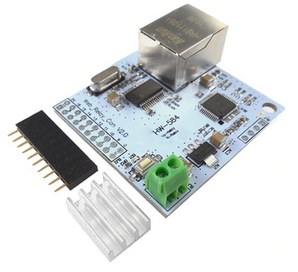

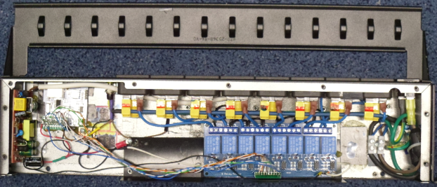
Preface.
This module acts like a network controlled 16 ports relay interface unit. The relays are not part of the board, but there are relay boards available to connect to this board.
Together with such a relay board and a power supply, the board can replace a APC power distribution unit like the AP7920. The factory installed software used in the HW-584 is is not designed for such a use, mainly because there is no user/password feature to protect the unit against hackers.

Luckely, the software can be replaced. The processor on the board is an STM8S005C6 and the Ethernet controller is an ENC28J60.
On https://github.com/nielsonm236/NetMod-ServerApp you can find the complete source code for an upgraded version of the unit. But still there is no user/password check and the code can only be compiled by the STM8 compiler (IdeaSTM8/CXSTM8), not be compiled by Platformio. So I decided to make a PlatformIO version.

Protected device.
A new HW584 module is protected against reading/writing. I used STVP to clear the protection.

PlatformIO version.
I took major parts of the source code from NielsonM236 to port it to PlatformIO. It was necessary and handy to make a “board” file for this board, so that the processor definitions were set automatically during compilation. The “hw_584.json” file looks like this:
{
"build": {
"core": "sduino",
"extra_flags": "-DHW_584 -DSTM8S005",
"f_cpu": "16000000L",
"cpu": "stm8",
"mcu": "stm8s005c6",
"variant": "hw_584"
},
"frameworks": [
"arduino",
"spl"
],
"debug": {
"svd_path": "STM8S005MB.svd",
"openocd_target": "stm8s"
},
"upload": {
"maximum_ram_size": 2048,
"maximum_size": 32768,
"protocol": "serial",
"protocols": [
"stlinkv2",
"serial"
]
},
"name": "HW-584 Network Board",
"url": "",
"vendor": "sduino"
}

The board file is in C:\Users\<user>\.platformio\platforms\ststm8\boards.
It seems that it is sometimes removed after an update.

Pin usage.
The module has a 20 pin connector. There are 2 pins for the 5 Volt power, 2 pins for ground and 16 pins, numbered 1 to 16 for the digital I/O. The 16 I/O pins were meant to be for output to a relay board. But in this case I reserved 8 pins for output to relais, 1 pin for output enable, 5 pins for input (pull-up) and 2 pins for RS232 serial I/O. In detail:
I/O pin Port/Bit IN/OUT  ------- --------- ------  1 A3 INPUT 0  2 A5 INPUT 1  3 D6 UART2_RX  4 D4 INPUT 3  5 D2 INPUT 4  6 E0 INPUT 5  7 G1 OUTPUT Enable  8 C7 OUTPUT 1  9 A4 OUTPUT 2  10 D7 OUTPUT 3  11 D5 UART2_TX  12 D3 OUTPUT 4  13 D0 OUTPUT 5  14 E3 OUTPUT 6  15 G0 OUTPUT 7  16 C6 OUTPUT 8 | ◘ ◘ +5 Volt  O 8 O 16  O 7 O 15  O 6 O 14  O 5 O 13  O 4 O 12  O 3 O 11 RX/TX  O 2 O 10  O 1 O 9  ◙ ◙ Gnd

The ground pins are closest to the reset button.
I/O signals are 3.3 Volt.
“Output enable” is the common power line for the relais. The relais are in fact isolation circuits using an optocoupler for the relais
The serial I/O is vital for debugging during development.

Web interface.
A web interface is available at the configured IP address (default 192.168.2.88). An inlogpage will be opened to log in before any actions can be performed.

Inlog (home) page.
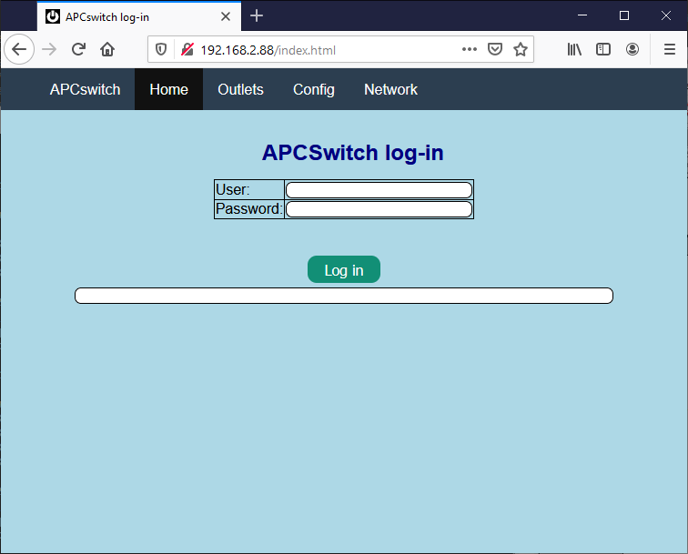
The page looks like this:
Enter user name and password (default is “admin” and “admin”). The user “admin” has full access to the other pages. After log in, you may access the other pages during 5 minutes.

The config page.
The “admin” user may access the config page. It looks like this:
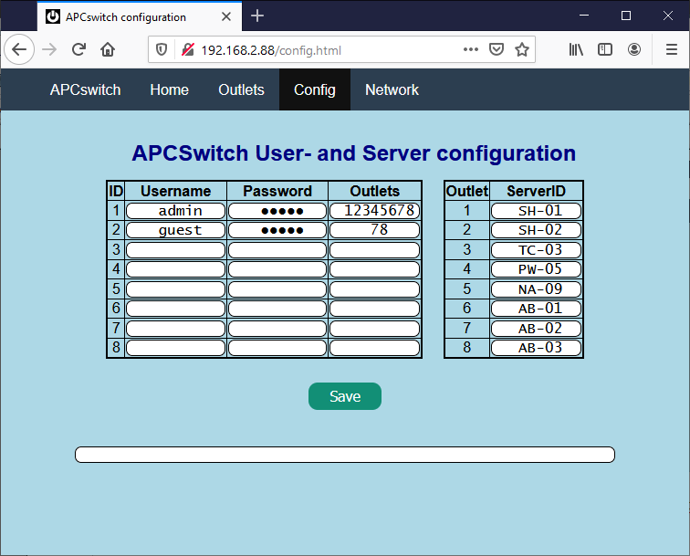
In this page you may add extra users. Specify the password and outlets to be controlled by this user.
You may also assign names to all 8 outlets.
Note that “admin” should always be the first user! Admin has all privileges.

The network page.
In this page, the user “admin” may change the network settings and the firewall. It looks like this:
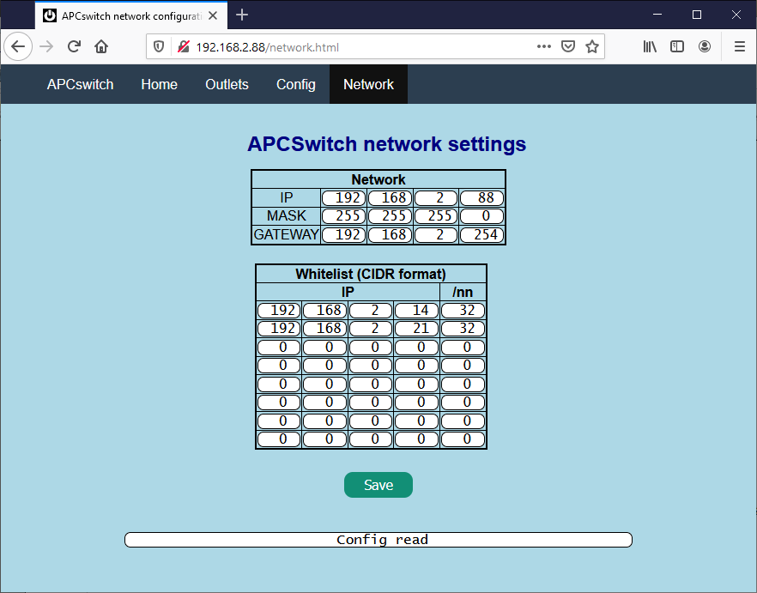
The IP, MASK and GATEWAY settings are straight forward. Access to the APCswitch is only allowed for external addresses that are whitelisted. Note that the whitelist entries are in CIDR format. In the above example there are only 2 addresses whitelisted.

The outlets page.
All users may access the outlet page after log in. It looks like this:

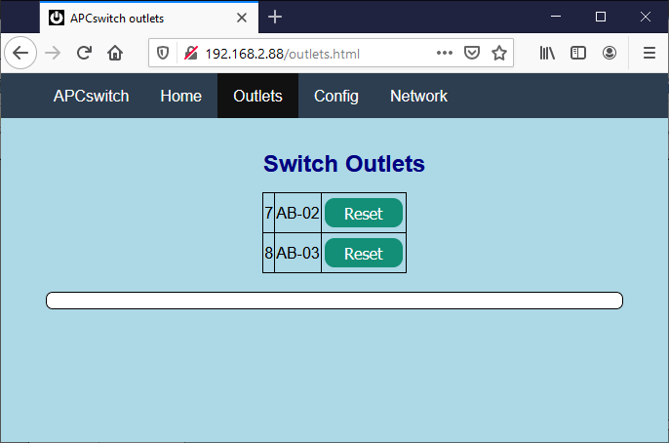
The page will show the outlets that are assigned to the user. Pressing a “Reset”-button will power cycle the connected server (in the second column) by activating the outlet in the first column for 6 seconds.

Network settings.
The network settings are kept in EEPROM. You may modify this are with STVP, tab “DATA-MEMORY”. The lay-out should be like this:
struct netdata_t // For all etwork related data
{
uint8_t ip[4] ; // IP address of this host
uint8_t mask[4] ; // Mask or IP address
uint8_t gw[4] ; // Gateway for this network
uint8_t whitelist[8][5] ; // Whitelist for access (CIDR, like 192.168.2.128/25)
char valpat[12+1] ; // Pattern to check valid EEPROM
} ;

00004000 : 4 byte IP address
00004004 : 4 byte mask
00004008 : 4 byte gateway
0000400C : 8 times 5 bytes CIDR notations
00004034 : 12 bytes pattern to assure valid EEPROM,
If the “valid EEPROM” pattern is not correct, the values will be overwritten by deaults. The IP-address will be 192.168.2.88 (see main.c: defnet):

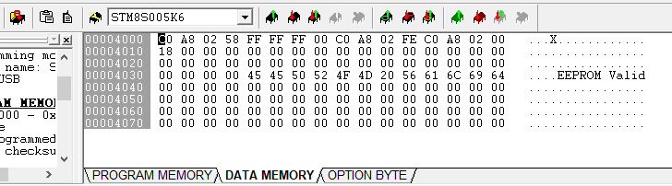

Ethernet packet handling.
There are two types of incoming ethernet packages that are handled by the software:
- ARP packages.
- IP packages.
ARP packages are broad-casted to all stations on the subnet. An example is:
FF FF FF FF FF FF 54 13 79 17 17 9D 08 06 00 01
08 00 06 04 00 01 54 13 79 17 17 9D C0 A8 02 07
00 00 00 00 00 00 C0 A8 02 07 00 00 00 00 00 00
00 00 00 00 00 00 00 00 00 00 00 00

The orange part shows the package type (=ARP), the green part is the MAC address of the sender, the blue part is the IP address of the sender.
The HW-584 returns its own MAC address is the message was addressed to its IP-address.

