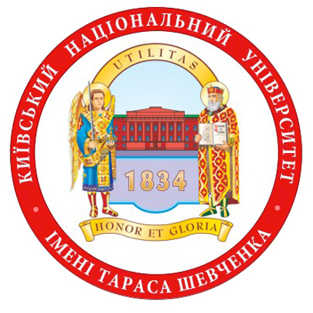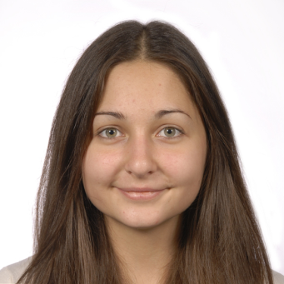

**Anna MELENCHUK**

**Born in** Lviv, Ukraine

**Hometown**: Kyiv

**Kyiv National Taras Shevchenko University** was established in 1834.Faculty of international relations.

**Motto of University**: Utilities Honor ET Gloria. – Корисність, честь та слава. –

Utility, Honor and Glory.

**Foreign languages**: English, German, Russian, Polish

**Last book read**: «Statecraft: strategies for a changing world» by Margaret Thatcher

**Favourite quote by Ukrainian author**:

Любіть Україну у сні й наяву, вишневу свою Україну, красу її, вічно живу і нову, і мову її солов'їну. /Володимир Сосюра/

Love Ukraine in dreams and in reality, yours

cherry Ukraine, it’s beauty, always alive and new,

it’s nightingale’s language. /Volodymyr Sosyura /

**Favourite quote by foreign author**: «Ask not what your country can do for you, ask what you can do for your country». /John F. Kennedy/

**My favourite musical recording**:

Chris de burgh «Lady in red»

**Outstanding landmark or architecture in Ukraine:**

Bucky Canyon is situated in the village Buky in the Cherkasy region on the river Hirskyj Tisch. It was formed 2 billion years ago and today is one of the most gorgeous and mysterious places in Ukraine. In 1975 this natural phenomenon became a state monument .Some people call it Little Switzerland. I visited this place last week and was really fascinated. Here you can find the remains of the handmade monument that look like Stonehenge .There are areas of this “Ukrainian Stonehenge” that remain unexplored. In some places cliffs are 20 meters that make this place interesting for rock climbers. It is also famous for its waterfall Vyr. A big water mill was constructed in the 19th century. If you go a little further you will see the first water power plant in Ukraine .I strongly encourage everyone to visit this place.

