**K**ingsway **I**mperial **N**eighbourhood **A**ssociation - **KINA**

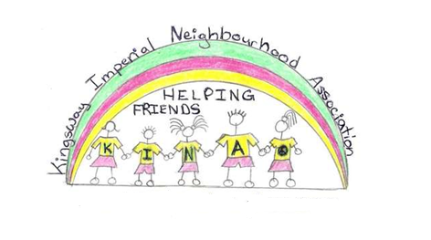

***Saturday, September 13, 2014***

The Courtyard of Burlington Square

5172 Kingsway

(between Royal Oak and Burlington)

9:30am: Registration

10am – 12pm: Clean up

12pm: BBQ for Participants

*Building our Community*

*We welcome all residents and businesses in our Community!*

*Come and have some fun while helping to clean up your community and get to know your neighbours!*

*Refreshments to be provided to all participants!*

**www.KINAburnaby.ca**