**Save us, Port Metro Vancouver is a liar**

Port Metro Vancouver announced Aug.21, 2014 that it granted a permit to build a Direct Coal Transfer Project at Fraser Surrey Docks. The $15 million invested new coal terminal will transfer U.S. coal arriving by rail onto 8,000 dead weight tonne barges every day. This is going to be a health disaster for people in Metro Vancouver.

Fraser Surrey Docks CEO Jeff Scott said “over the past 2 years, a number of comprehensive studies have gone into ensuring this project is safe”. The port authority is confident the project poses “acceptable” risks to human health.

I am a resident at Port Royal, Queensborough, New Westminster, BC, just opposite of the Fraser Surrey Docks. Like many in this area, what I witness every day is not as what the Port Authority said.

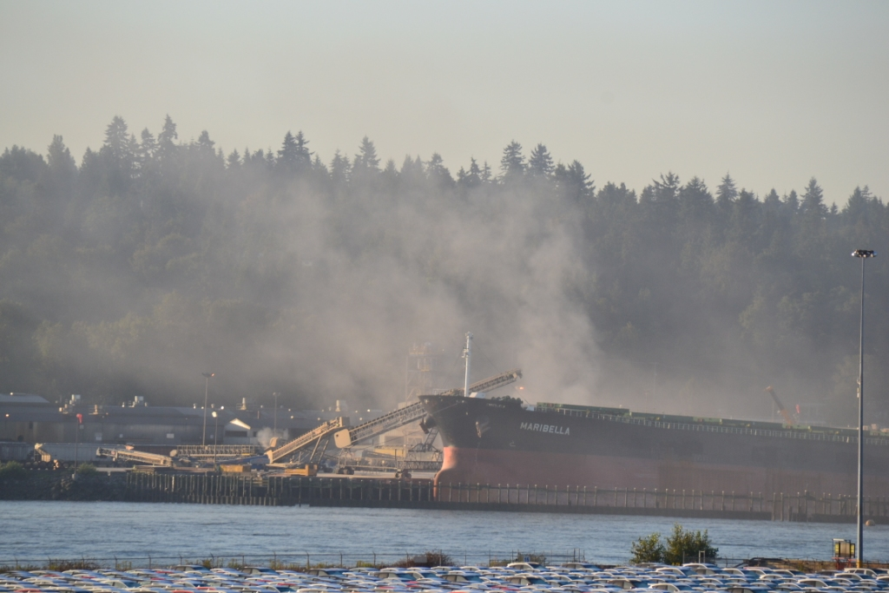

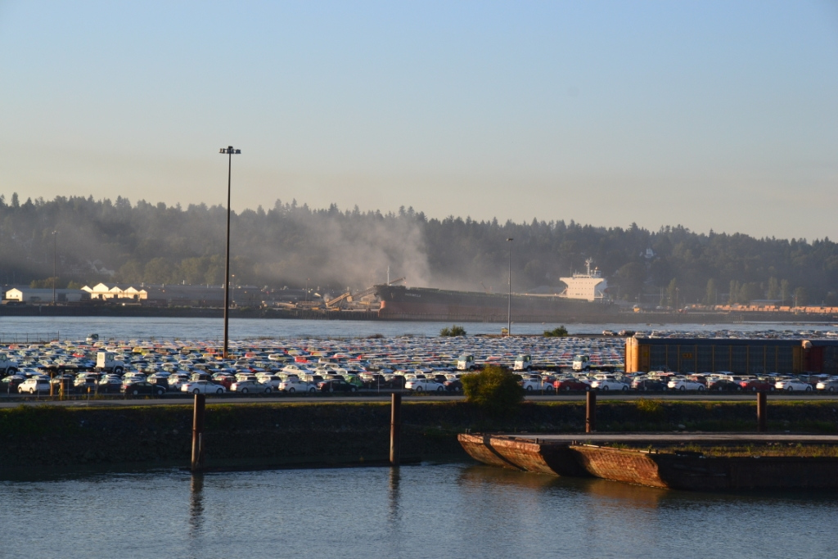

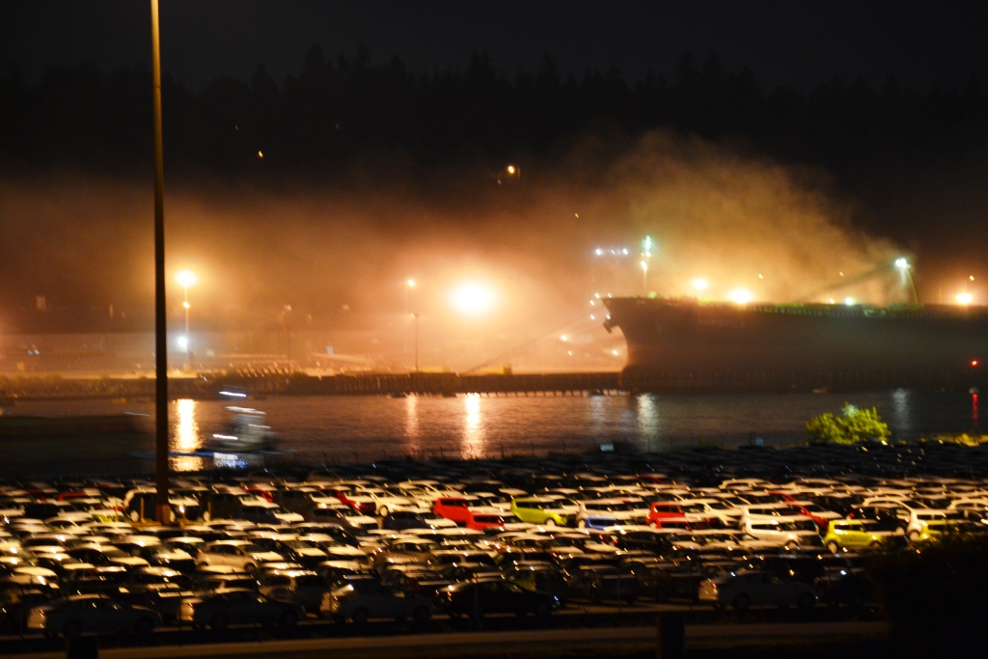

They are already making huge dust and air pollution every day, all day and night, and I can imagine they will make even heavier pollution to Metro Vancouver and jeopardize the human health nearby if the Coal Terminal put into use.

Resident in Port Royal, New Westminster, BC: Boris Liao

Email: [borishbl@gmail.com](mailto:borishbl@gmail.com)

Tel: 604-445-2357