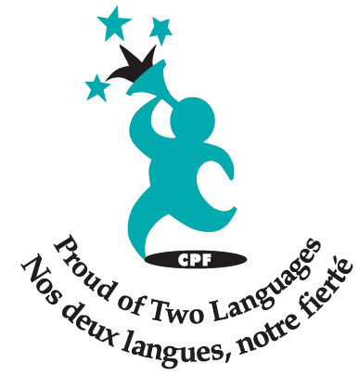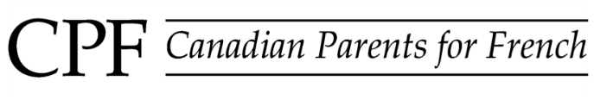

***New Westminster Chapter***

**April 8, 2015**

Dear Lindsea,

Canadian Parents for French New Westminster is excited to be holding their Second Annual pancake breakfast for families in our school district to help celebrate French Immersion in our local schools. In order to ensure the success of this event, we are seeking donations from local businesses such as yours. Generous donors like you are the key to our ability to help students in our community continue with their French Immersion education.

Our breakfast event will be held on Saturday May 2, 2015. We have entertainment, a French book resource fair, a raffle table, as well as face painting and a craft table for the kids. We have been fortunate to have the New Westminster Rotary Club offer to help us cook the breakfast and Save On Foods help out with some of the food.

We hope that you will consider donating an auction item, gift certificate or gift basket for our raffle table. As a donor, you will receive publicity prior to and during the event, which will be viewed by every invitee and attendee. We will be inviting all the over 900 French Immersion families in the district to attend.

Canadian Parents for French (CPF) is the national network of volunteerswhich values French as an integral part of Canada and which is dedicatedto the promotion and creation of French second language learning opportunities for young Canadians. The New Westminster Chapter of CPF focuses efforts directly on students within our district.Last year, with grants and funds raised, we were able to co-sponsor thousands of dollars worth of workshops, presentations, performers, and events for all French Immersion students in the district. We co-sponsor events for education that schools may not be able to fully fund alone.

May we count on your help? An event committee member would be happy to pick up your donated item at your convenience. **Please submit your donation no later than April 25th to ensure proper recognition at the auction.**

Thank you for your support of French Immersion education in New Westminster and Canadian Parents for French – New Westminster Chapter. Please feel free to contact me if you have any questions at [cpfnewwest@gmail.com](mailto:cpfnewwest@gmail.com) or 604-418-9073.

Merci!

Stephanie Hogan

Chair, CPF-NW

604-418-9073

116 Eighth Ave

New Westminster, BC

V3L 1X8