 | Curriculum: ACCP2003  Subject: HDJ, Dreamweaver MX  Duration: 120 minutes  Total Marks: 25  Exam Date: 16-Jun-06

MODULE TEST PRACTICAL

Question 1: [15]
Create a form as shown in Figure 1 using HTML and Dreamweaver:

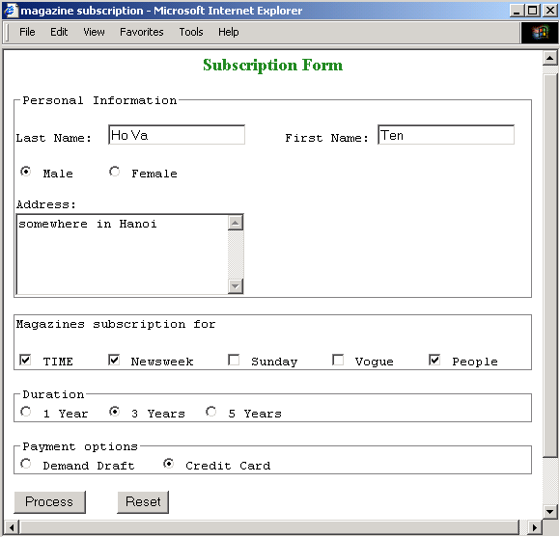
Figure 1
Duration:trong thời gian bao lâu
Following validations to be performed:

- | When the Process button is clicked and if the form is not correctly(đúng) filled in, a message box should be displayed to inform(thông báo) the user about his (or her) mistake. (Lỗi)
 | - | the first name field can not be empty
 | - | the last name field can not be empty
 | - | the address field can not be empty
 | - | user must choose at least(tói thiểu) a magazine, duration(khoảng thời gian) and payment options
- | if the form is correctly filled in, a confirm message box should be displayed (see figure 2). The chosen(quyết định) magazines and the chosen payment option must be correctly displayed.
 | - | If then the OK button is pressed, an other message box should be displayed (see figure 3). The gender and the address of the user must be correctly displayed.
 | - | If then the Cancel button is pressed, then the last name field has focus and the user can change his (or her) choices.
- | When the Reset button is clicked, all the fields should be cleared.

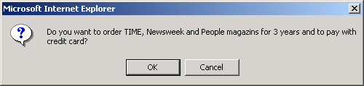

Figure 2

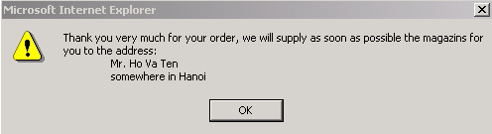

Figure 3
Question 2: [6]
Write a script that accepts a child’s name and his telephone number, and then checks that the telephone number is in form of “(Ccode)-Acode-Local number”. The user interface can be created using Dreamweaver. Note:
- Ccode (country code) has one or two number
- Acode (area code) has one or two or three number
- Local number has minimum 6 number and maximum 9 number

For example:
- (84)-4-8344669 is valid form
- (090)-1-234567 is invalid form
Question 3: [4]
Write a script that convert and copy the character entered into the textfield BOX A into textfield BOX B as shown in Figure 2.

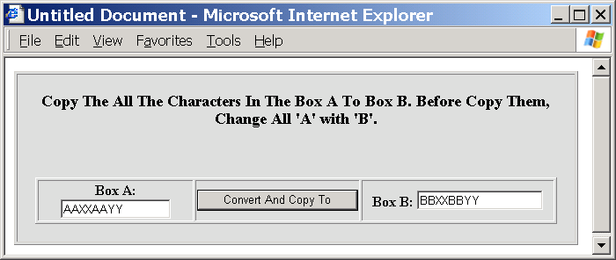

Figure 4

The interface is as shown in Figure 4 and can be created using Dreamweaver.

