|  | Curriculum: **ACCPi7.1**  Subject: HDJ-DWMX  Duration: **120 minutes**  Total Marks: **25**  Exam Date: **31-Dec-08** |
| --- | --- |

**MODULE TEST PRACTICAL**

| **If this rule is violated, the examination will be ignored.** |
| --- |

**Question 1 [8.0]**

Create a form as shown in Figure 1 using HTML and Dreamweaver : **[8.0]**

**Note :** Students must save his/her programs as following rules:

* Put all files for Question 1 into **QUESTION1** Folder.
* Put all files for Question 2 int **QUESTION2** Folder.

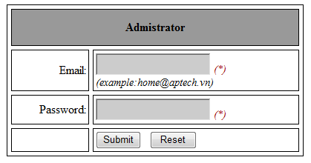

Figure 1

* When user Click on Reset Button, all field must be cleared.
* When user Click on Submit Button, following validations will be performed:
* Email can not be empty.
* Email must be format.(example: [admin@aptech.vn](mailto:admin@aptech.vn)).
* Password can not be empty.
* Password must include full character as: a-z; A-Z;1-9, ~;@;#;$;?; *(each character appears at least 1 times)*
* If value are invalid, display an error message corresponding.(use alert function)
* If value are valid and email equal to ‘admin@aptech.vn’ , password equal to ‘aA1~@#$?’ show the productadnew.html page. (as shown in Figure 2).

**Question 2 [17]**

Create a form as shown in Figure 2 using HTML and Dreamweaver : **[5]**

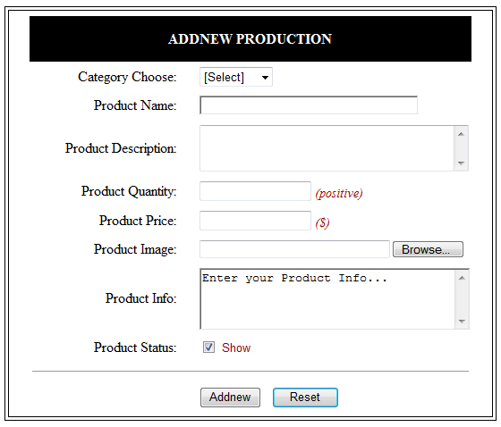

Figure 2

* When user Click on Reset Button, all field must be cleared, field Product Info is value “*Enter your Product Info…..*”. **[0.5]**
* Change the color of ‘**ADDNEW PRODUCTION’** when the mouse is moved over it to **RED**, and back to original color when the mouse pointer moves out of it. **[0.5]**
* Category choose drop down list has the follwing option: **[1.0]**

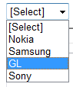

User must select 1 category

* **[1.0]**



* When user Click on Product Status check: **[1.0]**
* If Product Status is true, display ‘show’ as Figure 2 else display ‘hidden’.

*Example:*

* When user Click on Addnew Button, following validations will be performed :

*(NOTE: If value are invalid, display an error message corresponding)*

* Category choose must select. **[1.0]**
* Product Name only contain characters, digits, minus sign , space and not empty. (a-z,A-Z, 0-9, ,-,_). **[1.0]**
* Product Quantity must be positive and not empty. **[1.5]**
* Product Quantity is value ranges from 1-100. **[1.0]**
* Product Price must be the number and greater than 0 and not empty. **[1.0]**
* Product Description not empty and not exceed 200 characters. **[1.0]**
* If values in all field are valid, an Message Box will be display with these information. **[1.5]**

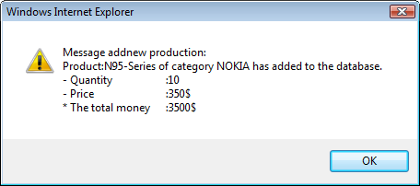

*where,*

* + ‘N95-series’ from the product name.
  + ‘NOKIA’ select category.
  + ‘10’ from the Product Quantity.
  + ‘350’ from the Product Price.
  + ‘3500$’ calculated from [Product Name] * [Product Price].