**DEEN DAYAL UPADHYAYA COLLEGE**

**(UNIVERSITY OF DELHI)**



**PRACTICAL FILE**

**(DATABASE MANAGEMENT SYSTEMS )**

**NAME :** SAKSHAM NEGI

**COURSE :** B Sc(H) COMPUTER SCIENCE

**ROLL NO. :** 22HCS4146

**SEMESTER :** IV

**SUBMITTED TO:**

MRS. SHWETA WADHERA

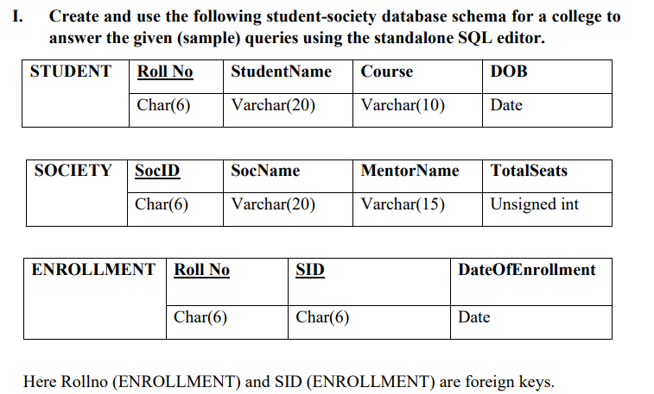

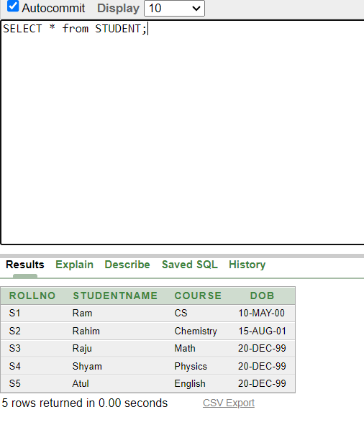

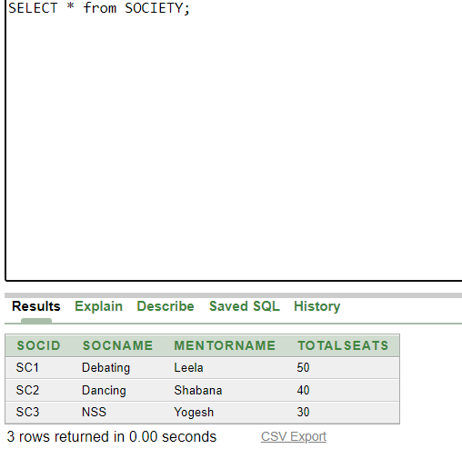

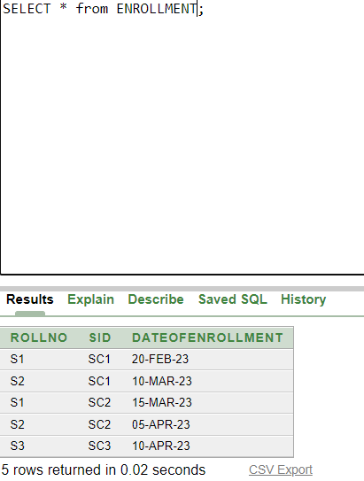

1. **Retrieve names of students enrolled in any society.**

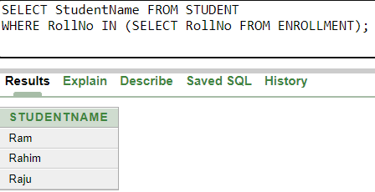

1. **Retrieve all society names.**

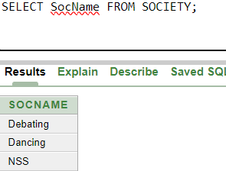

1. **Retrieve students' names starting with letter ‘A’.**

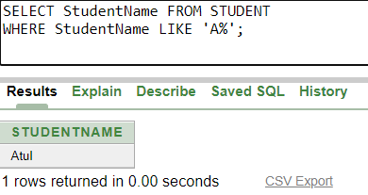

1. **Retrieve students' details studying in courses ‘computer science’ or ‘chemistry’.**

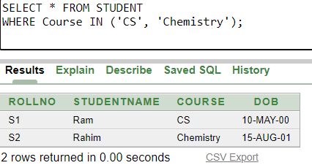

1. **Retrieve students’ names whose roll no either starts with ‘X’ or ‘Z’ and ends with ‘9’**

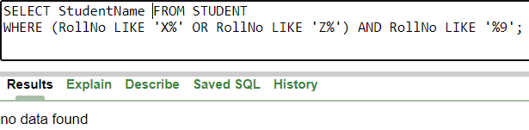

1. **Find society details with more than N TotalSeats where N is to be input by the user**

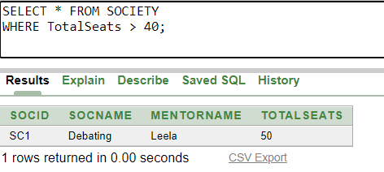

1. **Update society table for mentor name of a specific society**

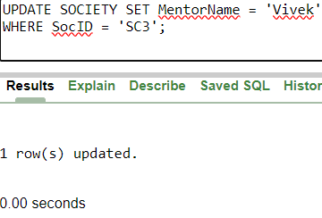

1. **Find society names in which more than five students have enrolled**

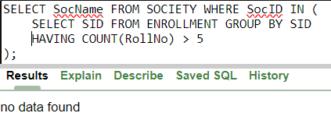

1. **Find the name of youngest student enrolled in society ‘NSS’**

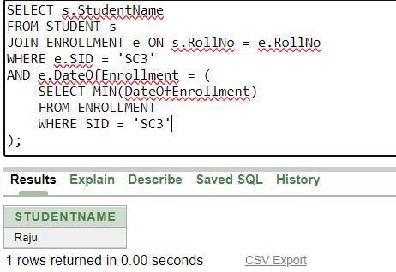

1. **Find the name of most popular society (on the basis of enrolled students)**

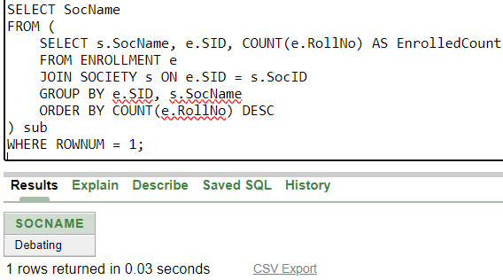

1. **Find the name of two least popular societies (on the basis of enrolled students)**

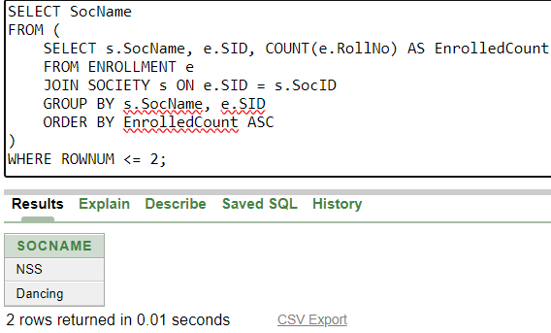

1. **Find the student names who are not enrolled in any society**

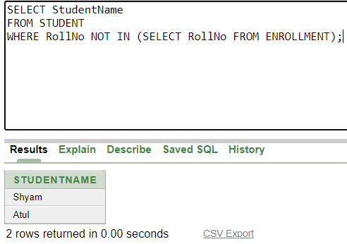

1. **Find the student names enrolled in at least two societies**

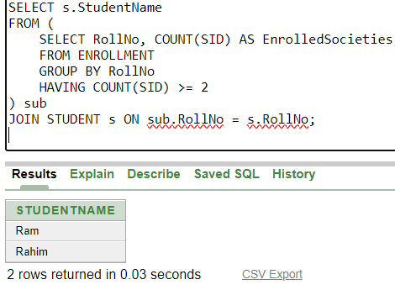

1. **Find society names in which maximum students are enrolled**

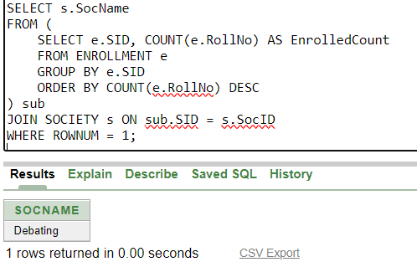

1. **Find names of all students who have enrolled in any society and society names in which at least one student has enrolled**

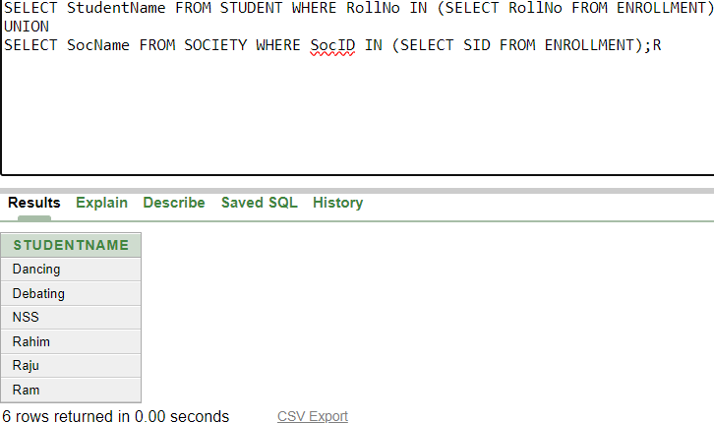

1. **Find names of students who are enrolled in any of the three societies ‘Debating’, ‘Dancing’ and ‘Sashakt’.**

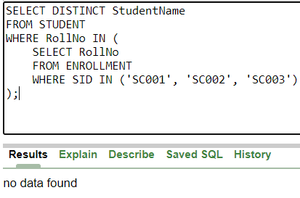

1. **Find society names such that its mentor has a name with ‘Gupta’ in it.**

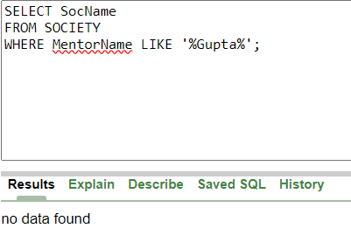

1. **Find the society names in which the number of enrolled students is only 10% of its capacity.**

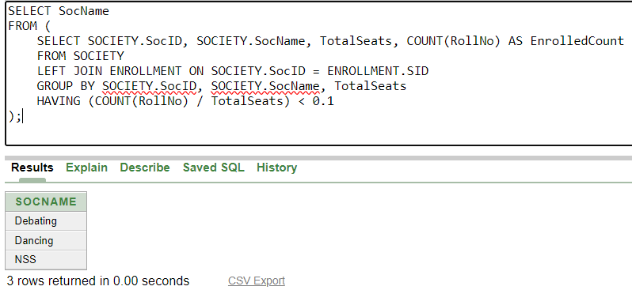

1. **Display the vacant seats for each society.**

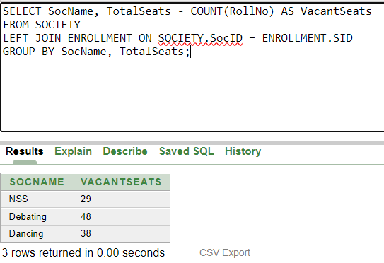

1. **Increment Total Seats of each society by 10%**

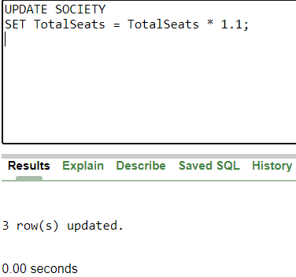

1. **Add the enrollment fees paid (‘yes’/’No’) field in the enrollment table.**

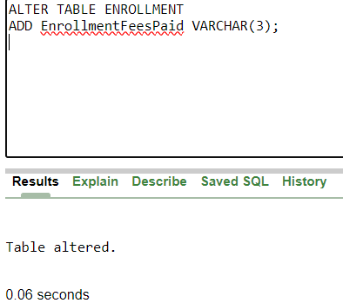

1. **Update date of enrollment of society id ‘s1’ to ‘2018-01-15’, ‘s2’ to current date and ‘s3’ to ‘2018-01-02’.**

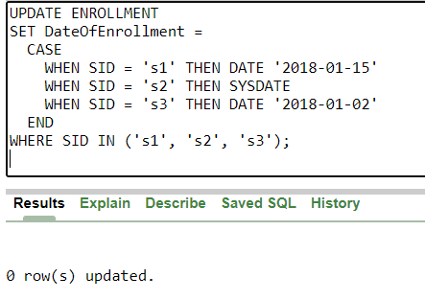

1. **Create a view to keep track of society names with the total number of students enrolled in it.**

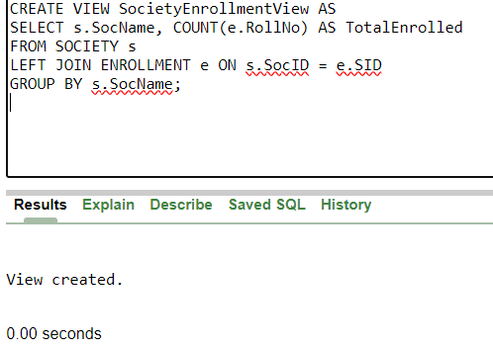

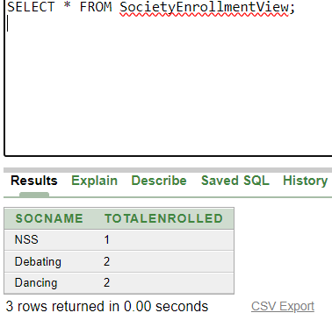

1. **Find student names enrolled in all the societies.**

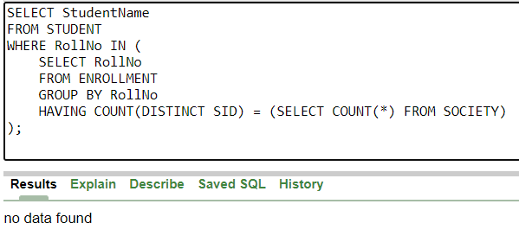

1. **Count the number of societies with more than 5 students enrolled in it**

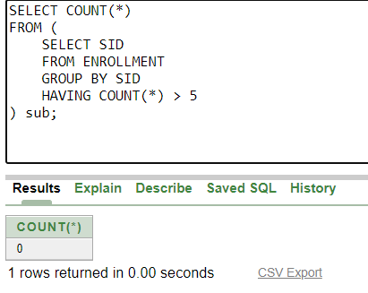

1. **Add column Mobile number in student table with default value ‘9999999999’**

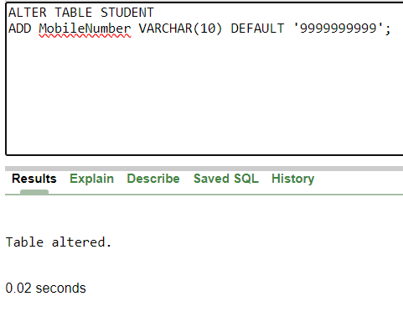

1. **Find the total number of students whose age is > 20 years.**

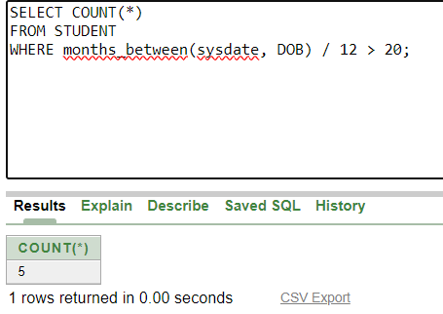

1. **Find names of students who are born in 2001 and are enrolled in at least one society.**

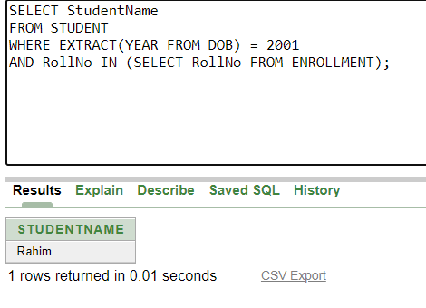

1. **Count all societies whose name starts with ‘S’ and ends with ‘t’ and at least 5 students are enrolled in the society.**

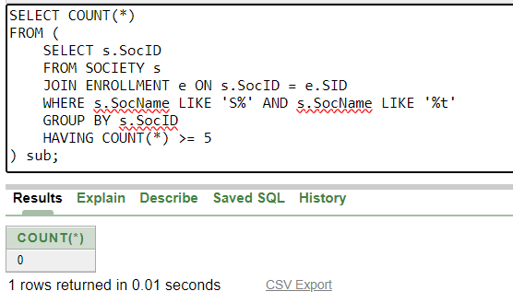

1. **Display the following information: Society name Mentor name Total Capacity Total Enrolled Unfilled Seats**

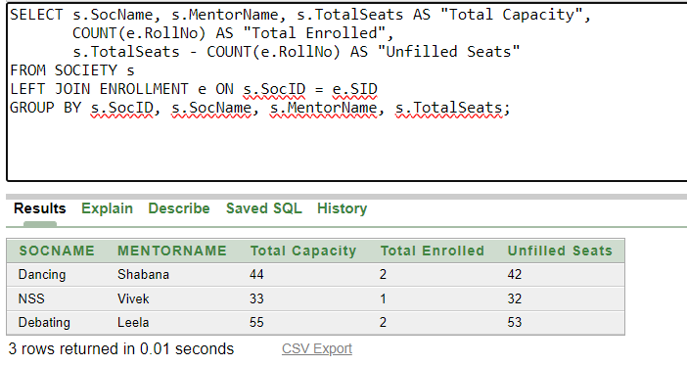

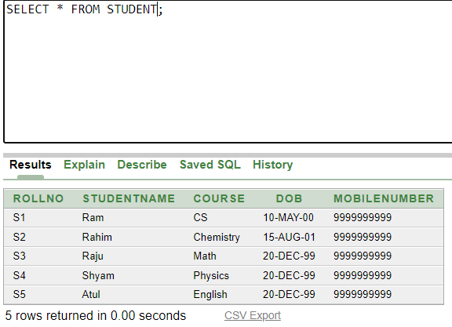

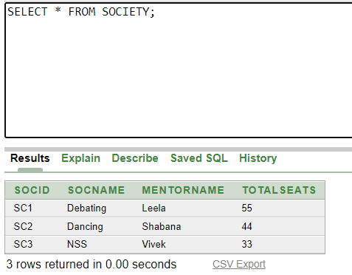

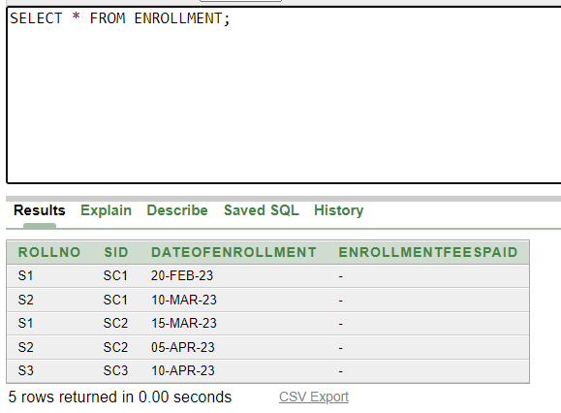

**Ques2) Do the following database administration commands: create user, create role, grant privileges to a role, revoke privileges from a role, create index**

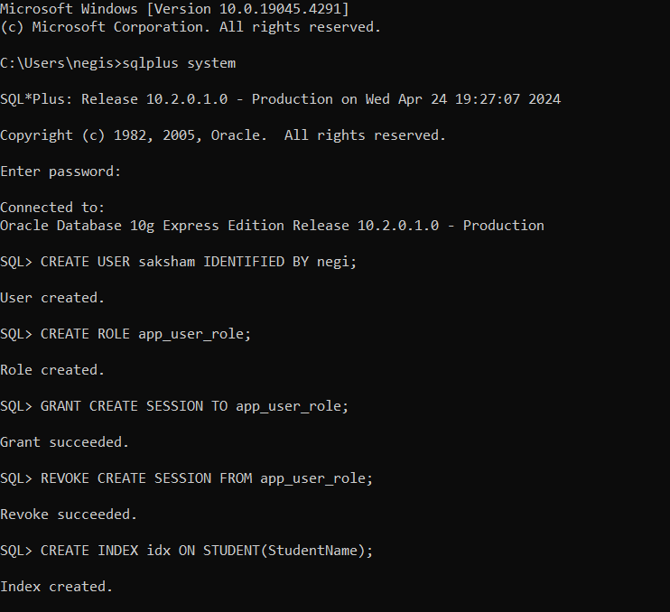

**PRACTICE QUESTIONS**

**CREATING STUDENT TABLE**

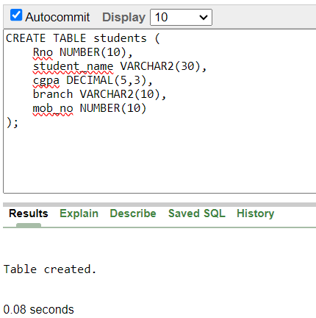

**Describing the students table**

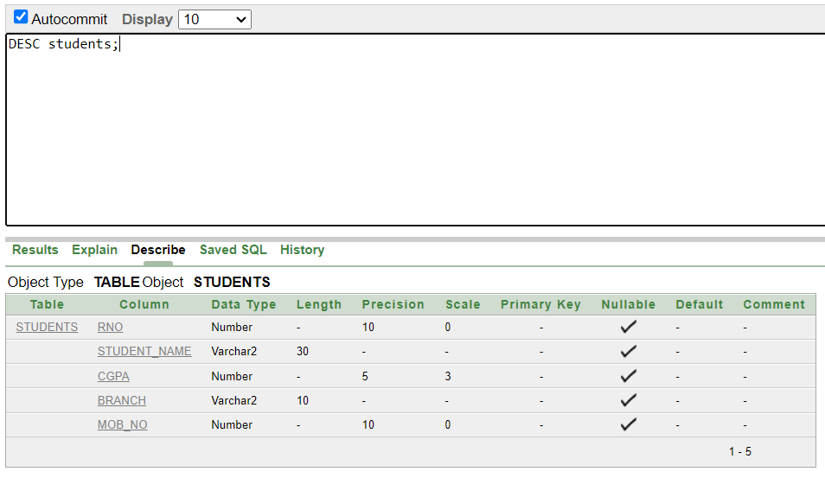

**INSERTING RECORDS**

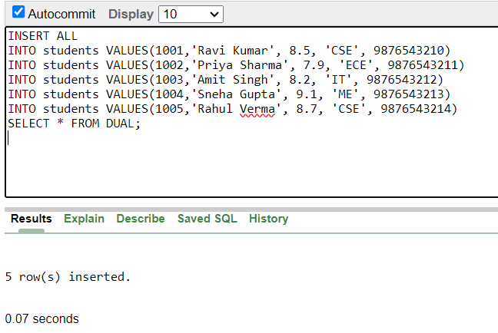

**CREATING EMPLOYEE TABLE**

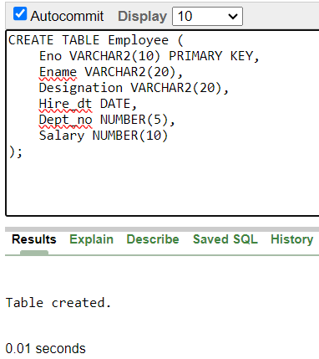

**Describing Employee Table**

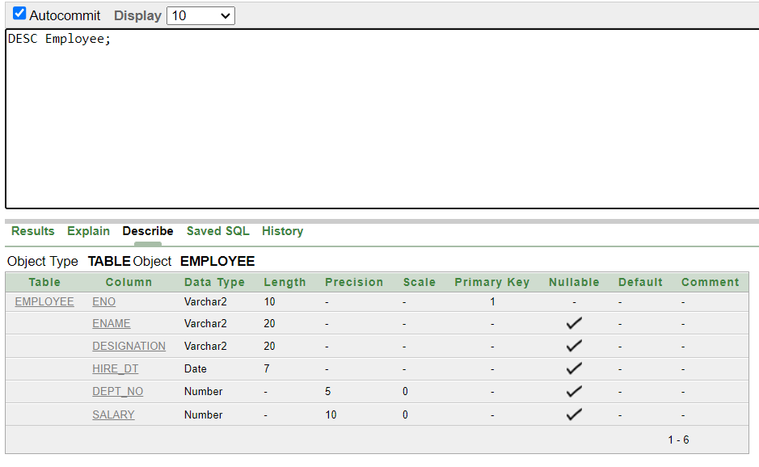

**INSERTING RECORDS**

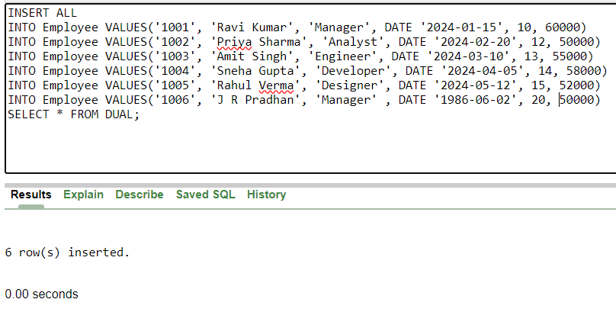

**USING SELECT STATEMENT**

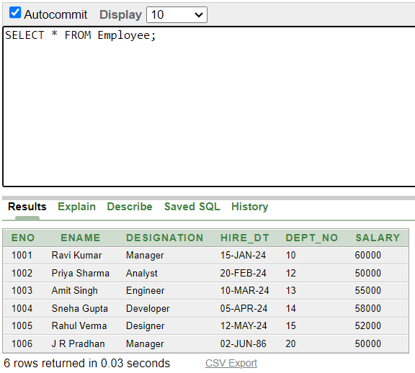

**RETRIEVAL OF SPECIFIED COLUMN**

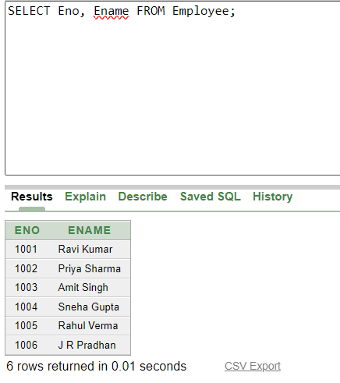

**TO DISPLAY ONLY UNIQUE VALUES**

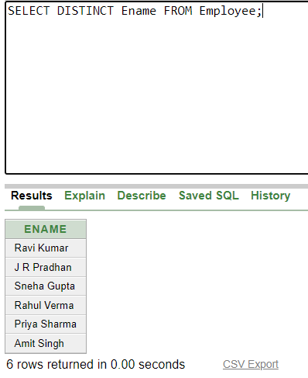

**SORTING OF DATA**

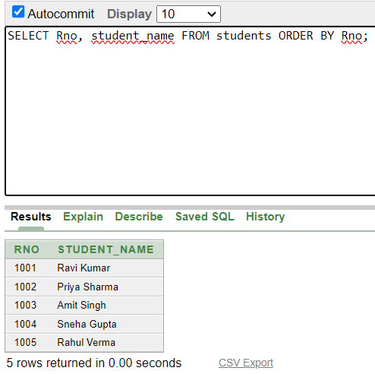

**USING WHERE CLAUSE**

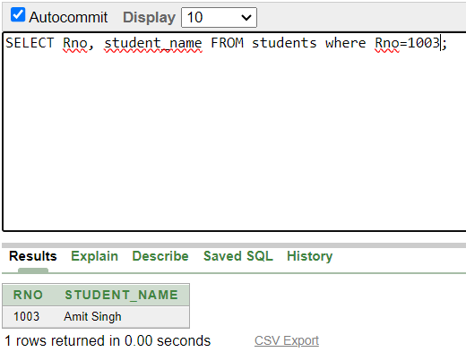

**MODIFYING THE STRUCTURE**

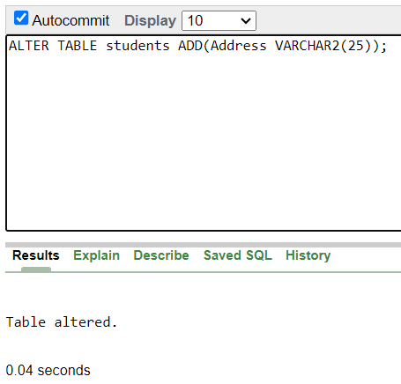

**MODIFYING EXISTING COLUMN**

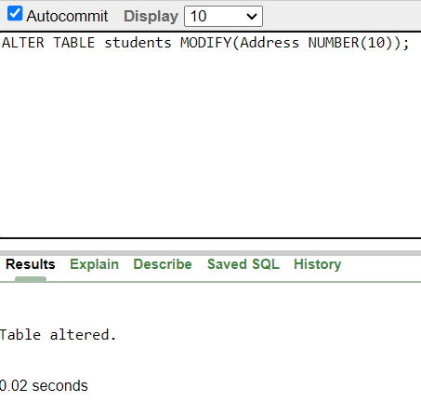

**UPDATING THE CONTENTOF TABLE**

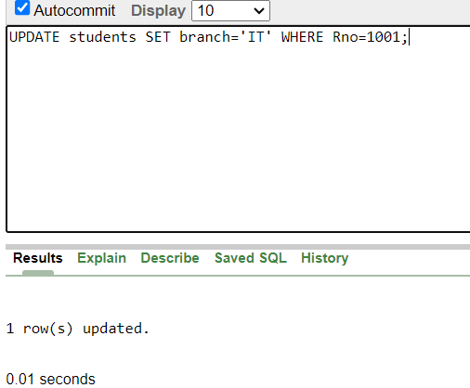

**DELETING TABLE CONTENT**

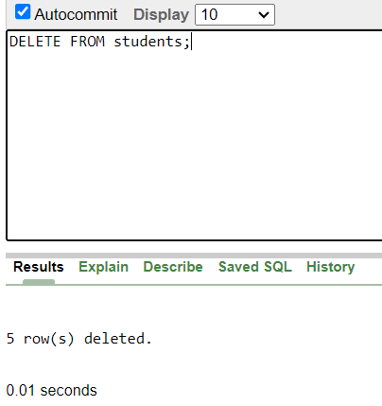

**DELETING TABLE**

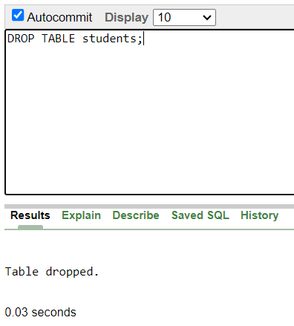

**Ques) Create the following table to store the details of an Employee…… EMPLOYEE ( Empno , Ename , JOB, Mgr , Hire Date, Salary , Commission, Department no )**

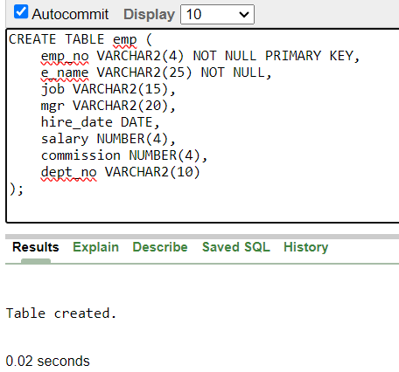

**INSRTING RECORDS**

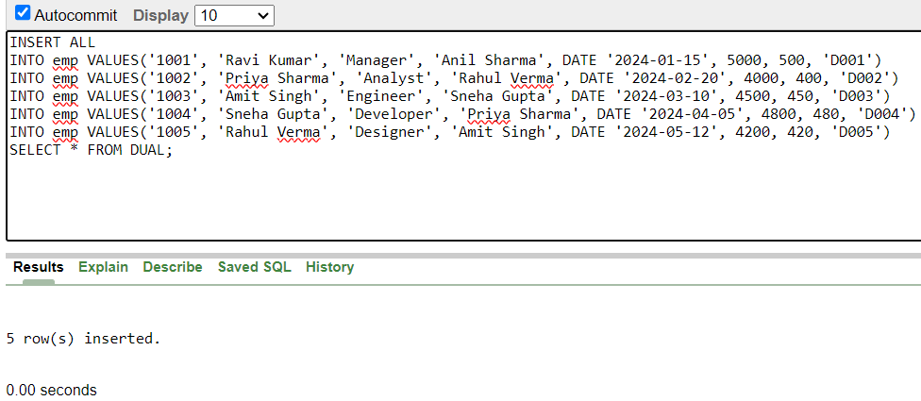

**1) Write a query to display name, job,hire date and employee no for each employee with empno appearing first.**

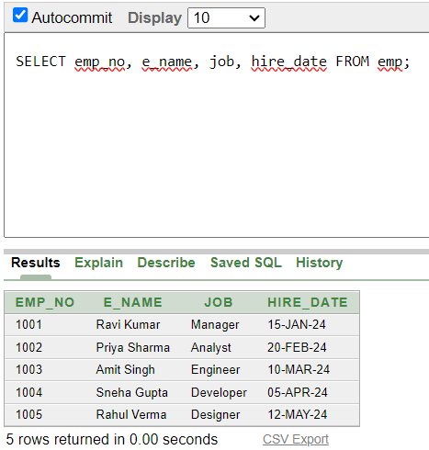

**2) Write a query to display unique jobs from the employee table.**

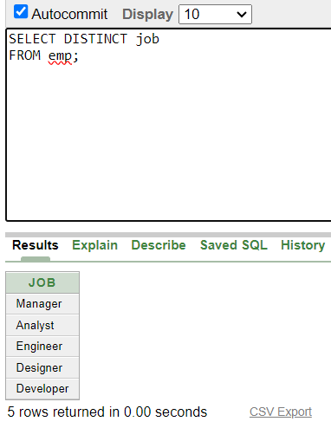

**3 ) Write a query to display name concatenated by a job separated by a comma .**

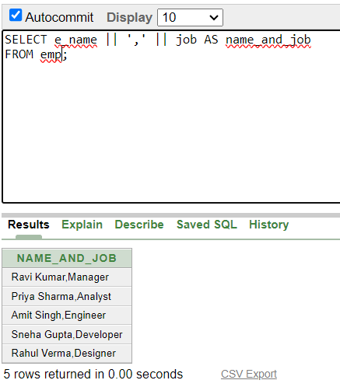

**4) Write a query to display all data from employee table. Separate each column by a comma and name the column THE_OUTPUT .**

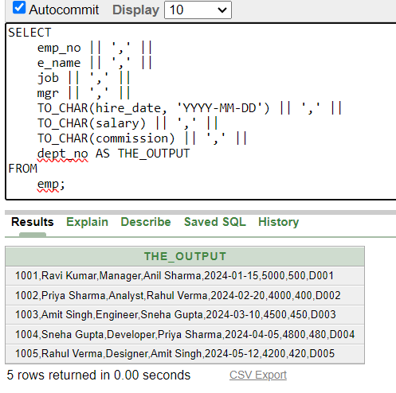

**5) Write a query to display the name and salary of employees earning more than $2850 .**

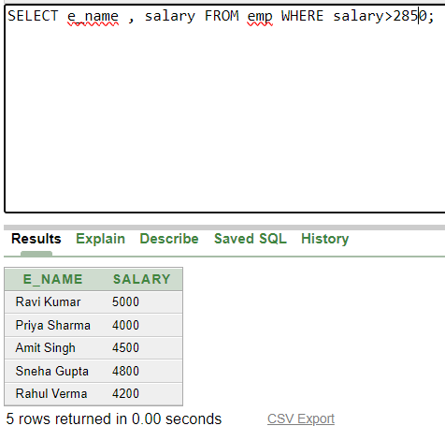

**6) Write a query to display the name and Department number for emp no 7900.**

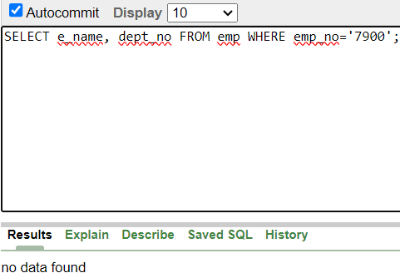

**7 ) Write a query to display the name and salary of all employees whose salary is not in the range of $1500 and $3000.**

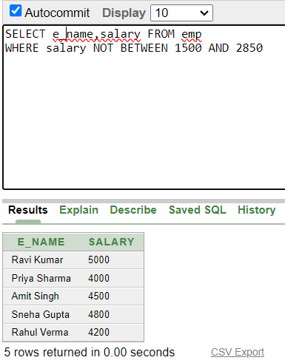

**8 ) Write a query to display employee name, job, hire date of employees hired between FEB 20, 1981 and MAY 1, 1981. Order the query in ascending order of start date.**

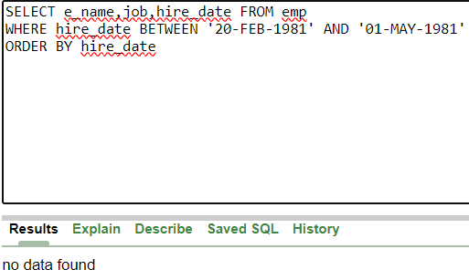

**9) Write a query to display the name and department number of All employees in departments 10 and 30 in alphabetical order by name.**

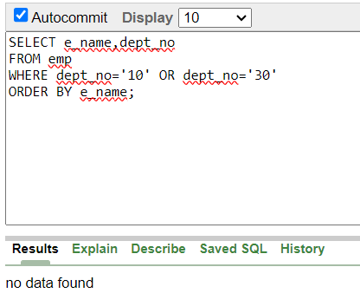

**10 ) Write a query to display the name and salary and Dept no of employees who earnes more than $1500 and are in dept no 10 or 30 .**

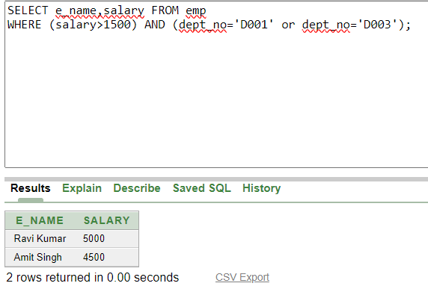

**11 ) Write a query to display the name and hire date of every employees who were hired in 1981.**

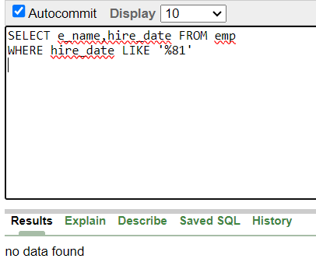

**12 ) Write a query to display the name and Job of all employees who do not have a manager.**

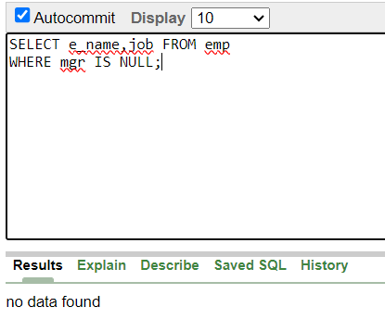

**13 ) Write a query to display the names of all employees where the second letter of their name is A.**

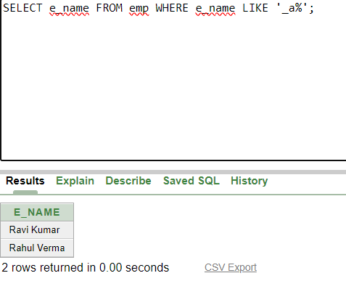

**14) Write a query to display the names of all employees that have two ‘R ‘s or A ‘s in their name and are in department num D003 or their manager is Anil Singh.**

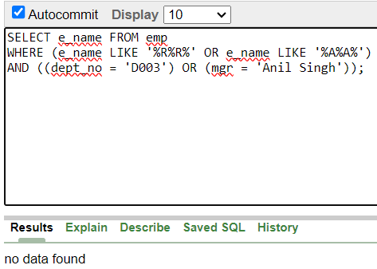

**15) Display the average salary of employees as AVERAGE SALARY**

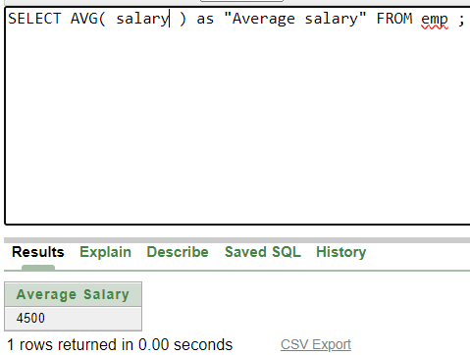

**AVERAGE OF DISTINCT SALARIES**

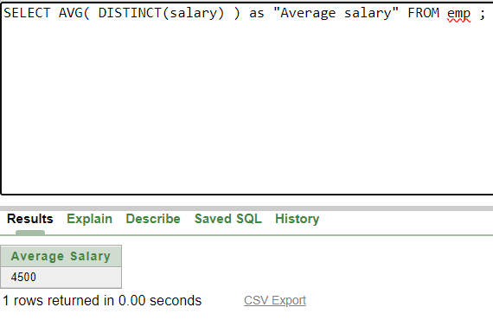

**Q16) Count the number of employees**

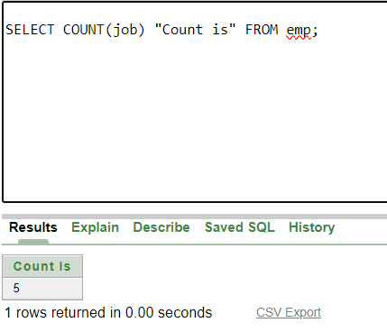

**INCLUDING NULL VALUES**

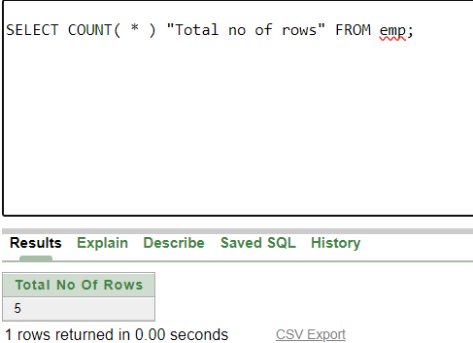

**Q17) Display the Maximum salary of the employee**

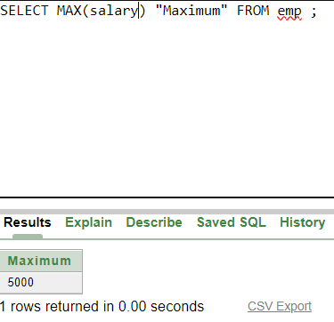

**Q18) Display minimum date on employees**

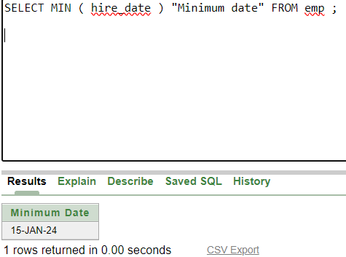

**Q19) Query to display the no. of managers without listing their names .**

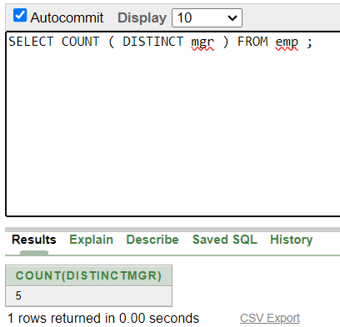

**Q20) Query to display the difference b/w the highest and lowest salaries**

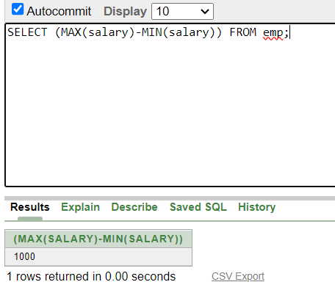

**Q21) Write a query to display Name, Job, and salary of all employees whose Job is Clerical or Analyst & their salaries are not equal to 1000, 3000 or 5000**

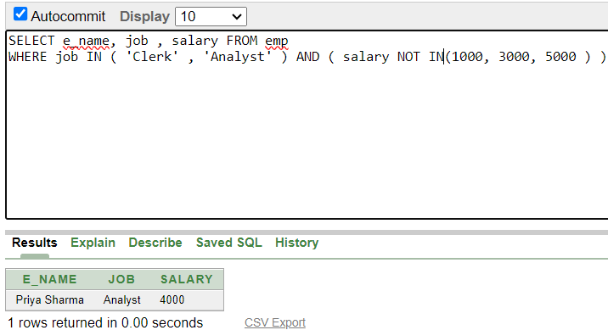

**Q22) Write a query to display Name , Salary , Commission for all employees whose commission amount is greater than their Salary increased by 5% .**

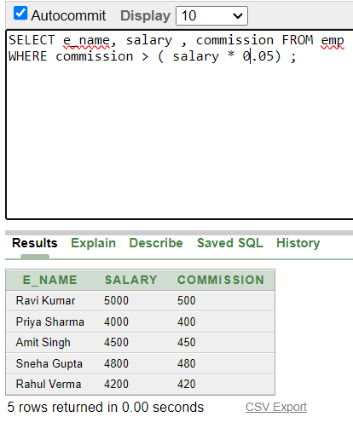

**Q23) Query to display Employee No. , Name , Salary and the Salary increased by 15 % expressed as absolute whole number .**

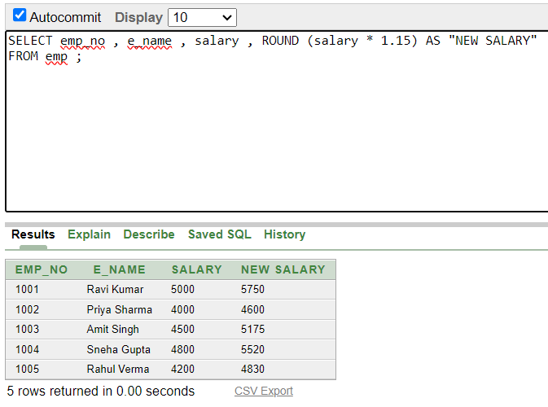

**Q24) Query to display name and calculate the number of months between today and the date each employee was hired.**

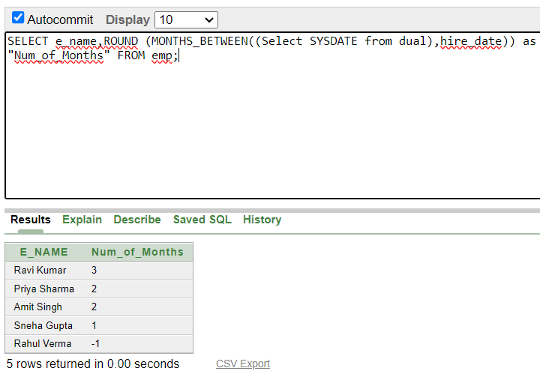

**Q25) Query to display the following for each employee :-- < ename > earns < salary > monthly but wants < 3 * current salary > . Label the column as DREAM SALARY .**

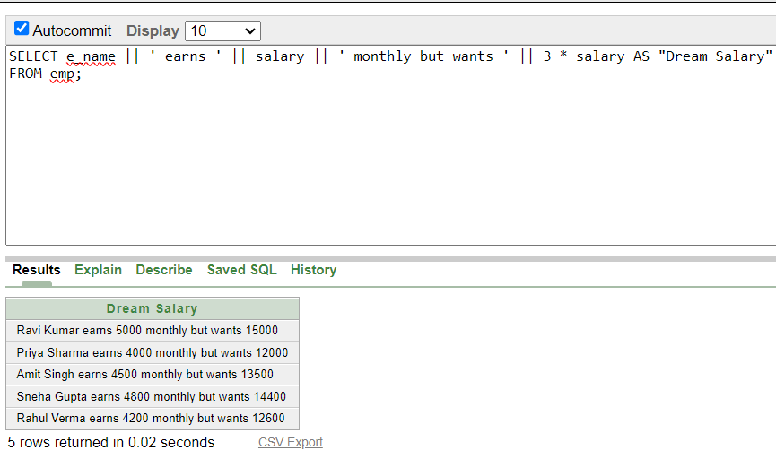

**Q26) Query to display name and salary for all employees . Format the salary to be 15 character long, left padded with $ sign .**

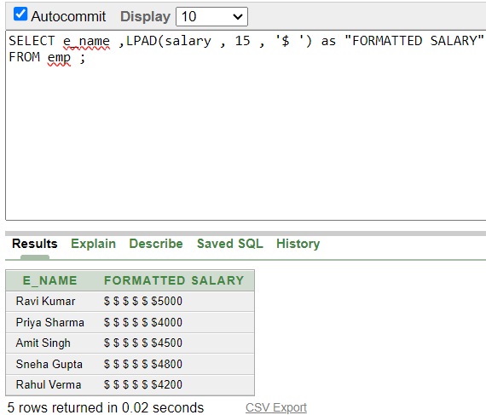

**Q27) Query to display Name with 1st letter capitalized and all other letters lower case & length of the name of all the employees whose names start with ‘ J’ , ‘ A” and ‘M’ .**

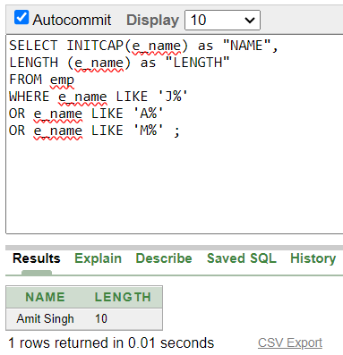

**Q28) Query to display the Employee No , name and salary for all employees who earn more than the average salary .**

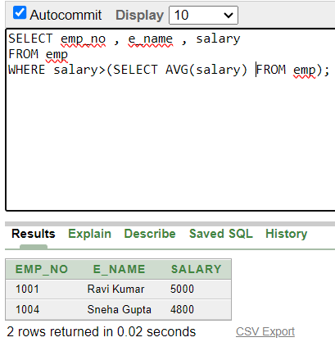

**Q29) Query to display Name and Hiredate for all employees in the same dept as BLAKE .**

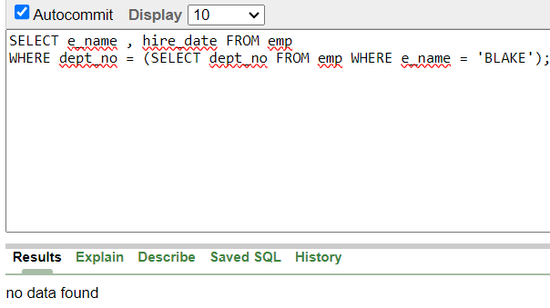

**Q30) Query to display the employee name and salary of all employees who report to king**

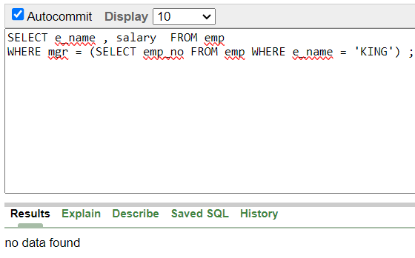

**Q31) Query to display name , hiredate and day of the week on which the employee started .**

