Dodging:
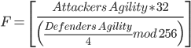
If then the defenders dodges, otherwise if then the defender doges the attack.
Damage:

