

AI-Powered IRTC Rajadhani Express Solution
October 2025

Contents

About Company
AIonOS is a global enterprise AI company established in April 2024 as a joint venture between InterGlobe Enterprises (majority stakeholder) and Assago Group. The company represents a strategic alliance that combines InterGlobe's extensive experience in aviation, hospitality, and travel sectors with Assago Group's technology expertise. Headquartered in Singapore, AIonOS maintains operational centers across Noida, Hyderabad, the United States, the United Kingdom, Paris, Africa, and the Middle East, establishing a truly global presence.
The company is co-founded by Rahul Bhatia, Group Managing Director of InterGlobe, and CP Gurnani, former CEO of Tech Mahindra and current Executive Vice Chairman of AIonOS. This leadership combination brings together decades of industry expertise spanning aviation, hospitality, travel, and technology services. Their shared vision focuses on transforming traditional businesses into AI-native enterprises through innovative solutions that address real-world operational challenges.
AIonOS's fundamental mission centers on empowering businesses with advanced AI solutions that streamline workflows and elevate customer experiences. The company is dedicated to enabling enterprises to accelerate their digital transformation journey by enhancing both human capabilities and system functionalities through AI-powered solutions. The organizational culture emphasizes groundbreaking progress, teamwork, and inclusivity, fostering innovation through collaborative efforts across all business units.
The company's flagship offering, the IntelliMate™ platform, serves as a proprietary agentic AI solution that unifies, orchestrates, and observes AI agents within enterprise environments. This platform integrates AI into every decision-making process, delivering tangible business results through task automation and predictive customer analytics. AIonOS provides comprehensive AI-driven solutions including custom IT implementations, industry-specific AI products, data intelligence services, and customer experience transformation tools.
Initially targeting the Travel, Transportation, Logistics, and Hospitality (TTLH) sectors, AIonOS has strategically expanded its services across multiple industries including banking, retail, telecommunications, healthcare, education, and real estate. The company leverages predictive learning technologies using artificial intelligence and machine learning to deliver customized solutions that integrate operations and provide personalized services to end customers.
With a workforce ranging from 51-200 employees and operating within an estimated addressable market of $150 billion, AIonOS maintains significant market presence. The company has established strategic partnerships and made key investments, including the recent acquisition of Cloud Analogy, a Salesforce Summit Partner, to enhance its AI-powered CRM capabilities and expand its global reach.
AIonOS actively pursues strategic partnerships and collaborations to deliver industry-specific solutions at enterprise scale. The company has successfully secured launch customers across its target verticals and continues expanding its technological capabilities through strategic investments and partnership agreements. This approach positions AIonOS as a leading provider of AI-native enterprise solutions, committed to driving digital transformation across diverse industry sectors.

Problem Statement
Develop an AI-powered solution to enhance the passenger experience and improve operational efficiency of IRTC Rajadhani Express trains.

Key Challenges
- Integrating AI with existing infrastructure
- Ensuring seamless passenger experience
- Addressing data security and privacy concerns

Our Solution Approach

Step 1: AI-Powered Passenger Experience Enhancement
Implement AI-powered chatbots and virtual assistants to provide passengers with real-time information and assistance.

Step 2: Predictive Maintenance and Asset Management
Utilize machine learning algorithms to predict maintenance needs and optimize asset utilization, reducing downtime and improving overall efficiency.

Step 3: Automated Ticketing and Payment Systems
Develop an AI-driven ticketing and payment system to streamline passenger transactions and reduce queues.

Step 4: Real-Time Passenger Feedback and Sentiment Analysis
Implement a system to collect and analyze passenger feedback, enabling IRTC to identify areas for improvement and enhance overall passenger satisfaction.

Step 5: Integration with Existing Infrastructure
Integrate the AI-powered solution with existing infrastructure, including ticketing systems, passenger information systems, and maintenance management systems.

Step 6: Data Security and Privacy Measures
Implement robust data security and privacy measures to protect passenger data and ensure compliance with relevant regulations.

Architecture Diagram
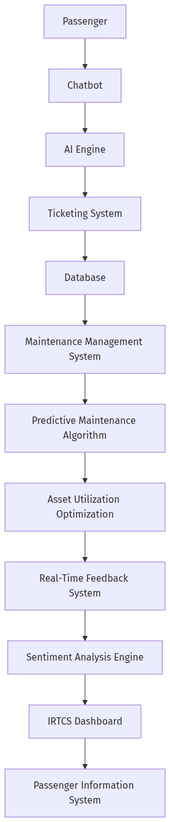

Technology Stack
- Python
- TensorFlow
- Keras
- Docker
- Kubernetes

Key Milestones
Phase | Duration | Description
Phase 1: Requirements Gathering and Solution Design | 4 weeks | Gather requirements from IRTC stakeholders and design the AI-powered solution.
Phase 2: Development and Testing | 12 weeks | Develop and test the AI-powered solution, including chatbots, predictive maintenance, and automated ticketing systems.
Phase 3: Integration with Existing Infrastructure | 6 weeks | Integrate the AI-powered solution with existing infrastructure, including ticketing systems and passenger information systems.
Phase 4: Data Security and Privacy Measures | 4 weeks | Implement robust data security and privacy measures to protect passenger data.
Phase 5: Deployment and Training | 4 weeks | Deploy the AI-powered solution and provide training to IRTC staff on its use and maintenance.
Phase 6: Post-Implementation Review | 2 weeks | Conduct a post-implementation review to evaluate the effectiveness of the AI-powered solution and identify areas for further improvement.

Objectives
- Enhance passenger experience through AI-powered chatbots and virtual assistants
- Improve operational efficiency through predictive maintenance and asset utilization optimization

Acceptance Criteria
- Passenger satisfaction ratings increase by 20%
- Downtime reduction by 30% through predictive maintenance

Resources
Role | Count | Years of Experience | Responsibilities
AI Engineer | 3 | 5 | Design and develop AI-powered chatbots and virtual assistants, predictive maintenance algorithms, and automated ticketing systems.
Data Scientist | 2 | 4 | Develop and train machine learning models for predictive maintenance and asset utilization optimization.
DevOps Engineer | 2 | 3 | Design and implement containerization and orchestration using Docker and Kubernetes.

Cost Analysis
Item | Cost (INR) | Notes
AI Engineer Salaries | ₹1,500,000 | Salaries for 3 AI engineers for 12 months
Data Scientist Salaries | ₹900,000 | Salaries for 2 data scientists for 12 months
Infrastructure Costs | ₹1,200,000 | Costs of servers, storage, and networking infrastructure

Key Performance Indicators
Metric | Target | Measurement Method | Frequency
Passenger Satisfaction Rating | 80% | Surveys and feedback forms | Quarterly
Downtime Reduction | 30% | Maintenance records and downtime reports | Monthly
Predictive Maintenance Accuracy | 90% | Machine learning model performance metrics | Quarterly
Automated Ticketing System Uptime | 99.99% | System logs and uptime reports | Monthly

