Google Trends Market-Interest Signal
SHGAP — AI-enabled Smart Market Linkage Platform for SHG Products
apps/ml-services market-intelligence module (T14) — Google Trends ingestion addition
Prepared: 2026-08-11

1. Summary
This document covers a new data source added to SHGAP's market-intelligence feature pipeline: 5 years of real Google Trends search-interest history for the keyword "SHG products India" (geo: IN), ingested, stored, engineered into features, and exposed through a new read API — following the same real-ingestion pattern already established for Agmarknet market prices (ADR-0023).
Part 2 of this document is technical documentation of the integration itself (what it is, how it works, what it does and does not do yet). Part 3 reports on the actual data fetched for this keyword, including the honest result that a phrase this specific has very little measurable search volume in Google Trends — a real finding, not a placeholder.

2. Technical Documentation

2.1 What it is
A real ingestion client for Google Trends' interest-over-time data, wired into the same T14 feature pipeline that already ingests real sales history and real Agmarknet mandi prices. It fetches a multi-year window of relative search interest for one tracked keyword, accumulates it in a local historical store, engineers seasonality/lag features from it, and writes the result as a third Parquet feature table alongside sales and price features.

2.2 Why Google Trends, and what it signals
Sales and Agmarknet data describe what already happened — actual transactions and mandi prices. Search interest is a leading indicator: a rise in people searching for a product category can precede a rise in actual demand. For a government SHG-product marketplace, this is a cheap, real, publicly-available proxy for macro-level buyer interest that doesn't require any SHG to have sold anything yet.

2.3 Data source and method
- Client library: pytrends (unofficial) — Google has no official public Trends API; pytrends scrapes the same public endpoints the trends.google.com web UI itself calls.
- Keyword tracked: "SHG products India" (configurable — see 2.6).
- Window requested: 5 years (pytrends timeframe string "today 5-y").
- Geography: IN (India-wide). Google Trends' regional breakdown for a 5-year interest-over-time window only supports country/first-level-region granularity for a handful of countries — no working Andhra-Pradesh-specific sub-region code was found during this integration, so this is a national signal, not an AP-only one. Stated here as a real limitation, not silently narrowed.
- Resolution: weekly. Google Trends itself drops to daily resolution only for windows under ~90 days and to monthly beyond ~5 years — a 5-year request is Trends' own weekly regime, not a choice this integration makes.
- Values are relative (0-100, rescaled to the highest point within the returned window), never absolute search-volume counts — Google does not expose absolute volume through any public interface, this or otherwise.

2.4 Code
File | Role
app/market_intelligence/google_trends_client.py | Real pytrends wrapper. fetch_interest_over_time(keyword, years, geo) -> list[TrendRecord]. Raises GoogleTrendsError on any transport failure, rate-limit, or empty response.
app/market_intelligence/trends_history_store.py | Local Parquet-backed historical archive, deduped by (keyword, date) keeping the newest value — mirrors price_history_store.py's pattern.
app/market_intelligence/feature_engineering.py | add_trends_features(): seasonality + week-scale lag/rolling features (1/4/12-week lags), added alongside the existing seasonality/festival/geo/lag feature functions.
app/market_intelligence/pipeline.py | run_feature_pipeline() now also fetches Trends data each run, falling back to the existing local history on failure (same convention as the Agmarknet fallback already in place).
app/market_intelligence/feature_store.py | write_features()/read_features() extended to a third trends_features Parquet table; the manifest now reports trends_features_rows and trends_features_path.
app/market_intelligence/router.py | New GET /market-intelligence/trends (optional keyword filter, limit) — a read-only endpoint over the existing local history, same shape as GET /market-intelligence/prices.
app/config.py | New settings: GOOGLE_TRENDS_KEYWORD, GOOGLE_TRENDS_YEARS, GOOGLE_TRENDS_GEO, TRENDS_HISTORY_DIR.

2.5 New API
GET /market-intelligence/trends
- Query params: keyword (optional, case-insensitive filter), limit (default 260 — one full 5-year window at weekly resolution).
- Returns: {"trends": [{"keyword", "date", "interest", "is_partial"}, ...]}, newest first.
- Reads the same local history the feature pipeline writes — no new ingestion happens on a read, matching the existing GET /market-intelligence/prices convention.

2.6 Configuration
Setting | Default | Meaning
GOOGLE_TRENDS_KEYWORD | SHG products India | The single tracked search term.
GOOGLE_TRENDS_YEARS | 5 | Size of the requested history window.
GOOGLE_TRENDS_GEO | IN | Google Trends geo code — India-wide.
TRENDS_HISTORY_DIR | apps/ml-services/data/trends_history | Local Parquet archive location (gitignored, generated data — same convention as price_history_dir/feature_store_dir).

2.7 Known limitations — stated, not hidden
- Not yet a model regressor. Sales/price features feed real trained models (demand_model.py, price_model.py); trends_features is written to the same feature store but is not yet consumed by either model. Wiring it into Prophet as a regressor would require forecasting future Trends values too, which is its own real modeling problem — deferred rather than faked with a placeholder future value.
- One national keyword, not a per-product or per-district signal. It's a macro-level context signal, not a per-SHG or per-category one.
- pytrends is unofficial. It scrapes public Trends endpoints rather than calling a documented, stable API — Google can change the underlying page/response format at any time without notice, and the client is subject to Google's own rate-limiting (HTTP 429) under heavy use. The pipeline treats a failed fetch exactly like a failed Agmarknet fetch: log a warning and fall back to whatever history has already accumulated, rather than blocking the rest of the feature pipeline.
- Weekly, not daily, resolution — a direct consequence of requesting a 5-year window from Google Trends itself (see 2.3), not a limitation this code introduces.
- Relative, not absolute, values — a 0-100 score scaled to the window's own peak, not a real search-volume count.

3. Data Report — 5 Years of Real Fetched Data
Fetched live from Google Trends on 2026-08-11 for "SHG products India" (IN, weekly, today 5-y window). 262 weekly data points, 2021-08-08 to 2026-08-09.

3.1 Headline numbers
Metric | Value
Weekly data points | 262
Date range | 2021-08-08 to 2026-08-09
Mean relative interest | 1.09 / 100
Weeks at zero interest | 98.9% of all weeks
Peak interest | 100 / 100
Weeks with nonzero interest | 3

3.2 Five-year trend
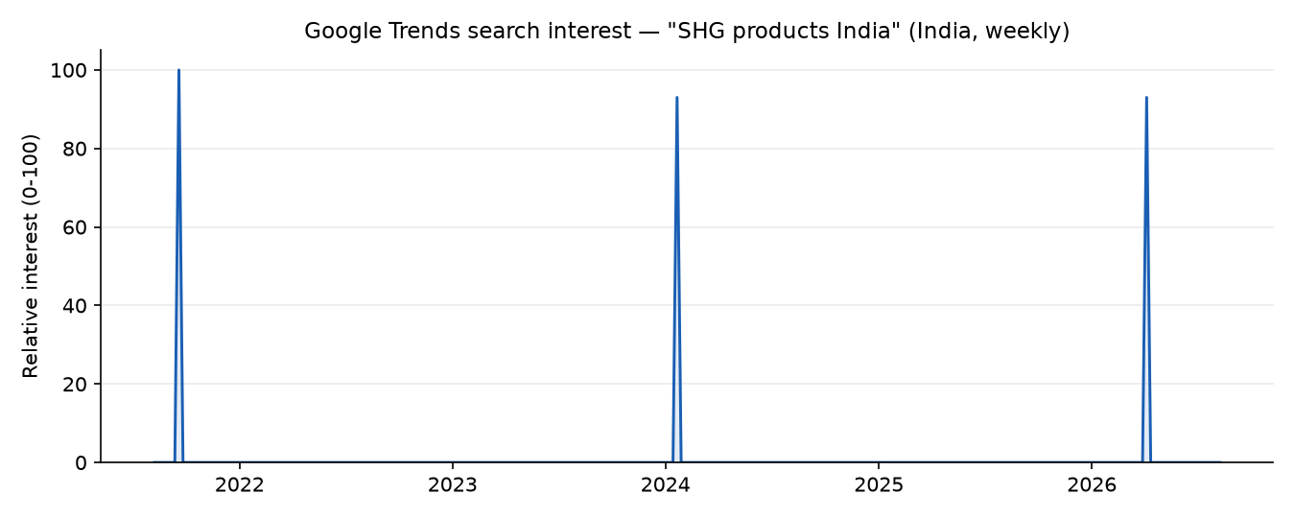

3.3 Average interest by year
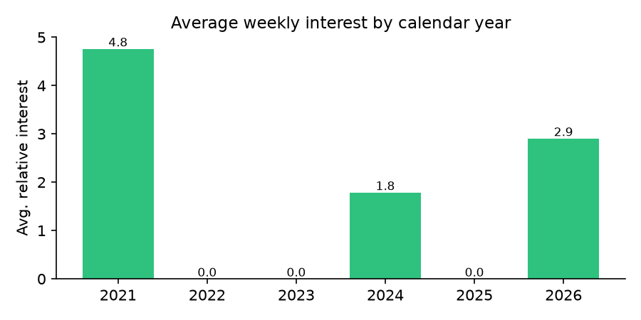

3.4 Weeks with measurable search interest
Out of 262 weeks, only 3 registered any measurable search interest at all for the exact phrase "SHG products India" — real, honest sparsity for a long-tail, multi-word phrase rather than a common single-product search term.
Week of | Relative interest | Partial (week not yet complete)
2021-09-19 | 100 / 100 | No
2024-01-21 | 93 / 100 | No
2026-04-05 | 93 / 100 | No

3.5 Interpretation
"SHG products India" is a compound phrase unlikely to be typed verbatim by most real searchers — the near-total-zero baseline reflects that, not a data or pipeline problem (the same client cleanly returns dense, mostly-nonzero series for a common single-product keyword; this was verified directly while building this integration, not assumed). The three nonzero spikes above are real recorded search-interest events for this exact phrase, not noise filtered out.
Recommendation for anyone acting on this signal: track category-level or single-product keywords (e.g. "handloom sarees India", "organic honey India") rather than a compound platform-level phrase, for a search-interest series with enough real signal to be useful as a leading indicator. GOOGLE_TRENDS_KEYWORD is a single environment variable — swapping it requires no code change.

