**External Calls**

**Avoid external calls when possible**

Calls to untrusted contracts can present a few sudden dangers or mistakes. Outside calls may execute noxious code in that contract or whatever another contract that it relies on. Thusly, every outer call ought to be dealt with as a potential security risk.

**Use send(), avoid call.value()**

When sending Ether, use someAddress.send() and avoid someAddress.call.value()().

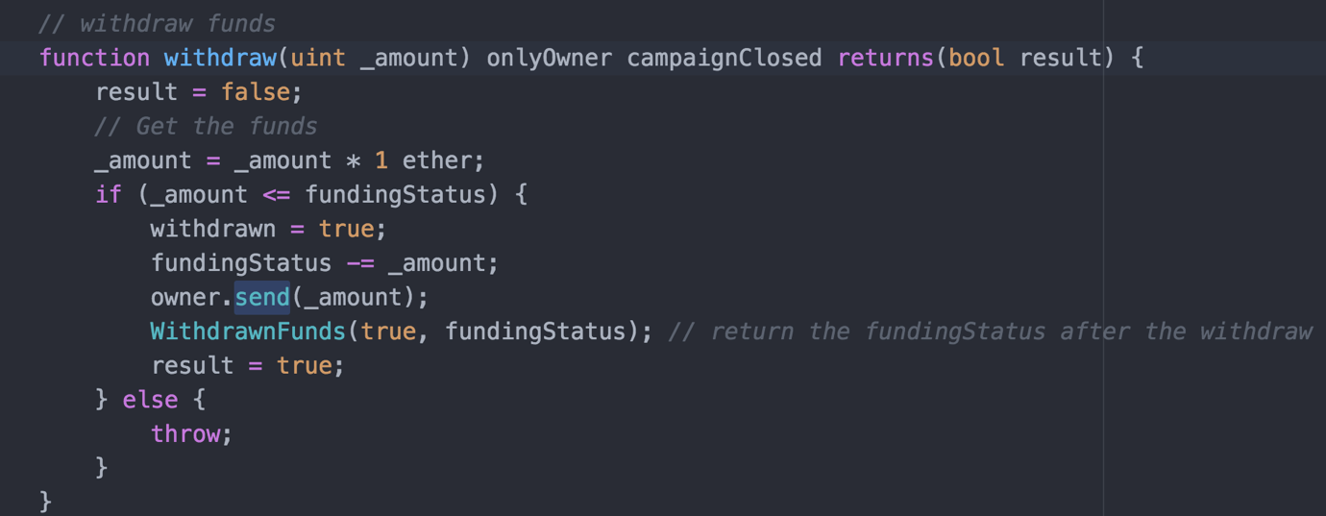

#### Reentrancy

The main form of this bug to be seen included methods that could be called over and again, before the first calling of the method was done. This may make diverse summons of the function cooperate in dangerous ways.

**Assert Guards**

An assert guard triggers when an assertion fails

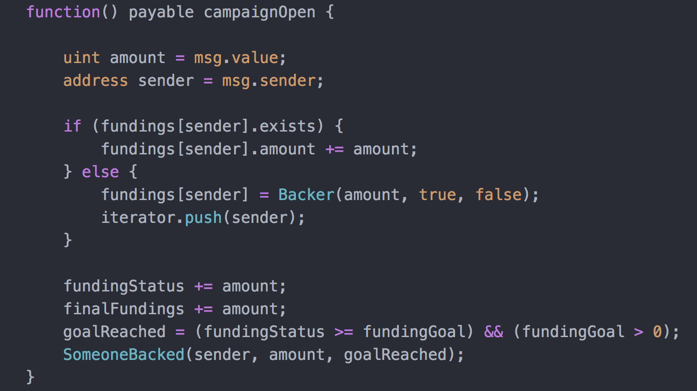

**Cross-function Race Conditions**

An attacker may likewise have the capability to complete a comparable assault utilizing two distinct methods that offer a similar state.

