**Circuit Breakers (Pause contract functionality)**

Circuit breakers stop execution if certain conditions are met and can be valuable when new bugs are found. For instance, most activities might be suspended in a contract if a bug is found, and the main activity that is active now is a withdrawal.

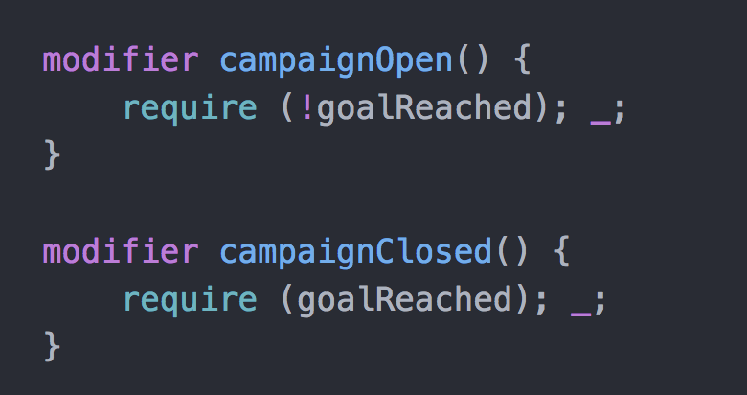

**Event-driven architecture** (**EDA**):

EDA is a software architecture pattern promoting the production, detection, consumption of, and reaction to events.

I used event-based approach over array structure with promise.

Waiting for the event completion ensure the success of the funding.