**Spring 2024: CS5720 Neural Networks & Deep Learning - ICP-5**

**Eekshitha Gujjala (700741491)**

GitHub Link: <https://github.com/Eekshi2001/ICP5.git>

**1. Implement Naïve Bayes method using scikit-learn library Use dataset available with name glass  
 Use train_test_split to create training and testing part Evaluate the model on test part using score and**

**classification_report(y_true, y_pred)**

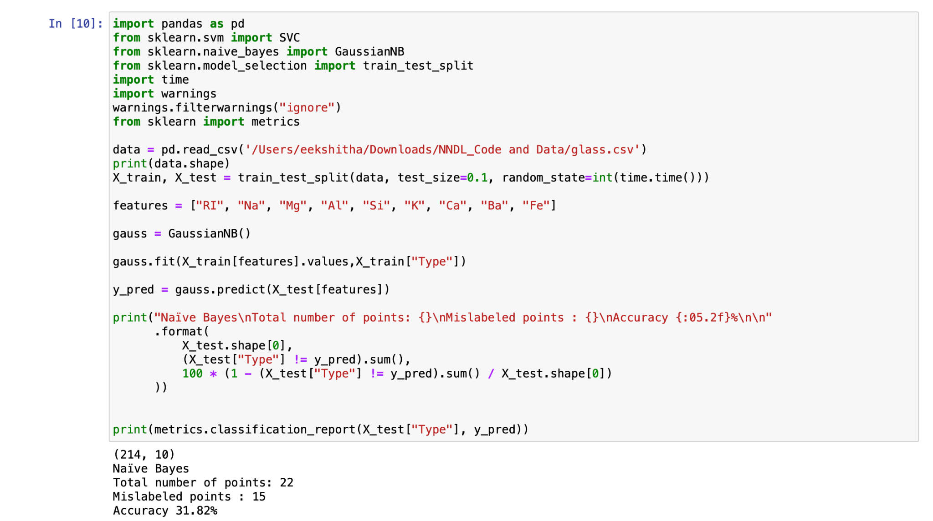

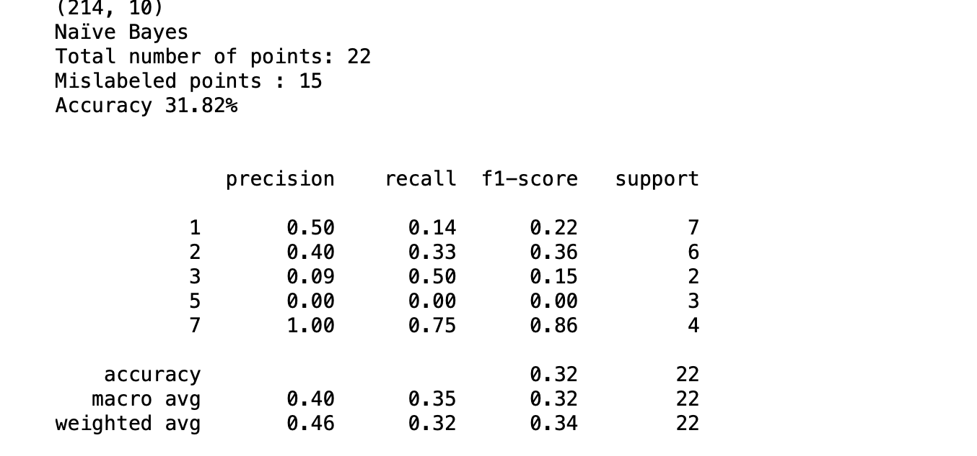

**2. Implement linear SVM method using scikit library Use the same dataset above  
 Use train_test_split to create training and testing part Evaluate the model on test part using score and**

**classification_report(y_true, y_pred)**

**Which algorithm you got better accuracy? Can you justify why?**

