Neural Networks & Deep Learning - ICP-9
Eekshitha Gujjala - 700741491
Git Hub Url:
https://github.com/Eekshi2001/ICP9.git

Program 9:
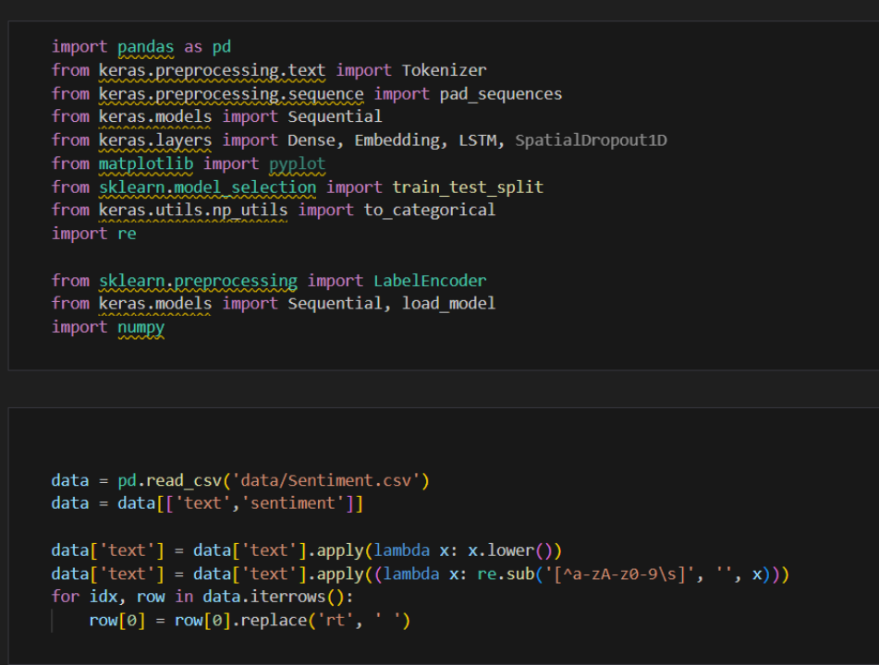

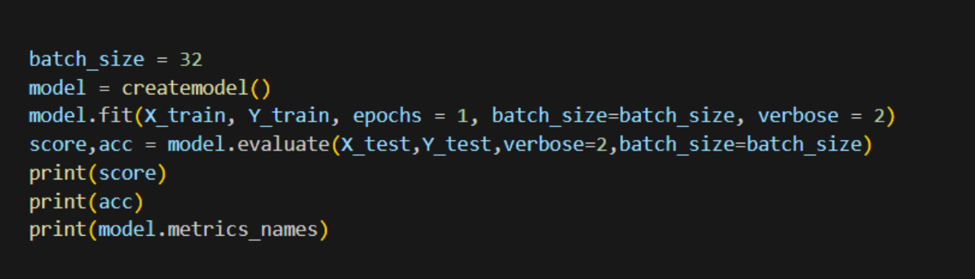

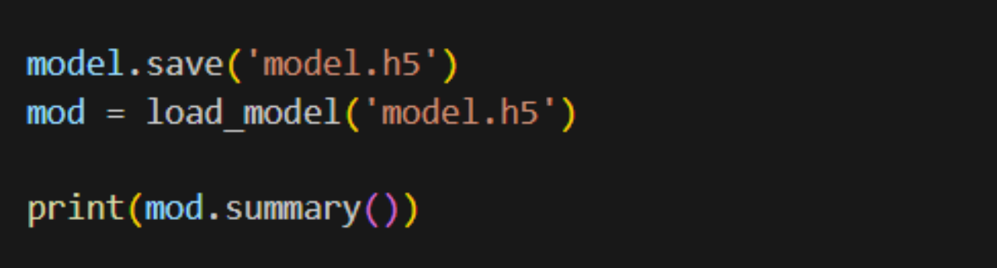
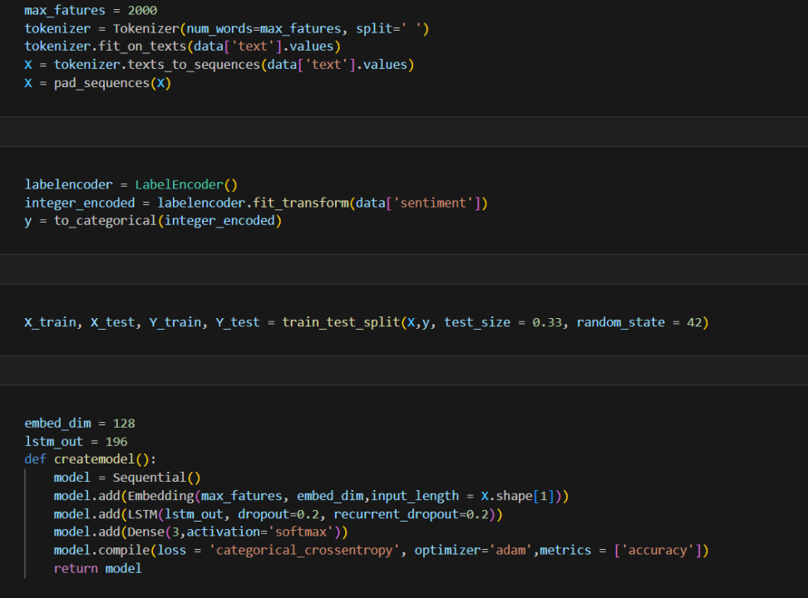

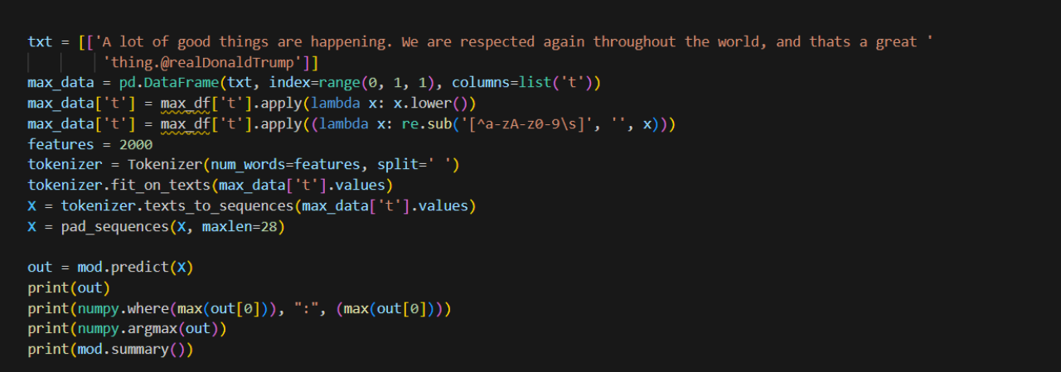

Output:
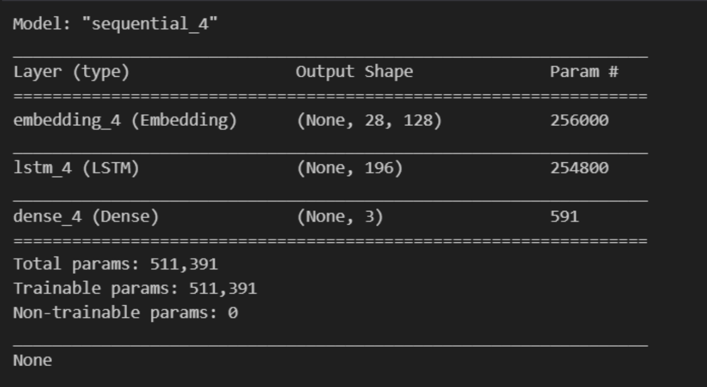
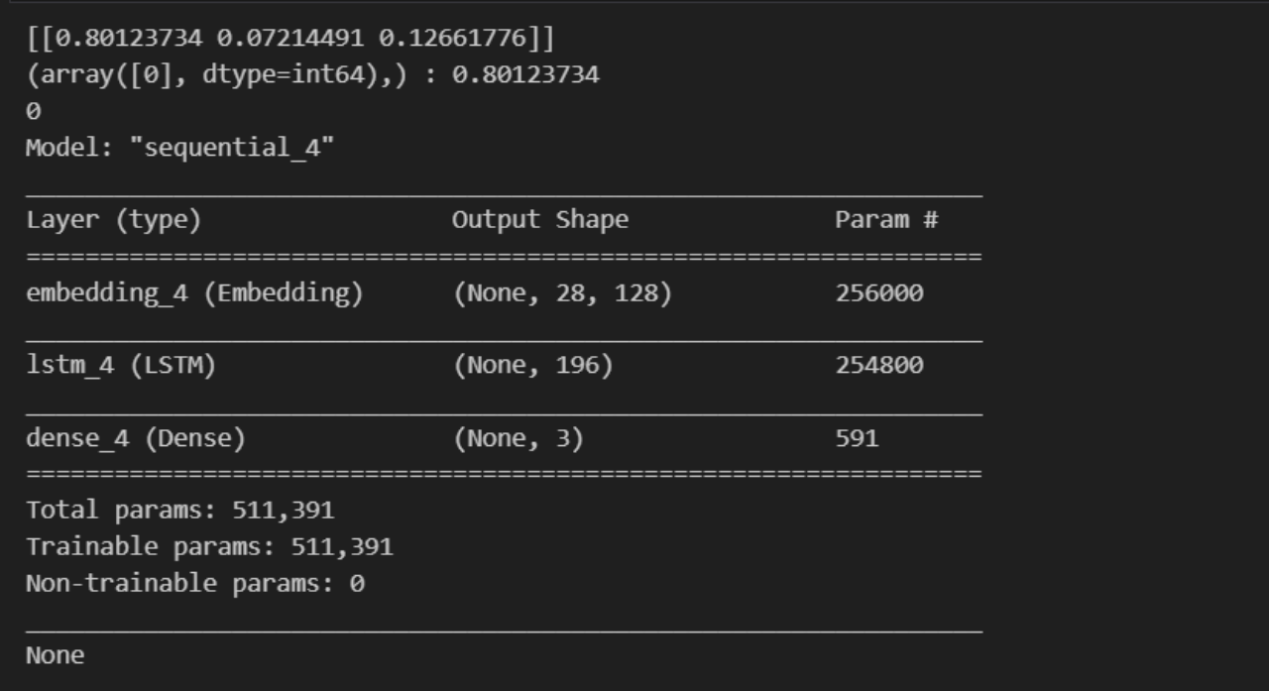

Program 9.2:

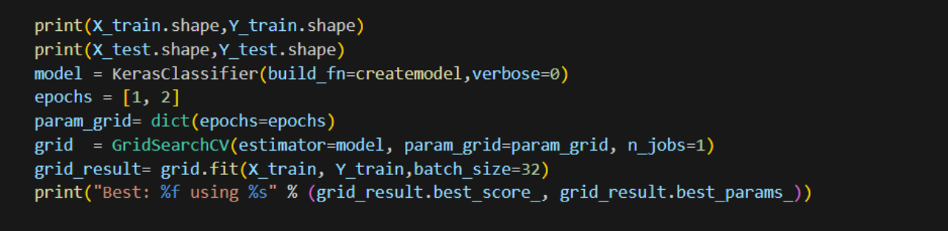

Output:

