PROGRAMMING QUIZ - WEEK 11

EEKSHITHA GUJJALA

700741491

GITHUB LINK: <https://github.com/Eekshi2001/PROGRAMMING-QUIZ.git>

VIDEO LINKS: <https://drive.google.com/file/d/1n8oz3ZiSCTxv39r144QZviBQcX0OxMvl/view?usp=share_link>

<https://drive.google.com/file/d/1TC7lZfDho7oNUbkD4ARfxIAH-Hxg55DY/view?usp=share_link>

**Programming task**

**Time Series Forecasting Task**:

Load a time series dataset (e.g., stock prices, weather data).

* Build a recurrent neural network (RNN) or LSTM model using Keras.
* Train the model to forecast future values based on historical data.
* Evaluate the model's performance using appropriate metrics (e.g., MAE, RMSE).

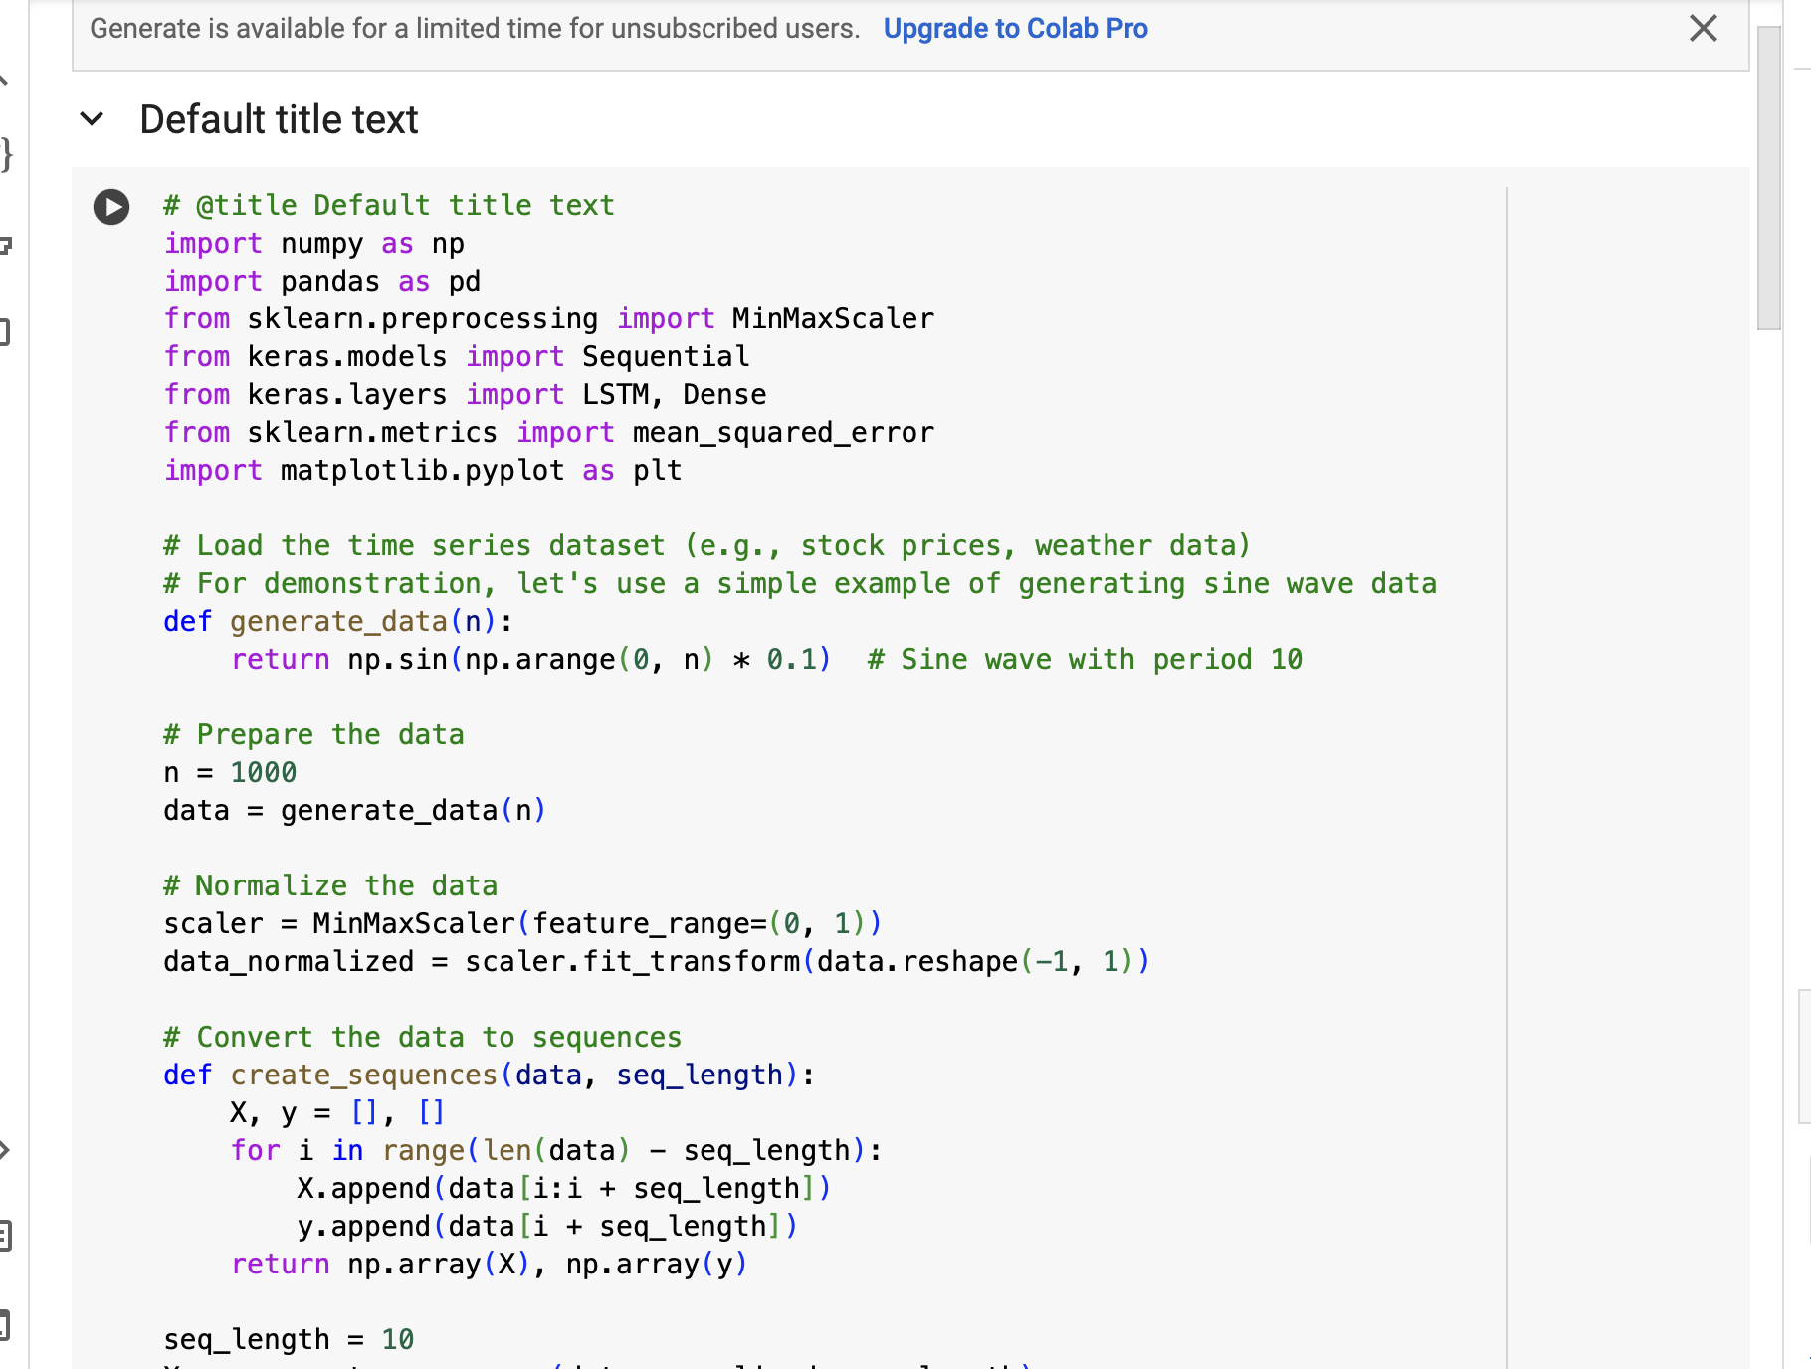

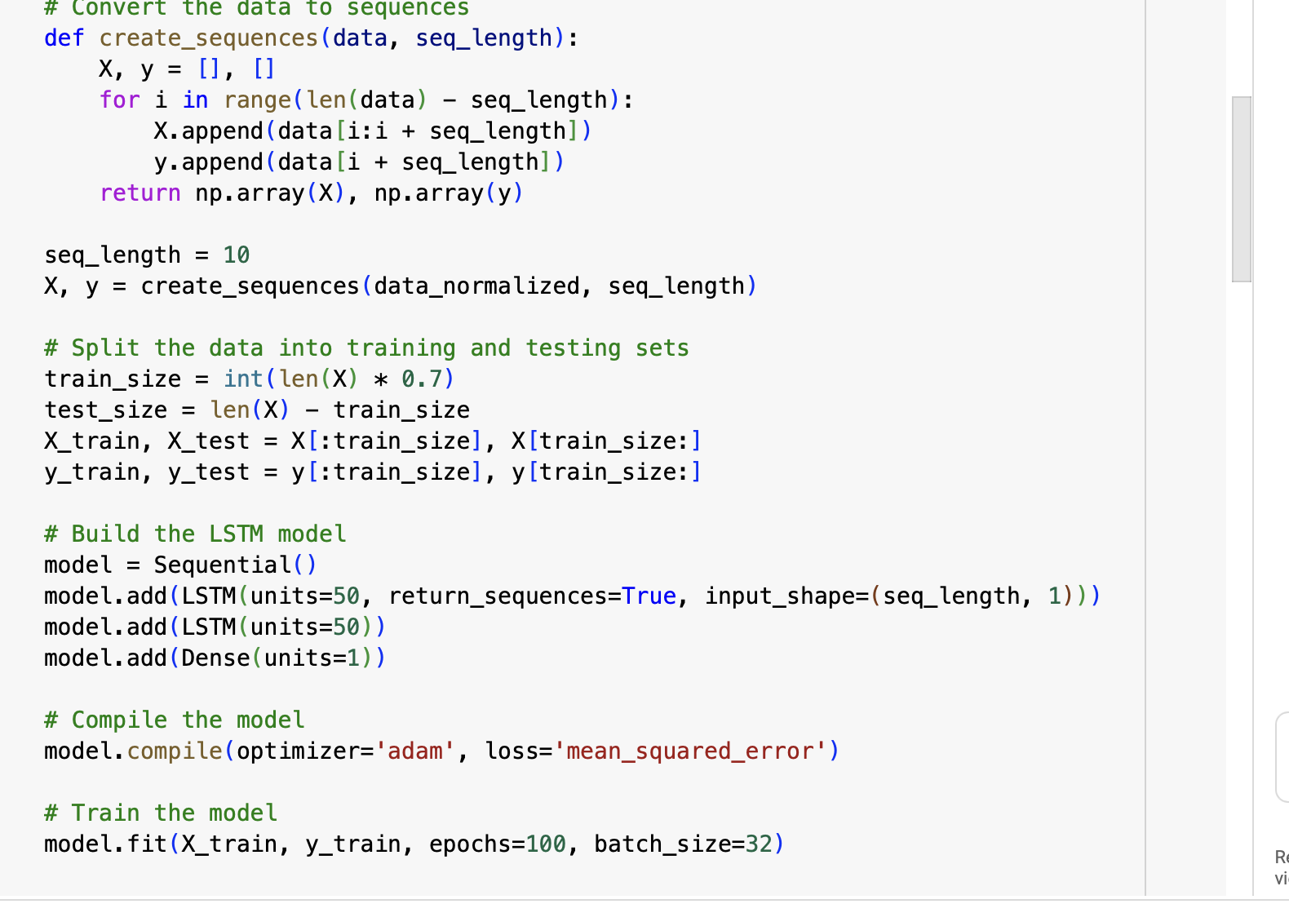

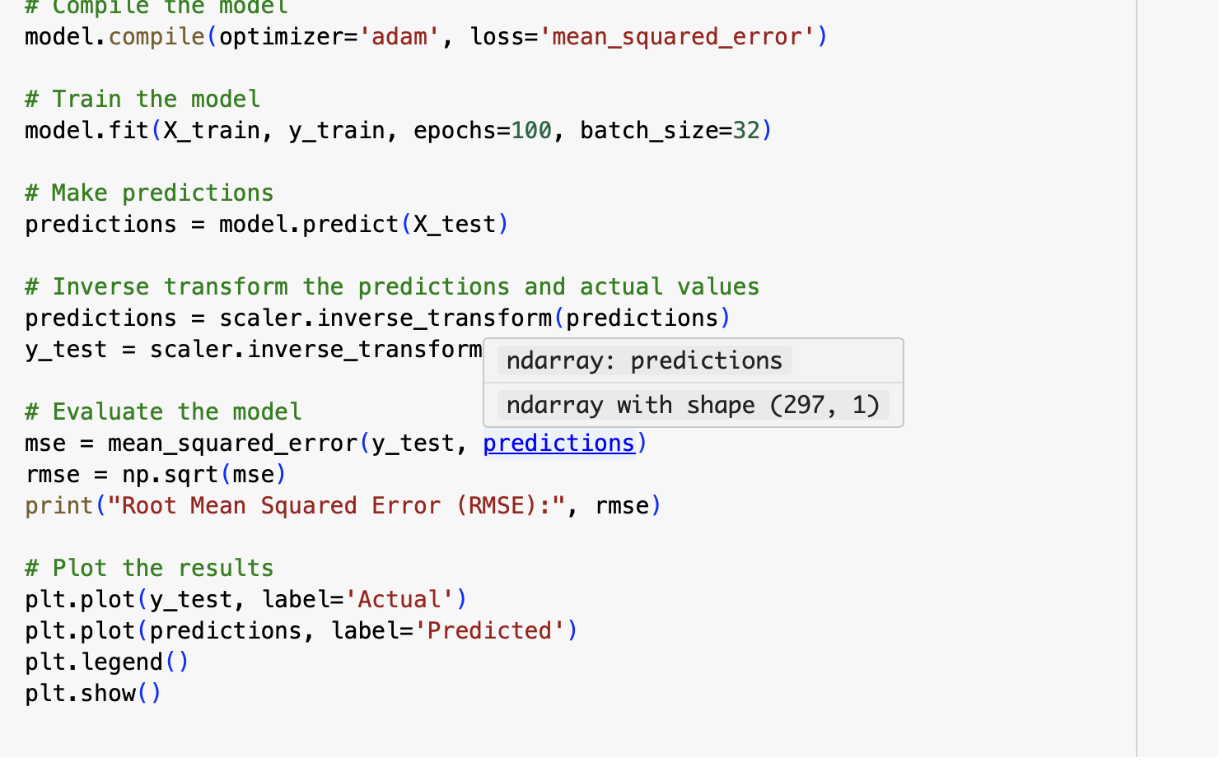

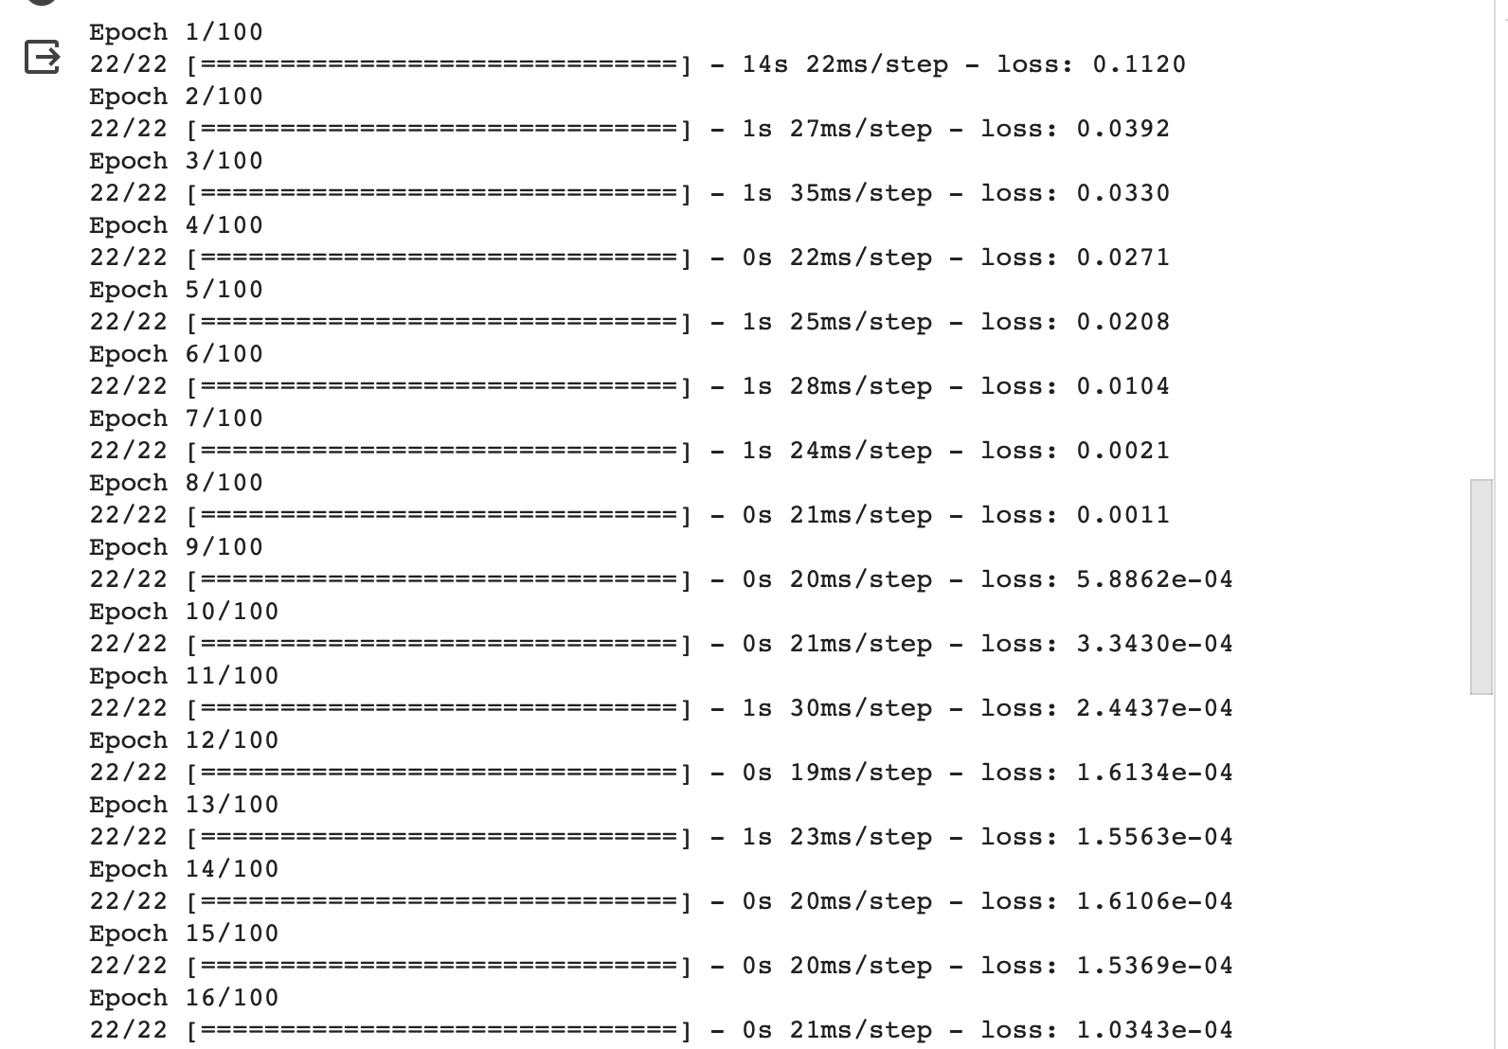

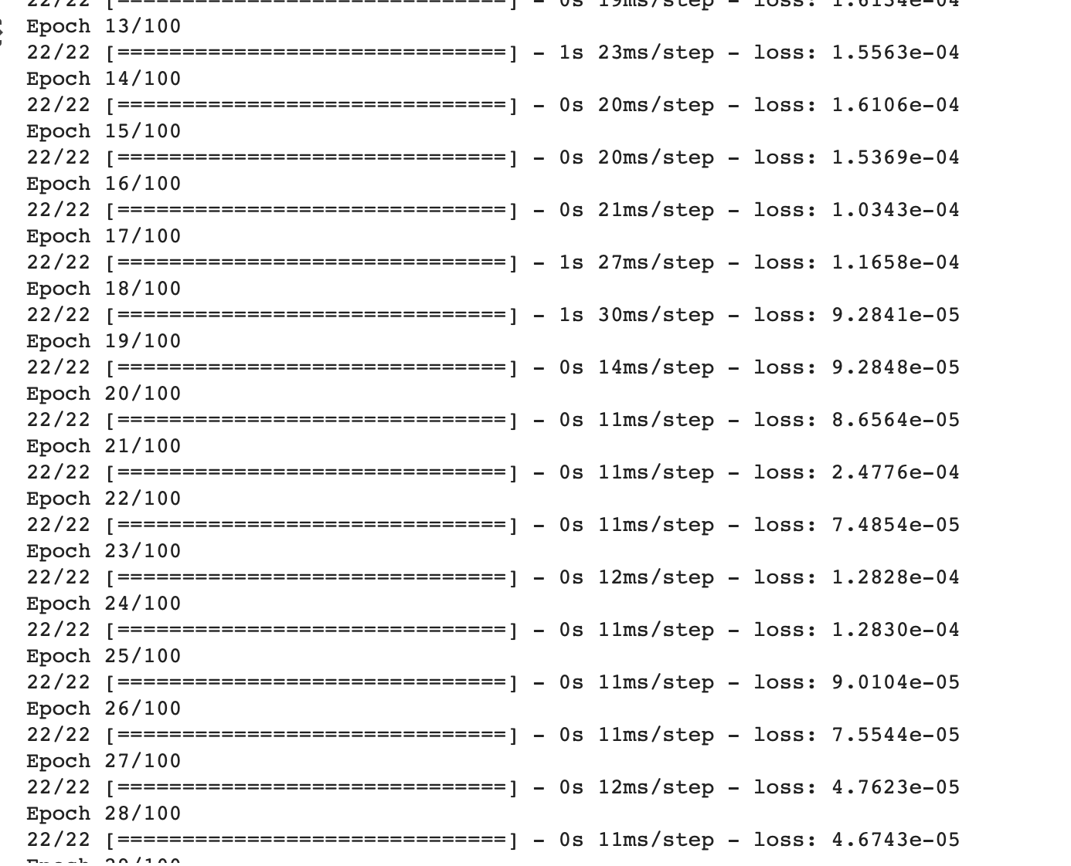

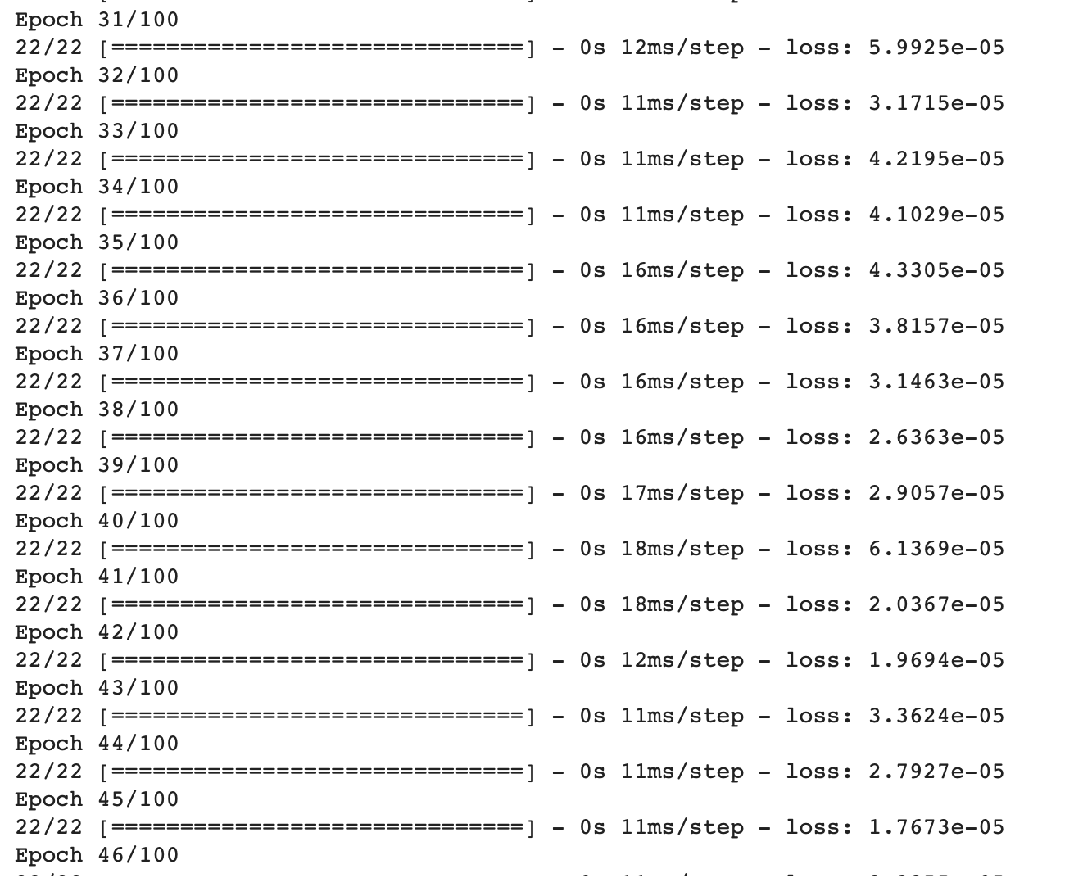

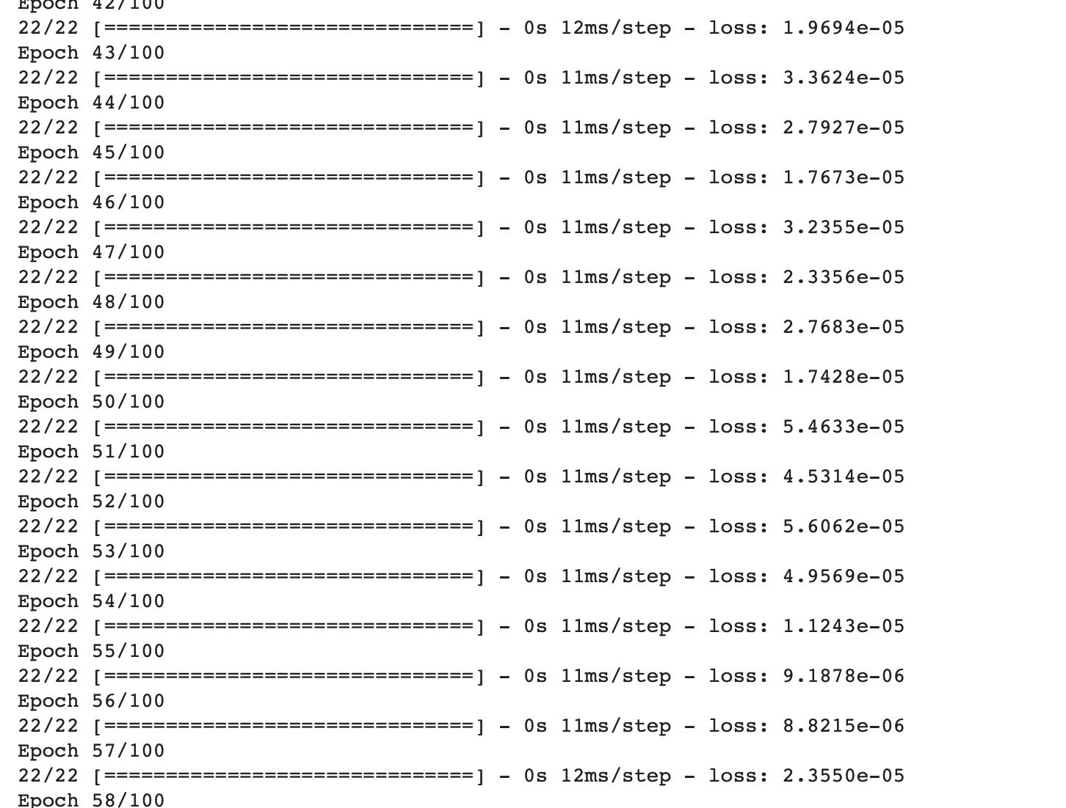

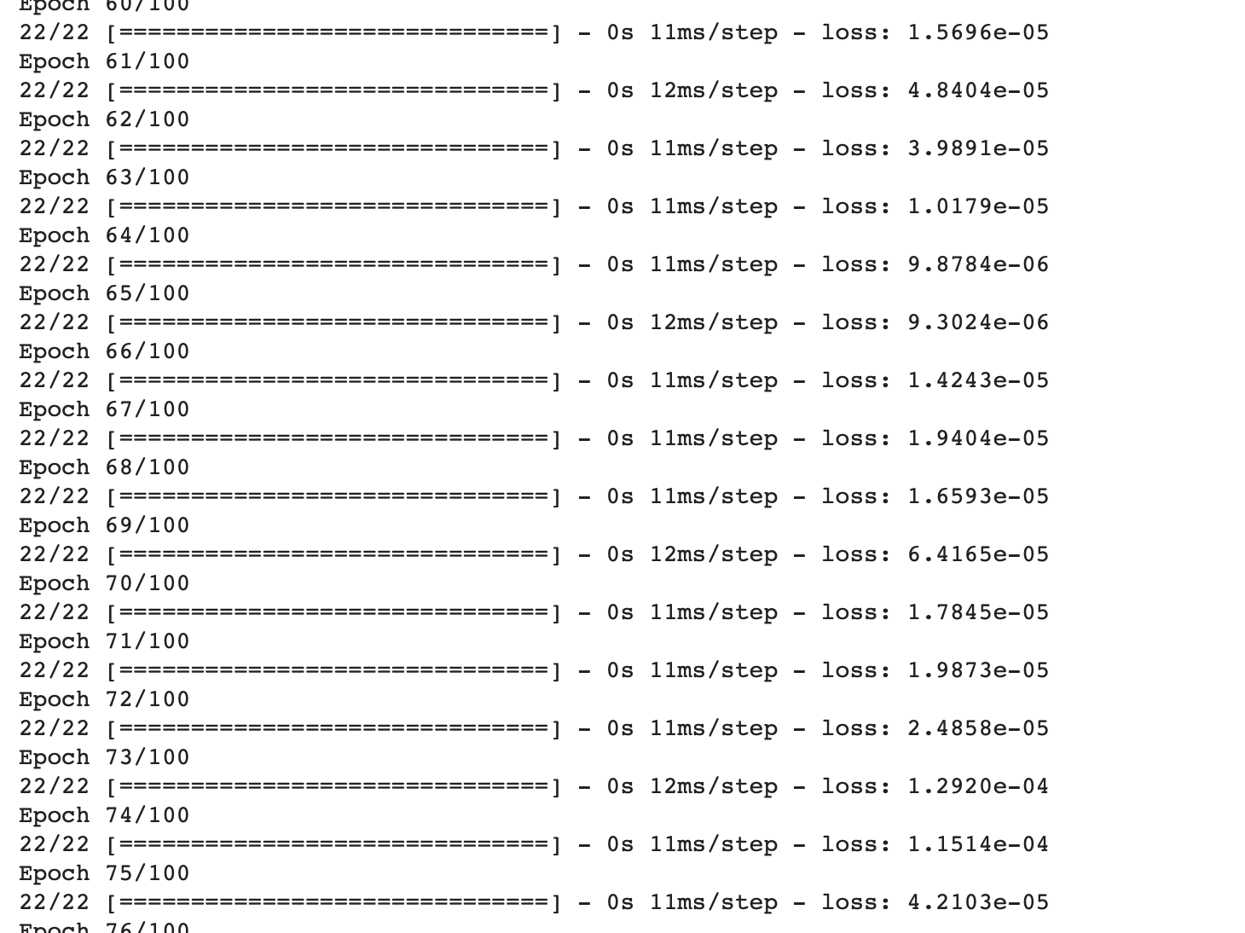

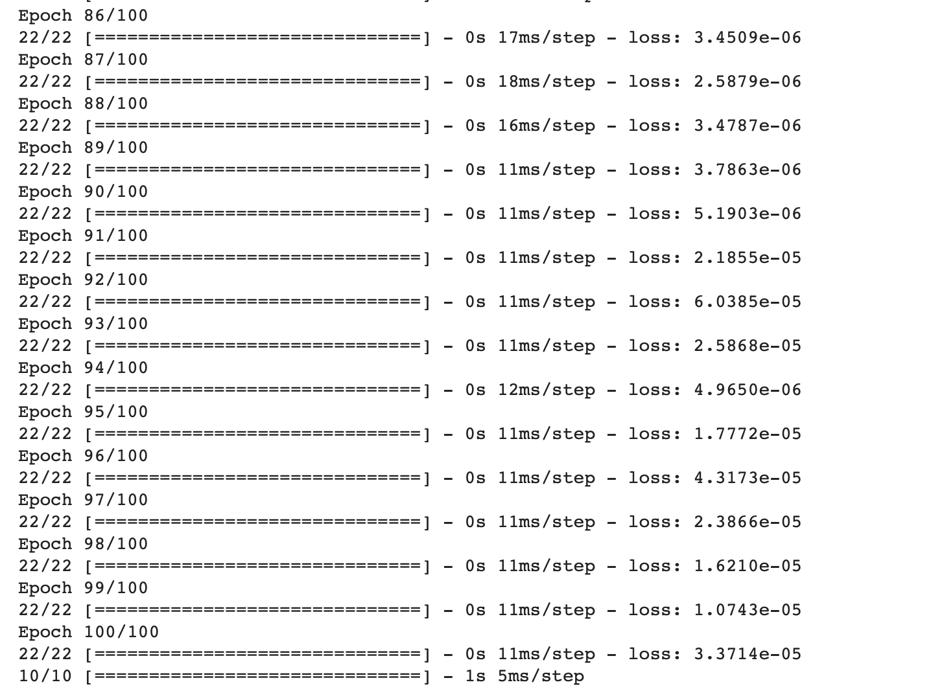

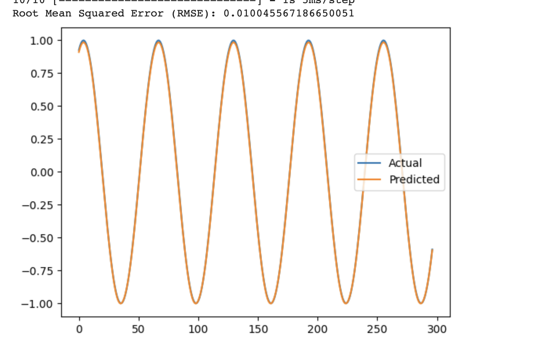

* **Image Classification Task**:
* + Load the MNIST dataset.
  + Build a simple convolutional neural network (CNN) using Keras Sequential model.
  + Train the CNN model on the MNIST dataset.
  + Evaluate the model's performance on a test set and report accuracy.
  + Use grid search to optimize hyperparameters such as learning rate, batch size, and optimizer choice.
  + Use Callback functions to automate training process like “ReduceLROnPlateau” and keep check on validation loss. Also use history object for result visualization.

