# Social media powerpoint presentation

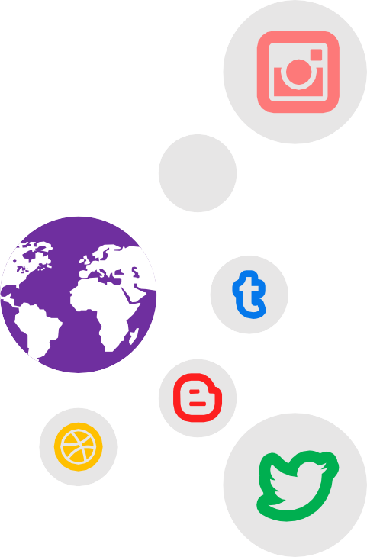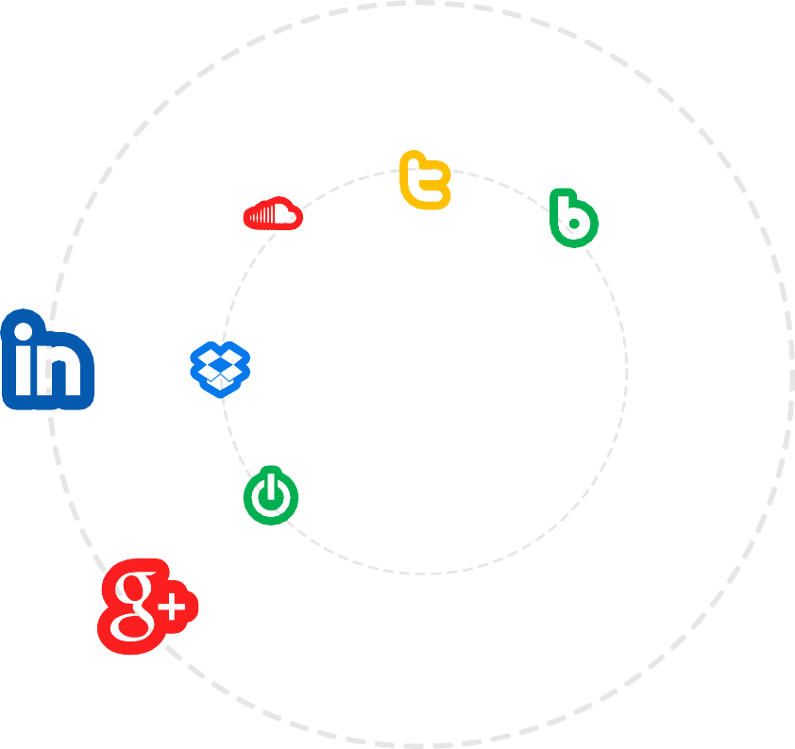

### Agenda

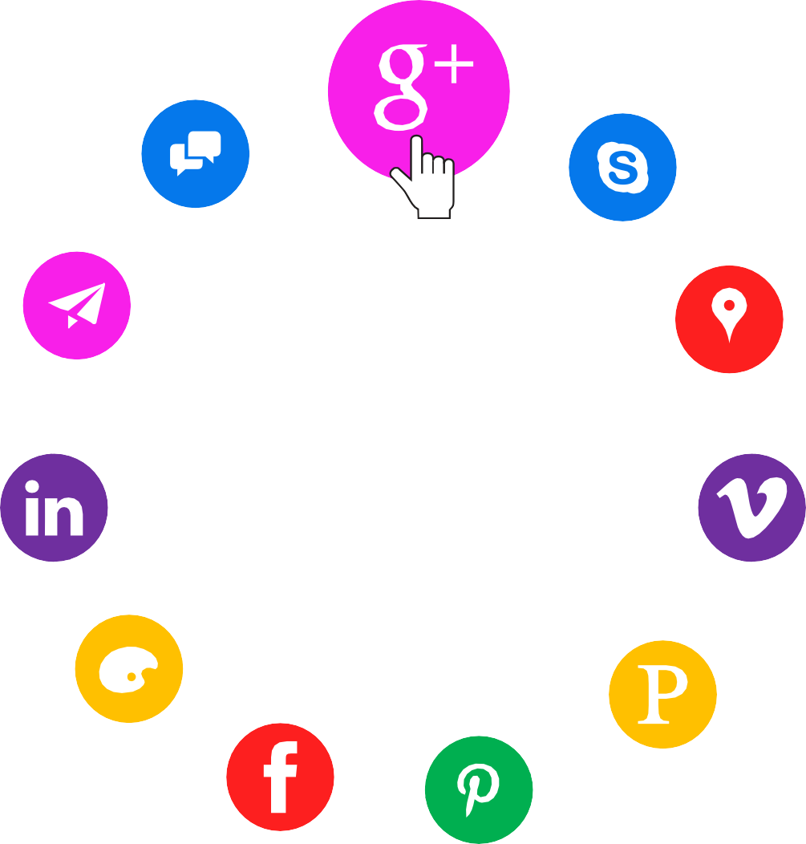

1. **What is social media?**
2. **Why social media is important**
3. **Different types of social media**
4. **Break**
5. **Advantages and disadvantages**
6. **How to use social media safely**
7. **Thank you**

## What is social media?

##### Social media

**50K**

Social media are interactive computer-mediated technologies that facilitate the creation and sharing of information, ideas, career interests and other forms of expression via virtual communities and networks



Users usually access social media services via web-

based technologies on desktops and laptops, or download services that offer social media functionality to their mobile devices

(e.g., smartphones and tablets). As users engage with

these electronic services, they create highly interactive platforms through which individuals, communities, and organizations can share, co-create, discuss, participate and modify user-generated content or self-curated content posted online.

### Why social media is important



##### Social media

Social media is an essential piece of your business marketing strategy. Social platforms help you connect with your customers, increase awareness about your brand, and boost your leads and sales. With more than three billion people around the world using social media every month

### Different types of social media



**Twitter**

**Facebook**

**You tube**

**Pinterest**

**Google**

## The coffee break presentation mystery

It’s Time For A

**Coffee Break**

### Twitter Social Media Presentation Template

Logo

Twitter has become internationally identifiable by its signature bird logo, or the Twitter Bird. The original logo, which was simply the word "Twitter", was in use from its launch in March 2006..

Privacy

Information about who has chosen to follow an account and who a user has chosen to follow is also public, though accounts can be changed to "protected" which limits this information (and all tweets) to approved followers.

Using SMS

users can communicate with Twitter through five gateway numbers: short codes for the United States, Canada, India, New Zealand, and an Isle of Man-based number for international use.



Media character limits

Twitter announced that media such as photos, videos, and the person's handle, would not count against the already constrictive 140 character limit.

# Facebook

Facebook is a social networking website where users can post comments, share photographs and post links to news or other interesting content on the web, chat live, and watch short-form video

Photos and videos



7.8%

Numbers of share



2.5%

Numbers of followers



6.7%

**You Tube**

YouTube is a social media platform. Its core functionality beyond presenting videos to watch is to allow

for social interactions. It's the quintessential social video platform because it reaches so many people



60%



45%



70%



70%

Photos and videos

Numbers of share

Updated News Numbers of followers

##### Instagram

Instagram is a free, online photo-sharing application and social

network platform that was acquired by Facebook in 2012. Instagram allows users to edit and upload photos and short videos through a mobile app.

|  |  |  |  |  |
| --- | --- | --- | --- | --- |
| Photos and videos |  |  | 50 |  |
|  |  |  |  |
| Number of share |  |  |  | 70 |
|  |  |  |  |  |
| Number of follwers |  |  |  | 80 |
|  |  |  |  |  |
| Updated News |  | 35 |  |  |

Users can connect their Instagram account to other social networking sites, enabling them to share uploaded photos to those sites.

LinkedIn

**About LinkedIn Posts**

LinkedIn is a social networking site designed specifically for the business community. The goal of the site is to allow registered members to establish and document networks of people they know and trust professionally.

in

Like

22K

###### Comment



1,506



Pros And Cons Of PowerPoint

#### Pros

* Connectivity
* Education



* Information and Updates
* Promotion
* Noble Cause
* Improves Business Reputation
* Helps in Building Communities
* Awareness

#### Cons

#### Pros Cons

* Cyberbullying
* Hacking
* Addiction
* Fraud and Scams
* Security Issues
* Cheating and Relationship Issues
* Health Issues

### How to use social media safely

* + Use a strong password. The longer it is, the more secure it will be.



* + Use a different password for each of your social media accounts.
  + Set up your security answers. This option is available for most social media sites.
  + If you have social media apps on your phone, be sure to password protect your device.
  + Be selective with friend requests. If you don’t know the person, don’t accept their request. It could be a fake account.
  + Click links with caution. Social media accounts are regularly hacked. Look out for language or content that does not sound like something your friend would post.
  + Be careful about what you share. Don’t reveal sensitive personal information i.e.: home address, financial information, phone number. The more you post the easier it is to have your identity stolen.
  + Become familiar with the privacy policies of the social media channels you use and customize your privacy settings to control who sees what.
  + Protect your computer by installing antivirus software to safeguard. Also ensure that your browser, operating system, and software are kept up to date.
  + Remember to log off when you’re done.

