**LAB 3**

**Assumption:**

A middle aged man has a good job and needs a reasonable and affordable car for his daily practical use. According to his demands, a car should have a good speed and mileage covering specifications. The price of car should also be within a certain range that can easily be purchased and maintained by a financially normally stable person.

**Graphs :**

GRAPH # 1 :

CODE:



OUTPUT:

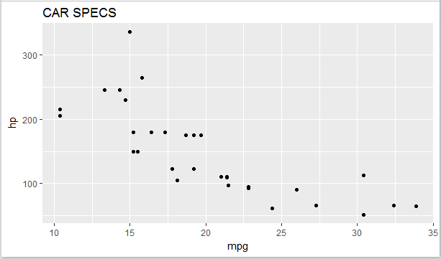

GRAPH # 2:

CODE:



OUTPUT:

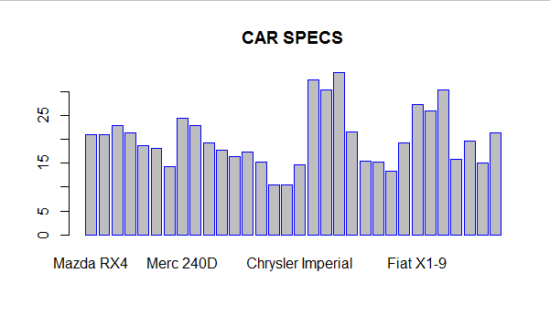

GRAPH # 3:

CODE:

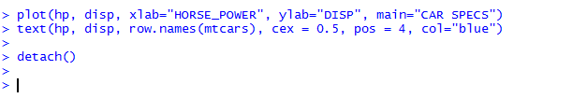

OUTPUT:

