Router Command

B1- R1

Router > enable
Router#config terminal
Router(config)#hostname B1-R1

B1-R1(config)#interface fastEthernet 0/0
B1-R1(config-if)#ip address 10.1.0.1 255.255.252.0
B1-R1(config-if)#no shutdown
B1-R1(config-if)#exit

B1-R1(config)#interface f0/1
B1-R1(config-if)#ip address 10.1.4.1 255.255.252.0
B1-R1(config-if)#no shutdown
B1-R1(config-if)#exit

B1-R1(config)#interface f1/0
B1-R1(config-if)#ip address 10.1.8.1 255.255.252.0
B1-R1(config-if)#no shutdown
B1-R1(config-if)#exit

B1-R1(config)#interface f1/1
B1-R1(config-if)#ip address 10.1.12.1 255.255.252.0
B1-R1(config-if)#no shutdown
B1-R1(config-if)#exit

B1-R1(config)#interface serial0/0/0
B1-R1(config-if)#ip address 10.1.244.2 255.255.252.0
B1-R1(config-if)#no shutdown
B1-R1(config-if)#exit

B1-R1(config)# router rip
B1-R1(config-router)#network 10.1.0.0
B1-R1(config-router)#network 10.1.4.0
B1-R1(config-router)#network 10.1.8.0
B1-R1(config-router)#network 10.1.12.0
B1-R1(config-router)#network 10.1.244.0
B1-R1(config-router)#no auto-summary
B1-R1(config-router)#exit

B1-R1(config)#router rip
B1-R1(config-router)#passive-interface f0/0
B1-R1(config-router)#passive-interface f0/1
B1-R1(config-router)#passive-interface f1/0
B1-R1(config-router)#passive-interface f1/1
B1-R1(config-router)#no auto-summary
B1-R1(config-router)#exit

B3-R1(config)#interface serial0/0/0
B3-R1(config-if)#ip address 10.1.252.2 255.255.255.0
B3-R1(config-if)#no shutdown

B1-R2
Router>enable
Router#conf t
Router(config)#hostname B1-R2

B1-R2(config)#interface f0/0
B1-R2(config-if)#ip address 172.20.0.1 255.255.254.0
B1-R2(config-if)#no shutdown
B1-R2(config-if)#exit

B1-R2(config)#interface f0/1
B1-R2(config-if)#ip address 172.20.2.1 255.255.254.0
B1-R2(config-if)#no shutdown
B1-R2(config-if)#exit

B1-R2(config)#interface f1/0
B1-R2(config-if)#ip address 172.20.4.1 255.255.254.0
B1-R2(config-if)#no shutdown
B1-R2(config-if)#exit

B1-R2(config)#interface f1/1
B1-R2(config-if)#ip address 172.20.6.1 255.255.254.0
B1-R2(config-if)#no shutdown
B1-R2(config-if)#exit

B1-R2(config)#interface serial 0/0/0
B1-R2(config-if)#ip address 172.20.250.2 255.255.254.0
B1-R2(config-if)#no shutdown
B1-R2(config-if)#exit

B1-R2(config)#router rip
B1-R2(config-router)#network 172.20.0.0
B1-R2(config-router)#network 172.20.2.0
B1-R2(config-router)#network 172.20.4.0
B1-R2(config-router)#network 172.20.6.0
B1-R2(config-router)#network 172.20.250.0
B1-R2(config-router)#no auto-summary
B1-R2(config-router)#exit

B1-R2(config)#router rip
B1-R2(config-router)#passive-interface f0/0
B1-R2(config-router)#passive-interface f0/1
B1-R2(config-router)#passive-interface f1/0
B1-R2(config-router)#passive-interface f1/1
B1-R2(config-router)#no auto-summary
B1-R2(config-router)#exit

B2-R1

Router>enable
Router#conf t
Router(config)#hostname B2-R1

B2-R1(config)#interface f0/0
B2-R1(config-if)#ip address 10.1.16.1 255.255.252.0
B2-R1(config-if)#no shutdown
B2-R1(config-if)#exit

B2-R1(config)#interface f0/1
B2-R1(config-if)#ip address 10.1.20.1 255.255.252.0
B2-R1(config-if)#no shutdown
B2-R1(config-if)#exit

B2-R1(config)#interface f1/0
B2-R1(config-if)#ip address 10.1.24.1 255.255.252.0
B2-R1(config-if)#no shutdown
B2-R1(config-if)#exit

B2-R1(config)#interface f1/1
B2-R1(config-if)#ip address 10.1.28.1 255.255.252.0
B2-R1(config-if)#no shutdown
B2-R1(config-if)#exit

B2-R1(config)#interface serial 0/0/0
B2-R1(config-if)#ip address 10.1.248.2 255.255.252.0
B2-R1(config-if)#no shutdown
B2-R1(config-if)#exit

B2-R1(config)#router rip
B2-R1(config-router)#network 10.1.16.0
B2-R1(config-router)#network 10.1.20.0
B2-R1(config-router)#network 10.1.24.0
B2-R1(config-router)#network 10.1.28.0
B2-R1(config-router)#network 10.1.248.0
B2-R1(config-router)#no auto-summary
B2-R1(config-router)#exit

B2-R1(config)#router rip
B2-R1(config-router)#passive-interface f0/0
B2-R1(config-router)#passive-interface f0/1
B2-R1(config-router)#passive-interface f1/0
B2-R1(config-router)#passive-interface f1/1
B2-R1(config-router)#no auto-summary
B2-R1(config-router)#exit

B2-R2

Router>enable
Router#conf t
Router(config)#hostname B2-R2

B2-R2(config)#interface f0/0
B2-R2(config-if)#ip address 172.20.8.1 255.255.254.0
B2-R2(config-if)#no shutdown
B2-R2(config-if)#exit
B2-R2(config)#interface f0/1
B2-R2(config-if)#ip address 172.20.10.1 255.255.254.0
B2-R2(config-if)#no shutdown
B2-R2(config-if)#exit

B2-R2(config)#interface f1/0
B2-R2(config-if)#ip address 172.20.12.1 255.255.254.0
B2-R2(config-if)#no shutdown
B2-R2(config-if)#exit

B2-R2(config)#interface f1/1
B2-R2(config-if)#ip address 172.20.14.1 255.255.254.0
B2-R2(config-if)#no shutdown
B2-R2(config-if)#exit

B2-R2(config)#interface serial 0/0/0
B2-R2(config-if)#ip address 172.20.252.2 255.255.254.0
B2-R2(config-if)#no shutdown
B2-R2(config-if)#exit

B2-R2(config)#router rip
B2-R2(config-router)#network 172.20.8.0
B2-R2(config-router)#network 172.20.10.0
B2-R2(config-router)#network 172.20.12.0
B2-R2(config-router)#network 172.20.14.0
B2-R2(config-router)#network 172.20.252.0
B2-R2(config-router)#no auto-summary
B2-R2(config-router)#exit

B2-R2(config)#router rip
B2-R2(config-router)#passive-interface f0/0
B2-R2(config-router)#passive-interface f0/1
B2-R2(config-router)#passive-interface f1/0
B2-R2(config-router)#passive-interface f1/1
B2-R2(config-router)#no auto-summary
B2-R2(config-router)#exit

B3-R1

Router>enable
Router#conf t
Router(config)#hostname B3-R1

B3-R1(config)#interface f0/0
B3-R1(config-if)#ip address 10.1.32.1 255.255.252.0
B3-R1(config-if)#no shutdown
B3-R1(config-if)#exit

B3-R1(config)#interface f0/1
B3-R1(config-if)#ip address 10.1.36.1 255.255.252.0
B3-R1(config-if)#no shutdown
B3-R1(config-if)#exit

B3-R1(config)#interface f1/0
B3-R1(config-if)#ip address 10.1.40.1 255.255.252.0
B3-R1(config-if)#no shutdown
B3-R1(config-if)#exit

B3-R1(config)#interface f1/1
B3-R1(config-if)#ip address 10.1.44.1 255.255.252.0
B3-R1(config-if)#no shutdown
B3-R1(config-if)#exit

B3-R1(config)#router rip
B3-R1(config-router)#network 10.1.32.0
B3-R1(config-router)#network 10.1.36.0
B3-R1(config-router)#network 10.1.40.0
B3-R1(config-router)#network 10.1.44.0
B3-R1(config-router)#network 10.1.252.0
B3-R1(config-router)#no auto-summary
B3-R1(config-router)#exit

B3-R1(config)#router rip
B3-R1(config-router)#passive-interface f0/0
B3-R1(config-router)#passive-interface f0/1
B3-R1(config-router)#passive-interface f1/0
B3-R1(config-router)#passive-interface f1/1
B3-R1(config-router)#no auto-summary
B3-R1(config-router)#exit

B3-R2

Router>enable
Router#conf t
Router(config)#hostname B3-R2

B3-R2(config)#interface serial0/0/0
B3-R2(config-if)#ip address 172.20.254.2 255.255.254.0
B3-R2(config-if)#no shutdown
B3-R2(config-if)#exit

B3-R2(config)#interface f0/0
B3-R2(config-if)#ip address 172.20.16.1 255.255.254.0
B3-R2(config-if)#no shutdown
B3-R2(config-if)#exit

B3-R2(config)#interface f0/1
B3-R2(config-if)#ip address 172.20.18.1 255.255.254.0
B3-R2(config-if)#no shutdown
B3-R2(config-if)#exit

B3-R2(config)#interface f1/0
B3-R2(config-if)#ip address 172.20.20.1 255.255.254.0
B3-R2(config-if)#no shutdown
B3-R2(config-if)#exit

B3-R2(config)#interface f1/1
B3-R2(config-if)#ip address 172.20.22.1 255.255.254.0
B3-R2(config-if)#no shutdown
B3-R2(config-if)#exit

B3-R2(config)#router rip
B3-R2(config-router)#network 172.20.16.0
B3-R2(config-router)#network 172.20.18.0
B3-R2(config-router)#network 172.20.20.0
B3-R2(config-router)#network 172.20.22.0
B3-R2(config-router)#network 172.20.254.0
B3-R2(config-router)#no auto-summary
B3-R2(config-router)#exit

B3-R2(config)#router rip
B3-R2(config-router)#passive-interface f0/0
B3-R2(config-router)#passive-interface f0/1
B3-R2(config-router)#passive-interface f1/0
B3-R2(config-router)#passive-interface f1/1
B3-R2(config-router)#no auto-summary
B3-R2(config-router)#exit

ISP-R1

ISP-R1>enable
Password:
ISP-R1#conf t
ISP-R1(config)#ip route 209.165.201.8 255.255.255.252 serial0/0/1
ISP-R1(config)#ip route 10.1.0.0 255.255.0.0 serial0/0/0
ISP-R1(config)#ip route 172.20.0.0 255.255.0.0 serial0/0/1
ISP-R1(config)#end

ISP-R2

ISP-R2>enable
Password:
ISP-R2#conf t
ISP-R2(config)#ip route 209.165.201.0 255.255.255.252 serial0/0/1
ISP-R2(config)#ip route 172.20.0.0 255.255.0.0 serial0/0/0
ISP-R2(config)#ip route 10.1.0.0 255.255.0.0 serial0/0/1
ISP-R2(config)#end

R1

R1>enable
Password:
R1#conf t

R1(config)#interface serial0/0/0
R1(config-if)#ip address 10.1.244.1 255.255.252.0
R1(config-if)#clock rate 64000
R1(config-if)#no shutdown
R1(config-if)#exit

R1(config)#interface serial 0/0/1
R1(config-if)#ip address 10.1.248.1 255.255.252.0
R1(config-if)#clock rate 64000
R1(config-if)#no shutdown
R1(config-if)#exit

R1(config)#interface serial 0/1/0
R1(config-if)#ip address 10.1.252.1 255.255.252.0
R1(config-if)#clock rate 64000
R1(config-if)#no shutdown
R1(config-if)#exit

R1(config)#interface serial 0/1/1
R1(config-if)#ip address 209.165.201.2 255.255.255.252
R1(config-if)#clock rate 64000
R1(config-if)#no shutdown
R1(config-if)#exit

R1(config)#router rip
R1(config-router)#network 10.1.244.0
R1(config-router)#network 10.1.248.0
R1(config-router)#network 10.1.252.0
R1(config-router)#no auto-summary
R1(config-router)#exit

R1(config)#ip route 0.0.0.0 0.0.0.0 serial 0/1/1

R1(config)#router rip
R1(config-router)#default-information originate
R1(config-router)#end

R1(config)#router rip
R1(config-router)#passive-interface serial0/1/1
R1(config-router)#no auto-summary
R1(config-router)#end

R2

R2>enable
Password:
R2#conf t

R2(config)#interface s0/0/0
R2(config-if)#ip address 172.20.250.1 255.255.254.0
R2(config-if)#clock rate 64000
R2(config-if)#no shutdown
R2(config-if)#exit

R2(config)#interface s0/0/1
R2(config-if)#ip address 172.20.252.1 255.255.254.0
R2(config-if)#clock rate 64000
R2(config-if)#no shutdown
R2(config-if)#exit

R2(config-if)#interface s0/1/1
R2(config-if)#ip address 209.165.201.10 255.255.255.252
R2(config-if)#no shutdown
R2(config-if)#exit

R2(config)#router rip
R2(config-router)#default-information originate
R2(config-router)#passive-interface serial 0/1/1
R2(config-router)#end

R2(config)#router rip
R2(config-router)#network 172.20.250.0
R2(config-router)#network 172.20.252.0
R2(config-router)#network 172.20.254.0
R2(config-router)#no auto-summary
R2(config-router)#exit

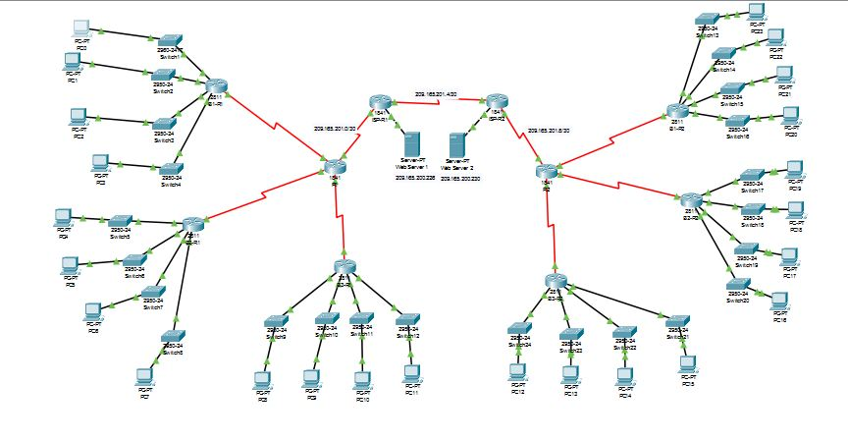

PC Configuration

PC0
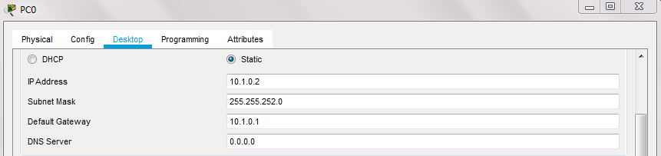

PC1
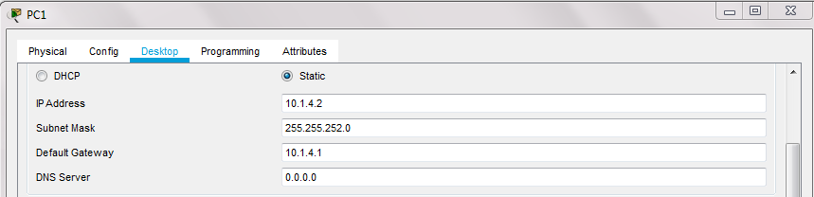

PC2
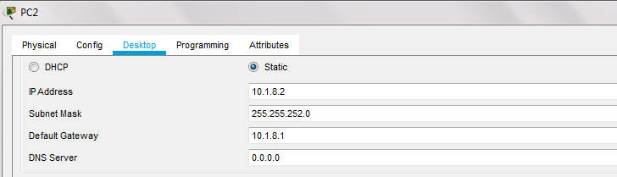

PC3
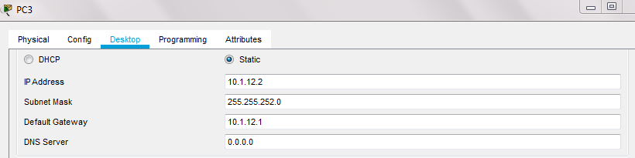

PC4
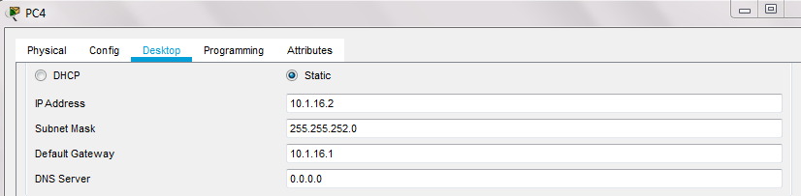

PC5
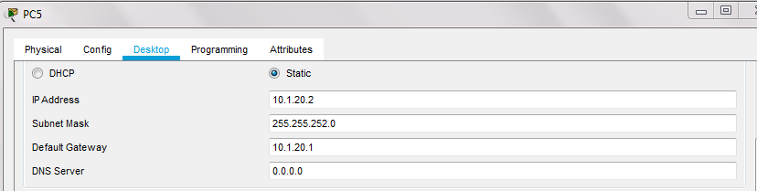

PC6
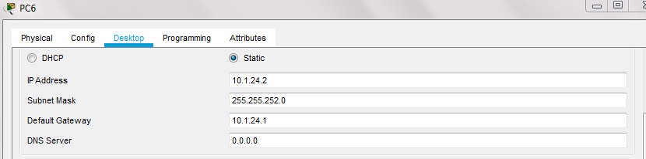

PC7
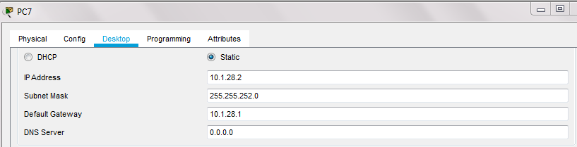

PC8
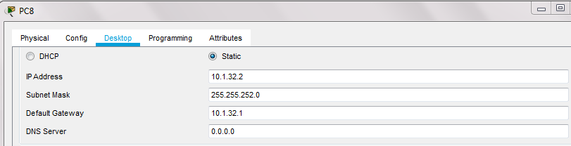

PC9
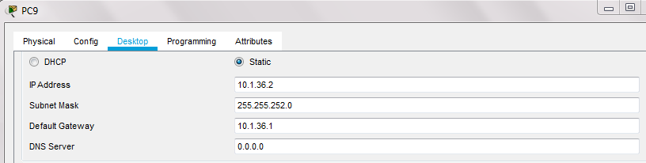

PC10
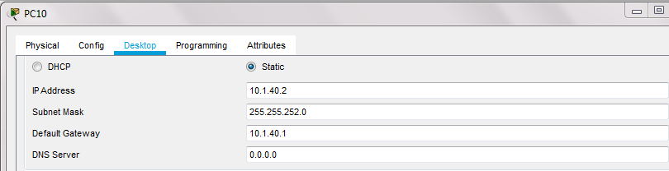

PC 11
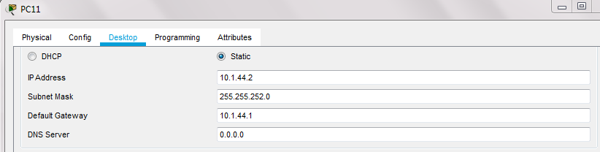

PC12
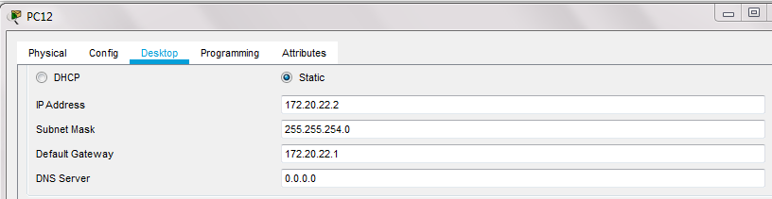

PC13
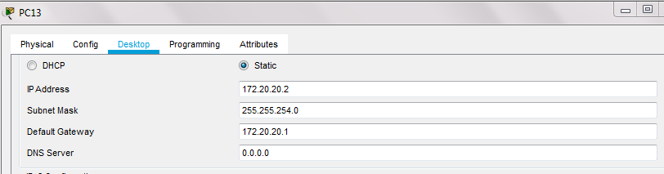

PC14
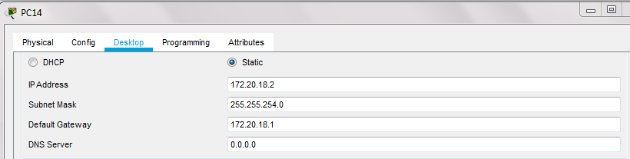

PC15
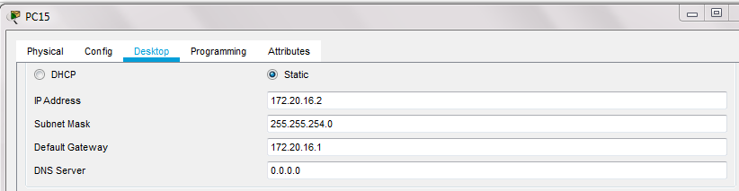

PC16
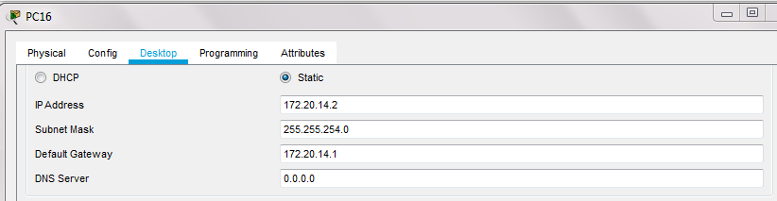

PC17
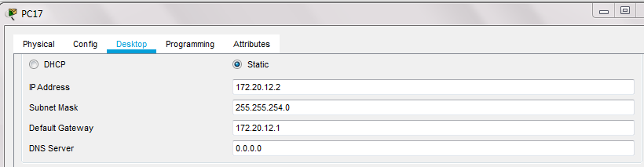

PC18
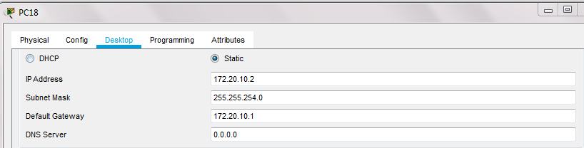

PC19
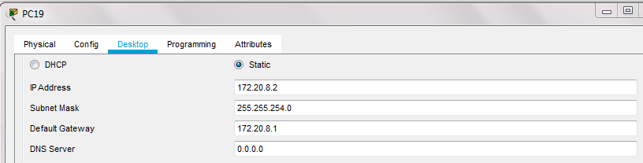

PC20
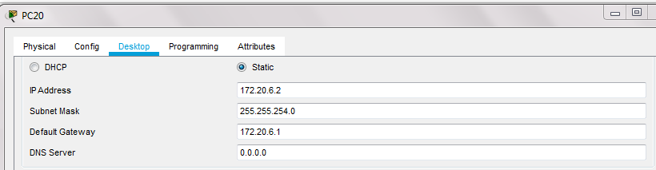

PC21
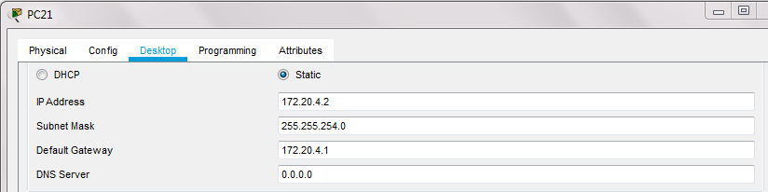

PC22
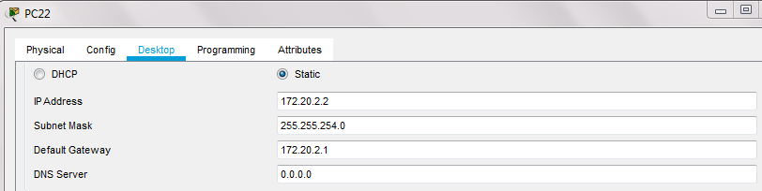

PC23
