School application &web system mangment

Project name

Tabachira

Team member

Omnea Mohamed sayed (section 3)

Amany farouk abdlstar(section 3)

Ereny naiem fares(section 3)

Alshimaa gamal dahy (section 3)

• Project Name:

Tabachira

• Project Sponsor:

1-Ministry of Education.

2-Ministry of communication and information technology

• Project manager: Eng/Ahmed ElSayed

• Purpose of the project: School administration assistance

. • Project scope:

1-You can record the attendance and departure of staff, student absence

2-follow-up to the school gate

3-delivery of textbooks

4-bus management

5-settings for creating and printing the class schedule, and many other administrative details. 6-Providing an integrated environment that facilitates communication between teachers, students, parents and administration .

7-Follow up on everything related to the reception department and the school's security department.

8-Manage student accounts in an easy and more controlled way.

9-Organizing the administrative structure of the staff in the school and organizing the departments and sections of the Personnel Administration.

10-Saving wasted time and effort during school control work.

• Key deliverables of the project:

- It is an administrative system that will help in registering and following up on all of the

1-Student Affairs

2-personal affair

3-school control

4-Student accounts and public school accounts

–A application that is a powerful interface for the school and a means of communication between the school administration, teachers, students and parents.

-A mobile application that enables the guardian to follow up on all the details of the student

• Project milestons (Time line of project):

-In the first 4 weeks , team of engineers will collect information about the school and it's data.

- For seven months , a team of programmers will make the mobile application .

- The project is being tested for a month

•Risks:

1-Misuse of the application leads to its destruction.

2-The lack of sufficient technological awareness among students, teachers and staff to deal with the application.

3-Sudden fall of the system.

4-Not providing the internet to run the application.

•Solving problems:

1-Regarding the lack of technology awareness among students, educators, and employees

2- increase the technology awareness and training of teachers, students, and employees. As for its misuse, it is necessary to know the correct use of the application, and students, staff and teachers must learn to use the application correctly

As for not providing a net, a net must be placed in all parts of the school to ensure the high quality of the application and they run well. As for the sudden fall of the system, intensive maintenance must be done and the application should be followed up on a daily basis.

•Requirements:

-Software Developers to create, add and edit the app.

-Network.

-social media specialist

. •Project Budget:

5.000.00 LE.

•Project Timeline:

-Date of Project Approval: 25 january 2022

-Date of Project last Revision: 25 seb 2022

•Project Scope Description:

It's an application to manage the school system that allows :

•Recording student absence .

•Follows up on the school gate.

•Facilitates communication between students , teachers , parents ,and school management .

•Organizes lesson times , and study materials .

•Provides services such as delivering exams to students and sending them to the teacher , and student assessment , and raising academic schedules , and student results.

Project acceptance criteries:

•Beautiful user interface .

•Easy to use , faster , and comfortable.

•Allow big data.

•has various platform such as ios,android, linux,mac,windox

-Project deliverables:

•Project plan , reports ,documents , and resources.

•Saving money , and time .

-Project exclusions:

•One of the parents requirements that the application show them detailed report for each student , but it need a lot of time and cost .

- Project Constraints :

•Budget .

•Time of submit .

-Project Assumptions :

•student can't comfortable with it

wbs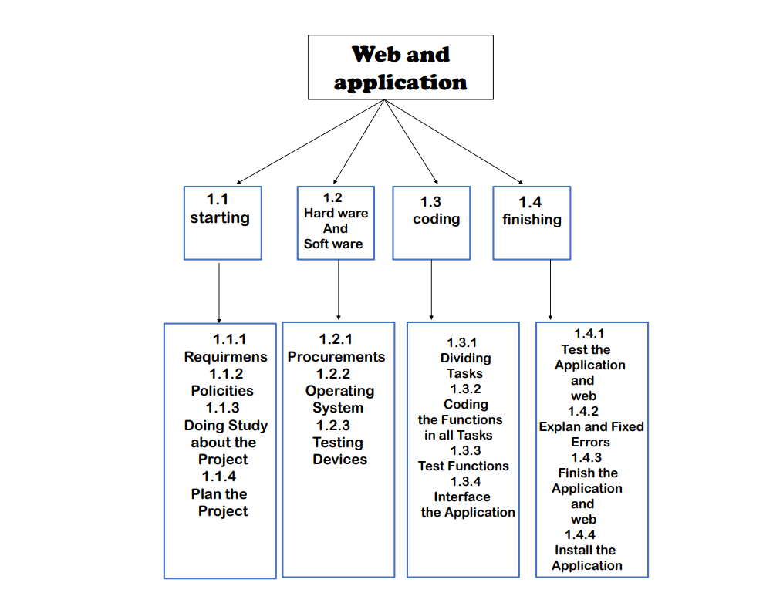

Dictionary of WBS

* 1. *Start*

*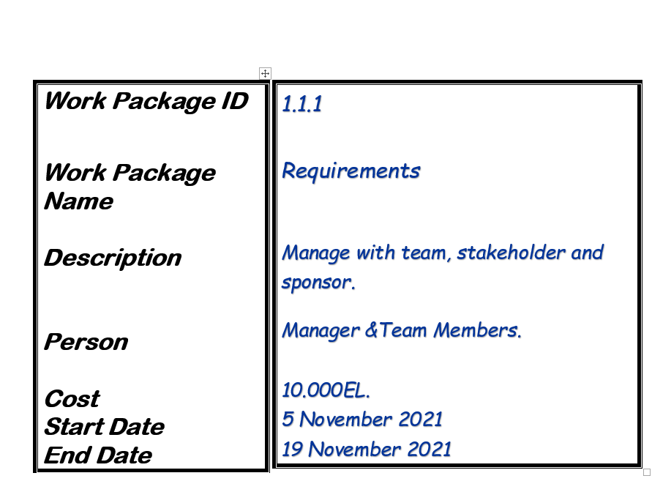*

*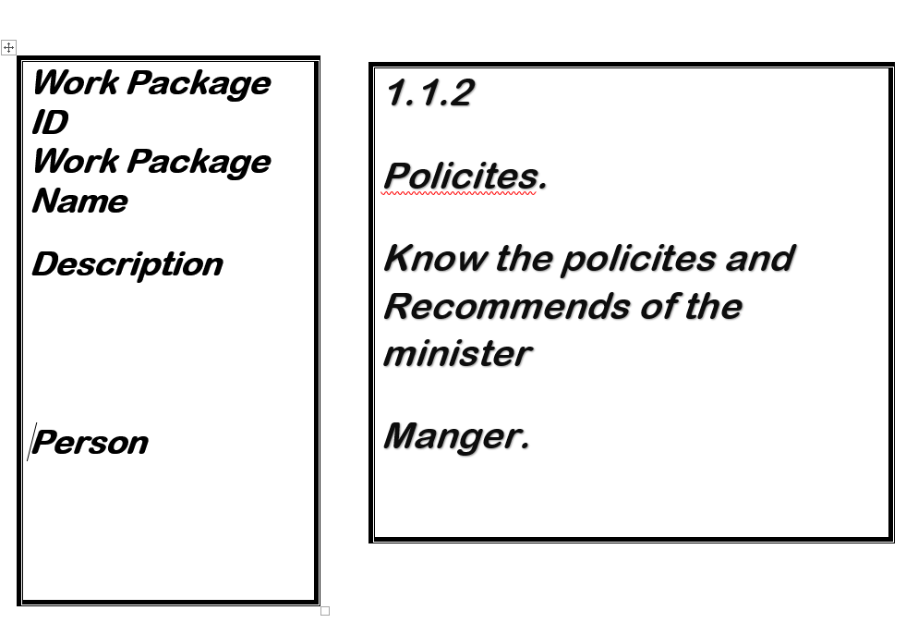*

*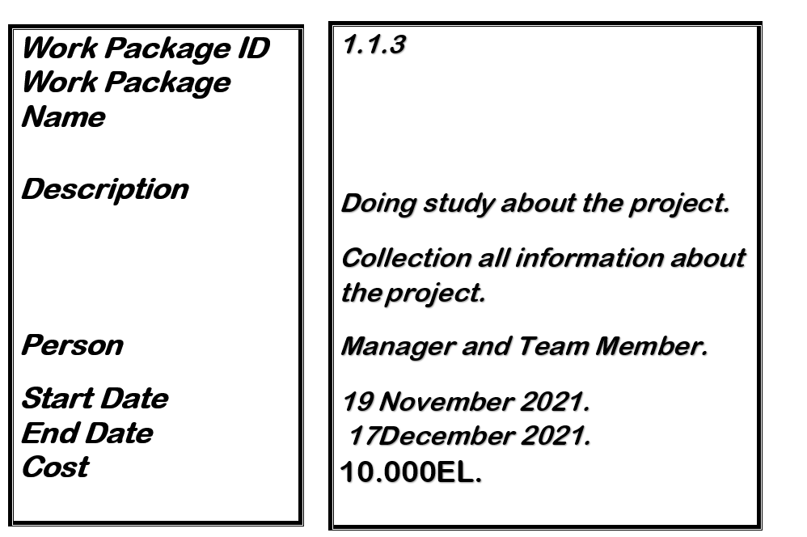*

*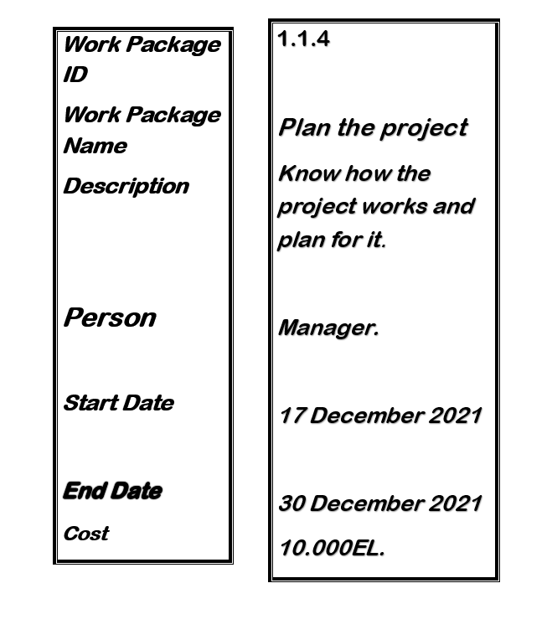*

*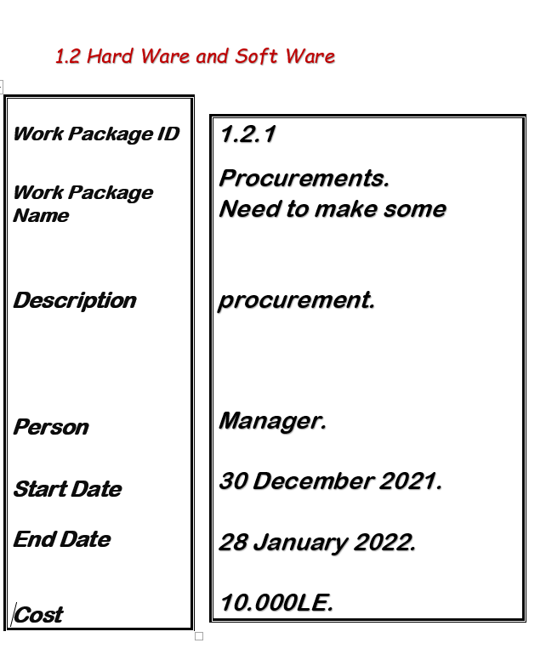*

*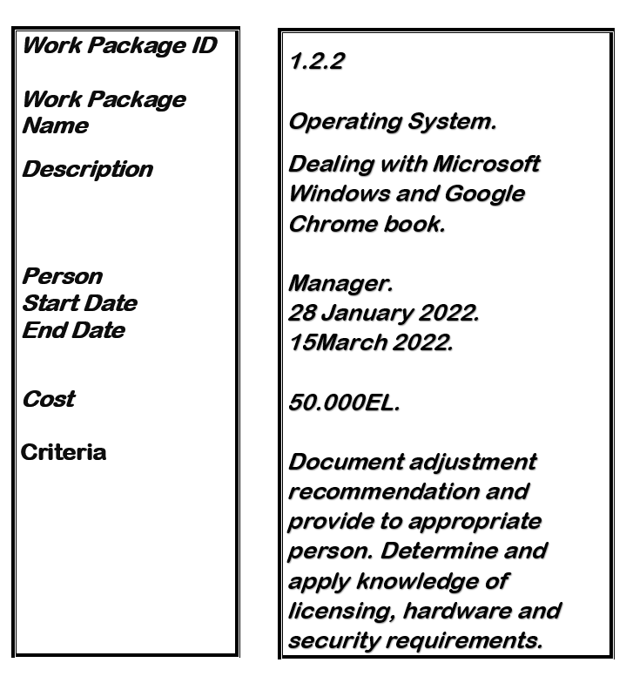*

*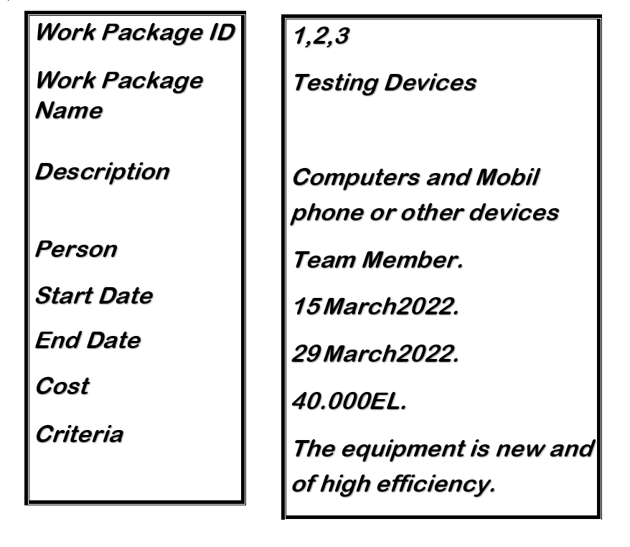*

*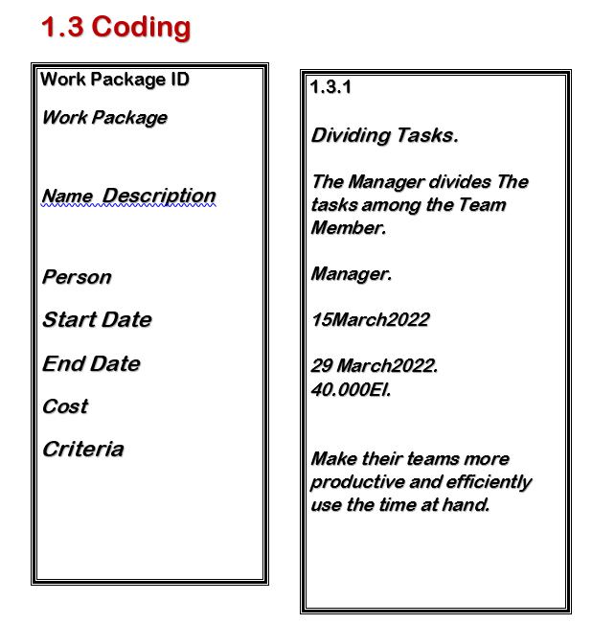*

*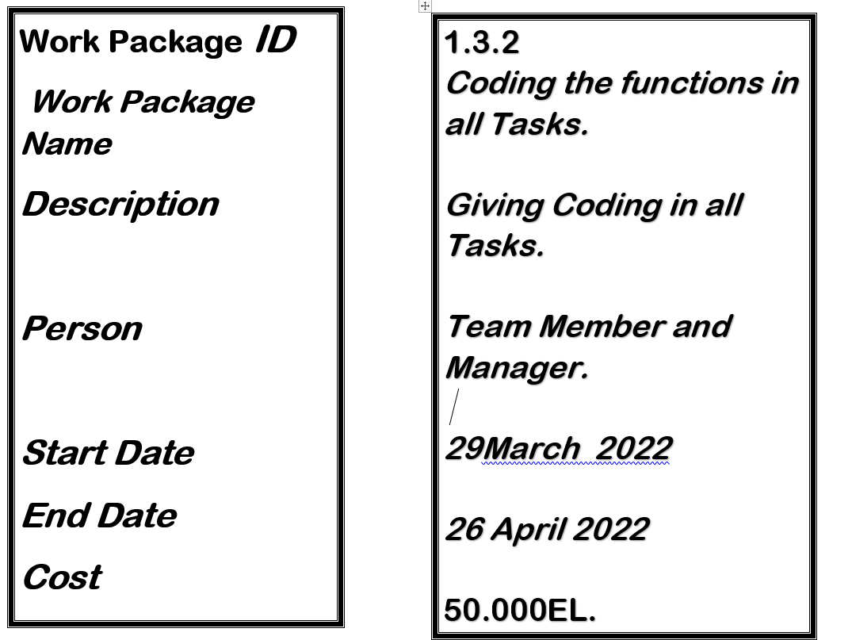*

*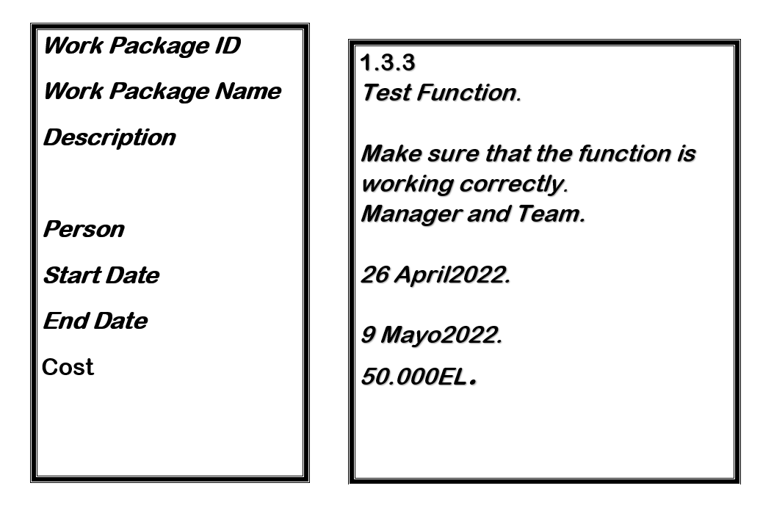*

*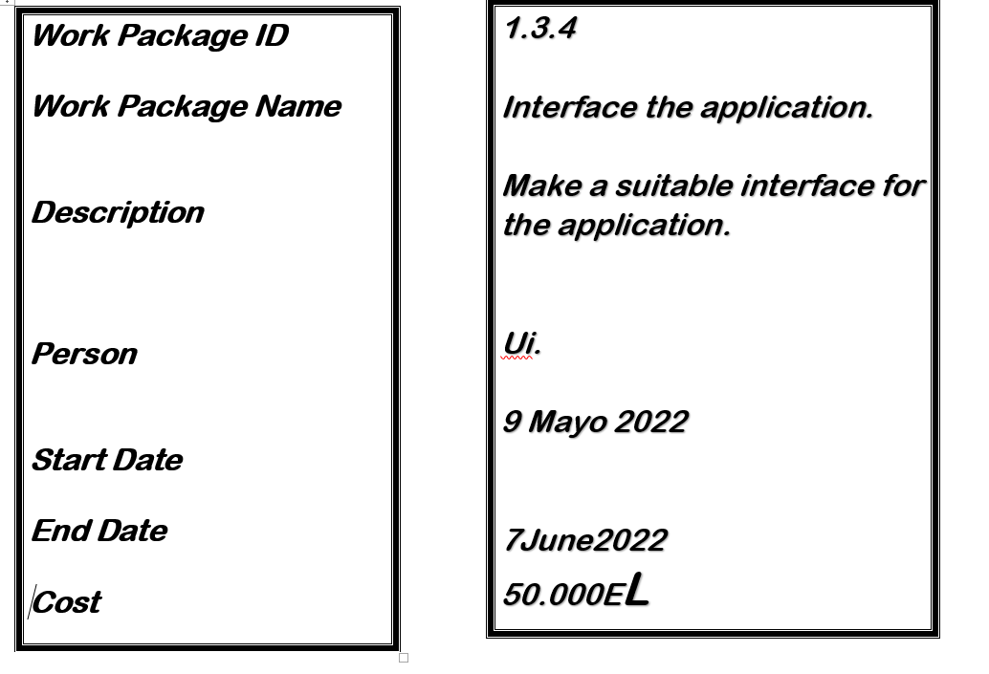*

*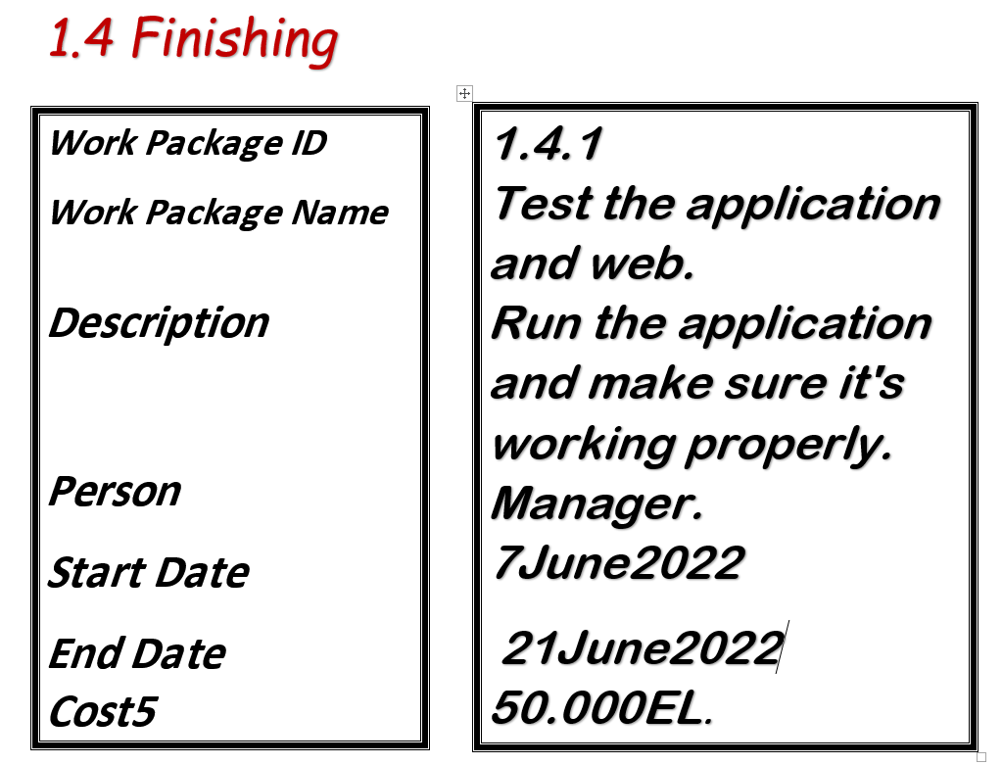*

*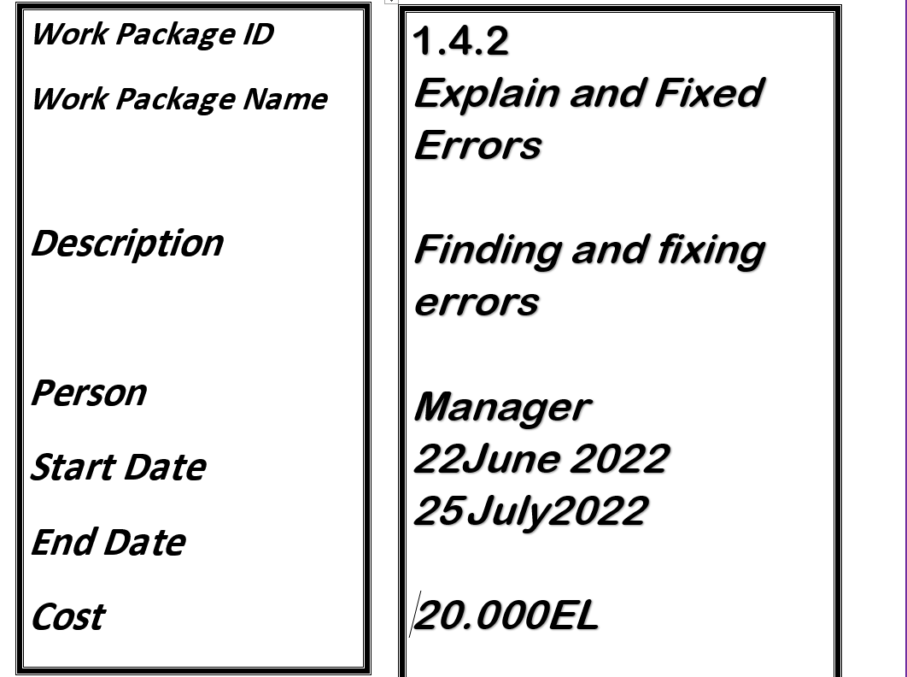*

*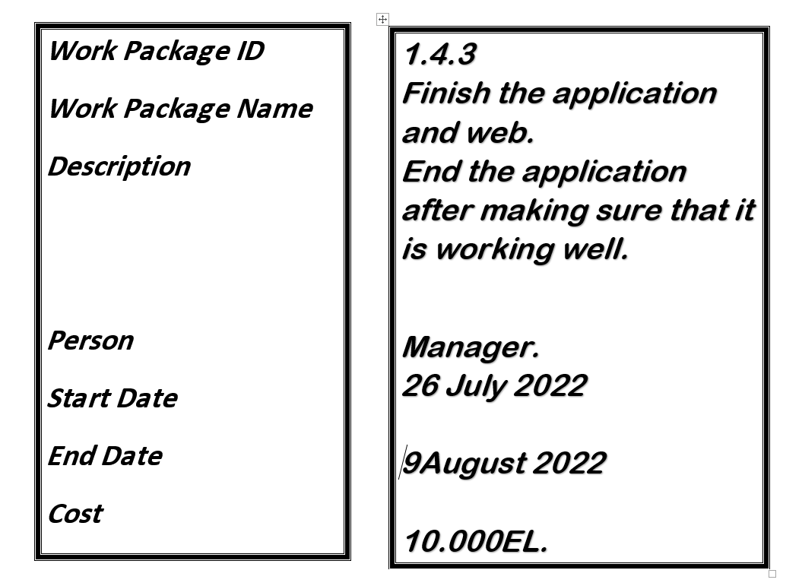*

*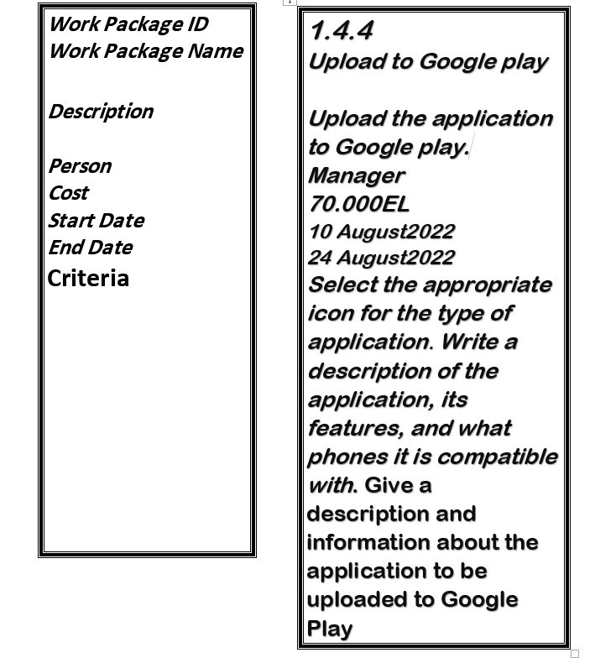*

Responsibility Matrix*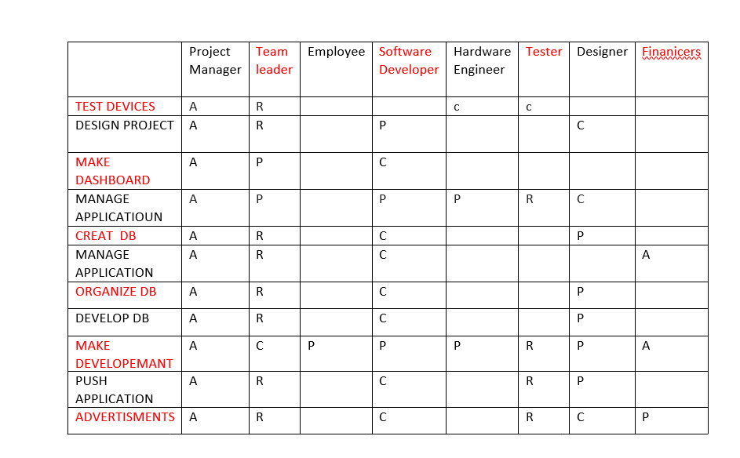*

Project Network*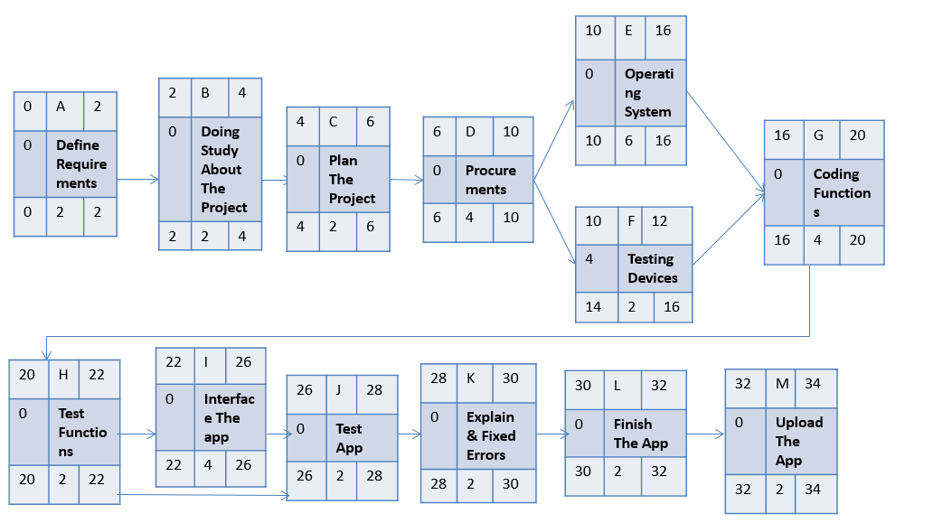*

*Resource Constrained*

*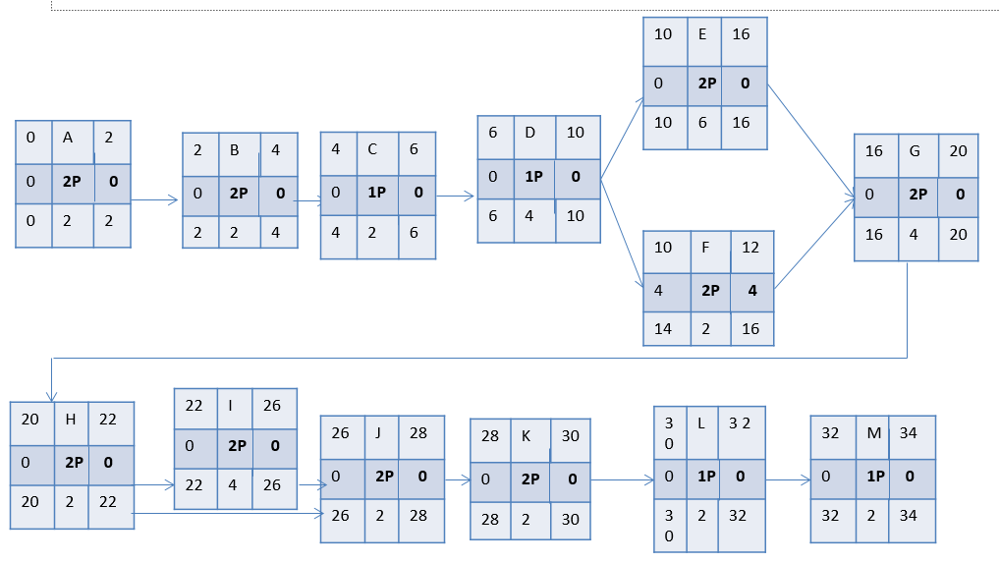*

*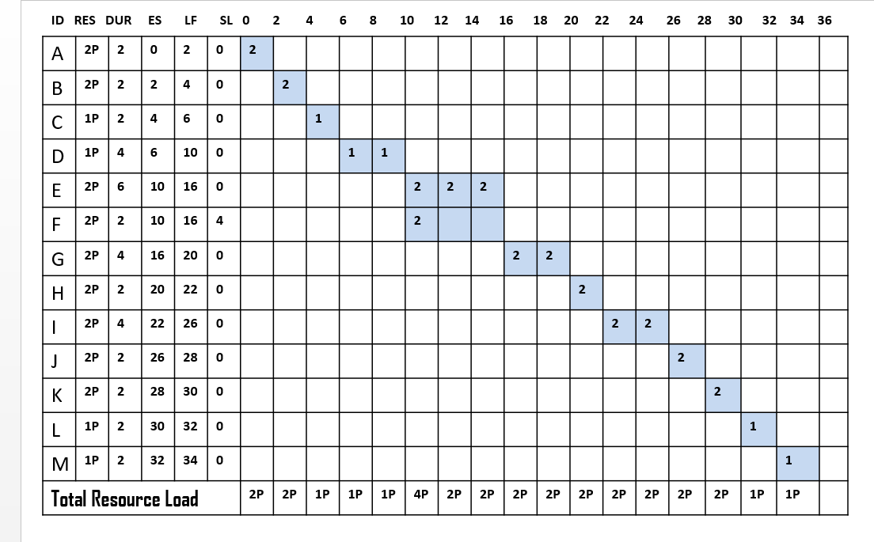*

*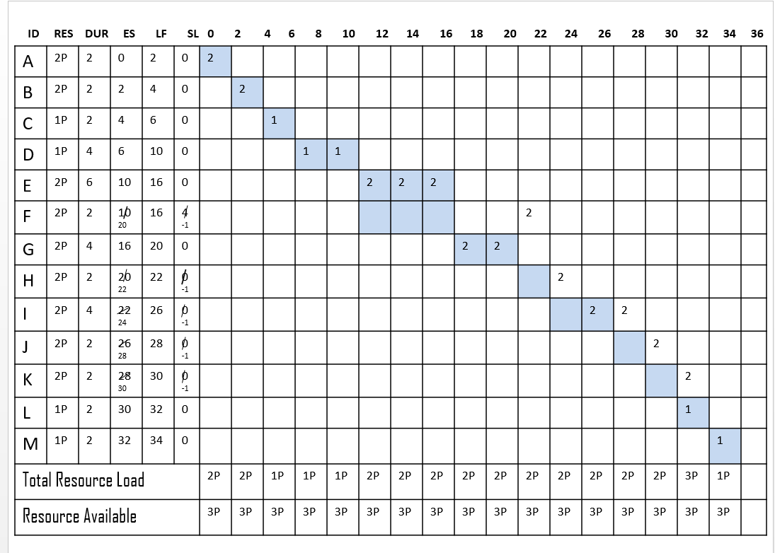*

Budget Baseline

*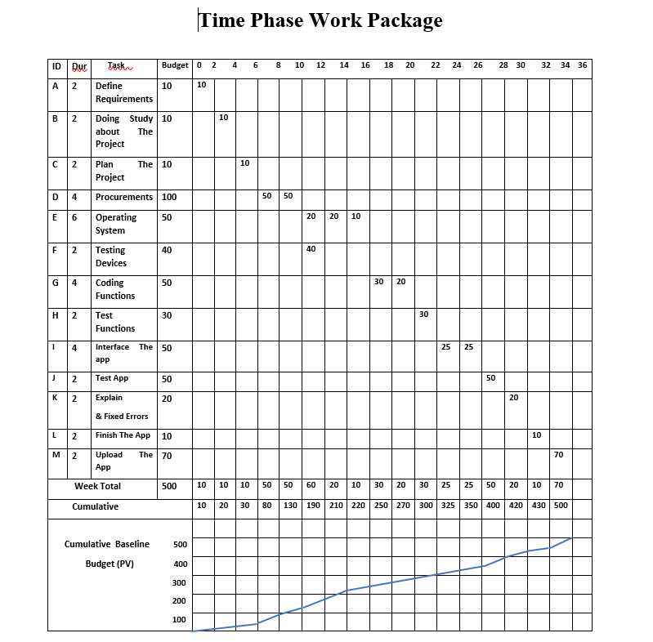*

*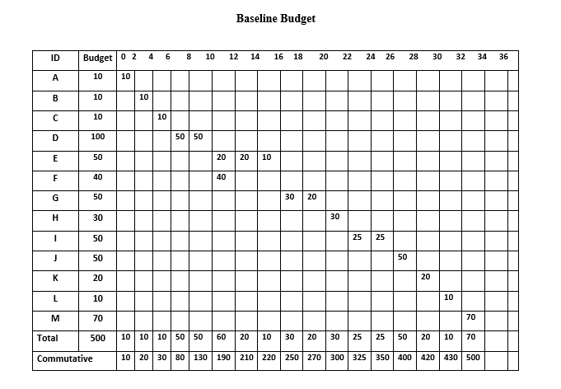*

Risk Management

What are the risks that can face your project?

1-Misuse of the application leads to its destruction.

2-The lack of sufficient technological awareness among students, teachers and staff to deal with the application.

3-Sudden fall of the system.

4-Not providing the internet to run the application.

How to deal with these risks?

1-Regarding the lack of technology awareness among students, educators, and employees

2- increase the technology awareness and training of teachers, students, and employees. As for its misuse, it is necessary to know the correct use of the application, and students, staff and teachers must learn to use the application correctly

Demostrate how to montior your project?

*We will hold a meeting every month to find out what progress the project has reached and what remains for it to finish, and to follow up on the specified budget, whether it is more than expected or not.*