Dirty COW Attack Lab
Member 6 — ISSD
SEED Ubuntu 12.04 • CVE-2016-5195 • Completed experimental report
Fresh experiments and evidence: 9 October 2026

Executive summary
The two official SEED Dirty COW tasks were completed in the prescribed isolated, 32-bit Ubuntu 12.04 VM. An ordinary seed process first modified a root-owned dummy file, then changed the UID field of the lab account charlie. Both changes were checked against complete before/after files, fresh backing-file reads, hashes and restrictive ownership/mode.
The normal-COW control changed private memory while leaving the backing file unchanged. In contrast, the vulnerable-kernel race produced the exact dummy result 111111******333333\n. The account trial replaced charlie's four-character UID field 1001 with 0000, preserving every other byte. A fresh non-sudo `su - charlie` subsequently gave numeric UID 0. Its first authentication attempt failed; the successful retry and the failure are both retained.
Each task used one bounded 30-second trial and recorded 0 integer elapsed seconds. This is the supplied wrapper's timing resolution, not zero execution time or a measured kernel race-attempt count. The UID-0 shell was exited, the complete normal account baseline was restored, and a new charlie login returned UID 1001 / GID 1002. The dummy and experiment processes were removed, evidence was exported and verified, and the VM was shut down normally.
The optional patched-VM comparison was not performed; discussion only. Kernel patching, system updates, limiting local access and monitoring privilege escalation are discussed as required by the group allocation.

1. Aim and scope
The aim was to reproduce and explain the historical Linux Dirty COW vulnerability, CVE-2016-5195, in the required SEED environment [1–3]. The official practical consists of Task 1, modifying a dummy read-only file, and Task 2, modifying a password-file UID to obtain root privilege. Member 6's allocation additionally requires the COW explanation, important commands, environment/attack/result screenshots, four countermeasure themes and a short live demonstration [4].
All experiment operations on /zzz, /etc/passwd and charlie took place inside ISSD-Member6-SEED12, UUID 242db196-83e1-4b7a-9f0b-e399d6f8b9dc. The programs ran as ordinary seed on native guest ext4 storage. Arch-host tools delivered visible commands, captured the actual guest framebuffer and checked exported evidence. Administrator privileges were used to prepare and restore the lab state; both attacks ran with real/effective UID 1000.

2. Background and security model

2.1 Normal copy-on-write
Copy-on-write allows memory pages to be shared until modification requires a private copy. With a private file mapping, a process's private modifications must not update the backing file. MAP_PRIVATE specifies this isolation; it does not grant ordinary file-write permission [5].
File-backed page -> private mapping -> private write
|
v
private copy changes
backing file unchanged
The control opens /zzz with O_RDONLY, maps it using PROT_READ | PROT_WRITE and MAP_PRIVATE, and uses memcpy() on the private mapping. A fresh pread() and a separate terminal read check the underlying file. This is a deliberately writable private mapping, unlike the attack's read-only mapping.

2.2 The Dirty COW race
The attack opens the protected target read-only and privately maps it with PROT_READ. One worker repeatedly writes through /proc/self/mem, an interface to its own address space. The other repeatedly calls madvise(..., MADV_DONTNEED), discarding relevant mapping/page state so subsequent access can refault or repopulate it [5–7].
Writer worker Discard worker
pwrite(/proc/self/mem, ...) MADV_DONTNEED
\ /
concurrent kernel COW/page handling
|
vulnerable interleaving
v
backing-file bytes can change
In affected kernels, this interaction can mishandle COW/write-protection state and allow modification of the file-backed page despite the caller lacking file-write permission. Neither MAP_PRIVATE nor madvise() alone causes the bypass. A direct assignment through the read-only pointer is not the exploit method. The diagram is a high-level mechanism explanation; no kernel instruction trace or exact winning interleaving was measured here.
Dirty COW is a local kernel privilege-escalation vulnerability. Member 5's application-level race instead swaps a symlink between a deliberately privileged program's check and use. This lab requires no installed root-owned Set-UID victim. The supplied attack and control binaries remained ordinary seed-owned 0755 executables.

3. Environment and research-based choice
The official lab is hosted under a Labs_20.04 URL, but specifies the historical SEED Ubuntu 12.04 VM. The historical VM manual identifies its 32-bit environment and kernel 3.5.0-37-generic [1, 3]. The previously downloaded official image and existing VirtualBox installation were reused. The fresh run rechecked the actual guest rather than treating the VM profile or old captures as runtime evidence.
Item | Actual recorded value
Host | Arch Linux x86-64; kernel 7.2.9-arch1-1
VirtualBox | 7.2.20r175154; installed module matched the host kernel
Guest VM | ISSD-Member6-SEED12; separate SEED12 disk
Image | SEEDUbuntu12.04.zip; official-linked download verified during preparation
Guest release | Ubuntu 12.04.2 LTS, precise
Architecture | i686; getconf LONG_BIT returned 32
Running kernel | 3.5.0-37-generic
Kernel package | 3.5.0-37.58~precise1; i386; source linux-lts-quantal
Resources | 2048 MB configured RAM; two virtual CPUs
Compiler | GCC 4.6.3, Ubuntu/Linaro 4.6.3-1ubuntu5
Ordinary caller | seed, UID 1000, GID 1000
Workspace | /home/seed/issd-member6/lab-files; native ext4
Transfer | M6pack read-only input; M6export writable export, mounts verified
Network | Virtual network cable disconnected throughout the fresh experiments
Clean snapshot | M6-clean-SEED12; pre-execution
Prepared snapshot | M6-charlie-normal-ready; powered-off normal account/dummy state

The image's published MD5 was checked during preparation to detect transfer corruption; a SHA-256 and ZIP CRC checks were also retained. Runtime vulnerability assessment uses the actual kernel/package family and vendor information [8]. The Ubuntu fixed version 3.2.0-115.157 belongs to a different kernel stream and is not a universal numeric threshold for this linux-lts-quantal package. The observed protected-file changes establish this particular guest's vulnerable behaviour.
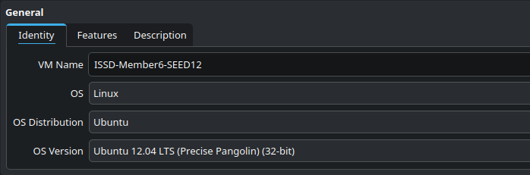
Figure 1a — S01 host settings, labelled profile excerpt. The separate VM name and Ubuntu 12.04 32-bit profile are visible. The full original also records 2048 MB RAM.
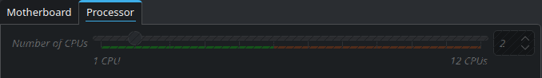
Figure 1b — S01c original user-supplied processor-region capture, showing two configured CPUs.
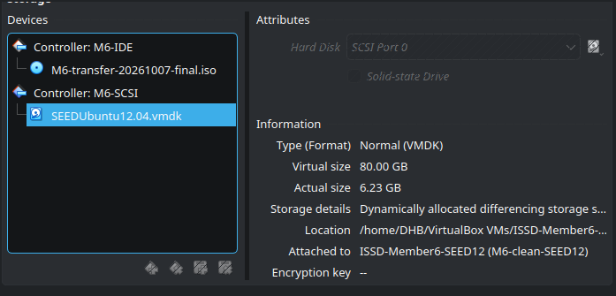
Figure 1c — S01d original user-supplied storage-region capture. The attached SEEDUbuntu12.04.vmdk, M6-SCSI controller and 80 GB virtual size are visible. The truncated path is supplemented by the full host disk-chain record.
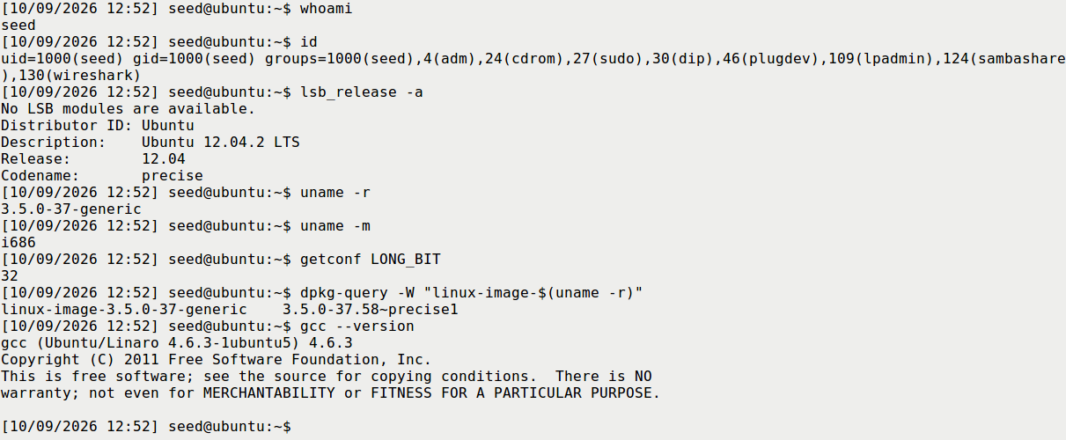
Figure 2a — S02 real guest commands: seed identity, Ubuntu 12.04.2, 32-bit i686, running kernel/package and GCC. Readability crop of the unedited framebuffer.
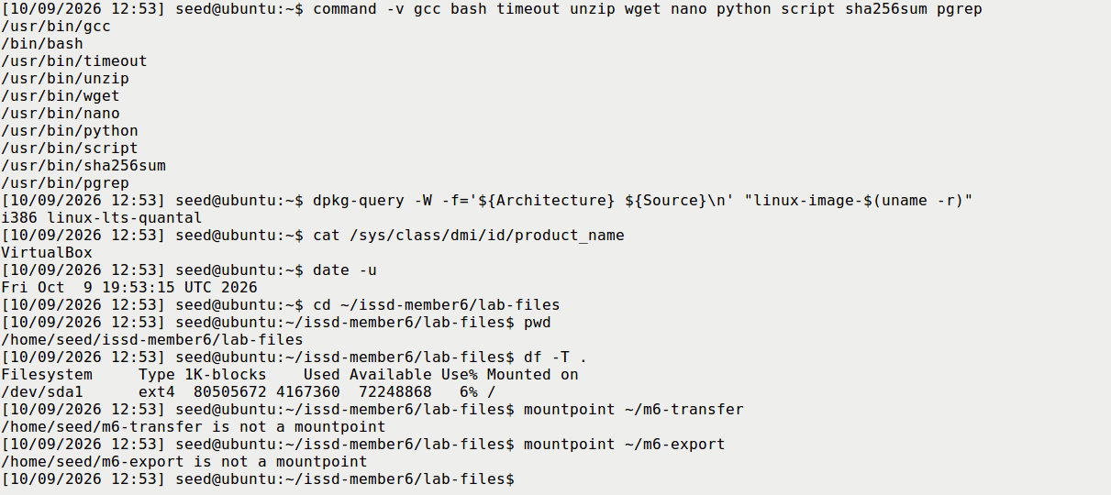
Figure 2b — S02b actual tools, linux-lts-quantal package family and native ext4 workspace. Transfer directories were unmounted at this early checkpoint; they were verified as mounted before later exports.

4. Code and build
The four supplied files, cow_attack.c, cow_control.c, build.sh and run_trial.sh, were preserved byte-for-byte. Host and guest hashes matched SOURCE_SHA256SUMS; source content retained LF line endings. A fresh bash build.sh returned 0 and produced ordinary seed-owned ELF32 executables, 12,540 bytes for the attack and 7,601 bytes for the control.
The build used the supplied commands:
gcc -std=gnu99 -Wall -Wextra -O2 -pthread cow_attack.c -o cow_attack
gcc -std=gnu99 -Wall -Wextra -O2 cow_control.c -o cow_control
Source location | Meaning
cow_attack.c:31–61 | Two concurrent discard/write workers; checked madvise and process-memory writes
cow_attack.c:73–98 | Rejects root execution; fixed dummy/passwd modes; validates actual nonzero UID
cow_attack.c:100–114 | Opens target read-only; checks target; privately maps it with PROT_READ
cow_attack.c:116–131 | Bounded unique-pattern search and correct-width virtual-address conversion
cow_attack.c:139–150 | Creates and joins both workers
cow_control.c:24–42 | Writable private mapping, memcpy, complete fresh backing-file read
run_trial.sh | Reads actual UID, saves full copies, limits runtime and stops on detected change

The repository adaptation uses pwrite() instead of the upstream separate lseek()/write() pair. Its offset is a virtual address in the attacker's process, not an ordinary byte offset used to open the protected file for writing. _FILE_OFFSET_BITS=64 and conversion through uintptr_t avoid signed truncation of a 32-bit pointer. The reported file-byte-offset separately identifies the intended target location.
Fixed task modes, bounded memmem() searching, unique account-prefix matching, same-width UID replacement and checked setup calls make the educational example easier to inspect. The workers still repeat a timing-dependent kernel race. The shell wrapper polls the file hash, normally sleeping 0.2 seconds between observations; its timer counts integer wall seconds, not worker iterations.
Supplemental helpers verified the exact VM/workspace, whole files, metadata, process exit and cleanup. The host capture helper gained a fresh-output-directory option and exact VM UUID validation. Detailed verification was redirected to logs. These changes did not modify the supplied four C/build/trial files or manufacture terminal output.
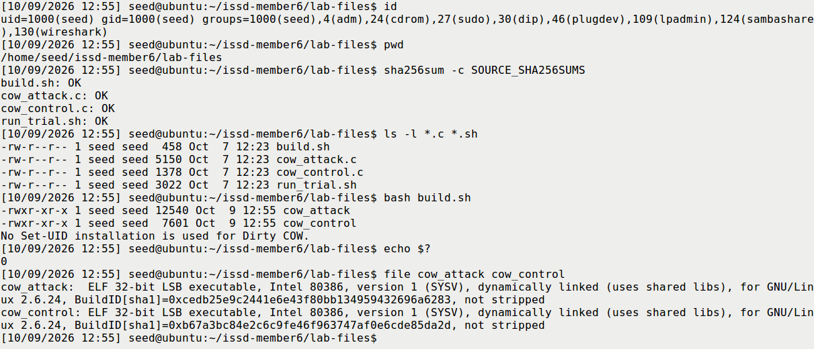
Figure 3 — S03 source hashes, ordinary fresh build, exit 0 and seed-owned 0755 ELF32 binaries.
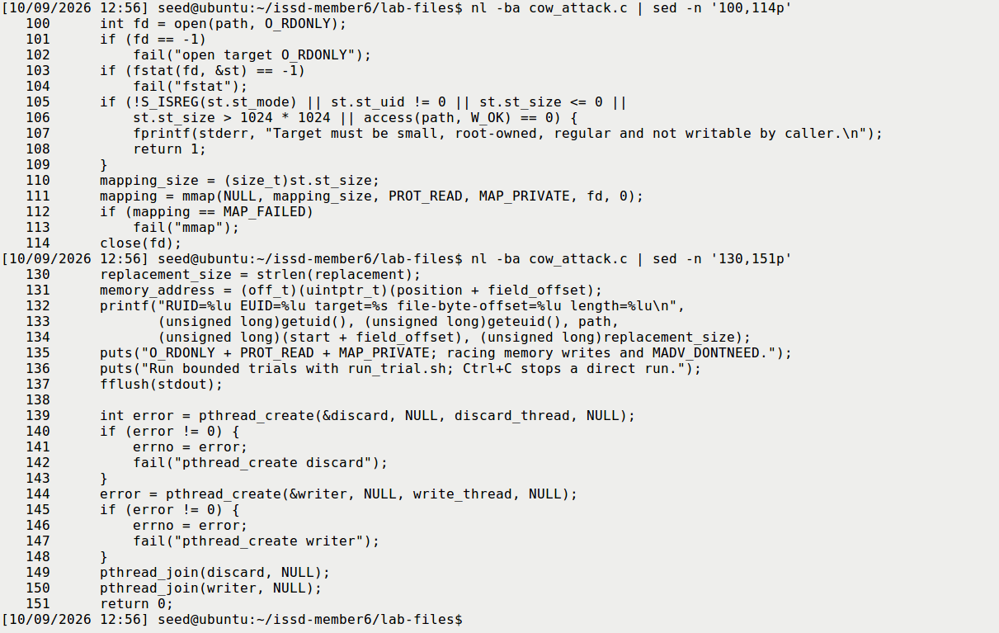
Figure 4a — S03b actual numbered source: target checks, read-only private mapping, virtual-address conversion and worker creation.
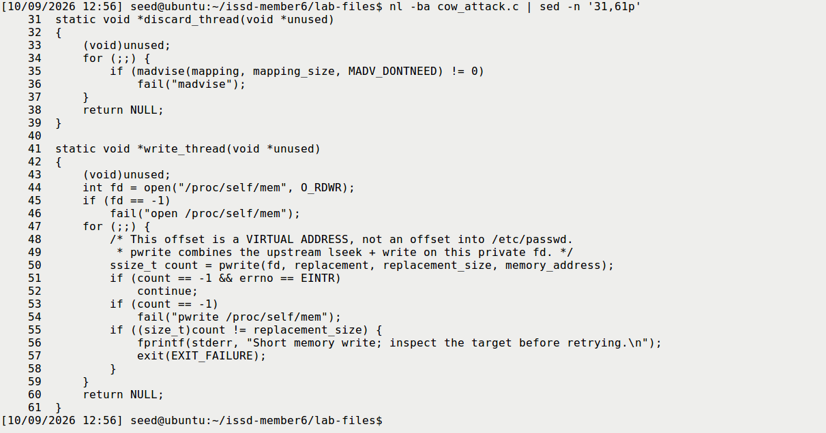
Figure 4b — S03c actual numbered source: repeated MADV_DONTNEED and pwrite through the process's own memory interface.

5. Task 1 — dummy file

5.1 Starting permissions and denied normal write
The initial inspection established that /zzz was absent. It was created administratively with exactly 111111222222333333\n, root:root ownership and mode 0644. The 19-byte file was readable but not writable by ordinary seed. A normal shell redirection was then attempted as seed:
echo 99999 > /zzz
cat /zzz
sha256sum /zzz
EXPECTED: ordinary writing fails and the original remains. ACTUAL: Bash reported Permission denied, exit 1; the fresh content and hash were unchanged. EXPLANATION: ordinary permission enforcement works for this direct file-write path. Here “read-only” is relative to seed, not a read-only-mounted filesystem.
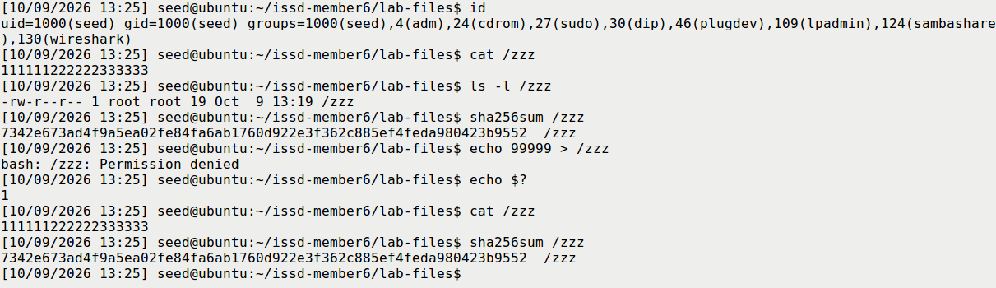
Figure 5 — S04 root-owned 0644 original, denied ordinary write and identical before/after hash.

5.2 Normal copy-on-write control
The supplied ./cow_control was run as seed and its output retained in logs/fresh-control-01.txt. It reported:
Private memory: 111111******333333
Backing file: 111111222222333333
EXPECTED: private memory changes while the backing file does not. ACTUAL: a new cat /zzz returned the original, the saved-hash check passed, and complete baseline cmp returned 0. EXPLANATION: the writable private mapping and direct memcpy() correctly affected only a private copy. This control differs from the exploit's read-only mapping and /proc/self/mem path; it is not simply the same exploit with one thread removed.
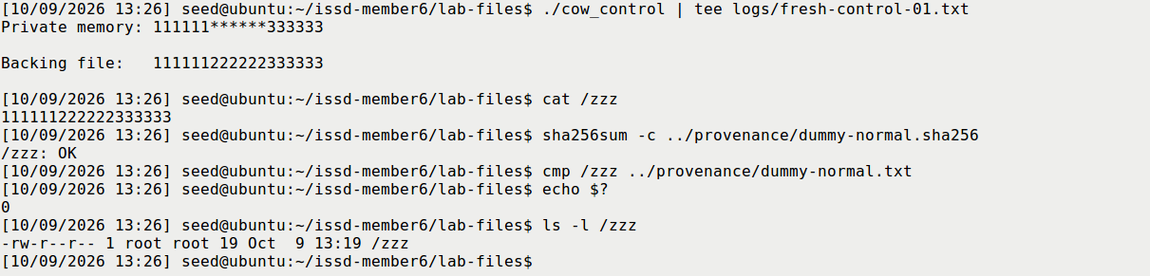
Figure 6 — S05 private stars versus original backing file, followed by fresh read, saved-hash and whole-byte comparisons.

5.3 Bounded race and exact backing-file result
The visible invocation was:
id
bash run_trial.sh dummy 30 fresh-t1-01
Measurement | Actual value
Start | 2026-10-09 13:28:48 -0700, or 20:28:48 UTC
Trial count | One; no Task 1 attack retry
Runtime limit / integer elapsed | 30 seconds / 0 seconds
Program identity | RUID 1000, EUID 1000
Intended field | Byte offset 6; replacement width 6
Full result | 111111333333 followed by newli
Owner/mode/length | root:root, 0644, 19 bytes before and after
Program errors | None in the retained three-line program output

EXPECTED: exact replacement can occur on the prescribed vulnerable kernel. ACTUAL: the complete backing file became the expected 19-byte sequence. EXPLANATION: the ordinary memory-management race changed data that the direct file write could not change. A fresh complete expected-byte comparison returned 0, and live and independent exported-file verifiers accepted the same copies, metadata and program identity.
Before SHA-256:
7342e673ad4f9a5ea02fe84fa6ab1760d922e3f362c885ef4feda980423b9552
After/live SHA-256:
97c0ed6bb0deb556349015713d1c0a86d11e1bf5572a78b087650e814479b47b
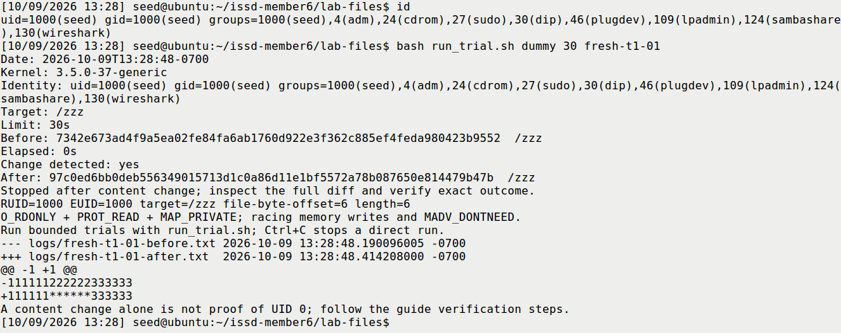
Figure 7 — S06 completed fresh-t1-01 trial: ordinary identity, actual command, 30-second limit, 0 integer elapsed seconds and exact diff. Despite the checklist filename “running”, this capture was taken after completion.
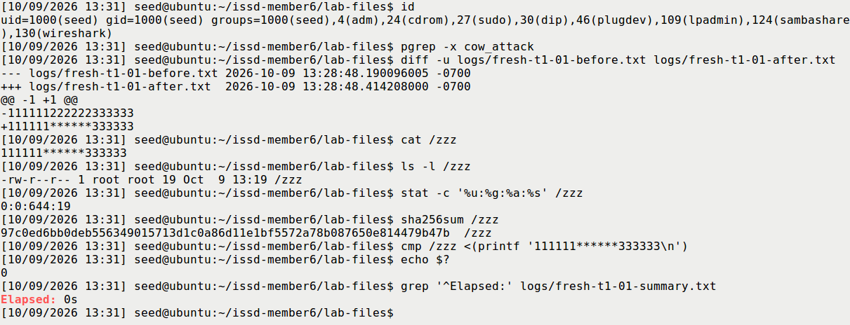
Figure 8 — S07 independent fresh read, full expected-byte comparison, metadata and elapsed-time check after the attacker ended.

5.4 Interpretation and reset
The evidence chain is direct write denied → normal private copy leaves the file intact → ordinary race changes the actual backing file. A changed hash alone could indicate an unintended or partial modification, so the full file was compared. The displayed file modification time still showed the setup minute, illustrating why timestamps alone are inadequate integrity evidence.
No fine-grained attack runtime or kernel-level attempt count was measured. A 0s integer reading does not mean instantaneous execution, and one successful trial does not establish a general success probability. After the attacker stopped and evidence was exported, an administrative reset restored the exact original dummy before the prepared snapshot. That reset is not counted as attack evidence.

6. Task 2 — account UID modification

6.1 Normal account and protected baseline
After another absent-account check, adduser charlie created the lab account. Password entry and optional-field prompts were handled interactively. The actual seven-field record was:
charlie:x:1001:1002:,,,:/home/charlie:/bin/bash
The fields are username, password reference, UID, GID, comment, home and shell. x refers to the existing shadow entry; no password hash was overwritten by the attack. UID and GID were measured independently: they were 1001 and 1002, not an assumed identical pair.
A fresh non-sudo login returned UID 1001, GID 1002 and whoami charlie, then exited to seed. Only afterward was /root/issd-member6-passwd.normal created without overwriting a previous backup. Its complete bytes were compared to /etc/passwd; the original hash, charlie record and numeric UID-0 list were separately saved. Only root:0 was present in that original list.
EXPECTED: a working ordinary login and restorable post-creation account state. ACTUAL: both passed. EXPLANATION: this establishes a usable password and a baseline that includes the normal charlie account. A pre-adduser file would not be the same restoration target.
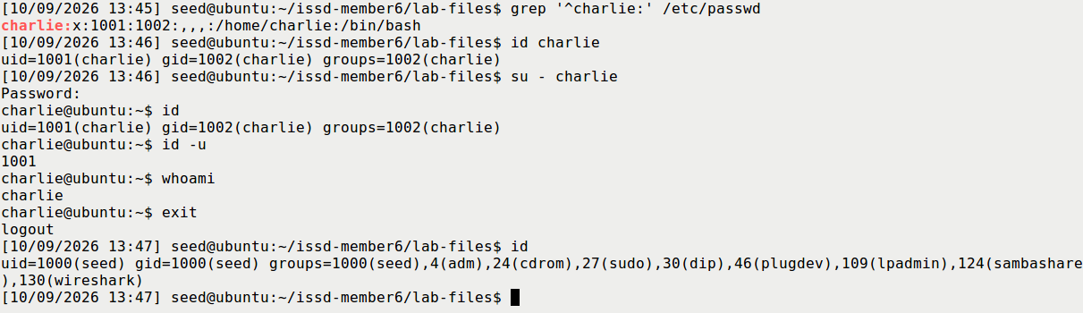
Figure 9a — S08 fresh ordinary charlie login with UID 1001 / GID 1002 and return to seed.
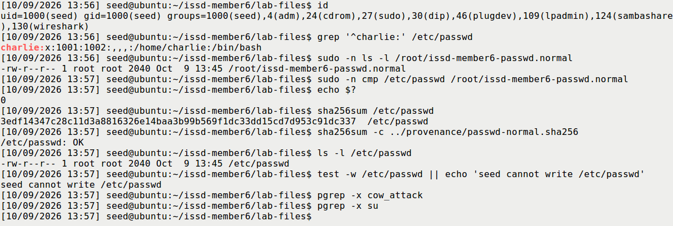
Figure 9b — S08b root-held backup, byte-for-byte comparison, saved hash, restrictive mode and denied seed write access.
The first transcript was closed/exported and the dummy reset before the VM was shut down normally. M6-charlie-normal-ready, UUID 0d3457ab-f5ce-4606-8bee-1842809ca831, was then taken powered off. After boot, source hashes, normal file hash, protected-backup comparison, identity and stopped-process checks passed again before Task 2.

6.2 Exact same-width UID overwrite
The ordinary-seed invocation was:
id
grep '^charlie:' /etc/passwd
bash run_trial.sh passwd 30 fresh-t2-01
The wrapper read charlie's actual UID and passed it to the supplied C program. That program uniquely matched the exact account prefix and wrote the same number of zero characters into the UID field. The complete-file comparison established:
-charlie:x:1001:1002:,,,:/home/charlie:/bin/bash
+charlie:x:0000:1002:,,,:/home/charlie:/bin/bash
Measurement | Actual value
Start | 2026-10-09 14:17:08 -0700, or 21:17:08 UTC
Trial count | One; no Task 2 exploit retry
Limit / integer elapsed | 30 seconds / 0 seconds
Program identity | RUID 1000, EUID 1000
UID-field offset / width | Byte offset 2002 / four characters
File owner/mode/length | root:root, 0644, 2040 bytes before and after
Other file differences | None; live and exported whole-file comparisons agree

EXPECTED: only the UID field is replaced with same-width zeroes. ACTUAL: exact 1001 → 0000, with all other bytes identical. EXPLANATION: fixed-width replacement preserves separators, GID and the rest of the account database. Two original positions already contained zero; the operation replaces a four-character field, not four necessarily different bytes. A single-character overwrite would have left unwanted original digits.
Normal/restored SHA-256:
3edf14347c28c11d3a8816326e14baa3b99b569f1dc33dd15cd7d953c91dc337
After/live SHA-256:
99fced9d0853d999474f92617022e78efe7c87b0f63450da264c46bfa9d47cd2
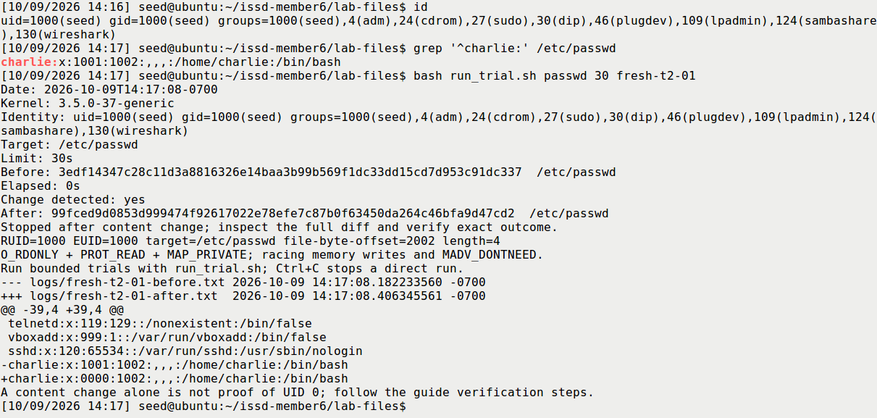
Figure 10a — S09 completed fresh-t2-01 trial, actual UID discovery, ordinary execution and same-width account diff.
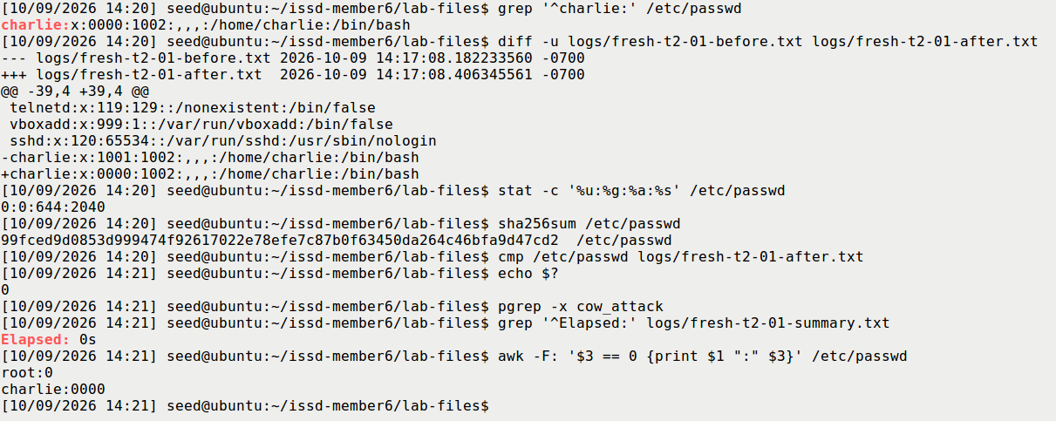
Figure 10b — S09b complete diff, root:root 0644/2040-byte metadata, fresh-file comparison and numeric UID-0 enumeration.

6.3 Fresh non-sudo privilege proof
A new su - charlie was attempted from seed after the attacker stopped. The first attempt returned su: Authentication failure. Its cause was not established. A second non-sudo attempt accepted interactive authentication and opened a child shell. Actual commands in that session returned:
id
uid=0(root) gid=1002(charlie) groups=0(root),1002(charlie)
id -u
0
whoami
root
EXPECTED: a successful fresh login applies numeric UID 0. ACTUAL: UID 0 was observed, with proof-shell PID 3392. EXPLANATION: UID 0 supplies root authority regardless of the login account name. whoami resolved it to root; primary GID remained charlie's 1002. The existing seed shell had stayed UID 1000. The successful authentication was not a sudo su, and no new exploit trial occurred between the failed and successful authentication attempts.
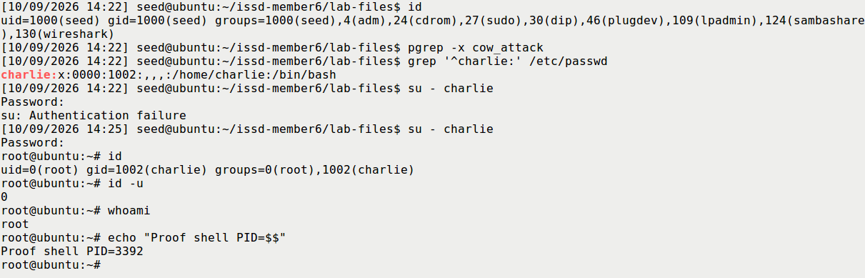
Figure 11 — S10 the preceding seed identity and both non-sudo authentication attempts, followed by actual id, id -u, whoami and proof-shell PID. The failed attempt remains visible.
This establishes both protected-file modification and actual privileged authentication. The file diff, a shell prompt or a successful memory write alone would not establish the latter.

6.4 Exact restoration and new ordinary login
Proof shell 3392 was exited. A subsequent ps found it absent, pgrep su found no remaining login process, and the caller was seed. The protected baseline was compared to the pre-attack file, the current target to the saved attack result, and the original was restored administratively:
sudo cp -a /root/issd-member6-passwd.normal /etc/passwd
sudo cmp /etc/passwd /root/issd-member6-passwd.normal
sha256sum -c ../provenance/passwd-normal.sha256
su - charlie
EXPECTED: exact normal file restored and a new login uses the original nonzero UID. ACTUAL: the full-file comparison and hash passed; metadata returned 0:0:644:2040; the fresh non-sudo login returned UID 1001 / GID 1002, id -u 1001 and whoami charlie. It then exited to seed. The exported complete restored file also matched the original pre-attack copy.
EXPLANATION: restoring the account database affects subsequent lookups/logins. It does not revoke credentials of already-running privileged processes, which is why exiting and checking the old UID-0 shell came first.
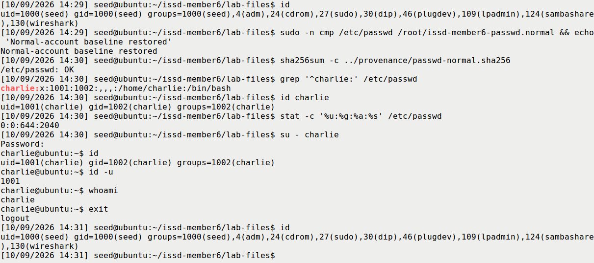
Figure 12 — S11 full normal-baseline verification followed by a new ordinary-charlie login and return to seed.

7. Countermeasures
Required theme | How it addresses this threat | Practical limitation
Kernel patching | Corrects the vulnerable kernel COW/write-protection handling | Confirm the distribution-supported fixed kernel is actually booted; an installed package alone is insufficient
System updates | Maintain vendor fixes and move obsolete production systems to supported releases | Track the actual kernel package family and backports; the isolated teaching snapshot intentionally preserves historical behaviour
Limit local access | Reduce unnecessary shell accounts and opportunities to run untrusted local code | Reduces exposure but does not repair the kernel; another compromise may supply a local foothold
Monitor privilege escalation | Compare trusted account-file baselines, enumerate numeric UID-0 records and investigate privileged sessions | Detection is not prevention; memory-path changes may evade ordinary write/timestamp assumptions

This run actually examined account hashes, full-file differences, metadata, numeric UID-0 enumeration and process identities. Before/after/restored enumeration was respectively root only → root and charlie → root only. Numeric comparison detects zero-padded 0000. Authentication-log tailing is a discussion example, not an operation claimed to have been performed in this fresh run.
File permissions were already restrictive. Removing an unrelated Set-UID bit or enabling Member 5's symlink protection cannot repair this COW bug. The primary preventive fix is correct kernel handling; access restriction and integrity monitoring are complementary measures [8].

Optional patched-VM comparison
Not performed; discussion only. S12 was not collected. A correctly patched kernel should preserve backing-file isolation under this race. A valid empirical comparison would need a separate fixed environment, confirmed running package, successful build/setup and bounded dummy trial. A compile error, missing target or failed memory-interface open would not be evidence of corrected COW behaviour. Even a clean bounded run without change is a finite observation rather than universal proof.

8. Consolidated findings and limitations
Experiment | EXPECTED | ACTUAL | EXPLANATION / evidence
Ordinary dummy write | Denied | Permission denied; exit 1; original unchanged | Normal target permissions work, S04
Normal COW control | Private change only | Private stars; backing file/hash unchanged | Correct private-copy semantics, S05
Task 1 race | Exact protected-file replacement possible | Exact success; 0 integer seconds | Full fresh read/bytes/metadata, S06–S07
Task 2 file overwrite | Same-width UID-only replacement | 1001 → 0000; other bytes identical | Exact 2040-byte comparison, S09
Fresh account login | UID 0 if authentication succeeds | First failed; retry UID 0 | Separate privilege proof, S10
Restoration | Full normal file and ordinary new login | Exact restore; fresh UID 1001 | Database and process credentials both checked, S11
Patched comparison | Backing file remains protected | Not performed | Discussion only
Cleanup | Normal account, no lab processes/dummy | Checker exit 0; exported evidence retained | S13 and final export verification

Only one attack trial per task was performed. Repeated worker calls were not counted, no high-resolution runtime was measured, and the recording/monitoring activity can affect scheduling. Native before/after copy timestamps are not substituted for a measured kernel race duration. The findings demonstrate this specific historical guest; they do not imply that every Ubuntu 12.04 installation or current Linux kernel is vulnerable.
The first transcript lacked a completion footer. An initial footer-based assertion failed; closure was instead verified by absence of its recorder/shell processes and matching native/copied/archive hashes. No completion marker was inserted. The raw transcript, failure qualification and verification record are retained.
Selected screenshots are genuine host captures or unedited VirtualBox framebuffers. Report/slide crops are explicitly identified readability excerpts with source/rectangle/hash provenance. S06 and S09 show completed trials. Native Task 2 recordings are preserved; the classroom fallback identifies separate excerpts and omitted authentication waiting time. These are recorded findings, not predetermined future classroom output.

9. Cleanup and conclusion
The UID-0 and ordinary charlie test shells were exited. The complete normal account file, charlie record and original UID-0 list were restored and checked. After confirming the dummy was the known original lab target and no attacker remained, /zzz was removed. The cleanup checker returned 0: no attack/wrapper/control/su/privileged shell, only root:0, absent dummy, matching original sources and seed-owned 0755 executables.
Charlie remains an ordinary lab account for reproducibility; its protected post-creation baseline and both snapshots are retained. The input share was explicitly unmounted. The final output-share unmount required renewed sudo authentication and did not succeed; after the archive was verified on the host, normal guest shutdown closed remaining mounts. VirtualBox then confirmed poweroff with the network cable disconnected.
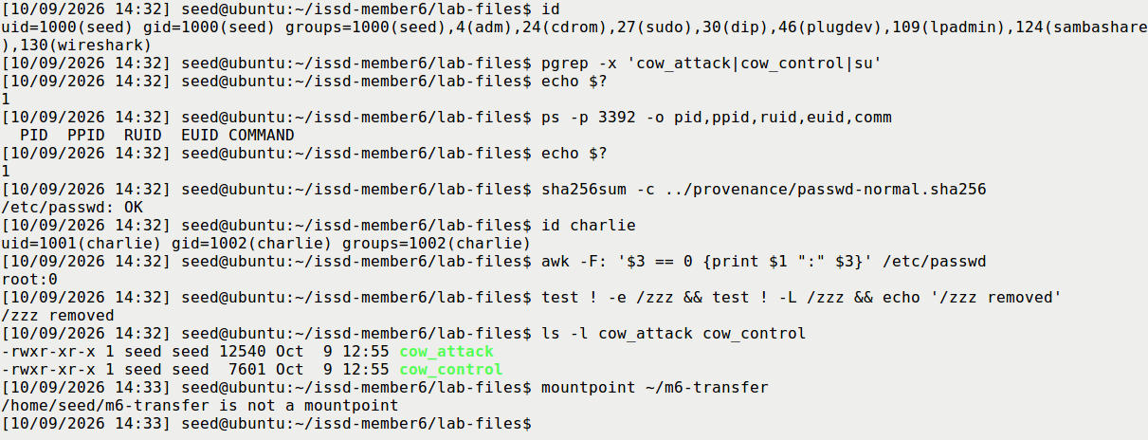
Figure 13 — S13 no experiment or login processes, absent proof PID, normal hash and UID list, removed dummy, ordinary executables and unmounted input share.
Both official tasks are supported by a complete evidence chain: ordinary write denial, correct normal COW, exact race-induced backing-file changes, a fresh non-sudo UID-0 login and verified restoration. The central lesson is that private memory changes must remain private. A kernel write-protection failure can undermine the account database trusted by authentication without cracking the user's password. Kernel patching is therefore the primary defence.

10. References and attribution
1. Wenliang Du / SEED Labs, Dirty COW Attack Lab, official page: https://seedsecuritylabs.org/Labs_20.04/Software/Dirty_COW/
2. Official task PDF and original setup: https://seedsecuritylabs.org/Labs_20.04/Files/Dirty_COW/Dirty_COW.pdf and https://seedsecuritylabs.org/Labs_20.04/Files/Dirty_COW/Labsetup.zip . Retained local copies are under Member6/reference/.
3. SEED VM download page and historical manual: https://seedsecuritylabs.org/labsetup.html and https://seedsecuritylabs.org/Labs_12.04/Ubuntu12_04_VM_Manual.pdf
4. Supplied lecturer text and ISSD presentation division PDF, Member 6 allocation, preserved in Member5/course-materials/.
5. Linux manual page, mmap(2): https://man7.org/linux/man-pages/man2/mmap.2.html
6. Linux manual page, madvise(2): https://man7.org/linux/man-pages/man2/madvise.2.html
7. Linux manual page, proc_pid_mem(5): https://man7.org/linux/man-pages/man5/proc_pid_mem.5.html
8. Ubuntu CVE-2016-5195 advisory: https://ubuntu.com/security/CVE-2016-5195 . The preparation audit retained the official tracker fallback after an advisory-page HTTP 504: https://git.launchpad.net/ubuntu-cve-tracker/plain/retired/CVE-2016-5195
9. Original SEED exploit source: https://github.com/seed-labs/seed-labs/blob/master/category-software/Dirty_COW/Labsetup/cow_attack.c
10. Repository Member 6 guide/adaptation, fresh run logs, full before/after copies, capture sidecars and live/offline verification records accompanying this report.
The repository's source research was checked during preparation on 29 September and 7 October 2026. The fresh session re-read the supplied task/source material and collected the reported experiment evidence on 9 October 2026; no new live advisory lookup is claimed here.
Attribution: the SEED task and exploit pattern are Copyright 2017 Wenliang Du / SEED Labs, licensed Creative Commons Attribution-NonCommercial-ShareAlike 4.0 International. The repository adaptation retains that attribution. The historical VM manual has its separate GNU Free Documentation License notice.
Assistance disclosure: GPT-6 Astra through OpenCode assisted with visible guest command delivery, source/evidence checks, genuine framebuffer/recording capture, export verification and document preparation. The user supplied the host settings captures and performed interactive authentication. The supplied four lab files were not rewritten during the fresh experiments. The folder name containing “opus” does not establish use of that model. No spoken rehearsal, classroom presentation or course upload is claimed to have already occurred.

Appendix — deliverables and provenance
README.md identifies the report, editable slides, speaker notes, live preparation/command guides and recorded Task 2 fallback. The user approved the generic Member 6 — ISSD cover. Personal/course identity, deadline/upload requirements and speaking allowance remain unconfirmed; the suggested 5–7-minute plan is provisional.
evidence/SELECTION.json maps 21 selected originals to their fresh sources and hashes. figures/CROP_MANIFEST.json records each readability crop. source/ contains the four unchanged lab files and hash manifest; automation/ contains the verification helpers used in the VM. logs/ retains both full transcripts, all task/control/restoration artifacts and the authentication failure. provenance/ retains the exact-file/export and snapshot/recording verification.
The complete fresh originals remain in Member6/evidence/incoming/opus-fresh-20261008/. The final 46-file guest export is member6-fresh-final-20261009.tar.gz, SHA-256:
08fe8d346f51f506a6b205683ead027d031a7d9fca34839045af7595bbb35fa1
The host compared its original sources, closed transcript, task artifacts, complete restored file and cleanup log. The protected root-held account backup and credential files remain in the guest. Follow LIVE_PREPARATION.md and LIVE_DEMO.md to prepare a future short dummy demonstration, state its actual outcome, and clean up afterward.

