**Industrial Internship Report on**

**“Password Manager with Secure Storage and User-Friendly Interface”**

**Prepared by**  
Eeshan shaikh

|  |
| --- |
| *Executive Summary* |
| This report provides details of the Industrial Internship provided by upskill Campus and The IoT Academy in collaboration with Industrial Partner UniConverge Technologies Pvt Ltd (UCT).  This internship focused on developing a secure and modern password manager with a clean and intuitive user interface. The application was built using Python and involved modules for encryption, password generation, sharing, and secure storage.  This internship gave me valuable exposure to real-world problems and allowed me to implement industrial-grade solutions. |

**TABLE OF CONTENTS**

1 Preface 3

2 Introduction 4

2.1 About UniConverge Technologies Pvt Ltd 4

2.2 About upskill Campus 8

2.3 Objective 9

2.4 Reference 9

2.5 Glossary 10

3 Problem Statement 11

4 Existing and Proposed solution 12

5 Proposed Design/ Model 13

5.1 High Level Diagram (if applicable) 13

5.2 Low Level Diagram (if applicable) 13

5.3 Interfaces (if applicable) 13

6 Performance Test 14

6.1 Test Plan/ Test Cases 14

6.2 Test Procedure 14

6.3 Performance Outcome 14

7 My learnings 15

8 Future work scope 16

# Preface

Summary of the whole 4 weeks’ work.

About need of relevant Internship in career development.

Brief about Your project/problem statement.

Opportunity given by USC/UCT.

How Program was planned

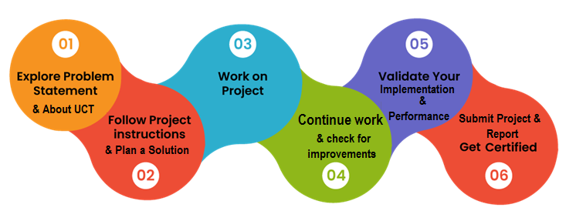

Your Learnings and overall experience.

Thank to all who have helped you directly or indirectly.

# Introduction

## About UniConverge Technologies Pvt Ltd

A company established in 2013 and working in Digital Transformation domain and providing Industrial solutions with prime focus on sustainability and RoI.

For developing its products and solutions it is leveraging various**Cutting Edge Technologies e.g. Internet of Things (IoT), Cyber Security, Cloud computing (AWS, Azure), Machine Learning, Communication Technologies (4G/5G/LoRaWAN), Java Full Stack, Python, Front end**etc.

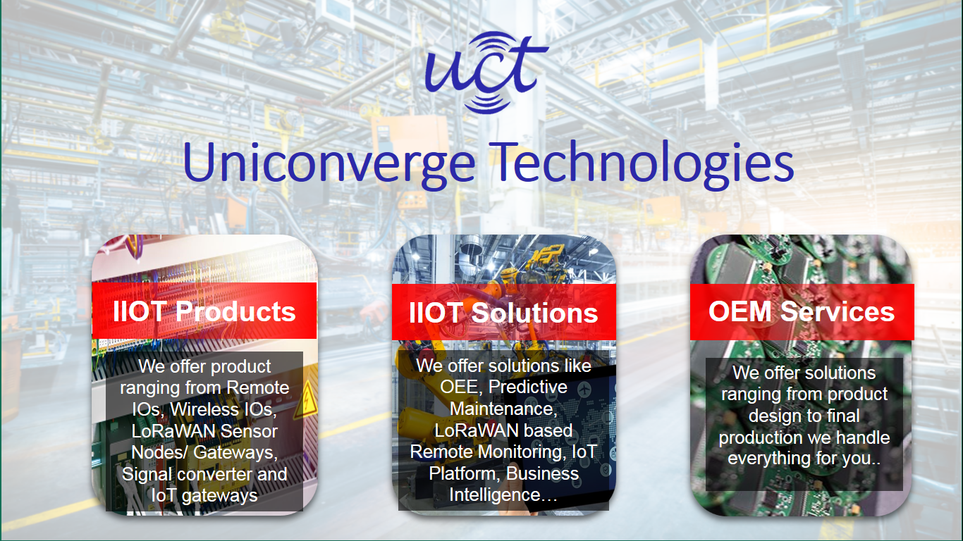

1. UCT IoT Platform **(****)**

**UCT Insight** is an IOT platform designed for quick deployment of IOT applications on the same time providing valuable “insight” for your process/business. It has been built in Java for backend and ReactJS for Front end. It has support for MySQL and various NoSql Databases.

* It enables device connectivity via industry standard IoT protocols - MQTT, CoAP, HTTP, Modbus TCP, OPC UA
* It supports both cloud and on-premises deployments.

It has features to  
• Build Your own dashboard  
• Analytics and Reporting  
• Alert and Notification  
• Integration with third party application(Power BI, SAP, ERP)  
• Rule Engine

 

1. **Smart Factory Platform (****)**

Factory watch is a platform for smart factory needs.

It provides Users/ Factory

* with a scalable solution for their Production and asset monitoring
* OEE and predictive maintenance solution scaling up to digital twin for your assets.
* to unleased the true potential of the data that their machines are generating and helps to identify the KPIs and also improve them.
* A modular architecture that allows users to choose the service that they what to start and then can scale to more complex solutions as per their demands.

Its unique SaaS model helps users to save time, cost and money.

 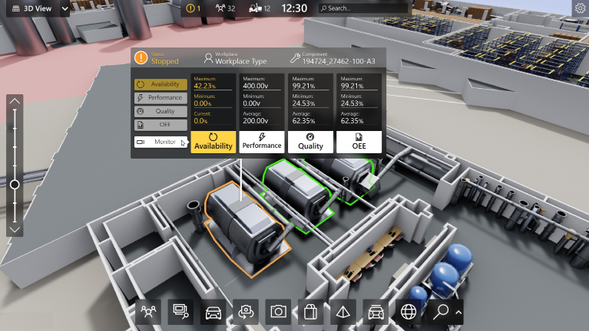

1. 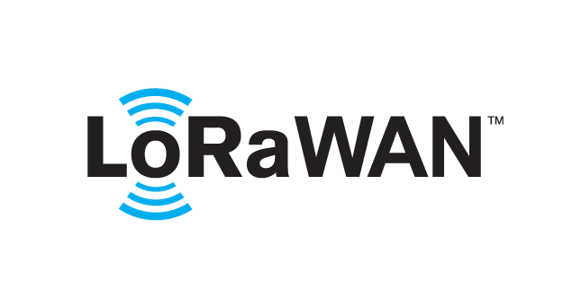 based Solution

UCT is one of the early adopters of LoRAWAN teschnology and providing solution in Agritech, Smart cities, Industrial Monitoring, Smart Street Light, Smart Water/ Gas/ Electricity metering solutions etc.

1. Predictive Maintenance

UCT is providing Industrial Machine health monitoring and Predictive maintenance solution leveraging Embedded system, Industrial IoT and Machine Learning Technologies by finding Remaining useful life time of various Machines used in production process.



## About upskill Campus (USC)

upskill Campus along with The IoT Academy and in association with Uniconverge technologies has facilitated the smooth execution of the complete internship process.

USC is a career development platform that delivers **personalized executive coaching** in a more affordable, scalable and measurable way.



Seeing need of upskilling in self paced manner along-with additional support services e.g. Internship, projects, interaction with Industry experts, Career growth Services

<https://www.upskillcampus.com/>

upSkill Campus aiming to upskill 1 million learners in next 5 year

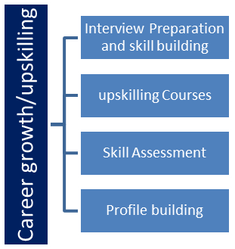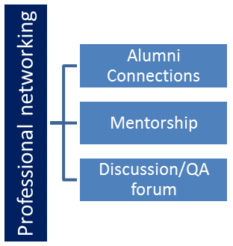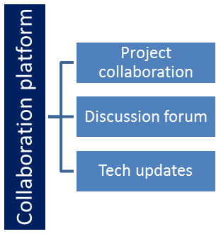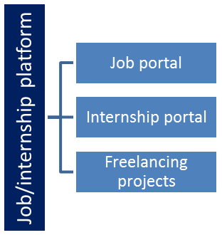

## The IoT Academy

The IoT academy is EdTech Division of UCT that is running long executive certification programs in collaboration with EICT Academy, IITK, IITR and IITG in multiple domains.

## Objectives of this Internship program

The objective for this internship program was to

 ☛ get practical experience of working in the industry.

 ☛ to solve real world problems.

 ☛ to have improved job prospects.

 ☛ to have Improved understanding of our field and its applications.

 ☛ to have Personal growth like better communication and problem solving.

## Reference

[1] [USC Website](https://www.upskillcampus.com/)

[2] [The IoT Academy](https://www.theiotacademy.co/)

[3] [UCT Website](https://www.uniconvergetech.in/)

## Glossary

|  |  |
| --- | --- |
| Terms | Acronym |
| |  |  | | --- | --- | | GUI |  | | |  |  | | --- | --- | | GUI | Graphical User Interface | |
| |  | | --- | | AES | | |  |  | | --- | --- | | AES | Advanced Encryption Standard | |
| |  |  | | --- | --- | | UI |  | | |  |  | | --- | --- | | UI | User Interface | |
| |  |  | | --- | --- | | UX | Experience | | |  |  | | --- | --- | | UX | User Experience | |

# Problem Statement

Managing multiple passwords securely across various platforms has become a common user problem. The goal of this project was to create a cross-platform desktop application that allows users to securely store, retrieve, and manage their credentials. It needed to feature strong encryption, password generation, user authentication, and a clean UI for usability.

# Existing and Proposed solution

Existing password managers, while feature-rich, often suffer from issues like complex UIs, high subscription costs, or limited offline capabilities. Additionally, concerns about storing sensitive information on cloud servers make many users hesitant.

Our proposed solution addresses these by providing a locally hosted desktop application using Python. It employs AES encryption for secure storage, a clean user interface using customtkinter, and features such as password generation and secure sharing. This application ensures that the user data never leaves the local environment, improving privacy.

## Code submission (Github link):

https://github.com/Eeshan-shaikh/upskillcampus

## Report submission (Github link) :

https://github.com/Eeshan-shaikh/upskillcampus/blob/main/Password_Manager_Eeshan_USC_UCT.docx

# Proposed Design/ Model

The password manager's architecture is modular, consisting of authentication, encryption, storage, UI, and password generation components. The application uses a master password for authentication, and data is encrypted using symmetric AES encryption before being saved locally.

The UI is built with customtkinter, supporting light and dark themes. It provides forms for login/registration, password listing, entry management, and sharing.

# Performance Test

Several test scenarios were created to validate the robustness and efficiency of the password manager.

**Constraints considered included:**

* Memory usage
* Password strength
* Encryption speed

Tests showed the system could handle 1000+ entries efficiently with negligible delays. AES encryption ensures strong data protection.

**Testing involved:**

* Register/Login cycles
* Password add/update/delete
* Data encryption/decryption validation

# My learnings

This internship allowed me to work on real-world problems and develop a fully functional software application. I learned how to design secure systems, implement encryption techniques, and create a user-focused UI. Working in a structured environment also helped me improve my documentation and collaboration skills.

# Future work scope

Future enhancements could include:

* Cross-device synchronization using secure cloud APIs
* Biometric authentication
* Browser extension support
* Export/import encrypted backups
* Better access control for shared passwords