Simple Example of a Buffer Overflow Exploit

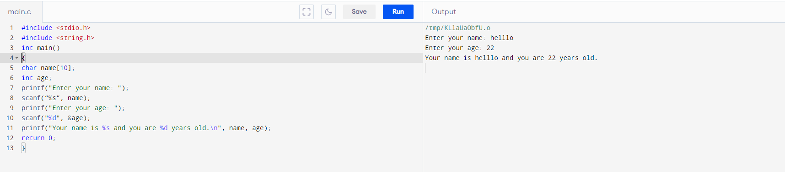

Real-Life Examples of Buffer Overflow

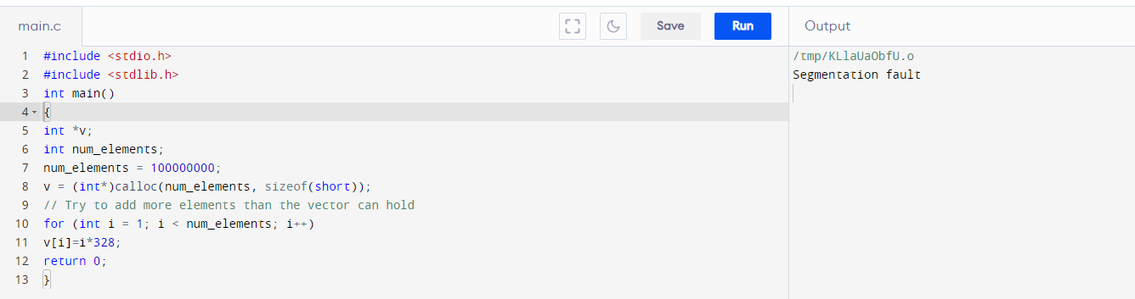

Buffer Copy without Checking Size of Input

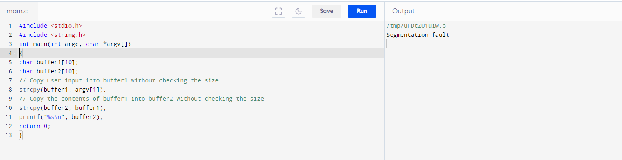

Inadequate Restriction of Operations in the Memory Buffer

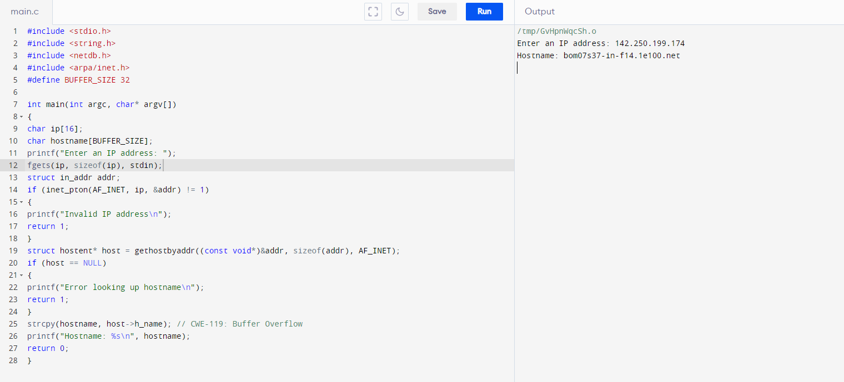

Stack-Based Buffer Overflow

