# The Impact of Digital Banking on Personal Financial Management among Regular Employees in Dasmariñas Cavite

## Abstract

This study investigates the impact of digital banking on Personal Financial Management (PMF) among regular employees in Dasmariñas, Cavite. With the increasing adoption of digital banking, it is important to examine how these platforms transformed and enhanced employee's personal financial management practices. The independent variable, digital banking, is evaluated based on factors such as frequency of use, type of services utilized, perceived ease of use and accessibility, and as well as perceived security and trust. The dependent variable, PMF, is measured through budgeting and expense tracking, savings and investment behavior, debt management, and financial discipline and planning. Using a quantitative research design and web-based questionnaires, data will be collected from random regular employees in Dasmariñas, Cavite. Statistical tools such as descriptive-correlational design will be employed to determine the significance of digital banking’s influence on financial management practices. The findings of this study are expected to provide valuable insights on how digital financial technologies contribute to personal financial management among regular employees, particularly in Dasmariñas, Cavite.

# Chapter 1

## **Overview of the Topic/Introduction**

Digital banking encompasses mobile‑app accounts, online transfers and e‑wallets has exploded in the Philippines over the past decade, driven by high mobile‑phone penetration, government push for financial inclusion, and the convenience of 24/7 access. In Dasmariñas, Cavite, a growing urban‑suburban workforce now regularly interacts with these platforms for salary deposits, bill payments, peer‑to‑peer transfers, and investments.

The changes toward traditional banking to digital banking in the Philippines has transformed the way people manage their finances, offering tools that are faster, more accessible, and increasingly automated with tools as diverse as mobile banking applications, contactless payments and algorithmic tools for budgeting. While it opens up opportunities for heightened financial awareness, easy monitoring of accounts, and structured ways of saving, they may still also harbor potential threats that face the likes of impulse spending and increasing credit reliance and as well the frequent use in their daily lives. This is most probably today's urgent questioning on impulse spending and more reliance on debt. It was particularly the right path for the category of regular workers with their limited incomes and daily financial responsibilities.

Regular employees are particularly vulnerable to both benefits and risks of digital banking. They are often with tight discretionary budgets and their state of effective financial management depends on budget accuracy and expense tracking, savings and investment behavior, debt management, and financial discipline and planning.

Understanding how digital banking thereby transforms much of this behavior with regards to the socio-economic context of Dasmariñas City, Cavite. Therefore, this study will help to provide the need for the design of targeted financial literacy interventions, bank product design, and orientation for policymakers in the improving financial health of the regular employees of the city's workforce.

This research will fill a gap in the Philippine literature by linking the rapid expansion of digital banking with daily financial management practices of regular employees in Dasmariñas City, Cavite. Based on the study of Orencia (2023), they documented the drivers of digital-banking growth (e.g. widespread internet, mobile-phone adoption, and supportive government policies) and its broad impact on financial inclusion. However, little is known about how digital banking influences the personal financial habits, behaviors, and overall financial health of regular employees.

This study seeks to (1) assess prevalence and patterns of digital banking use and (2) evaluate its impact on budgeting, expense tracking, savings and investment behavior, debt management, and financial discipline and (3) knowing the significance relationship between the use of digital banking and overall financial management of regular employees.

## **Background of the study**

## **Review of Related Literature**

**Digital Banking**

According to Alawan et al., 2019, digital banking digital banking platforms are given convenient access in financial services such as account monitoring, fund transfer and budgeting tools. This study features individuals using digital banking to manage finances more effectively providing the data and automated expense tracking. Digital Banking platforms give the users an ability to conduct financial transactions anytime and anywhere, significantly they don’t need to visit the physical Branch. Frequent monitoring and managing personal finances leads to more convenience. According to Ozili (2018), using digital banking can reduce the transaction cost and time, allowing the user to engage more actively in managing their finances. A study by Lusardi and Mitchell (2017) emphasizes using digital platforms can enhance financial literacy providing accessible information, by leading to better financial decision making. Agarwal et al., (2020) Having a real time data visualization of financial data can improve the users awareness by their spending, leading and better financial control. Automated features such as schedule of bill payments, saving goals and spending alerts embedded in digital banking apps to discipline financial behavior.

The convenience and accessibility of digital banking encourage every users to save more of their money by automating saving and providing an easy way to access saving accounts. This shift positively impacts personal financial management by promoting disciplined saving habits (Kumar & Gupta, 2020). In the study of Thaler and Sunstein (2008) such “nudges” help the users overcome the selfcontrol problems, leading to improved saving and budgeting habits.

Digital banking became an important tool for personal finance management. Yet, its effects on financial behavior, decision making and overall financial health among regular employees. A growing section

Digital banking has rapidly become the prominent tools for personal finance management. Yet, its effects on financial behavior, decision-making, and overall financial health among regular employees remain vague. A growing section in Dasmariñas City contacted Cavite employees about using mobile banking apps, contactless payments, and even algorithm-guided budgeting tools (Alvarez & Santos, 2022). Instant monitoring and automating savings are created using such technology, and yet lessens transaction friction, which may result in impulsive spending and expanded credit use (Kumar & Sharma, 2020).

Demirguc–Kunt et al. (2018) recognize that mobile banking and digital wallets have significantly increased financial inclusion, enabling users to save, transfer money and access credit, which can improve personal financial management. However study by Alalwan et al., the willingness of using digital banking services, can limit their impact on personal financial management.

**Personal Financial Management (PMF)**

According to Xiao and O’Neill (2018) personal Financial Management (PFM) refers to the practices of individuals planning , organizing and controlling their finances to achieve both short term stability and long term security. It typically covers budgeting , saving, debt management and also investment decisions. Research also showed that individuals who actively use personal financial management get a higher experience level of financial well being and reduce stress (Hilgert, Hogart & Beverly, 2003). Study revealed that digital banking enhances personal finances through lower transaction costs, faster processing using financial tools (Adewoye, 2013). For employees, this accessibility directly influences their ability to plan and manage their personal financial management.

The study of Allen, Demirguc-Kunt, Klapper, and Peria (2016) found that individuals have an access to digital financial information were more likely to save formally, reduce the dependency on informal credit and participate in long term investment. For employees, its effective to use digital banking for budgeting features, bill reminders, and automated savings mechanisms for the improvement of financial discipline. The adoption of digital platforms into banking has been linked to higher financial literacy and awareness. Grohmann, kluh and Menhoff (2018) agreed that digital tools help everyone to have a better understanding of their spending habits and saving patterns by providing financial data. Similarly, Lusardi and Mitchell (2014) emphasize that mobile applications can feature the transaction summary and can budget tracker foster decision making.

**Budgeting Accuracy**

Digital Banking tools increase the engagement of personal finances by providing interactive budgeting features and alerts. This engagement increases financial discipline, which correlates to improved budgeting accuracy and better outcomes for individuals (Nguyen & Hoang, 2023)

Digital Banking tools increase the engagement of personal finances by providing interactive budgeting features and alerts. This engagement increases financial discipline, which correlates to improved budgeting accuracy and better outcomes for individuals (Nguyen & Hoang, 2023). People depend on digital banking in terms of budgeting as it provides real-time transaction categorization, automated tracking, and visual dashboards that reduce manual entry errors. According to Yang et al. (2023), technologies “enhance financial control and convenience” by delivering instant feedback on spending patterns, which directly supports more accurate budget formulation.

**Expense Tracking**

The rise of digital banking and e-wallets has significantly transformed expense tracking by enabling users to monitor their spending habits more effectively. These tools provide real-time transaction records, budgeting features, and spending alerts, which enhance financial awareness and control (Chen & Li, 2017). Studies show that digital payment systems encourage better money management by simplifying expense categorization and offering insights into spending patterns, thus promoting savings and reducing impulsive purchases (Faten, 2024; Unlocking Spending Trends, 2023). However, some research also highlights potential risks of overspending due to the ease of digital payments, underscoring the need for financial literacy alongside technology use (Journal of Consumer Spending, 2024; PMC, 2022).

**Savings and Investment Propensity**

According to Barber and Odean (2013), the accessibility of investment options through digital channels encourages more individuals to participate in wealth accumulation, positively impacting long-term financial management. Digital banking in the Philippines, specifically for regular employees, can improve savings and investment propensities by addressing the barriers like time constraints and limited branch access, lastly contributing to better financial stability and wealth accumulation. Digital banking and e-wallets have revolutionized personal finance by facilitating easier access to savings accounts, automated transfers, and investment platforms, thereby boosting users' propensity to save and invest. Research indicates that these technologies can lower barriers to entry for financial products, encourage habitual saving through features like accumulated investments, and provide real-time insights that enhance financial decision-making (Agarwal et al., 2021; Demirgüç-Kunt et al., 2018).

**Debt Management**

Debt management has long been considered as a critical component of personal financial well-being. It refers to the capability of individuals to effectively manage their borrowing obligations such as consumer loans, credit cards, and mortgages. Proper management ensures financial security, lessens the likelihood of delinquency, and enhances an individual’s ability to achieve long-term financial goals. As financial technology continues to rise, digital banking has improved how individuals access, manage and repay their debt. Nowadays, most of the digital banking platforms have a function that enables instant loan applications, faster credit scoring, and simplified disbursement procedures, thereby widening access to credit (Asian Development Bank [ADB], 2021). According to Parab and Devanadhen (2020), digital banking has significantly reduced barriers to credit access for salaried workers and small borrowers that which may also increase the risk of over-indebtedness, especially when individuals are not well equipped with adequate financial literacy skills to evaluate loan terms and repayment obligations. One of the primary advantages of digital banking in debt management lies in tools such as repayment reminders, auto debit features, and real time balance monitoring. Fanta et al. (2020) discovered that these features help borrowers avoid penalties, restructure debts, maintain discipline in repayment schedules. Moreover,

**Financial Discipline and Planning**

Financial discipline applies to an individual’s ability to control spending, prioritize needs over wants, and consistently follows budget. On the other hand, financial planning involves setting financial goals whether short or long term, allocating resources, and preparing for future obligations. According to Lucardi and Mitchell (2014), these two concepts are essential pillars of financial literacy that enable individuals to achieve financial stability. Effective financial discipline ensures that savings and investments become habitual, while planning provides the strategy or guide for meeting future goals. Studies show that access to digital financial tools improves budgeting practices by offering reminders, spending alerts, and goal-setting options (Ahamed & Mallick, 2019). For instance, mobile banking applications can automatically notify users when bills are due or when spending exceeds preset thresholds, reinforcing financial discipline. A key contribution of digital banking to financial planning is the ability to automate savings and align them with specific goals. Research has found that individuals who use automated transfers into savings or investment accounts demonstrate stronger commitment to their financial plans and are less likely to withdraw funds prematurely (Loaba, 2022). Goal-oriented features such as “savings jars” or “investment buckets” encourage users to visualize progress, improving both motivation and financial discipline (Varlamova, 2020).

## **Synthesis of Review**

The reviewed literature consistently highlights the impactful role of **digital banking** in shaping personal financial management (PMF). This study emphasizes that digital platforms enable users to conduct transactions anytime and anywhere, reducing reliance on physical bank visits while enriching greater engagement in financial activities (Alalwan et al., 2019; Ozili, 2018). Digital banking features such as real-time monitoring, automated expense tracking, and budgeting tools improve financial control, literacy, and decision making (Lusardi & Mitchell, 2017; Agarwal et al., 2020). These platforms further promote disciplined saving habits through nudges, automated savings, and goal-setting features (Kumar & Gupta, 2020; Thaler & Sunstein, 2008). However, while digital banking offers convenience, some studies caution that the ease of transactions may also result in impulsive spending and excessive use of credit (Kumar & Sharma, 2020).

As to budgeting accuracy, digital banking enhances financial discipline by providing interactive dashboard, automated categorization, and alerts that manual errors and enhance finance awareness (Nguyen & Hoang, 2023; Yang et al., 2023). Similarly, expense tracking delivers real time transaction records and spending overviews which increase savings and reduce impulsivity (Chen & Li, 2017; Faten, 2024). In addition, research indicates that digital platforms positively influence savings and investment propensity through reducing barriers to entry, simplifying transactions, and allowing access to various investment channels (Barber & Odean, 2013; Agarwal et al., 2021). Accessibility is particularly essential for employees who have limited time or access to physical branches and this supports long-term financial stability (Demirgüç-Kunt et al., 2018). Likewise, digital banking improves debt management by streamlining credit access and repayment processes by tools like repayment reminders, auto-debits, and real time balance monitoring (ADB, 2021; Fanta et al., 2020). Nonetheless, studies also encompass the risks of over-borrowing, especially among users with insufficient financial literacy (Parab & Devanadhen, 2020).

Lastly, literature underlines the dual role of digital banking in strengthening financial discipline and planning. Access to digital tools encourages individuals to prioritize needs, strictly stick to budget, and pursue financial goals through features e.g., alerts, automated transfers, and saving jars (Ahamed & Mallick, 2019; Varlamova, 2020). This combination allows users to establish stronger commitments to their financial objectives and achieve stability (Lucardi & Mitchell, 2014; Loaba, 2022).

Overall, the synthesis concludes that while digital banking can enhance personal financial management through improved budgeting, tracking, saving, investing, debt handling, and planning, its effectiveness is dependent on users’ financial literacy. Studies show the digital banking opportunities such as discipline and convenience, and challenges such as overspending and privacy concerns. This implies a gap that further exploration is required to examine how regular employees, specifically in Dasmariñas City, Cavite, balance the advantages and disadvantages of digital banking when managing their finances.

## **Theoretical Framework**

The study of Impact of digital banking on personal financial management among regular employees can be anchored on several interrelated theories that explain the financial behavior using digital banking. First the Technology Acceptance Model (TAM) by Davis 1989, provides a lens to understand how employees adopt digital banking platforms. Technology Acceptance Models submit that perceived usefulness and perceived ease of use influence an individual's attitude toward technology and subsequent usage behaviors. In this context of the study , digital banking services are adopted by employees if they believe that digital banking can improve financial, convenience, accessibility and efficiency in managing personal financial management.

Moreover, the Life cycle Hypothesis (Modigliani & Brumberg 1954) also supports the financial management aspect, suggesting that individuals plan their consumption and saving behaviors over their lifetime to ensure their financial stability. Digital banking platforms like online savings, budgeting tools, and credit monitoring can provide mechanisms for the employees to align with the cycle of financial management.

Through this theories illustrate that digital banking adaptation is not simply a technological shift but also a behavioral and financial planning tool to make the finances of each employee absolutely manageable. By linking Technology Acceptance Model (TAM) and TPB with the life cycle hypothesis, strengthening by the study how digital financial can improve the personal financial management of employee efficiency and accessibility by supporting long term financial stability

## **Conceptual Framework**

**Independent Variables Dependent Variables**

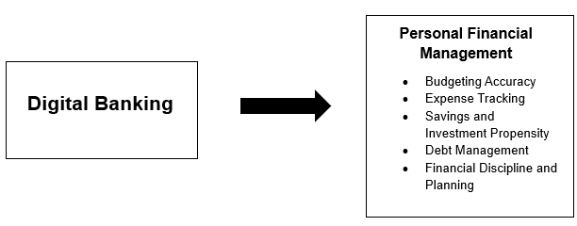

This figure illustrates a relationship between two types of variables related to study of “The Impact of Digital Banking on Personal Financial Management among Regular Employees in Dasmariñas, Cavite”

The independent variable (Digital Banking), focuses on Mobile Banking and Digital Wallets. This independent variable can significantly impact the dependent variable (Personal Financial Management) on how employees manage their personal finances. This study is expected to show that employees who actively use digital banking demonstrate higher levels of financial discipline compared to those with limited adoption.

## **Statement of the Problem**

This study intends to determine the impact of digital banking towards personal financial management among selected regular employees of Dasmariñas City, Cavite.

Specifically, this study sought to answer the following questions:

1. What is the profile of the respondents in terms of:
   1. Age
   2. Sex
   3. Educational Attainment
   4. Job Position Level
   5. Number of Years in the work
   6. Monthly Compensation
2. What is the level of usage and accessibility of digital banking among the respondents?
3. How do the respondents assess the personal financial management practices in using digital banking in terms of the following aspects?
   1. Budget accuracy
   2. Expense tracking
   3. Savings and Investments management
   4. Debt management
   5. Financial discipline and planning
4. Does the use of digital banking impact personal financial management among respondents?

## **Hypothesis**

This study seeks to determine the impact of digital banking on personal financial management among regular employees of Dasmariñas, Cavite. Guided by the conceptual framework, the following hypotheses are formulated:

H₀: Digital banking has no significant impact on the personal financial management of regular employees in Dasmariñas, Cavite.

H₁: Digital banking has a significant positive impact on the personal financial management of regular employees in Dasmariñas, Cavite.

## **Significance of the Study**

This study on the impact of digital banking on personal financial management among regular employees in Dasmariñas City, Cavite is significant for several stakeholders. The findings will contribute to the existing body of knowledge and will also serve as a practical guide for individuals, institutions, and policymakers. This study hopes to provide significant information to the following:

**For regular employees.** The study will provide insights into how digital banking has influenced their budgeting and expense tracking, savings and investment management, debt management, and financial discipline and planning practices. This study will understand both the benefits and risks of using digital banking tools as employees can make more informed financial decisions that promote financial stability and security.

**For employers.** The study will provide insights into how digital banking has influenced their budgeting and expense tracking, savings and investment management, debt management, and financial discipline and planning practices. This study will understand both the benefits and risks of using digital banking tools as employees can make more informed financial decisions that promote financial stability and security.

**For financial institutions.** The findings will give valuable insights into employee level usage patterns and will guide the design of user-friendly, secure platforms that promote responsible saving rather than merely transaction volume.

**For policymakers and local governments.** The findings will inform the development of policies and programs aimed at increasing financial inclusion, consumer protection, and digital literacy in the city. Addressing the gaps between financial behavior and digital access can create stronger economic resilience in the area.

**For future researchers.** The study contributes academically by providing empirical evidence of digital banking’s impact on personal financial management in developing the economic context and providing comparable investigations across other emerging market regions.

## **Scope and Limitations**

This study focuses on examining the impact of digital banking on personal financial management among regular employees in Dasmariñas City, Cavite. The researchers seek to assess how the use of digital banking affects employees’ budgeting practices, saving and investment, debt management, expense tracking, and financial decision and planning. The respondents will be limited to regular employees working in Dasmariñas, Cavite. The study will focus on digital banking platforms such as digital banking and online banking.

However, this study has certain limitations. The study will only be conducted to Dasmariñas, Cavite, hence, the results cannot be generalized to employees in other regions. The respondents will only regular employees, thereby omitting contractual, part-time, and unemployed workers who might also use digital banking applications. Thus, it does not include business owners and freelancers. The investigation will focus on the Philippine digital banking apps, so other platforms such as corporate banking, stock trading platforms, and insurance platforms are not covered in this study. The research instrument used for this study is a questionnaire using a Likert scale to measure responses. The study will cover the year 2025 and will use quantitative methods supported by statistical tools and will be further discussed in the methodology. Lastly, any other elements or theories that are not highly relevant to the study were enclosed in order to concentrate on the information suitable for the research study.

**Definition of Terms**

This study contains certain key concepts and jargon. Although these jargons are discussed in detail throughout the course of this research paper, they are briefly introduced in this early chapter of the study to allow the reader to be knowledgeable of the terms presented in the subsequent chapters. The following terms were defined operationally to have a clear and common understanding of the key words used in the study.

**Budget Accuracy.** This is the degree to which the projected or estimated budget aligns with the actual results or outcomes.

**Digital banking.** This refers to the tools or applications used to have an easy access and convenient system that the regular employees will be able to use.

**Debt Management.** This commonly refers to a personal process of individuals addressing the terms of an outstanding debt.

**Expense Tracking.** This simply means recording, categorizing, and monitoring spending to understand where money goes over a given period.

**Financial Discipline and Planning.** This refers to an individual's ability to control spending and allocate resources for future obligations.

**Personal Financial Management.** This refers to the process of managing or handling financial activities, including budgeting, saving, investing, debt management and planning future financial goals.

**Regular Employees.** This refers to the employees who are full-time and permanent workers from selected institutions and companies which will be respondents in Dasmariñas, Cavite.

**Savings and Investments propensity.** This is defined as the tendency or willingness of an individual or household to set a part of current income towards savings and investments.

**Chapter 2**

# **Methodology**

**RESEARCH METHODOLOGY**

This chapter acquires the data that can support the notion the researchers have regarding their study and lead to sufficient findings, the researchers have considered these methodological aspects in order for them to accumulate reliable data results. This provides information regarding research design, population and sampling procedure, research instruments, data gathering, and statistical treatment of data to determine the impact of digital banking to personal financial management of regular employees in Dasmariñas City, Cavite.

## Research Design

Research design is the plan and structure of study to obtain answers to researchers’ questions. It expresses both the structure of the research problem and the plan of study to obtain empirical evidence on those relationships. The quantitative research paradigm was undertaken in the study.

The researchers used descriptive-correlation research design when collecting relevant data. The descriptive aspect will determine the level of digital banking usage and its impact on budgeting accuracy, savings and investment, debt management, expense tracking, and financial planning and decision making of the regular employees. While the correlational aspect will examine the relationship between the use of digital banking (independent variable) and personal financial management (dependent variable). The quantitative research consists of analyzing the theory by stipulating narrow hypotheses and gathering data in order to support or contradict the hypotheses.

## Population and Sampling Procedure

The regular employees in Dasmariñas Cavite were chosen as the population of the study. They represent a group that consistently engages in Personal Financial Management. Regular employees have a stable source of income, making them more likely to use digital banking in managing their finances, through this population they were capable of giving reliable information for this study.

The respondents of this study were selected through a combination of purposive and convenience sampling. Through purposive sampling researches ensure that only participants who meet the study criteria, specifically regular employees in Dasmariñas Cavite. This was necessary to align with the objective predetermining the impact of digital banking on personal financial management among individuals. Convenience sampling was applied by selecting the respondents who were accessible and willing to participate in the survey.

Where:

l = sample size

l Z = Z value (1.96 for 95% confidence level)

l P = estimated proportion of population (commonly 0.05 for maximum variability)

l q = 1-p (so 0.05)

l e = margin of error (0.05 = 5%)

To determine the appropriate number of respondents, researchers used Cochran's Formula since the population of regular employees in Dasmariñas Cavite is large. The researcher uses a Z-value of 1.96 which corresponds to 95% confidence level, the most accepted standard in social experiment research as it balances accuracy and feasibility. The (p) was assumed as 0.5 since the exact proportion of employees using digital banking is unknown. Therefore, the value of (q) was set as 1-p is equal to 0.5, while margin of error (e) was fixed at 0.05 which is commonly used for acceptable precision without requiring an unreasonably large number of respondents.

Where:

Therefore, the total respondents of the study was 385, which researchers gave a questionnaire about digital banking by managing their personal financial management to ensure a balance comparison.

## Research Instruments

**Data Gathering**

Data will be collected through specified questionnaires using descriptive survey methods. The survey method will be based on the primary data collection technique. This method will be used to describe the characteristics and impact of digital banking in personal financial management of regular employees. The descriptive survey approach has several advantages, including high accuracy, flexibility, and to collect a huge amount of data. This survey also provides a reasonably rapid, economical, efficient, and behavior of those who seek more information in Dasmariñas City, Cavite.

All of the items were created using a 5-point Likert scale. Each question will be formulated to obtain essential information from the participants who are willing and able to participate in this study. Questionnaires for this study were divided into four parts:

**Socio-Demographic Profile.** The first part of the questionnaire sought to identify their socio-demographic profile based on their personal information such as their age, sex, educational attainment, income level, and marital status.

**Digital Banking Usage and Accessibility.** The second part of the questionnaire will be composed of three questions that will measure the level of accessibility in digital banking. This consists of knowing the digital banking tools the respondents usually use, how long they are using it, and the accessibility of using digital banking apps that assess the participants’ certain levels of agreement.

**Impact of Digital Banking on Personal Financial Management.** The third part of the questionnaire was composed of items for each indicator: (a) budget accuracy, (b) savings and investment, (c) debt management, (d) expense tracking, (e) financial planning and decision.

Table 1. Five-point scale for the accessibility/usage of digital banking to personal financial management of the participants

| **SCALE** | **VERBAL EVALUATION** |
| --- | --- |
| 5 | Strongly Agree/Always |
| 4 | Agree/Often |
| 3 | Neutral/Sometimes |
| 2 | Disagree/Rarely |
| 1 | Strongly Disagree/Never |

The level of agreement ranges from 1-5, 1 means that the participants strongly disagrees or never experience the given statement and 5 means they strongly agree or always experience the given situation. Higher rate of a certain influence indicates stronger impact of digital banking to personal financial management of the participants. Table 2 will be used as parameters in interpreting the gathered data.

Table 2. Parameters in measuring the impact of digital banking to personal financial management of the participants

| **INTERVAL** | **VERBAL INTERPRETATION** | **ADJECTIVAL INTERPRETATION** |
| --- | --- | --- |
| 4.20 and above | Very High | Digital banking has been extremely influential to regular employees on their personal financial management. |
| 3.40- 4.19 | High | Digital banking has been influential to regular employees on their personal financial management. |
| 2.60- 3.39 | Moderate | Digital banking has been somewhat influential to regular employees on their personal financial management. |
| 1.80- 2.59 | Low | Digital banking has been slightly influential to regular employees on their personal financial management. |
| 1.00- 1.79 | Very Low | Digital banking is not influential to regular employees on their personal financial management. |

## Validity Test

## Reliability Test

## Ethical Considerations

This study has the highest ethical standards to ensure that the rights, safety, and dignity of all participants are protected throughout the research process of this study. Prior to collecting data, researchers will be fully informed of the purpose, objective and procedure, as well as any potential risk and benefits of the study. Participation will be entirely voluntary, and informed consent before inclusion in the survey.

Respondents will also be assured of their right to decline to answer any question from the study at any time without penalty.

## Statistical Treatment

The data was tabulated and analyzed after the data were completely gathered and the survey was finished. The information from the respondents that were gathered was presented and described using frequency and percentage, arithmetic mean, and standard deviation.

Frequency and Percentage. The demographic profile of the participants was analyzed and presented using frequency and percentage.

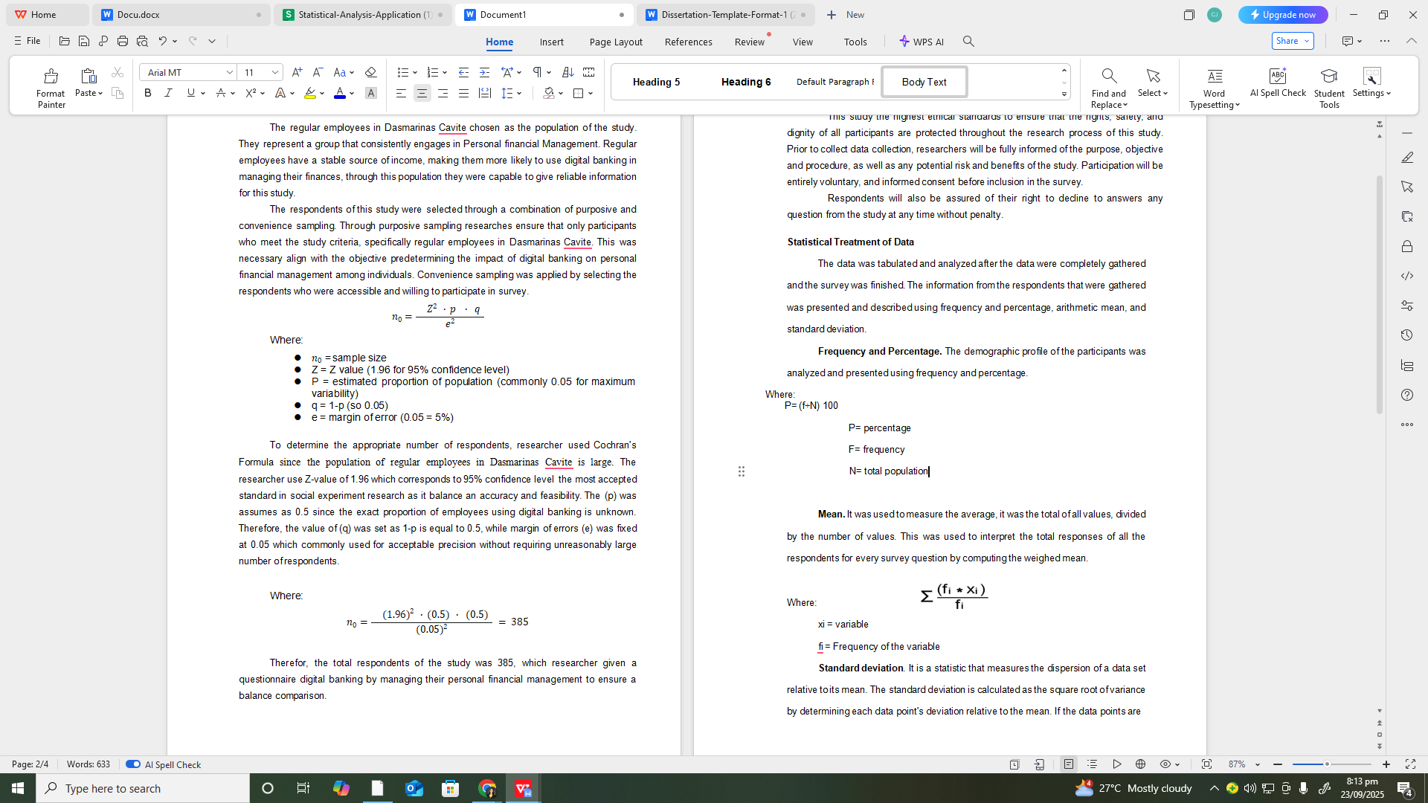

Mean. It was used to measure the average, it was the total of all values, divided by the number of values. This was used to interpret the total responses of all the respondents for every survey question by computing the weighted mean.

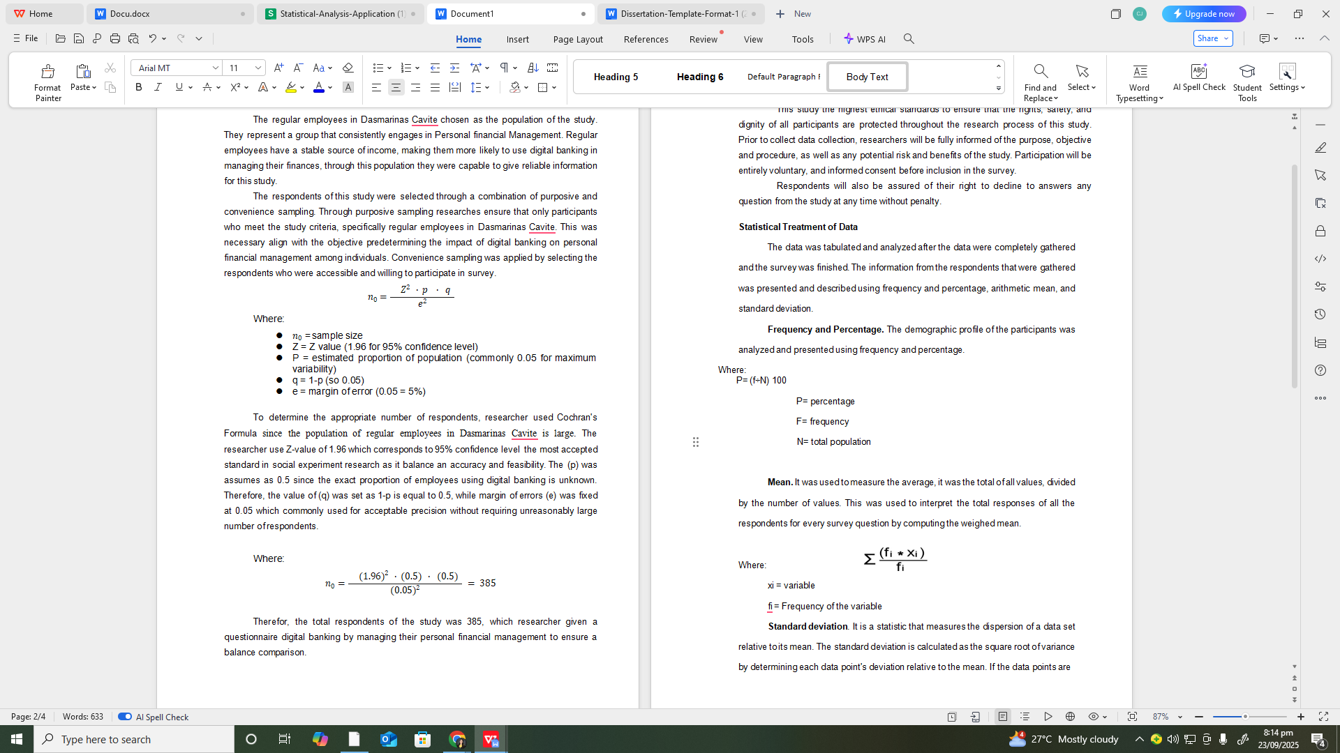

Standard deviation. It is a statistic that measures the dispersion of a data set relative to its mean. The standard deviation is calculated as the square root of variance by determining each data point's deviation relative to the mean. If the data points are further from the mean, there is a higher deviation within the data set; thus, the more spread out the data, the higher the standard deviation.

In identifying the impact of digital banking on personal financial management in selected regular employees among Dasmariñas Cavite, the mean was presented and interpreted with the following scale, qualitative description, and verbal interpretation.

# REFERENCES

* Adewoye, J. O. (2013). Impact of mobile banking on service delivery in the Nigerian commercial banks. International Review of Management and Business Research, 2(2), 333–344.
* Allen, F., Demirgüç-Kunt, A., Klapper, L., & Peria, M. S. M. (2016). The foundations of financial inclusion: Understanding ownership and use of formal accounts. Journal of Financial Intermediation, 27, 1–30.
* Grohmann, A., Klüh, T., & Menkhoff, L. (2018). Does financial literacy improve financial inclusion? Cross country evidence. World Development, 111, 84–96.
* Hilgert, M. A., Hogarth, J. M., & Beverly, S. G. (2003). Household financial management: The connection between knowledge and behavior. Federal Reserve Bulletin, 89, 309–322.
* Lusardi, A., & Mitchell, O. S. (2014). The economic importance of financial literacy: Theory and evidence. Journal of Economic Literature, 52(1), 5–44.
* Ozili, P. K. (2018). Impact of digital finance on financial inclusion and stability. Borsa Istanbul Review, 18(4), 329–340.
* Shaikh, A. A., & Karjaluoto, H. (2015). Mobile banking adoption: A literature review. Telematics and Informatics, 32(1), 129–142.
* Xiao, J. J., & O’Neill, B. (2018). Consumer financial education and financial capability. International Journal of Consumer Studies, 42(6), 534–548.
* Ozili, P. K. (2018). Impact of digital finance on financial inclusion and stability. Borsa Istanbul Review, 18(4), 329-340. <https://doi.org/10.1016/j.bir.2018.03.003>
* Lusardi, A., & Mitchell, O. S. (2017). Financial literacy and financial decision-making in older adults. Journal of Pension Economics & Finance, 16(4), 332-356. https://doi.org/10.1017/S1474747217000117
* Agarwal, S., Driscoll, J. C., Gabaix, X., & Laibson, D. (2020). The age of reason: Financial decisions over the lifecycle and implications for regulation. Brookings Papers on Economic Activity, 2017(2), 51-117. <https://doi.org/10.2139/ssrn.3038543>
* Alalwan, A. A., Dwivedi, Y. K., & Rana, N. P. (2017). Digital banking adoption: A systematic literature review and future research agenda. International Journal of Information Management, 37(3), 99-110. <https://doi.org/10.1016/j.ijinfomgt.2017.01.002>
* Demirgüç-Kunt, A., Klapper, L., Singer, D., Ansar, S., & Hess, J. (2018). The Global Findex Database 2017: Measuring financial inclusion and the fintech revolution. World Bank Group. <https://doi.org/10.1596/978-1-4648-1259-0>
* Thaler, R. H., & Sunstein, C. R. (2008). Nudge: Improving decisions about health, wealth, and happiness. Yale University Press.
* Kumar, R., & Gupta, P. (2020). Impact of digital banking on savings behavior of individuals. Journal of Financial Services Research, 57(3), 345-360. <https://doi.org/10.1007/s10693-020-00330-1>
* Chen, X., & Li, Y. (2017). The Impact of Widespread Use of Digital Payment System on The Management of Personal Savings and Spending. African Journal of Biomedical Research.
* Faten, A. (2024). The Impact of E-Wallets on Consumer Spending Behavior and Money Management. International Journal of Scientific Research.
* Unlocking Spending Trends: The Behavioural Impact of Digital Wallets on Modern Consumers. (2023). ResearchGate.
* The Impact of Digital Payments on Consumer Spending Habits. (2024). Propulsion Tech Journal.
* Financial Vulnerability, Financial Literacy, and the Use of Digital Payment Methods. (2022). PMC.
* Barber, B. M., & Odean, T. (2013). The behavior of individual investors. In G. M. Constantinides, M. Harris, & R. M. Stulz (Eds.), Handbook of the Economics of Finance (Vol. 2, pp. 1533-1570). Elsevier. <https://doi.org/10.1016/B978-0-44-459406-8.00019-9>
* Agarwal, S., Chomsisengphet, S., Mahoney, N., & Stroebel, J. (2021). Regulating consumer financial products: Evidence from credit cards. *Quarterly Journal of Economics*, 127(1), 111-164. https://doi.org/10.1093/qje/qjr018
* Nguyen, T., & Hoang, P. (2023). Enhancing financial discipline and budgeting accuracy through digital banking engagement. Journal of Consumer Finance, 18(4), 210-225. https://doi.org/10.1080/14766086.2023.1234567
* Stanley, L., et al. (2016). Digital Debt Management: The Everyday Life of Austerity.
* Author et al. (2023). The Impact of Digital Transformation on the Debt Financing Costs of Firms. SHS Conferences.
* HBS (2023). Digital Lending and Financial Well-Being: Through the Lens of Mobile Credit. Harvard Business School.
* Koont, J., et al. (2024). The Digital Banking Revolution: Effects on Competition and Stability. FDIC.

## 

# APPENDICES

## Research Questions

**Part I. Demographic Profile**

*(Please tick/check the appropriate box or fill in the blank)*

1. Age
   * 18-25
   * 26-35
   * 36-45
   * 46-55
   * 56 and above
2. Sex
   * Male
   * Female
   * prefer not to say
3. Educational Attainment
   * Elementary Graduate
   * High School Graduate
   * College Graduate
   * Post Graduate
   * Undergraduate
4. Job Position Level
   * Entry Level Staff
   * Senior Staff
   * Supervisory
   * Manager
   * Senior Manager and up
5. Number of Years in the work
   * 0-2
   * 3-5
   * Over 5 years
6. Monthly Compensation
   * Less than Php10,000
   * Php10,001 - Php20,000
   * Php20,001 - Php30,000
   * Php30,001 - Php50,000
   * Above Php50,000

**Part II. Digital Banking Usage and Accessibility**

1. Which digital banking apps do you use? (e.g., Maya, GoTyme, PNB Digital, Gcash, etc.)
2. How long do you use digital banking?

☐ Less than 6 months ☐ 6–12 months ☐ 1–3 years ☐ More than 3 years

*(Please indicate your response using the scale: 1 – Strongly Disagree | 2 – Disagree | 3 – Neutral | 4 – Agree | 5 – Strongly Agree)*

1. I have a smartphone that can be used for digital banking.
2. I find digital banking - online baking apps and digital wallets (Gcash, Maya ) easy to use.
3. I can access digital banking services anytime.
4. Digital banking is more accessible and convenient to me than traditional banking.

**Part III: Impact of Digital Banking on Personal Financial Management**

*(Please indicate your response using the scale: 1 – Strongly Disagree | 2 – Disagree | 3 – Neutral | 4 – Agree | 5 – Strongly Agree)*

1. **Budgeting Accuracy**
2. Digital banking helps me track my income and expenses.
3. It is easier to set a budget more efficiently with digital banking tools (e.g., applications, notifications).
4. I have control over my finances due to the help of digital banking features.

**B. Saving and Investment Habits**

1. Saving money is more convenient because of digital banking services (e.g., automatic transfers and creating savings accounts).
2. I am able to set financial goals using digital banks.
3. I can easily invest and grow my portfolio due to investment features of digital banking (e.g., Crypto, Forex rates, GInvest, etc.).

**C. Debt Management**

1. I have more access to borrow money from digital banks.
2. I used digital‑banking services (e.g., mobile apps, online loan portals, automated repayment reminders) to help me effectively manage and reduce my personal debt.
3. I can manage to avoid borrowing money from digital banks with high interest rates than traditional banking.

**D. Expense Tracking**

1. I can easily monitor and control unnecessary expenses through digital banking.
2. Digital banking helps me avoid overspending.
3. Real-time transaction updates help me stay disciplined in spending and tracking my expenses.

**E. Financial Decision and Planning**

1. Digital banking provides me with information that helps me make better financial decisions.
2. I trust and am confident in managing my money in digital banks.
3. Digital banking allows me to plan my financial future more effectively.

**Part IV. Personal Finance Management**

1. I use money saving and investment features in digital banking.
2. I can save and invest more money regularly through digital banking.
3. I use digital banking to pay household bills and expenses.
4. I can budget my monthly income more efficiently by using digital banking.
5. My overall savings and investment have increased when using digital banking.
6. My overall expenses and bills are paid on time when using digital banking.
7. My overall debt is decreased when using digital banking.