APPENDIX I
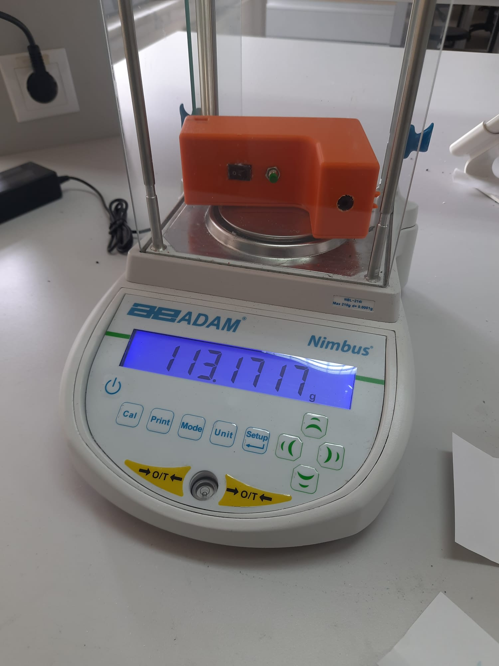
Figure AI.1 Weight of Designed Non-Contact Clinical Thermometer

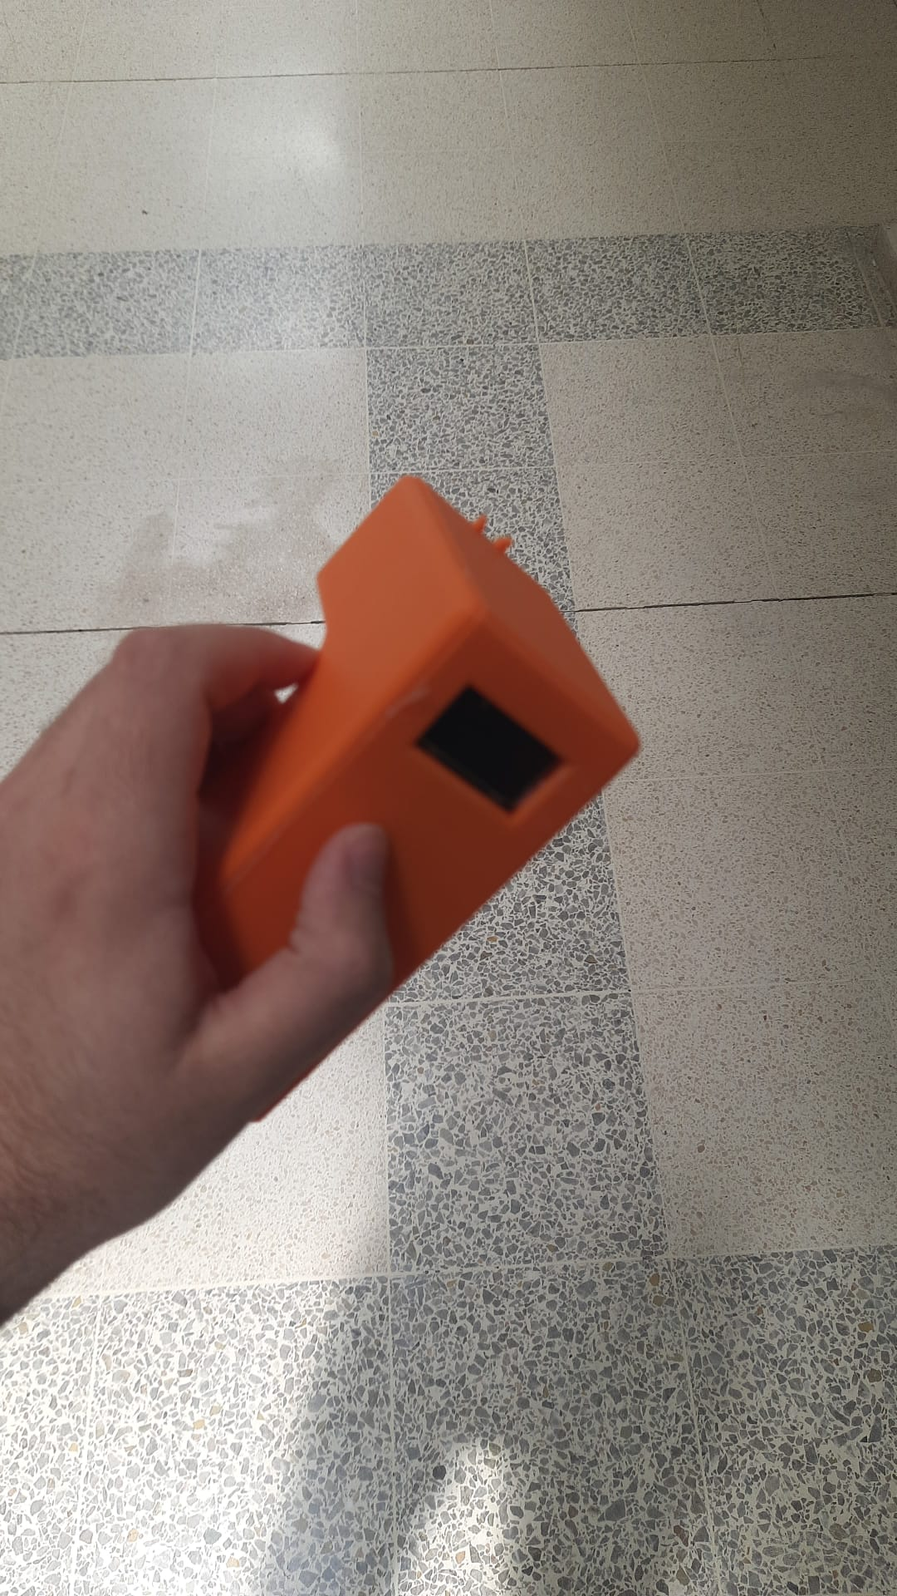
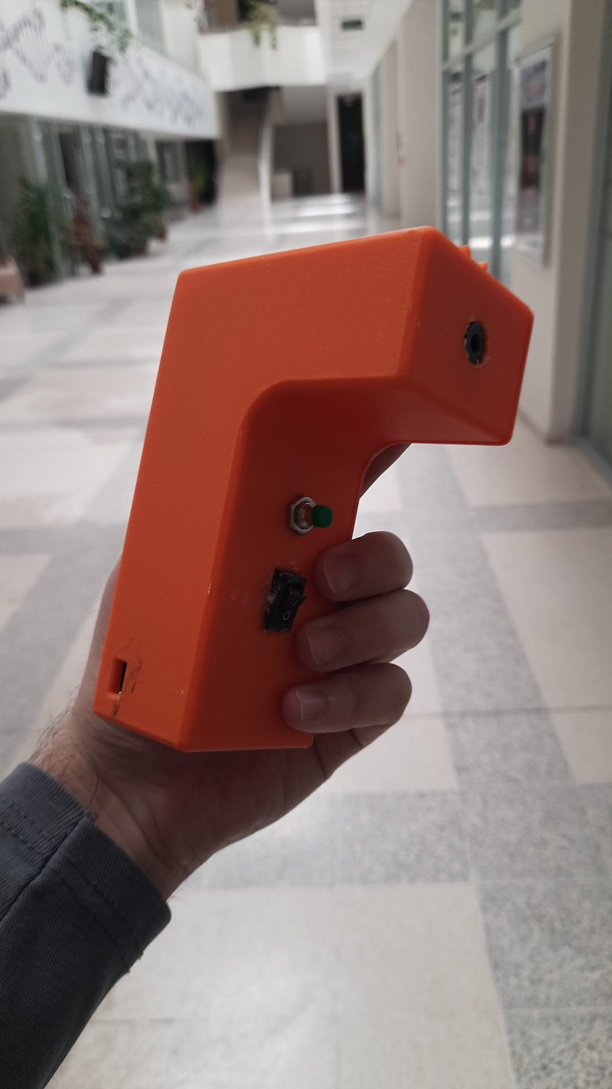
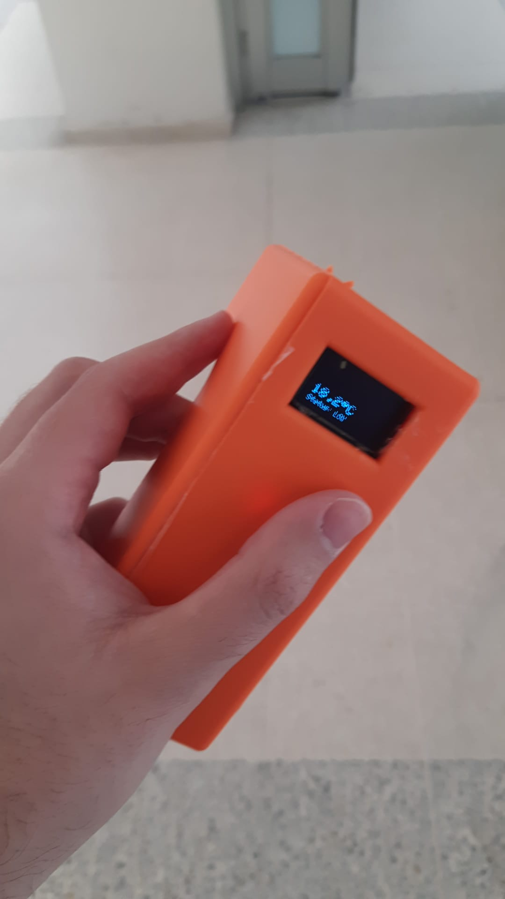

Figure AI.2 Non-Contact Clinical Thermometer designed by Group 1 in 2026

