
Faculty of Engineering
Department of Biomedical Engineering

Non-Contact Type Clinical Thermometer

Design Description

Part Number: 11-MIY-003

Rev-1

Date: 24/11/2025

CHANGE RECORDS

FIRST RELEASE

CREATED BY
Name | Title | Date Sign.
Gülşen Demir | System Engineer | 24.11.2025 
Augusta Nwosu | Electrical Engineer |   24.11.2025
CHECKED BY
Name | Title | Date Sign.
Fadime Taş | Quality Engineer | 24.11.2025 
APPROVED BY
Name | Title | Date Sign.
Efe Ateş | Program Manager |   24.11.2025

REVISIONS

Rev. No | Change Description | Date | QA Approval
TABLE OF CONTENTS
CHANGE RECORDS 2
FIRST RELEASE 2
REVISIONS 2
1. SCOPE 4
2. DESCRIPTION 4
3.REFERENCES 5
4.SYSTEM ARCHITECTURE 6
4.1. PHYSICAL (BLOCK DIAGRAM) 6
4.2. FUNCTIONAL (OPERATION) 7
4.3. PRINCIPLE OF OPERATION 8

1. SCOPE

Body temperature is one of those basic but vital signs that tells us a lot about someone's health, right alongside blood pressure and pulse. These days, with hygiene concerns front and centre and the need for quick assessments, the old-fashioned contact thermometers feel slow and raise worries about spreading germs.

That's where a non-contact infrared thermometer comes in. You simply point it at someone's forehead from a short distance, and the infrared sensors do the rest, giving you an accurate reading instantly without ever touching the skin. It's a significant change for health monitoring.

2. DESCRIPTION
The non-contact thermometer measures forehead temperature by detecting infrared radiation emitted from the skin. This radiation is captured by the infrared camera module, where the IR sensors generate an analogue signal. The signal is immediately processed through an internal LNA, ADC, and DSP to produce accurate digital temperature data.
The processed signal is sent to the ESP32-C3 Mini, which performs final calculations and system control through its embedded firmware. After computing the temperature, the microcontroller transmits the result to the OLED display via serial communication, ensuring clear and fast visual output.
The device is powered by a rechargeable Li-ion battery. A dedicated charging circuit receives 5 V from a USB source and manages safe charging of the 3.7 V battery that runs the entire system. This enables fully portable operation.
User-interaction components, including the ON/OFF switch, buzzer, and reset button, are connected directly to the microcontroller for simple and reliable control. A USB programming interface on the ESP32-C3 Mini allows easy firmware updates when required.
This configuration provides a compact, efficient, and touch-free solution for quick and accurate forehead temperature measurement.

3.REFERENCES
3.1. 01-TRM-800: System Requirement Specification
3.2. ISO 80601-2-56:2017 : Particular requirements for basic safety and essential performance of clinical thermometers for body temperature measurement
3.3. IEC 60601–1:2005+A1:2012 : Medical electrical equipment - Part 1: General requirements for basic safety and essential performance
3.4. IEC 60601‐1‐2:2014 : Medical electrical equipment — Part 1-2: General requirements for basicsafety and essential performance — Collateral Standard: Electromagnetic disturbances ,Requirements and tests
3.5. ASTM E1965-98(2016) – Standard Specification for Infrared Thermometers for Intermittent Determination of Patient Temperature.

4.SYSTEM ARCHITECTURE

4.1. PHYSICAL (BLOCK DIAGRAM)

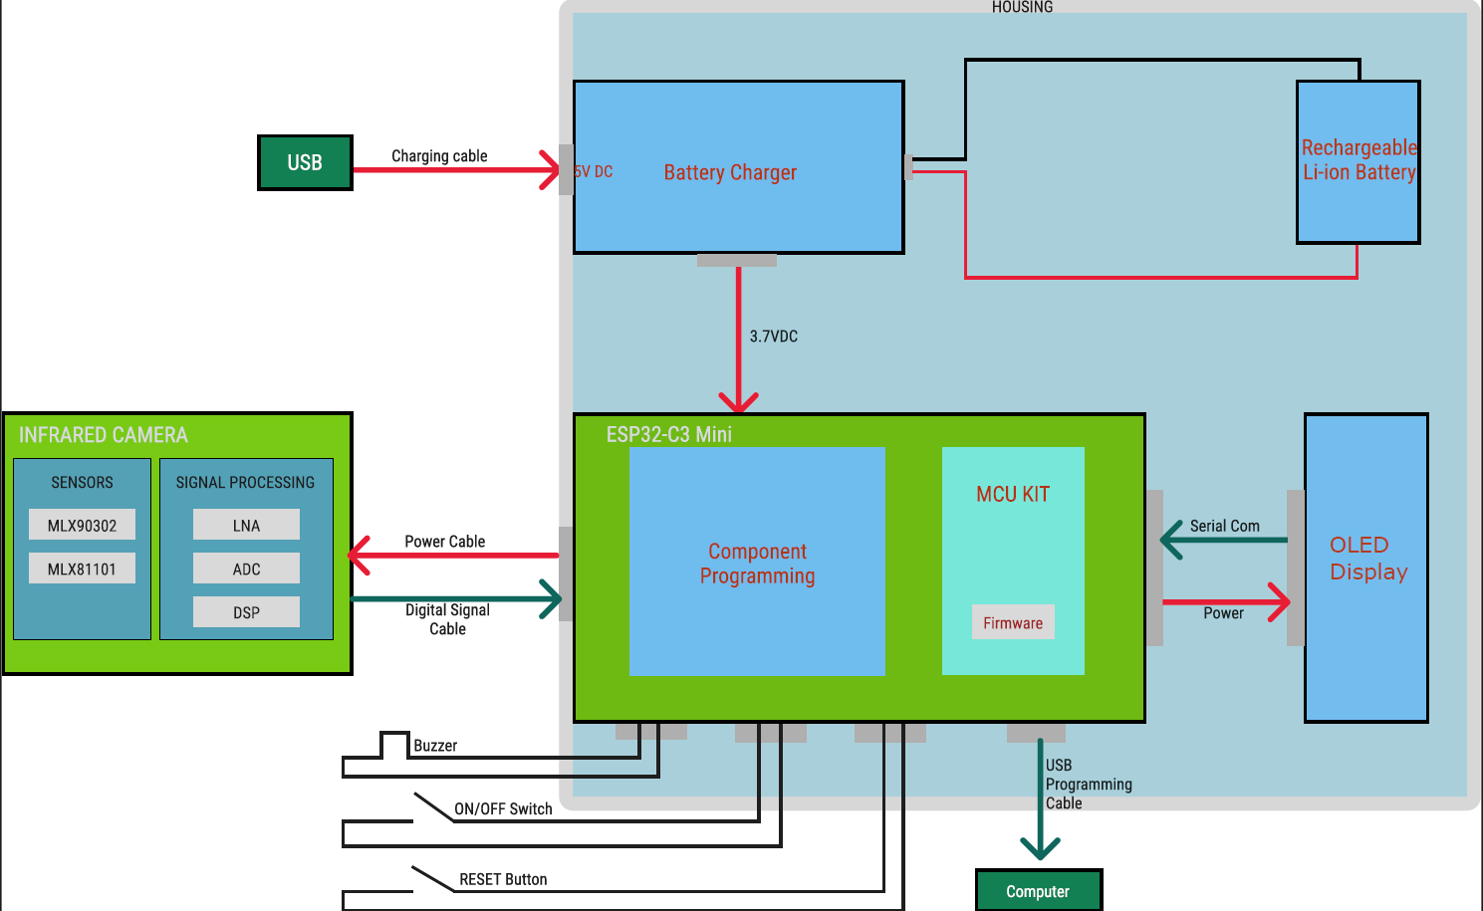

Figure 1:Block Diagram of The Design
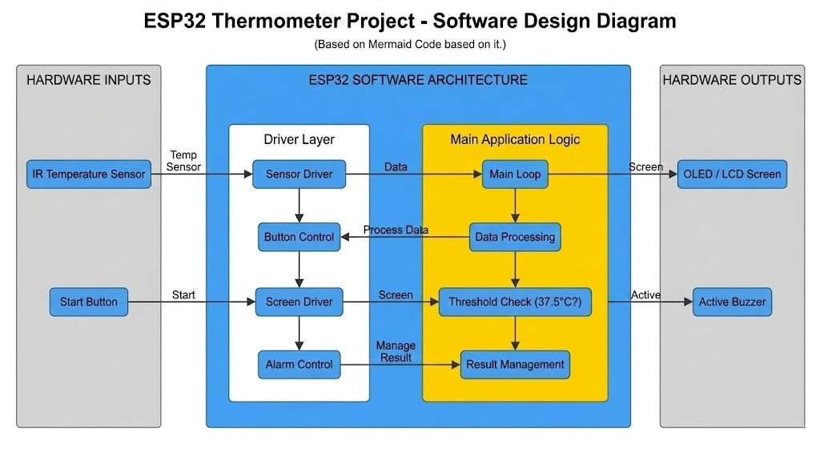
Figure 2:Software Design Diagram of The Design

4.2. FUNCTIONAL (OPERATION)
• While not in use, the thermometer can remain connected to the USB power source, allowing the battery-charging module to safely charge the internal Li-ion battery.
• Before taking a measurement, the user disconnects the USB cable (if desired) and powers on the device using the ON/OFF switch.
• The infrared camera module begins capturing emitted thermal radiation from the forehead and forwards the processed digital signal to the ESP32-C3 Mini.
• The microcontroller interprets the incoming data, executes the temperature-calculation algorithm, and prepares the final reading.
• The calculated temperature value is transmitted through serial communication to the OLED display for visual output.
• Once the reading is obtained, the buzzer activates briefly to inform the user that the measurement process is complete.
• Additional controls, such as the reset button, allow the user to restart the system if needed, and firmware updates can be performed using the USB programming interface.

4.3. PRINCIPLE OF OPERATION
- The designed non-contact thermometer measures body temperature from the forehead using an infrared camera module. Forehead measurement is selected because it allows fast, hygienic, and completely contact-free temperature assessment, which is especially suitable for elderly users and situations requiring strict hygiene.
- The system uses an infrared camera module that includes temperature-sensitive sensors (MLX90302, MLX81101) and an internal signal processing chain consisting of an LNA, ADC, and DSP. These components work together to detect the infrared radiation emitted from the forehead and convert it into digital temperature data.
- The infrared camera module sends digital temperature data through a power & data cable directly to the ESP32-C3 Mini microcontroller, eliminating the need for external analog circuits or amplifiers. Because the sensing unit already performs amplification, filtering, and ADC conversion internally, the microcontroller receives clean and processed data.
- The ESP32-C3 Mini acts as the main control unit. It receives measurement data from the camera, applies compensation algorithms, processes temperature values, and prepares the results to be displayed. Firmware inside the MCU performs noise reduction, ambient compensation, and final temperature calculation.
- System uses a rechargeable Li-Ion battery as its power source. The battery is charged through a 5 V USB power input, which feeds the battery charging module. The charging module safely manages the charging cycle and provides a stable 3.7 V DC output to power the ESP32-C3 Mini and other electronic elements.
- When the thermometer is unplugged, the Li-Ion battery continues powering the entire system. The ESP32-C3 Mini further regulates power internally to drive its logic circuits, the OLED display, and connected components.
- A 0.96-inch OLED Display is used to show the measured temperature clearly. OLED technology is chosen for its low power consumption, high contrast, and visibility under various lighting conditions.
- The thermometer includes user interface elements such as:
- Power button to turn the device ON/OFF
- RESET button for system restart
- USB programming cable connection for firmware updates and debugging
- Buzzer for acoustic feedback
- The buzzer alerts the user when the measurement process is complete, and the temperature value is ready to read on the display. This ensures ease of use, especially for elderly individuals.
- During measurement, the infrared camera detects the forehead temperature and communicates the processed digital data to the ESP32-C3 Mini. The microcontroller finalizes the computation and displays the temperature on the OLED screen within a short response time.
- Cable assemblies are used for system organization:
- Camera cable connects the infrared camera to the ESP32-C3 Mini.
- Battery cable connects the charging circuit to the Li-Ion battery and distributes power to the main PCB.
These cables ensure mechanical flexibility and electrical integrity of the system.

