
Faculty of Engineering
Department of Biomedical Engineering

Project Management Plan (PMP) for The Non-Contact Thermometer

Part Number: 01-MIY-001

Rev: 1

Date: 16/11/2025

CHANGE RECORDS

FIRST RELEASE

CREATED BY
Name | School Number |  | Title | Date Sign.
Efe Ateş | 22290588 |  | Program Manager |   16.11.25
APPROVED BY
Name | School Number |  | Title | Date Sign.
Augusta Nwosu | 21291005 |  | Electronic Engineer | 17.11.25 
Ayşe Sarıkaya | 21290474 |  | Mechanical Engineer | 18.11.25 
Eren Can Kayabaşı | 21290445 |  | Software Engineer | 17.11.25 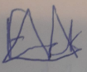
Fadime Taş | 21290304 |  | QA Engineer | 16.11.25 
Furkan Bacak | 20291193 |  | Production Engineer |   16.11.25
Gülşen Demir | 20291279 |  | System Engineer | 16.11.25 

REVISIONS
Rev. No | Change Description | Date | QA Approval

TABLE OF CONTENTS

CHANGE RECORDS 2
FIRST RELEASE 2
REVISIONS 2
1. PURPOSE 5
2. SCOPE 5
3. REFERENCES 5
4. RESOURCES 6
5. TEAM ORGANIZATION, RESPONSIBILITIES, COMMUNICATION 6
5.1. ORGANISATION CHART 7
5.2. JOB DESCRIPTIONS, RESPONSIBILITIES 7
5.2.1. PROGRAM ENGINEER 7
5.2.2. SYSTEM ENGINEER 8
5.2.3. ELECTRONICS ENGINEER 8
5.2.4. MECHANICAL ENGINEER 9
5.2.5. PRODUCTION ENGINEER 9
5.2.6. SOFTWARE ENGINEER 10
5.2.7. QUALITY ASSURANCE ENGINEER 10
5.3. COMMUNICATION 11
6. WORK BREAKDOWN STRUCTURE (WBS) 11
6.1.1.1. PLANNING 12
6.1.0.1. REQUIREMENTS CAPTURE 12
6.1.1.0 WEIGHT 12
6.1.1.1 SURFACE 12
6.1.2. FUNCTIONAL REQUIREMENTS 13
6.1.2.1 OPERATING CONTROLS 13
6.1.2.2 POWER SUPPLY 13
6.1.2.3 UNITS OF MEASURE 13
6.1.2.4 RATED OUTPUT RANGE 13
6.1.2.5 ACCURACY 13
6.1.2.6 MEASUREMENT TIME 14
6.1.2.7 ALARM CONDITIONS 14
6.1.3 ENVIRONMENTAL CONDITIONS 14
6.1.3.1 OPERATING TEMPERATURE 14
6.1.3.2 STORAGE TEMPERATURE 14
6.1.4 USABILITY 15
6.1.4.1 DISPLAY SIZE 15
6.1.4.2 MEASURING SITE 15
6.2.0 PROJECT MANAGEMENT PLAN 15
6.2.1.0 DESIGN PHASE (CONCEPTUAL/DETAILED DESIGN) 15
6.2.1.1 PRELIMINARY DESIGN (CONCEPTUAL DESIGN) 16
6.2.2. DETAILED DESIGN 16
6.2.3. DESIGN RESEARCH FOR EPIDERMAL THERMAL RESPONSE 17
6.3. IMPLEMENTATION 18
6.3.1. PROTOTYPE PRODUCTION 18
6.3.2. VERIFICATION/VALIDATION 18
6.4. SUPPORTING PROCESS 19
6.4.1. QUALITY ASSURANCE 19
6.4.2. RISK MANAGEMENT 19
6.4.3. PROCUREMENT 20
6.4.4. CONFIGURATION MANAGEMENT 20
6.4.5. DESIGN REVIEWS 21
7. SCHEDULE 22

PURPOSE
Purpose of this Project Management Plan is to show organization and Engineering design of this upcoming Non-Contact Clinical Thermometer. This thermometer will provide bodily temperature information from any humans that data derived from nearest tissue and fascia beneath the tissues. This data will be gathered optically in means of Infra-Red lights and their reflections coming to the lens.

SCOPE
The goal of this project is to create a clinical thermometer that meets ISO 80601-2-56:2017's fundamental performance and safety requirements. With the aid of academic resources from the university, fourth-year students will carry out all tasks, and the project will be completed in two semesters. A prototype will be manufactured in the scope of this project using the detailed design data and verified/validated according to the inspection/test procedures written by design group.
Each student will pay effort on varying fields such: Electrical Design, Software, Production, Q&A, Mechanical, System engineering.

REFERENCES
  - EN ISO 80601-2-56-2017: Requirements for basic safety and essential performance of clinical thermometers for body temperature measurement
  - IEC 60601–1:2005+A1:2012: Medical electrical equipment - Part 1: General requirements for basic safety and essential performance
  - ISO 9001: Quality management systems - Requirements
  - IEC 60601‐1‐2:2014: Medical electrical equipment — Part 1-2: General requirements for basic safety and essential performance — Collateral Standard: Electromagnetic disturbances Requirements and tests
  - ISO 14159: Safety of machinery — Hygiene requirements for the design of machinery
  - ISO 14971: Medical devices – Application of risk management to medical devices
  - IEC 60601‐1‐2:2014: Medical electrical equipment — Part 1-2: General requirements for basic safety and essential performance — Collateral Standard: Electromagnetic disturbances — Requirements and tests.
  - IEC 60601‐1‐6:2010+A1:2013: Medical electrical equipment — Part 1-6: General requirements for basic safety and essential performance — Collateral Standard: Usability +Amendment 1:2013
  - IEC 60601‐1‐11:2015: Medical electrical equipment — Part 1-11: General requirements for basic safety and essential performance — Collateral Standard: Requirements for medical electrical equipment and medical electrical systems used in the home healthcare environment.
  - IEC 60601‐1‐12:2014: Medical electrical equipment — Part 1-12: General requirements for basic safety and essential performance — Collateral Standard: Requirements for medical electrical equipment and medical electrical systems intended for use in the emergency medical services environment.
  - ISO 15223‐1:2016: Medical devices — Symbols to be used with medical device labels, labelling and information to be supplied — Part 1: General requirements.
  - IEC 62366‐1:2015: Medical devices — Part 1: Application of usability engineering to medical devices
  - IEC 60086-4, Primary batteries – Part 4: Safety of lithium batteries

RESOURCES
The human resources, seven engineering students will be sufficient to successfully complete the project. Allocation of work is as stated in the “job descriptions, responsibilities” section of this document. When necessary, allocation will be adjusted during the workflow.
Laboratories, workshops with equipments such as DMM, soldering iron, oscilloscope, power supplies etc. will be available at our university. Other equipments will be provided by our group or our advisor. Two semesters are expected to complete the whole project. At least one working prototype of clinical body thermometer is manufactured and tested for verification/validation and documented.
The money for materials, components and services is met by students.

TEAM ORGANIZATION, RESPONSIBILITIES, COMMUNICATION
Project teams constitute seven students selected for different tasks. Job descriptions and responsibilities are given in the following paragraphs as stated in start.

ORGANISATION CHART
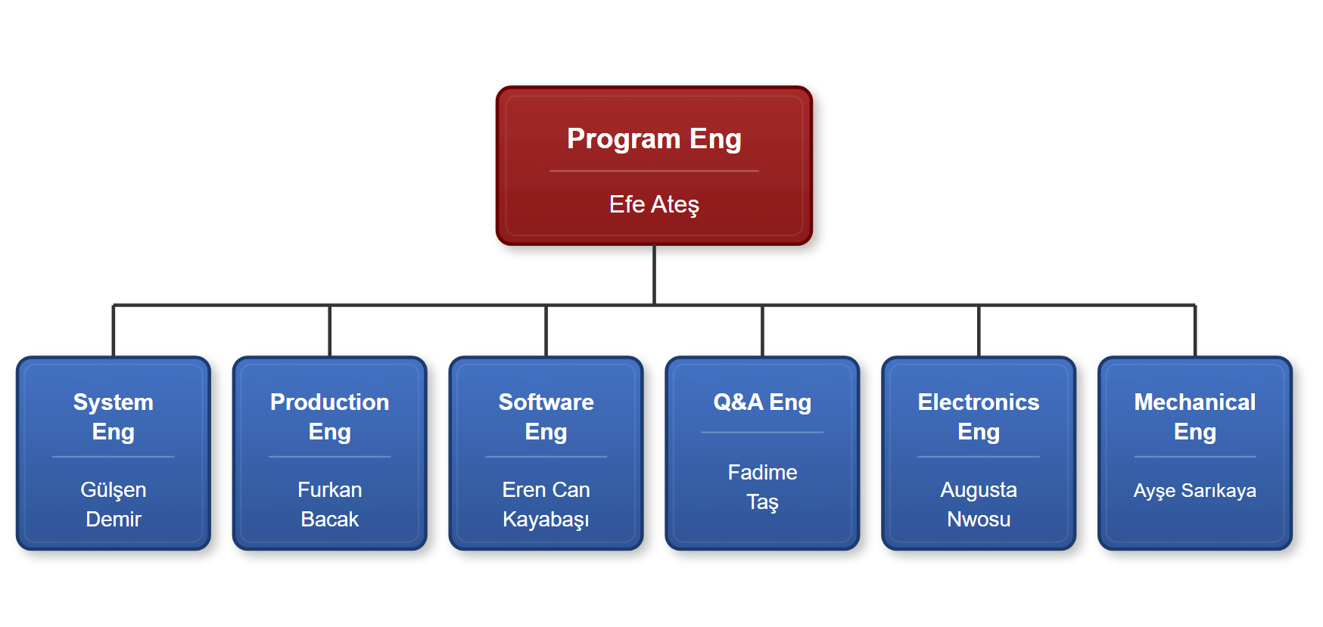

Figure-1: Structure of organization a non-contact clinical body thermometer

Engineers stated below part of chart will be administrated by Program Engineer. His role is making sure everyone doing their correspondence tasks at their times.

JOB DESCRIPTIONS, RESPONSIBILITIES

PROGRAM ENGINEER
- Prepares project management plan, including scheduling, finance, resources, milestones, reviews, and Earned Value Analysis (EVA).
- Monitors program objectives through design reviews.
- Manages program scheduling and execution, resolving cost, schedule, and quality challenges.
- Tracks risk management files for potential risks.
- Organize review sessions and write reports for program milestones.
- Maintains and prepares program documentation for audits. Uses EVA to track additional project activity over budget and schedule.
- Facilitates communication between management and team members.
- Collaborates with team members to overcome procurement, testing, and manufacturing restrictions such as cost, workshare, equipment, tooling, and facilities. Works with management and team members to eliminate procurement, test and manufacturing constraints including cost, workshare, equipment, tooling and facilities.
- Works with engineering (design engineers), quality, production and procurement to resolve non-conformances and contributes to mrb (material review board) meetings.

SYSTEM ENGINEER
- Prepares project management plan, including scheduling, finance, resources, milestones, reviews, and Earned Value Analysis (EVA).
- Monitors program objectives through design reviews.
- Manages program scheduling and execution, resolving cost, schedule, and quality challenges.
- Tracks risk management files for potential risks.
- Organize review sessions and author reports for program milestones.
- Maintains and prepares program documentation for audits.
- Uses EVA to track additional project activity over budget and schedule.
- Facilitates communication between management and team members.
- Collaborates with team members to overcome procurement, testing, and manufacturing restrictions such as cost, workshare, equipment, tooling, and facilities.

ELECTRONICS ENGINEER
- Works with system engineer for conceptual design
- Works with system engineer to prepare the conceptual design data (documents) like requirement specification, design description and configuration item list.
- Simulates the electronic circuits to be used in the project, using the simulation software like proteus, tina, electronic workbench etc.
- Investigates epidermal electronic devices/skin system, thermoregulation of human body.
- Makes the breadboard trials for electronic circuits.
- Designs the electronic circuits, creates the schematics and printed circuit board layouts if required.
- Designs the system software (firmware)
- Provides mechanical interfaces of electronic hardware to mechanical engineer.
- Recommends the measurement methods to test the hardware designed.
- Prepares the electronic hardware engineering drawings.
- Purchasing and kitting (material preparations, tinning, receiving inspection and test)

MECHANICAL ENGINEER
- Works with system engineer for conceptual design
- Works with system engineer to prepare the conceptual design data (documents) like requirement specification, design description and configuration item list.
- Designs the mechanical parts (like housing, battery compartment, probe tip etc.) in 3d cad software. Not only the single mechanical parts but the other parts also will be modelled using this software to be able to verify the interfaces of all parts.
- Installation and uninstallation of assemblies must be considered when designing the parts.
- Uses the 3D printing technique for rapid prototyping of mechanical parts.
- Investigates epidermal electronic devices/skin system, thermoregulation of human body and contribute to electronic and software engineer for temperature calculations.
- Designs and manufactures necessary tools and accessories when necessary.
- Provides necessary drawings to other design engineers for documentation or presentations.

PRODUCTION ENGINEER
- Assembling electronic components and perform inspections/testing for quality in the electronic assembly production task.
- Handling wiring connections for the Wiring assembly production task, verified through continuity testing.
- Obtaining QAE approval for the in-circuit test (ICT) to verify circuit functionality, assessed through Assembly Record review.
- Securing PE approval for Fabrication Tests (Fabtest) to ensure fabrication quality, with results documented in the Assembly Record.
- Applying operational/configurational markings correctly for the Marking task, verified by visual inspection.

SOFTWARE ENGINEER
- Prepares the initial firmware which will be uploaded into the MCU, by creating draft source code to communicate with the infrared sensor that will measure the temperature, providing basic functionality for the device to operate.
- Processes data by algorithms to convert the sensor data into clear temperature readings.
- Creates the code to control the display screen, which will show the measured temperature.
- Creates code to optimize the power consumption of the device. Also, coding user interaction, such as button presses.
- Prepares code documentation with comments beside the code for in depth explanation.
- For final software documentation, calibration and documentation of accuracy, regulatory compliance tests will be done.
- Verification/ validation tests will include testing the software modules individually, then testing the interaction between different software components to ensure it meets all the requirements.
- Tests the accepting range of the non-contact thermometer, to ensure that it is ready for release.
- Prepares the verification/validation test procedures.

QUALITY ASSURANCE ENGINEER
- Reviews requirements, technical specifications and design documents for approval
- Supports, designs, develops, and enhances test processes.
- Creates detailed, verification and validation test plan, approves the test procedures.
- Documents inspection and test results, offers improvements after analysis of test results and overall product quality.
- Collaborates with the design team on bug fixes.
- Executes audits to verify all the processes within the scope of this project comply with this project plan and applicable standards and procedures.
- Ensures the use of calibrated devices in test and measurements.
- Leads the Material Review Board for non-conforming materials.
- Keeps track of corrective actions to fix the bugs, failures, process related problems
- Acceptance Test Procedure (ATP)

COMMUNICATION
Communication may be carried out by e-mail for formal communication like meeting calls, technical information exchange, document transfer or through phone conversations for urgent cases. E-mails and phone numbers are given below. E-mails will be preferred since most of them can be used as input to the project records.
Job Name e-mail Phone Number
Electronic Engineer Augusta Nwosu nwosuaugustac@gmail.com +905436440761
Mechanical Engineer Ayşe Sarıkaya Sarikayaayse44@gmail.com +905070750572
Production Engineer Furkan Bacak furkanbacak00@gmail.com +905368763586
Program Engineer Efe Ateş efeates3300@gmail.com +905312209935
Software Engineer Eren Can Kayabaşı erencnkybs@gmail.com +905491749403
Q&A Engineer Fadime Taş fadimeibnisina@gmail.com +905516470514
System Engineer Gülşen Demir gultsn1127@gmail.com +905319482603

WORK BREAKDOWN STRUCTURE (WBS)
The object, the output of this project is the design data (Technical Data Package) of Clinical Body Thermometer. The structure of WBS with its work packages and expected work hours is given in Figure-1 and description of work packages is given in the following paragraphs.
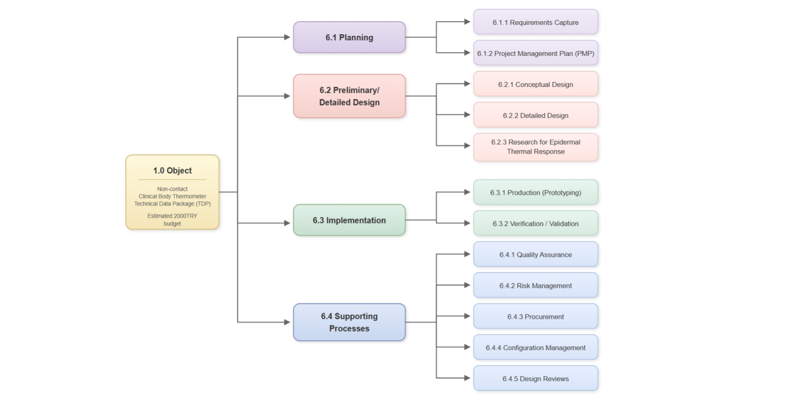
Figure-2: Work Breakdown Structure of designing a non-contact clinical body thermometer.

PLANNING

REQUIREMENTS CAPTURE
Process inputs: Standards in “References” section, customer expectations.
Process outputs: “Requirements Specification” document.

This section will specify what this design shall output and has specifications that will help to engineer this.
non-contact temperature.

6.1.1.0 WEIGHT
The non-contact clinical thermometer will be 50 grams to 400 grams maximum.

6.1.1.1 SURFACE
The non-contact thermometer’s surface will be smooth, durable and designed to be cleaned when needed. It must feel good on hand and people must feel the quality.

6.1.2. FUNCTIONAL REQUIREMENTS

6.1.2.1 OPERATING CONTROLS

The non-contact thermometer shall feature a minimal, user-friendly control interface (including elders), with no more than two buttons: a power button, a measurement button. Buttons shall be very easy to click and could be silent switch.

6.1.2.2 POWER SUPPLY
Supply should be provided from battery. The charging section should have battery production and must support 1A current. Charging section shall stop charging when battery has level of 100% charge and shall notify the user when its level reached full.

6.1.2.3 UNITS OF MEASURE
The non-contact thermometer will display the temperature in degrees Celsius ℃.

6.1.2.4 RATED OUTPUT RANGE
The output temperature of the non-contact thermometer shall measure from 25,0 °C to 45,0 °C.

6.1.2.5 ACCURACY
The accuracy of the non-contact thermometer will provide an accuracy of ±0.3 °C.

6.1.2.6 MEASUREMENT TIME
The measurement time shall be between 0 to 1 seconds.

6.1.2.7 ALARM CONDITIONS
Alarm conditions are optional. If value is above acceptable range (more than 39.5 degrees Celsius) it must alert using buzzer on board. This will express the situation’s emergency.

6.1.3 ENVIRONMENTAL CONDITIONS

6.1.3.1 OPERATING TEMPERATURE
The thermometer should operate in standard conditions with a range of 15°C to 80°C.

6.1.3.2 STORAGE TEMPERATURE
The thermometer should be suitable for storage at temperatures between -20°C and 90°C without damage.

6.1.4 USABILITY

6.1.4.1 DISPLAY SIZE
Character size will be greater than 4 mm for users to read easily. The screen must be an OLED. If it is an OLED display it shall be more than one colour and it shall be more than 0.96 inches. It shall work on <3.3 V DC voltage difference range. I2C communication protocol could be used or other favored communication protocol.

6.1.4.2 MEASURING SITE
The non-contact thermometer will have used and pointed on the forehead as a measuring site to read body temperature. To read the temperature correctly it should be within the distance of 1 to 5 cm from the forehead.

6.2.0 PROJECT MANAGEMENT PLAN
Process inputs: Requirements Specification
Process outputs: “Project Management Plan” document.
The design life cycle processes (Defining Requirements, Conceptual Design, Detailed Design, Implementation) clearly defined in this Project Management Plan including the activities, milestones, risk assessment, inputs, outputs and responsibilities.
Standards for design processes selected and defined in the plan.
Responsibilities for supporting processes have also been defined for smooth transition between the phases and to assure product quality, reliability, safety.

6.2.1.0 DESIGN PHASE (CONCEPTUAL/DETAILED DESIGN)
Design phase includes mainly two work packages: Preliminary Design showing the basic configuration items and their relations and Detailed Design consisting of final design of all assemblies, software, discrete parts and their tests.

6.2.1.1 PRELIMINARY DESIGN (CONCEPTUAL DESIGN)
Process inputs: “Requirement Specification” document
Process outputs: “Design Description”, “Configuration Item List” documents and Preliminary Design Review meeting report
The Preliminary Design process produces a high-level design concept to meet the requirements. The input to this process is Requirement Specification.
Preliminary Design can be accomplished using functional block diagrams, design and architecture descriptions, circuit card assembly outlines. A high-level description should be generated for the hardware item. This will include the architectural constraints, component over-stress, reliability, usability, safety, constraints on software or other system components. Configuration Items and major components should be identified at this stage.
Change control for the configuration items should be started when they are defined. To be able to track the changes, each configuration item shall have a item Part Number to establish a base line.
At this phase specific research studies may be performed to have necessary design documentation. To do this, breadboard designs may be done, simulation tools may be used.
When everything is ready to start to detailed design, a Preliminary Design Review will be realised to review the records, documents, and plans if all planned tasks are completed.
The outputs from this process are Design Description, Configuration Item List and Preliminary Design Review meeting report.

6.2.2. DETAILED DESIGN
Process inputs: “Design Description”, “Configuration Item List” documents
Process outputs: Assembly documents containing circuit schematics, component placement, Bill of Materials (BOM), CAD/CAM files (Gerber, STL, etc.), working brassboard level prototype thermometer, Critical Design Review meeting report, draft system software
The inputs to this process are Requirement Specification, Design Description, Configuration Item List and Preliminary Design Review meeting report.
Detailed electrical interfaces, mechanical interfaces software interfaces and user interfaces shall be defined and documented on assembly documents. Schematics of electronic assemblies are designed using electronic design automation softwares (EDA softwares like orcad, eagle, altium). Mechanical parts are designed with the help of Computer Aided Design (CAD) programs (like Pro-engineer, Solidworks, Catia, Inventor). The operation of electronic boards and mechanical parts/assemblies designed can be verified with simulation tools.
The materials required for detailed design procured, inspected/tested and datasheets obtained. The information in datasheets are very important in design work.
Easy installation and dis-installation, part (e.g battery) replacement, ergonomy and safety shall be considered when designing the mechanical parts and electronic circuits.
Necessary manufacturing files to manufacture the parts in house or to order shall be created both for Printed Circuit Boards and mechanical parts like Gerber Files, STL files. Mechanical parts are preferred to be manufactured by 3D printer in house.
Tests and other inspection activities shall be performed for each assembly to verify the compliance with the requirements.
A brassboard level prototype shall be produced and draft system software shall be coded during this design phase.
Note: Brassboard level prototype is a near final design circuit, built in a configuration which is representative of the final project, using similar construction methods and materials as the final project. It is between breadboard level prototype and engineering prototype where an engineering prototype is fully representative of the final product using approved components and suitable for complete evaluation of form, design and performance.
Documents including engineering drawings, bill of materials (BOM), component specifications, test procedures shall be prepared and change control activities shall be started for each new document.
Critical Design Review will be performed on this design documentation.

6.2.3. DESIGN RESEARCH FOR EPIDERMAL THERMAL RESPONSE
Process inputs: Working brassboard level thermometer, draft system software
Process outputs: Final system software, a white paper documenting the research results
The most challenging aspect of thermometer design is thermal response of skin and part of the thermometer contacting the body, especially for contact type thermometers. Although it is difficult to find sufficient data in literature, investigations shall be made in the internet and printed publications on this subject. If sufficient information can not be obtained from the literature, a research will be realized to obtain the necessary data to use in the calculations performed by microcontrollers enabling them to display correct body temperature.
The scope of work in this regard is limited with measurements in different ambient temperatures. The data including ambient temperature measured with a reference thermometer, measuring site temperature and reference body site temperature measured both by prototype thermometer and a reference clinical thermometer is collected. Data is analysed, correlation is established between ambient temperature and body temperature and a correction is made on the formula used in software.

6.3. IMPLEMENTATION
After successful completion of Critical Design Review, the implementation process will be started using the documents prepared at detailed design phase to produce the hardware item (Engineering Prototype)
This phase consists of production of engineering prototypes and qualification tests run on this prototype.

6.3.1. PROTOTYPE PRODUCTION
Process inputs: Assembly documents containing circuit schematics, component placement, Bill of Materials (BOM), CAD/CAM files (Gerber, STL, etc.), working brassboard level thermometer, Critical Design Review meeting report, draft system softare
Process outputs: Engineering Prototype which the verification/validation activities conducted with
An engineering prototype will be build using engineering drawings prepared during the detailed design process. The inputs to this process are assembly/part drawings including Bill Of Material (BOM), CAD files, Critical Design Review meeting report.
Missing parts are procured from suppliers or manufactured inhouse and the installation will start with the guidance of experienced engineers. Installation instructions will be created during the production and the drawings may be revised due to these instructions if necessary.
When required, special test set-up’s may be established for assemblies and sub-assemblies during the production of thermometer. The non-conformances will be documented and necessary corrective actions will be taken before proceeding.
An Acceptance Test Procedure will be created for the finished product to use before and during the Verification/Validation. The prototype production is completed only when the prototype passes the acceptance test successfully.

6.3.2. VERIFICATION/VALIDATION
Process inputs: Engineering Prototype with final system software, verification and validation test plans
Process outputs: Verification/validation report, Technical Data Package
The acceptance test is not intended to verify all requirements. Requirements which are not verified at acceptance test will be verified during the Verification Process.
Verification consists of reviews, analyses and laboratory tests (including the acceptance test) applied as defined in the Qualification Plan. The verification process should include an assessment of the results. After succesful completion of verification, Validation prosses in the field shall be applied to ensure that the requirements are correct and complete for intended use.

6.4. SUPPORTING PROCESS

6.4.1. QUALITY ASSURANCE
Process inputs: Project Management Plan, verification and validation test plans
Process outputs: Problem/Corrective Action Reports, MRB records, Audit records
Quality/Process assurance ensures that the life cycle process objectives are met and activities have been completed as outlined in plans or that deviations have been addressed.
Hardware design problems, process non-compliance with hardware plans and standards, and deficiencies in hardware life cycle data will be identified, documented and resolved by means of the Problem Reports. The purpose of problem reporting, tracking and corrective action is to record problems and ensure correct disposition and resolution. Problems may include non-compliance with plans and standards, deficiencies of life cycle process outputs, anomalous behavior of products, and inadequacy or deficiency of tools and technology processes.

6.4.2. RISK MANAGEMENT
Process inputs: Safety requirements, schedule, resources, budget
Process outputs: Risk Management Files
Responsibility: Program Engineer
The potential risks associated with harm to people and damage to property or the environment like threat of human errors (usability), wrong measurements are identified with the collective work of team members and defined at the end of the conceptual design phase.
Once risks have been identified, they must then be assessed as to their potential severity of impact (generally a negative impact, such as damage or loss) and to the probability of occurrence. For each potential risk, a risk management file is created to track the status of the risk. The risk management file contains the description of the risk, its impact, probability of occurrence, the actions to mitigate the risk to an acceptable level.
The risk management files are kept by program engineer as evidence of acceptable risk management process, required by most regulatory bodies.
The analysis in this project shall consider the risks of changing environmental conditions for the clinical thermometer and provide guidance regarding the residual risks in the instruction for use.
Also Hygiene risks to the consumer are important especially for contact type thermometers and shall be included in risk management files.

6.4.3. PROCUREMENT
Process inputs: Configuration Item List, BOM, schedule, resources, budget
Process outputs: Orders, components, nonconforming materials
Responsibility: Electronics Engineer
The procurements need to remain within the expenditure budget.
All records need to be kept for each order and must be kept in the correct auditable manner.
Procurements should be consistent with ethics and social responsibility and best practices and adherence to all laws and regulations is a strict requirement. Selection of the vendor depends on the cost and delivery time.
Risk analysis should be made especially for the materials supplied from abroad for delivery time.
The material supplied shall be inspected and or tested for identification and hazards.

6.4.4. CONFIGURATION MANAGEMENT
Process inputs: Configuration Baseline, engineering changes
Process outputs: Change orders, Revised Documents
Responsibility: Production Engineer
The configuration management process is intended to provide the ability to consistently replicate the configuration item, regenerate the information if necessary and modify the configuration item in a controlled fashion if modification is necessary.
Configuration items should be uniquely identified (e.g part number), documented and controlled and baselines should be established at the end of Conceptual Design phase as the “Configuration Item List” document. The purpose of baseline establishment is to define a basis for further activities and allow reference to, control of and traceability between configuration items.
Intermediate baselines may be established to aid in controlling hardware activities. Once a baseline is established it should be subject to change control procedures.
The purpose of the change control activity is to ensure the recording, evaluation, resolution and approval of changes. Change control should be started no later than the establishment of the baseline. Each change shall be recorded with its revision number, described on related documents and approved by quality assurance and program engineer.

6.4.5. DESIGN REVIEWS
Process inputs for PMR: “Design Description”, “Configuration Item List”, “Requirement Specification”
Process inputs for CMR: Assembly documents CAD/CAM files working brassboard level thermometer, Critical Design Review meeting report, draft system software
Process outputs: PMR, CMR reports
Responsibility: Program Engineer
Design reviews will be performed and documented as a review report, at multiple times during the project to determine that the design documents and implementation satisfy the requirements. All Project team members contribute to design reviews.
At least, the Preliminary Design Review is performed at the end of conceptual design and the Critical Design Review is performed when the detailed design with its design data is completed. Additional reviews may be carried out if necessary. Design reviews will check at least the following.
Minimum design data which shall be ready at Preliminary Design Review are;
· System Requirement Specification document
· Design Description document
· Configuration Item List document
Minimum design data which shall be ready at Critical Design Review are;
· Drawings for configuration items (schematics, layouts, assembly documents, solid model of designed parts, Bill Of Materials, system software)
· Working breadboard level thermometer
· Test/inspection results
· Risk management files
· Audit records
· Corrective Action reports

7. SCHEDULE
The project flow is shown in Figure-3
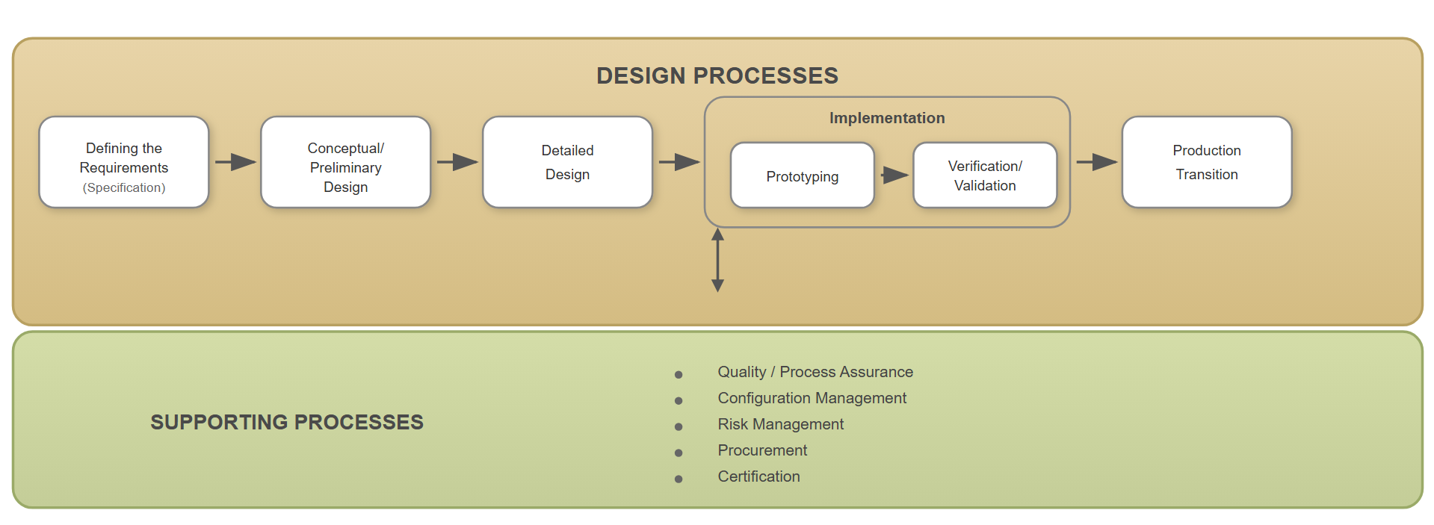
Figure-3: Design flow showing basic design activities
The Gantt chart given in Figure-4 shows the description and duration of tasks for scheduling. It has two main parts, a task list on the left side and a project timeline on the right.
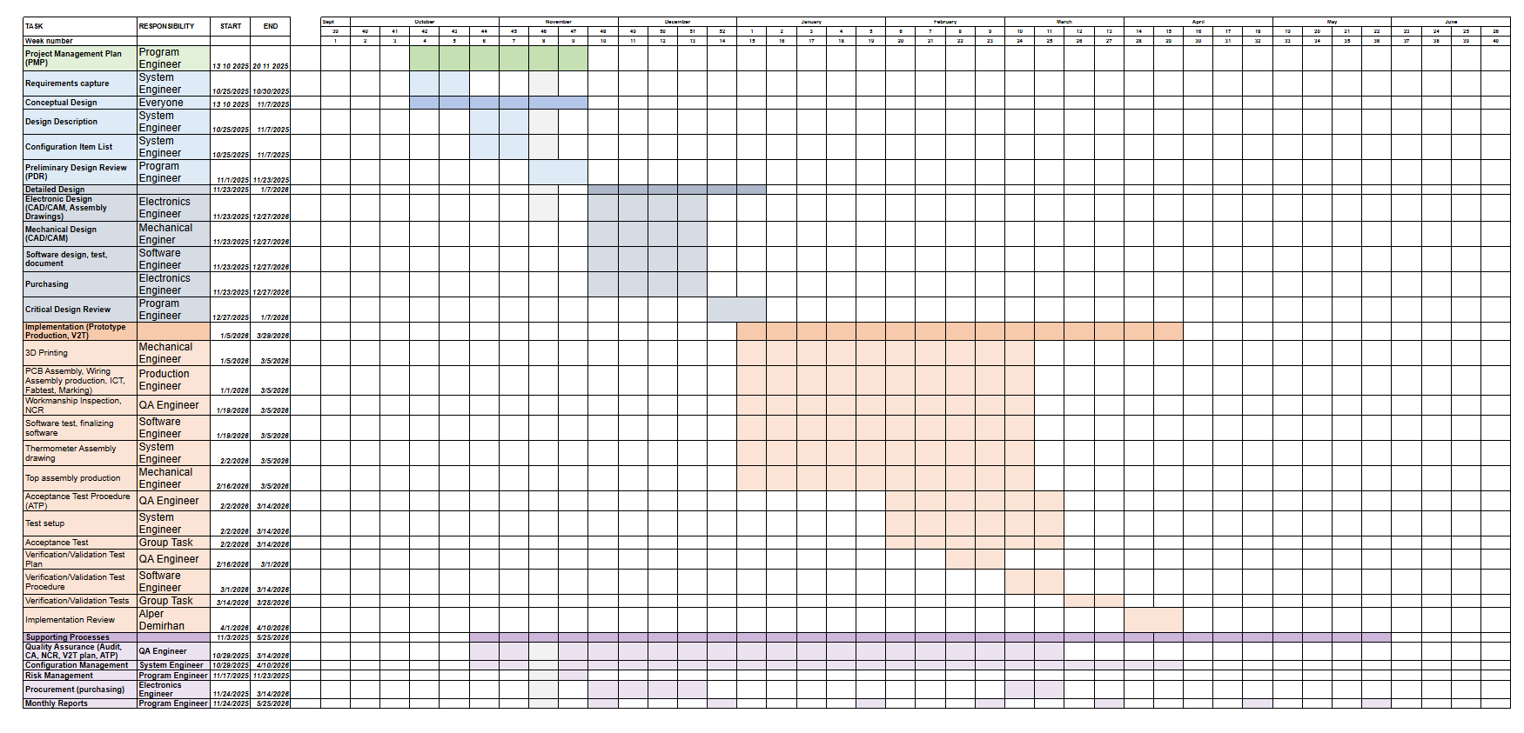
Figure-4: Gantt Chart for Non-Contact Thermometer Project

