

Verification/Validation Test Procedure (V2TP)
for Contact Thermometer

Part Number: 20-TRM-930
Rev: 1
Date: 23 April 2024

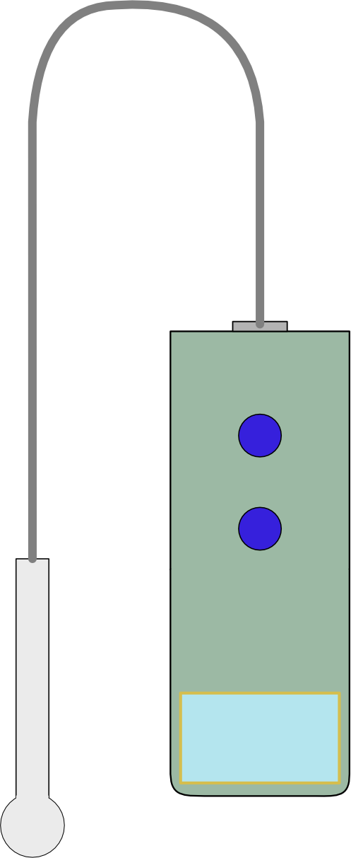

change records

fırst release
CREATED BY
Name | Title | Date Sign.
 | Program Eng
CHECKED BY
Name | Title | Date Sign.
 | Quality Eng
APPROVED BY
Name | Title | Date Sign.
 | System Eng

REVISIONS
Rev. No | Change Description | Date | QA Approval

TABLE OF CONTENTS
change records 2
fırst release 2
REVISIONS 2
1. scope 4
2. REFERENCES 4
3. verification tests 4
3.1. functıonal tests 4
3.2. weıght 4
3.3. surface 4
3.4. operatıng temperature 5
3.5. storage temperature 5
3.6. display sıze 5
3.7. measurıng sıte 5
3.8. power supply 5
4. valıdation tests 6
4.1. accuracy tests 6
5. test report 6
Attachment-1: verıfıcatıon/valıdatıon Test Data Sheet 7

scope
VALIDATION is the confirmation that the requirements of a contact clinical thermometer have been fulfilled through clinical tests on actual subjects (patients), using statistical methods where the VERIFICATION is the confirmation that the requirements of clinical thermometer have been fulfilled through laboratory tests using a reference temperature source.
For a CONTACT CLINICAL THERMOMETER that operates in the ADJUSTED MODE, the LABORATORY ACCURACY is VERIFIED in a DIRECT MODE and the CLINICAL ACCURACY is VALIDATED in the ADJUSTED MODE (OPERATING MODE) with a sufficiently large group of human subjects.

REFERENCES
  - ISO 80601-2-56:2017 : Part 2-56: Particular requirements for basic safety and essential performance of clinical thermometers for body temperature measurement
  - 20-TRM-800: System Requirement Specification, Contact Body Thermometer
  - 20-TRM-830: Verification-Validation Test Plan for Contact Body Thermometer
  - 20-TRM-900: Acceptance Test Procedure

verification tests
Most of the requirements which must be verified within the context of verification tests are covered by Acceptance Test Procedure. So, the first step for the verification tests is to perform a acceptance test. After successful completion of acceptance test, remaining tests, inspections and demonstration given in Verification/Validation matrix will be performed.

functıonal tests
Run the acceptance tests as per 20-TRM-900, Acceptance Test Procedure and record the results in Verification/Validation Test Data Sheet given in attachment-1.

weıght
Measure the weight of thermometer including its probe with a precision calibrated scale to verify its weight is less than the specified requirement of 200gr.

surface
Demonstrate that there is no malfunction, no damage or color changes after cleaning the thermometer with a IPA alcohol.

operatıng temperature
Operating temperature test is not applicable for this project, since necessary temperature chamber is not available.

storage temperature
Storage temperature test is not applicable for this project, since necessary temperature chamber is not available.

display sıze
The temperature reading on the screen will be measured with a scale to verify that the characters at least 4mm height and readable.

measurıng sıte
Demonstrate that the sensor tip can be easily put into the armpit.

power supply
- Remove the top cover of the thermometer.
- Plug the USB-C connector of 5VDC adaptor to the charge input of thermometer.
- Observe that the red LED of charger module is turned on showing the charging mode.
- After sufficient time the blue LED pf charger module will be turned on to show the charge is completed.
- Unplug the 5VDC adapter and verify that the thermometer can be operated with its battery.

valıdation tests
The CLINICAL ACCURACY of an ADJUSTED MODE CLINICAL THERMOMETER is required to be additionally VALIDATED with actual subjects (PATIENTS). Since all subjects are different, statistical methods are employed to compare the OUTPUT TEMPERATURES of the CLINICAL THERMOMETER under test (DUT) for the REFERENCE BODY SITE with those of a REFERENCE CLINICAL THERMOMETER (RCT) whose OUTPUT TEMPERATURES represent the same REFERENCE BODY SITE as the DUT.
In the scope of validation tests, the CLINICAL BIAS, Δcb, with its LIMITS OF AGREEMENT, LA, the CLINICAL REPEATABILITY, σr, the REFERENCE BODY SITE and MEASURING SITE for each OPERATING MODE shall be measured.

clınıcal accuracy tests
The methods, procedures and the calculations shall be performed in accordance with ISO 80601-2-56:2017: Part 2-56, paragraph 201.102 (CLINICAL ACCURACY VALIDATION).
the results for clinical bias, Δcb, with its limits of agreement, LA, the clinical repeatability, σr shall be documented verification/validation test data sheet given in attachment-1.

test report
- Test results will be recorded on the Acceptance Test Data Sheet in the Attachment-1

Attachment-1: verıfıcatıon/valıdatıon Test Data Sheet
 | VERIFICATION/VALIDATION TEST DATA SHEET
Assembly P/N: |  | Date:
Assembly S/N: |  | Test Operator:
Test Procedure: |  | QA
ATP paragraph | Description | Test Limits | Measurement Result | Pass/Fail
ATP para 4.1 | Operating Controls | N/A
ATP para 4.1.1 | MODE switch | Toggle the mode
ATP para 4.1.2 | POWER ON/OFF | Display Temperature
ATP para 4.1.2 | Automatic Turn Off | Turn off time < 30 sec
ATP para 4.2 | Accuracy | < 0.3°C
ATP para 4.3 | Rated Output Range | 34 °C < T < 43°C
ATP para 4.4 | Units of Measure | °C
ATP para 4.5 | Measurement Time | < 30 sec
ATP para 4.6 | Alarm Conditions | N/A
ATP para 4.6.1 | Completion of measurement | Sound alarm
ATP para 4.6.2 | Below The Tange | Blue Display
ATP para 4.6.2 | Above The Range | Red Display
V2TP para 3.2 | Weight | <200gr
V2TP para 3.3 | Surface | Demonstrate
V2TP para 3.4 | Operating Temperature | N/A
V2TP para 3.5 | Storage Temperature | N/A
V2TP para 3.6 | Display Size | > = 4 mm
V2TP para 3.7 | Measuruing Site | Demonstrate
V2TP para 3.8 | Power Supply | Rechargable
V2TP para 4.1 | Clinical Bias, Δcb
V2TP para 4.1 | Limits of Agreement, LA
V2TP para 4.1 | Clinical Repeatability, σr
 |  | Completion Date:
N/A: Not Applicable

