
COVER PAGE

Final Project Report

APPROVED BY
 | Name |  | School Number |  | Title |  | Date |  | Sign.
 | Efe Ateş |  | 22290588 |  | Program Engineer |  | 27.05.26 |  | 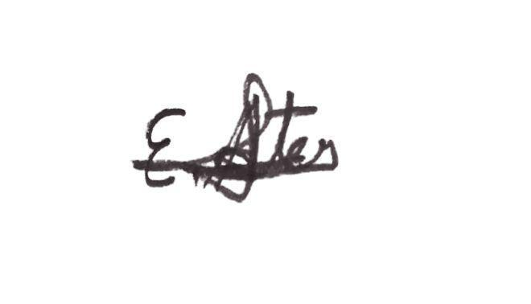
 | Augusta Nwosu |  | 21291005 |  | Electronic Engineer |  | 27.05.26 |  | 
 | Ayşe Sarıkaya |  | 21290474 |  | Mechanical Engineer |  | 27.05.26 |  |   
 | Eren Can Kayabaşı |  | 21290445 |  | Software Engineer |  | 27.05.26 |  | 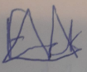
 | Fadime Taş |  | 21290304 |  | QA Engineer |  | 27.05.26 |  | 
 | Furkan Bacak |  | 20291193 |  | Production Engineer |  | 27.05.26 |  | 
 | Gülşen Demir |  | 20291279 |  | System Engineer |  | 27.05.26 |  | 

ALL RIGHTS RESERVED. REPRODUCTION OR ISSUE TO THIRD PARTIES IN ANY FORM WHATEVER IS NOT PERMITTED WITHOUT WRITTEN AUTHORITY FROM THE PROPRIETORS.

