
Faculty of Engineering
Department of Biomedical Engineering
Non-Contact Type Clinical Thermometer
Housing Assembly

PART NUMBER:01-MIY-010
REV:1
DATE:10.05.2026

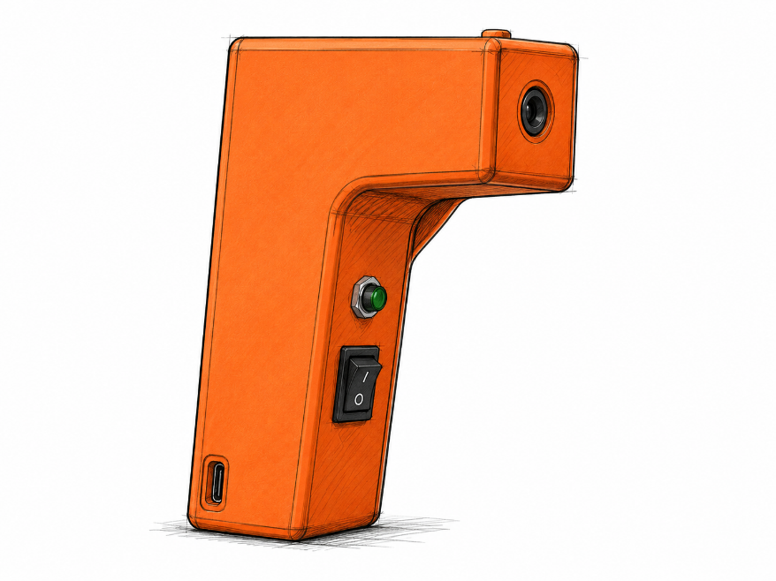

CHANGE RECORDS

FIRST RELEASE

CREATED BY
Name | Title | Date Sign.
Gülşen Demir | System Engineer | 15.05.2026 
CHECKED BY
Name | Title | Date Sign.
Fadime Taş | Quality Engineer | 15.05.2026 
APPROVED BY
Name | Title | Date Sign.
Efe Ateş | Program Engineer | 15.05.2026 

REVISIONS

Rev. No | Change Description | Date | QA Approval

TABLE OF CONTENTS

CHANGE RECORDS……………………………………………………………………………………………………2
FIRST RELEASE………………………………………………………………………………………………………….2
REVISIONS……………………………………………………………………………………………………………….2
1.DRAWINGS……………………………………………………………………………………………………………….4
2.PART LIST ( BILL OF MATERIAL)………………………………………………………………………………….5
3.TECHNICAL DESCRIPTIONS………………………………………………………………………………………..6

- DRAWINGS

1.1 COMPONENTS LOCATIONS & ELECTRICAL INTERFACE

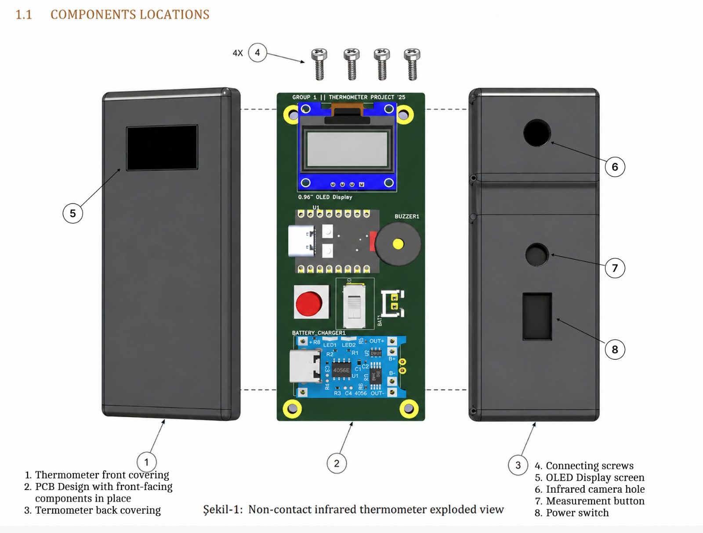

1.3 BLOCK DIAGRAM
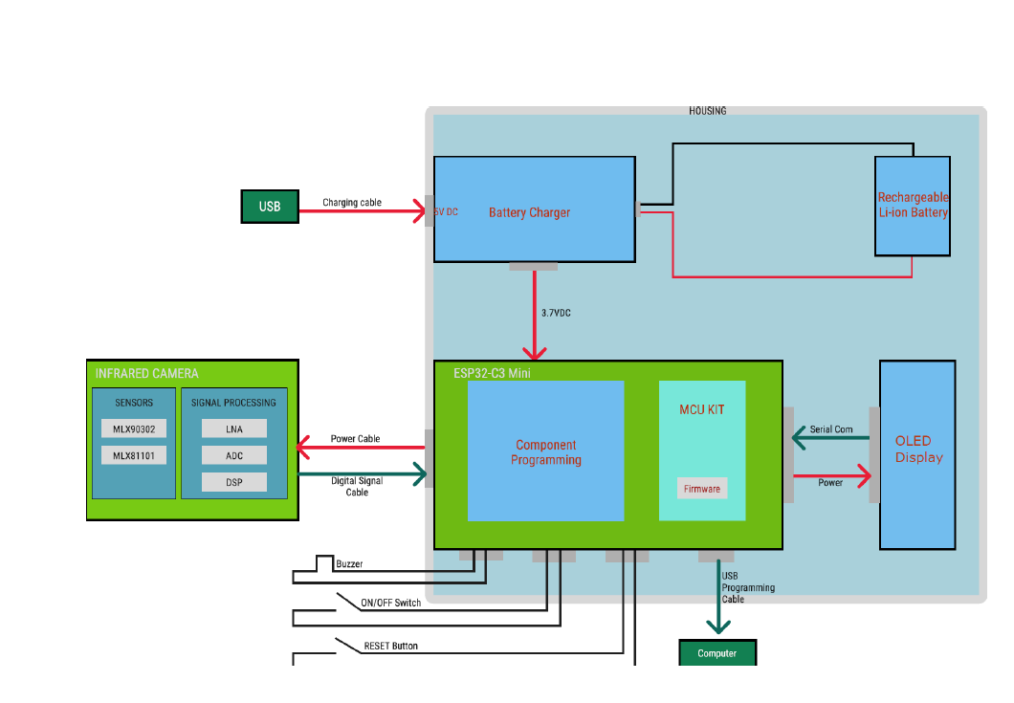
Figure 2:Block Diagram of The Design

2. PART LIST (BILL OF MATERIAL-BOM)
Item | P/N | Description | Location | Quantity
1 | 01-PRT-001 | ESP32-C3 Mini Control Board Assembly |  | 1
2 | 01-PRT-002 | Infrared Camera Module Assembly |  | 1
3 | 01-PRT-004 | OLED Display Module |  | 1
4 | 01-PRT-003 | Rechargeable Li-ion Battery |  | 1
5 | 01-PRT-005 | ON/OFF Push Button | S1 | 1
6 | 01-PRT-012 | Housing, Bottom |  | 1
7 | 01-PRT-012 | Housing, Top |  | 1
8 | 01-PRT-007 | Buzzer | BZ1 | 1
9 |  | Screw, M3 × 12 mm | H1–H4 | 4

3. TECHNICAL DESCRIPTIONS
3.1. The non-contact infrared thermometer is comprised of three main sub-assemblies: the Main Control Board Assembly, Infrared Sensor Assembly, and Power Supply Assembly.
3.2. The Infrared Sensor Assembly measures body temperature without physical contact by detecting the infrared radiation emitted from the target surface. The sensed infrared energy is converted into an electrical signal by the infrared temperature sensor. The sensor output is transmitted to the Main Control Board through the corresponding signal connections for further processing.
3.3. The Main Control Board Assembly provides power distribution to all electronic circuits, processes the sensor data received from the infrared sensor, converts the analog signals into digital values through the microcontroller, and displays the calculated temperature measurement on the OLED display screen. The board also controls the buzzer, measurement button, and power switch functions.
3.4. During assembly, the Main Control Board is first positioned into the bottom housing enclosure. The OLED display, infrared sensor alignment, measurement button, and power switch are then checked and secured in their designated locations before final enclosure assembly.

3.5. Before fastening the top housing cover, an operational verification test is performed to confirm proper device functionality, including display operation, sensor response, and power control. After successful verification, the enclosure is secured using four screws and properly tightened.
3.6. The completed device will undergo functional and performance testing in accordance with the specified Acceptance Test Procedure to verify accurate temperature measurement and overall system operation.

