Analysis of the Relationship Between BIST100 and CSI300 Stock Markets
Efe Demirçelik – 34303
1. Overview
This project investigated the lead-lag relationship between BIST100 and CSI300 from 2015 to 2025. While exploratory analysis revealed a statistically significant correlation, subsequent machine learning and causality tests demonstrated that this relationship is non-causal. The study identifies market volatility and shared global regimes as the primary drivers of simultaneous movements, rather than a direct predictive link.

2. Visualization
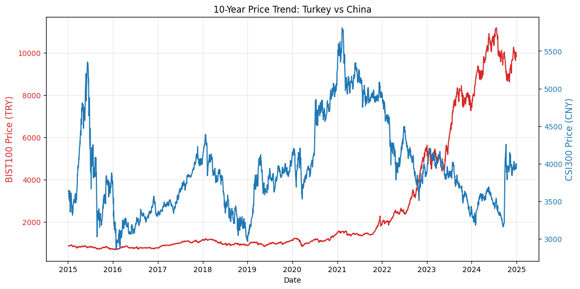
This graph represents the 10-year price trajectories of the BIST100 and CSI300 indices.
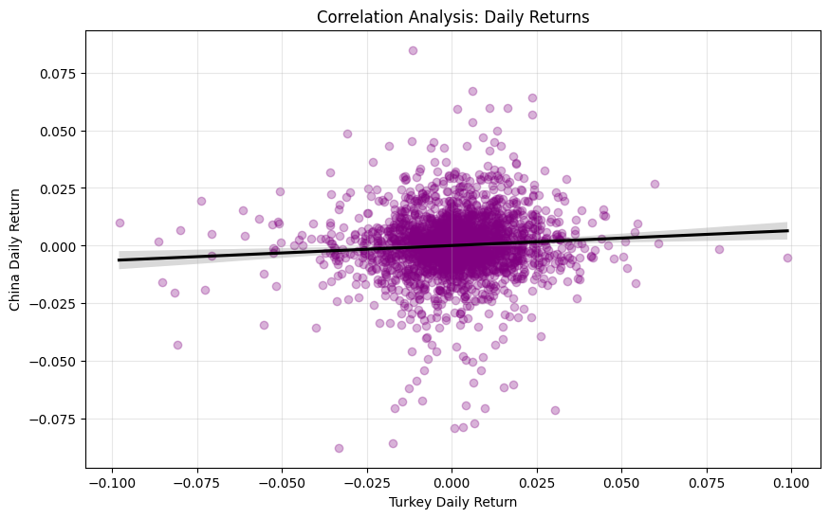
Scatter plot graph with a linear regression line to visually assess the relationship between daily returns of the BIST100 and CSI300 indices.

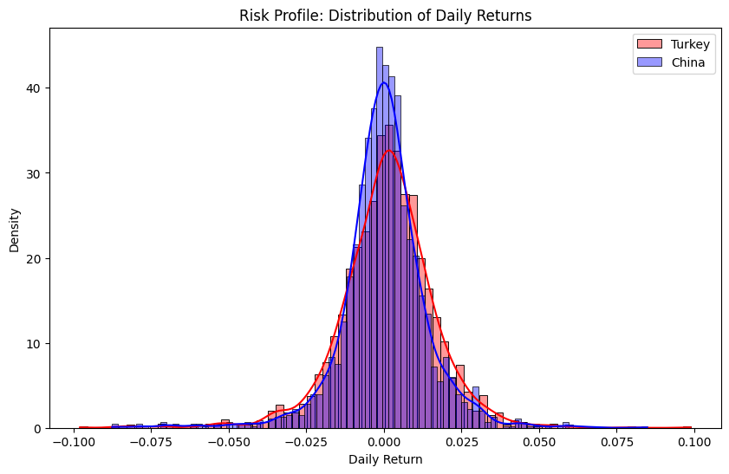
This graph represents an overlapping histogram to compare to the statistical distributions of daily returns for BIST100 and CSI300 markets.
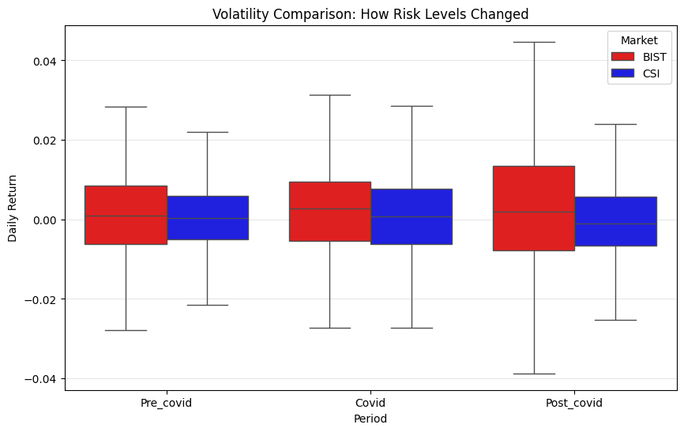
Here we analyze how the relationship between BIST100 and CSI300 changes across three major periods, Pre-Covid, Covid and Post-Covid.
3. Hypothesis Testing
- Null Hypothesis (H₀): There is no significant correlation between daily returns of BIST100 and CSI300 indices.
- Alternative Hypothesis (H₁): There is a statistically correlation between the daily returns of BIST100 and CSI300 indices.
Pearson Correlation (Linear): 0.0718 (p-value: 4.9646e-04)
Spearman Correlation (Rank): 0.0746 (p-value: 2.9581e-04)
Conclusion: Both correlations are very small (0.07) means almost no practical relationship between BIST and CSI daily returns. However, both p-values are extremely small, which means the correlations are statistically significant. For significance level 0.05, reject H₀.

- Null Hypothesis (H₀): The correlation between BIST100 and CSI300 remains constant across Pre-Covid (2017-2019), Covid (2020-2021), post-Covid (2022-2024) periods.
- Alternative Hypothesis (H₁): The correlation structure differs significantly between the pandemic and non-pandemic periods.
Periods Pearson Pearson p-value Spearman Spearman p-value
Pre-Covid 0.1210 0.0013 0.1145 0.0023
Covid 0.1548 0.0008 0.1195 0.0097
Post-Covid -0.0009 0.9818 0.0145 0.7021

Conclusion: BIST100 and CSI300 show correlation before and during Covid, and no correlation after Covid. However, even when statistically significant, the correlation magnitudes are very small. In other words, for pre-covid period reject H₀, for covid period reject H₀, and for post-covid period fail to reject H₀.

4. Machine Learning Analysis
We tested various models to see if we could predict the BIST100 and CSI300.
- Regression Performance
- Baseline Linear Regression: R² = -0.0307.
- Random Forest Regressor: R² = -0.1654.
- Interpretation: The negative R² scores indicate underfitting for linear models and overfitting for non-linear models.
- Directional Classification (Balanced Model)
- Accuracy: 0.5298.
- Class 0 (Down) Precision: 0.65.
- Using balanced class weights allowed the model to finally detect market drops.
- Interpretation: While overall accuracy is near 53%, the model is correct 65% of the time when it predicts a market drop. This shows that the Chinese market provides a more reliable signal for “down” risk than for “up” gains.
5. Advanced Statistical & Unsupervised Analysis
- Granger Causality Test
- P-values (Lags 1-3): 0.4559, 0.6711, 0.7508.
- Decision: Fail to reject H₀.
- Interpretation. There is no causal relationship. Past returns in China do not provide additional information to predict future returns in Turkey. The markets move together simultaneously due to global factors, rather than one market “driving” the other.
- K-Means Market Regimes
- Regime 0 (Growth): High returns (+1.18%), low volatility.
- Regime 1 (Local Bear): BIST drops (-1.04%) independent of China.
- Regime 2 (Crisis): High volatility (2.85%) and deep Chinese drops.
- Interpretation: These regimes prove that the relationship is dynamic. The markets only sync up strongly during Regime 2 (Crisis), while they remain independent during “Growth” periods.

6. Conclusion
The BIST100 and CSI300 share a significant correlation but not causal link. The Turkish market’s strong inflationary drift creates a persistent upward trend that masks international signals. This study concludes that while monitoring China is useful for identifying global “Crisis” regimes, it does not provide a statistically significant “lead” time for predicting daily Turkey returns.

References
Data: Investing.com (BIST100, CSI300, MSCI World Index)
Python Libraries: Pandas, NumPy, Matplotlib, Seaborn, Scikit-learn, Statsmodels

