Sabancı University
Faculty of Engineering and Natural Sciences
Computer Science and Engineering

PixelProof AI Image Detection and Reliability Evaluation
CS395 Internship Final Report
Efe Han Keleş
Student ID: 31994
Company: Türk Telekomünikasyon A.Ş.
Supervisor: Önder Çelebi
Supervisor title: Director
Internship: 20 July–18 September 2026
Approved duration: 40 internship days
Format: Hybrid
Submission date: 8 October 2026

Abstract
Türk Telekomünikasyon A.Ş. is a corporation which provides a wide range of technological services. The internship was completed at this institution. The internship project named PixelProof had some goals to achieve. One of them was making a detector which can differentiate AI generated images from real images and find areas edited by AI. Another goal was to reduce false alerts, such as classifying an image as AI generated even if it is real. There were several methods used in this project. Experiment results were recorded, and new steps were decided according to these results. The project produced a web demo which includes a system that classifies images. In addition, the web demo was designed with a user-friendly interface. False alerts like classifying a real image as AI generated decreased on the development data. However, this does not indicate that results are fully reliable. There were some challenges. One of them was the difficulty of detecting specific areas manipulated by an AI generator due to data problems and the way AI generators edit images. These problems contributed to this part of the project remaining experimental. For future development, the system should be tested on datasets not used during development, and new actions should be decided according to the results.

Table of Contents
1. Introduction: 4
2. Company information: 4
3 Project Background: 6
3.1 Department information: 6
3.2 Initial project status: 6
3.3 Motivation and problem definition: 6
3.4 Related Literature: 7
4. Internship project: 9
4.1 Project objective and scope: 9
4.2 My Responsibilities: 9
4.3 Methodology and tools: 10
4.4 Expected outcomes and deliverables: 11
4.5 Project details: 11
4.5.1 First models and early tests 11
4.5.2 Finding and correcting errors 12
4.5.3 Preparing the images 12
4.5.4 How E92 works 13
4.5.5 How we checked model performance 14
4.5.6 E92 results and remaining problems 15
4.5.7 How the web demo makes decisions 16
4.5.8 Further tests and unsuccessful changes 17
4.5.9 Detecting edited areas with Model2 18
4.6 Results 19
5. Internship experience 20
5.1 Learning: 20
5.2 Relation to undergraduate education: 20
5.3 Major Difficulties: 21
5.4 A typical day 22
6. Conclusion 22
7. Recommendations 23
8 REFERENCES 24

1. Introduction:
The main purpose of this Internship project called PixelProof is to detect whether a photograph is AI generated or AI manipulated. This project contains two modules. First one is Module1. This module simply looks at the whole image and searches for signs of AI generation. Second one is Module2. This module looks at specific areas of the image and tries to detect AI touched areas, but this module remains experimental. One of the major goals of this project is to avoid incorrect labeling, such as labeling real image as an AI generated image. Results of the project improved on the development data however, there are no guarantees that the result is fully trustworthy. The main result is a web demo which allows users to upload images supported by user friendly interface.
My internship was from 20 July to 18 September, and there were 40 working days. This report will show you the process of the development of the project and the experiment, decision-making process. The sections in this report refer to different contents. For instance, section 2 is about Company introduction, section 3 gives information about the background of the project and problem description, section 4 discusses development of the project and its results, section 5 gives information about Internship experience, section 6 and section 7 are about conclusion and recommendations, section 8 contains references.

2. Company information:
Türk Telekomünikasyon A.Ş. has a deep rooted history of over 185 years. The company has various technological services such as fixed phone, mobile services, television, broadband and data services for households and businesses. Clients of this company are individual users, businesses and other telecommunication operators (Türk Telekom, 2026b).
Address of the company registered at Turgut Özal Bulvarı, 06103 Aydınlıkevler, Ankara. However, my internship period continued at Fatih Sultan Mehmet Mah., Balkan Cad. No:49, 34771 Ümraniye, İstanbul. According to a report from June 2026 company has offices in each province in Turkey and has 31,756 employees (Türk Telekom, 2026b). Company's official web site is https://www.turktelekom.com.tr and internship contact number is +90 312 555 93 92. Ownership is 60% Türkiye Wealth Fund, 25% Treasury and Finance Ministry and 15% publicly traded shares. Subsidiaries include TT Mobil, TTNET, Argela, İnnova, SEBİT and AssisTT (Türk Telekom, 2026a). Nokia supplies fixed and mobile network equipment and related services to the Türk Telekom group (Finnvera, 2025). In addition, one of the main competitors mentioned in my internship period was Turkcell.
The various departments and their responsibilities are illustrated in Figure 1. Network and IT departments take care of infrastructure, commercial departments deal with customers, and financial, human resources, and coordination duties are managed by support departments (Türk Telekom, 2026a, p. 33). The department I worked for was Planning and Development Directorate, whose responsibility is Tivibu software and hardware. The head of this department was Önder Çelebi.
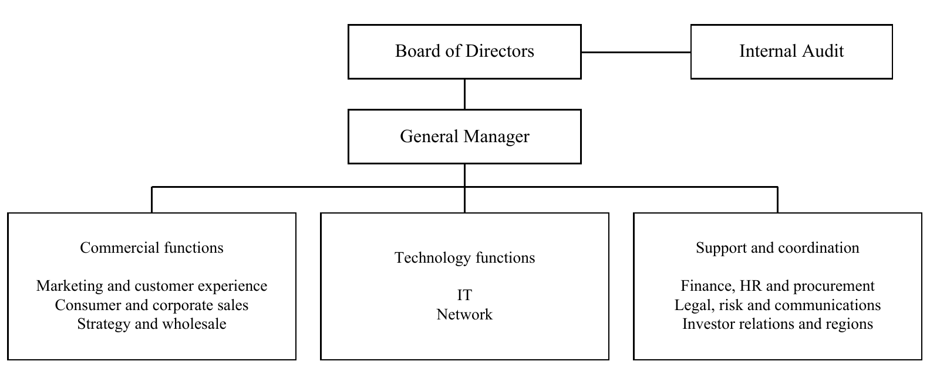
Figure 1. Simplified corporate reporting structure from the 2025 Annual Report.

3 Project Background:

3.1 Department information:
My working unit was the Planning and Development Directorate which focuses on the development of Tivibu software and hardware, my supervisors name was Önder Çelebi (onder.celebi@turktelekom.com.tr) who is the director of this unit. My mentors name was Hasan Çontuk (hasan.contuk@turktelekom.com.tr), who works for Önder Çelebi’s team.
This project was developed individually, there were no group members. I asked help for my project from my supervisor and my mentor time to time. Most decisions of the project were decided by me.

3.2 Initial project status:
Initial step was to prepare dataset which includes AI generated images and real images named CIFAKE. The dataset separated into 3 groups train, validation, test. Next step was to train a CNN model (small CNN) and investigate the results. This model showed good performance in the test set and accuracy was 96.75%, but in a different dataset which does not include CIFAKE images, the performance of the model dropped, and accuracy decreased to 77.1%. These results showed that performance changed on a different dataset. Later checks found differences in image format and size between real and AI images. The images were converted to a common JPEG format and cropped into squares, and the test was repeated. There was no clear drop in AUC after these changes, so this check did not prove that those differences caused the original performance gap (Keleş, 2026, E1 and E10).

3.3 Motivation and problem definition:
One of the main problems of this project was misclassification. This misclassification includes two types. The first type is false positive which means that a real image is considered as AI generated. The second type is false negative which means AI generated images do not get recognized by the model. There are some possible solutions, but there might be performance drop in other metrics. For instance, when more images are classified as AI generated, AI detection may increase. However, more real images may also be incorrectly classified as AI generated. Another factor is image features such as format, size, compression level. These factors may lead the model make mistakes. Therefore, these image features should be optimized.
The main motivation of this project to build a system that help users to differentiate AI generated images from real images. Therefore, reducing the error rates was crucial. Optimization of the features is necessary. Also, the system has a web demo with user friendly UI

3.4 Related Literature:
There are several related literatures that this project took advantage, and these literatures will be explained, and they are related for this project will be discussed.
Wang et al. (2020) explored that a model that learned images that generated from certain AI generator could detect other images that generated from different generators this research is related since this project tries to detect images from various generators.
Ojha et al. (2023) studied how a pretrained vision model’s features could be used to detect AI generated images by adding a simple classifier. This is related to this project because some methods follow similar approaches.
CLIP could be considered as a feature extractor from images (Radford et al., 2021). The Project used these extracted features to detect AI generated images.
DINOv2 is a pretrained model that learns features that could be used in different tasks, and this model does not need handmade class labels while learning (Oquab et al., 2024). Its relationship with this project is that features extracted from images by DINOv2 were used in training models that differentiate real and AI generated images.
According to Grommelt et al. (2024) model could learn image size or compress methods instead of AI traces. Therefore, this might produce misleading results. Relationship between this project is there are some findings that patterns of image size and compression methods could affect performance.
DEAR uses inpainting of a specific region of an image to examine the features and discards some features in order to have stronger results (Kim et al., 2026). In this project this model should be examined carefully since capabilities of this model does not mean that these capabilities could help to solve our problem or enhance our results.
SIDD is a dataset which contains images from 10 different scenes taken with 5 different smartphone cameras. This might be valuable for this project because of camera diversity. However, this does not mean that there is a wide variety of scenes; on the contrary, scene diversity is limited (Abdelhamed et al., 2018).
The SID dataset has paired images that were captured using low light conditions RAW images (Chen et al., 2018). The use of SID in the current project made it possible to incorporate actual images captured in low light situations. Nevertheless, RAW images are processed under different conditions compared to JPEG images.
High score of the model does not mean that the result will have the same accuracy rate. Scores need to be examined carefully and some methods like calibration can make scores match actual accuracy better (Guo et al., 2017). In our web demo we cannot demonstrate the score as the probability of being AI generated. Also, choosing a threshold value does not mean transforming the score into a probability.
Dwork et al. (2015) explains that repeatedly using the same evaluation results to make changes can make those results less reliable as evidence of performance on new data. This is related to our project because some datasets were used several times during development. Therefore, an independent final test was still needed.
Adobe Content Credentials records information about where content comes from and how it was edited (Adobe, 2026). PixelProof follows a different approach by examining image pixels for AI traces. Checking Content Credentials was not implemented in this project.

4. Internship project:

4.1 Project objective and scope:
This project has two modules. First module name Modul1 aims to reduce false alerts while preserving rates of AI detection. Second module named Modul2 aims to detect specific areas that are manipulated by an AI generator. These are the main objectives that project considers.
The scope consists of several concepts. First one is data auditing which means investigate the data and find abnormal features such as format, size, compression and normalize. Second one is model adaption that allows already trained model to solve your problem. Third one is evaluating the results and take an action according to the results. Production deployment and checking content credentials were outside the scope of this student project.

4.2 My Responsibilities:
My Responsibilities were Directing the experiments and take actions according to results and saving experiment results for future experiments. Another one is organization and normalization of the data and that includes tasks such as find suitable dataset, normalize the features or change the format of the images. Another one is asking questions to my supervisor and mentor and learn new concepts or review concepts that I already knew and give reports on what I achieved and what decision I made. Also, my work includes designing user friendly interface, model training.

4.3 Methodology and tools:
There were several main documents that recorded named as PLAN.md , EXPERIMENTS.md , HISTORY.md , DATASETS.md. First one is planning the action that the next step will execute. In this document rules, restrictions, and order of the steps were written. Second one is recording results of the experiments that conducted. Third one is important took records of why and how the decisions made, forth one is the record of dataset that used in the project and small information about the why this dataset selected and mostly numerical information about what the dataset includes. Table 1 shows how these records used and what changed in the next step (Keleş, 2026).
Table 1. Examples of findings that changed development.
Finding | Response
Reversed source labels | Remap labels and rerun experiments
Evaluation-dependent threshold | Use calibration data only
Better average but new AI misses | Reject the candidate
Dataset used to train model. Results of experiments allowed to find when and in which data the model make false detections. While doing this concept called AUC helped to evaluate model performance. Development of model performance did not mean fully reliable results. Therefore, in some experiments new dataset added to library to train or evaluate. Also, threshold values are determined by calibration data.
Some tools that used in this project were: AI tools for implementing code, documenting records, Python, PyTorch, NumPy, SciPy and scikit-learn supported modelling; React, TypeScript and FastAPI supported the demo. Git, saved scores, artifact hashes and automated checks made changes traceable. Full experiment settings, corrections and aggregate evidence remain in the repository snapshot cited as Keleş (2026). Private images and large weights are excluded from Git.
In every new model, if fixing a mistake cause another mistake such as, AI detections rate increased but, real image detection rate decreased did not count as a valid development. However, these developments were recorded even if they are count as unsuccessful. That’s why it is understandable that a new model developed but web demo did not updated.

4.4 Expected outcomes and deliverables:
A model that trained which is integrated in a web demo, reproducible experiments, records that are includes whole project timeline, an experimental Model2, but needs further research and experiments.

4.5 Project details:

4.5.1 First models and early tests
The first model called small CNN trained with CIFAKE dataset which includes 90,000 training images, 10,000 validation images and 20,000 test images. Another model called ResNet-18 which is a pretrained model performed similar 97.66%. However, when dataset separate data set which is consist of 995 images model performance drop down to 25.2%. A resolution control improved performance, suggesting that the difference in input preparation contributed to this result. (Keleş, 2026, E1-E6).
After training the first models, next step followed by comparing several methods. Such as analyzing images in their original resolution, utilized features extracted from smaller image patches, use already trained detectors and combining model outputs. Some of these methods achieved higher scores on certain datasets than others. However, in some cases error rates increased in both cases such as detecting real or generated image. These controlled experiments lead us to give more importance to quality of the data and diversity and determining the criteria for models rather than looking camera noise or other features of image (Keleş 2026, E8-E50)
It turns out that before making an expensive change in a model data quality and status should be examined more comprehensively.

4.5.2 Finding and correcting errors
Noticing reverse labeling in two dataset which means real, and AI generated images labelled opposite after correcting this labeling and repeating experiments scores of AUC of DINOv2 increased 0.480 to 0.764. Therefore, interpretation of unsuitableness of the model was wrong and using more training data decreased the false alerts compared to first calculations
In a different experiment, the threshold selection procedure can employ test data. This is like having access to the exam questions before sitting for the exam. Once this issue was fixed, the candidate model no longer satisfied the acceptance criteria and thus failed (Keleş, 2026, E19b-E19c and E27).
Reverse labeling may cause a model to perform poorly in the task, therefore after correction experiments repeated and recorded.

4.5.3 Preparing the images
Parent means that initial image that there was no process applied by us. In E92 there were 7,674 real and 4,595 AI generated images in total 12,269. For each image 4 versions were created. First one is clear version, second one is imitating transport version, third one is compressed version JPEG with quality 75, fourth is reduced version with the longest edge at most 1080 pixels and compressed with JPEG quality 75. Therefore 49,076 image versions were obtained from 12,269 initial images.
Table 2 shows the datasets that were used in separate processes. The sum of the images cannot be represented as independent images because groups might overlap. Experiments E42 and E43 did not meet the conditions. E43 passed 11 out of 20 conditions in the test where 1,000 real and 1,000 AI generated images were used. There were 391 false alerts in original versions of real images and 490 false alerts in processed real images. E92 did not meet the acceptance rule and therefore did not reach the last evaluation phase. So, development results should not be confused with the last test phase (Keleş, 2026, E42,E49, E92 and E139).
Table 2. Training and evaluation populations at different stages.
Population | Parents | Views | Role
E42 evaluation | 16,953 | 50,858 | Earlier model evaluation
E43 on E49-C | 2,000 | 4,000 | Earlier final evaluation
E92 training | 12,269 | 49,076 | Training
E92 on E66 | 320 | 640 | Reused development
Later research | 12,525 | 50,100 | Internal diagnostics

4.5.4 How E92 works
Firstly, several methods tried such as retraining already trained model (fine tuning) or change image tones to grey or making modifications on model scores. However, all the conditions were not met. After adding features of CLIP and DEAR and developing new pieces that can learn from these features, E83 and E86 passed 17 out of 20 controls. E92 passed 20 of them. However, understanding and explaining explicitly what change made the model passed the controls cannot be determined. Because in every phase there were more than one changes. In addition, passing 20 controls does not mean rule of detecting AI generated images also passed. In E92 weights of DINOv2, CLIP and DEAR weights did not change only training the little pieces with the information that these models extract from image. The main goal was preserving AI detection rates while reducing the false alerts on real images. However, this needs to be tried on other datasets. Figure 2 shows that how the learned system connected the web demo.
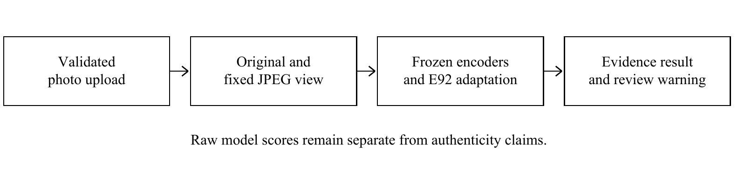
Figure 2. PixelProof inference flow from upload to displayed evidence.
Transfer learning means using what trained models learned previously and benefiting from them. Encoder transforms images into numerical information. This information was used to train little pieces. In addition, weights of the encoder did not changed. Therefore, this method resulted in a more suitable workflow on this computer. DINOv2, CLIP or DEAR were not developed in this project. Only the information that these models extract from images was used to train little pieces. The system resulting from this method was evaluated and modified.

4.5.5 How we checked model performance
Table 3 shows the scores that E92 got and includes 10 numerical conditions for both image versions such as original image and processed image, so in total there are 20 conditions. This list created for this project these conditions are not mean universal standards for image detection model. Some of the conditions are related to each other. Even if E92 passed all the conditions but missed an AI generated image which was detected by previous model. Therefore, passing all conditions does not mean full acceptance.
Table 3. E92 numerical development checks and their measured values.
Criterion | Requirement | Original | Social
Valid-score coverage | 100% | 100% | 100%
ROC-AUC | ≥0.90 | 0.9998 | 0.9942
Balanced accuracy | ≥85% | 99.69% | 95.31%
Pooled real false alerts | ≤10% | 0.00% | 8.75%
Worst real source | ≤20% | 0.00% | 18.75%
Pooled AI detection | ≥80% | 99.38% | 99.38%
Worst AI source | ≥60% | 98.75% | 98.75%
Automatic coverage | ≥80% | 98.75% | 98.44%
Accuracy when automatic | ≥95% | 99.68% | 95.24%
Uncertain fraction | ≤20% | 1.25% | 1.56%

4.5.6 E92 results and remaining problems
Figure 3 includes E43, E86 and E92 results on the same 160 real images. The following comparison focuses on E43 and E92. There are three key findings. First one is false alert on real images were dropped down 68 to 0. Second one is false alert of processed image dropped down 68 to 14. Third one is E92 detected 159 out of 160 in both original version and processed version of AI generated images. For both versions, 10 numerical conditions were determined, making 20 in total, and all were passed. However, E92 missed one original AI image which E43 had detected. In addition, there was a rule that a new model should not miss an AI image detected by the reference model. Therefore, E92 passed all 20 numerical conditions, but did not meet all the acceptance conditions.
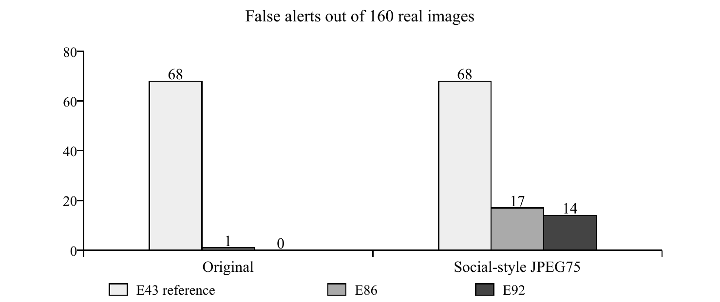
Figure 3. False alerts among 160 real development images per condition.
This set have been used few times in separate experiments. This set includes ten real SIDD scenes and two previously seen AI families. In addition, E102 performed 12 out of 160 false alerts in processed real images which indicates that better performance than E92. Since E92 performed 14 out of 160 false alerts in processed real images. However, E102 missed same AI generated image, so the model cannot be accepted. (Keleş, 2026, E92 and E102).

4.5.7 How the web demo makes decisions
In the web demo 0-100 does not demonstrate that the probability of an image being AI generated. There are two threshold values that come from previous experiments. The first one is the upper bound which comes from E48 calibration. If the original image’s score exceeds 7.94 or at this score demo gives AI alert. The second one is lower bound which comes from E49 calibration and development analysis. If both version of image, original and processed, are below approximately 1.15 demo indicates that there are no clear signs to label as AI generated. Otherwise, the result is ambiguous, which means demo cannot classify the image AI or real image. However, this is not mean that an image with no clear AI signs is definitely real.
In the same development dataset, out of 160 real images, 139 had no clear signs of being AI generated, and 21 images were uncertain. There were no AI alerts on real images. Out of 160 AI generated images, the demo gave 159 AI generation alerts, but one image was uncertain. These results came from the web demo, which considered two versions of each image, original and processed. According to previous findings, evaluation was done separately for both versions of the images. In addition, there were some controls that checked the uploading process and code flow. These controls checked software operation, not image detection accuracy (Keleş, 2026).

4.5.8 Further tests and unsuccessful changes
Photographs that come from mostly same mobile phone and contains similar scenes were selected from my gallery. And number of photographs were 206 and real image. Then conducting a test score were like this. 9 false alerts in original version of image and there were 18 false alerts in processed version. In addition to this, this set cannot be considered as independent test and the last one since this development set used in development phase. (Keleş, 2026, E95).
While checking the training data there were reduced images to 224 pixel which are percentages were 29.18 for real, 7.68 for AI generated images. This encouraged to think if this difference affecting model performance. However, no clear proof by self. Then new candidate model which uses pixel structure features added. Results were better in non-processed images but worse in processed images. In JPEG75 test AI detection rate reduced 75.73% to 74.15% therefore this rejected. After these experiments there was no enlightening answer that why model performance dropped down. However, the method dropped down the performance identified. (Keleş, 2026, E148–E152). There is need to be conduct independent test for this.

4.5.9 Detecting edited areas with Model2
The main goal of Model2 was to detect areas edited by an AI generator. However, there were several challenges that limited the development experiments. For example, finding a suitable dataset for manipulated areas. In addition to this some AI generator might affect areas that outside of the specific region which was intended to be manipulated. According to Table 4, detecting edits in a new area improved, but performance in the original area decreased and false alerts on real images increased. Because of this, Model2 remained experimental, and this candidate was rejected (Keleş, 2026, E105, E109, E117, E122 and E129–E135).
Table 4. Model2 trade-offs on sixteen reused parents, original-image condition.
Endpoint | Earlier head | Two-placement head
Original-placement pixel AUC | 0.74 | 0.70
New-placement pixel AUC | 0.57 | 0.64
Authentic falsely flagged area | 17.11% | 25.74%

4.6 Results
Result of this all experiments and development phase a web demo and repeatable experiment system. Table 5 indicates the measurements that E92 performed in particular dataset which has two version of datasets which are original, and processed images and dataset split in terms of real and AI generated. There were 160 real and 160 AI generated images, making 320 initial images. Each had an original and a processed version, producing 640 views in total. These versions came from the same initial images and were not independent examples. In addition, these are not the results that web demo gave.
Table 5. E92 per-view results on the reused development collection.
Measure | Original | Social-style
AI detection | 159/160 (99.38%) | 159/160 (99.38%)
Real false alerts | 0/160 (0.00%) | 14/160 (8.75%)
Balanced accuracy | 99.69% | 95.31%
Numerical criteria | 10/10 | 10/10
New AI misses versus E43 | 1 | 0
Performance of E92 got better but current model missed an AI generated image, so this is not a proof for reliable result for every images. Model2 remains experimental. 1,245 Python tests passed, but these check software behavior, not image detection accuracy. This was a student research prototype. It was not deployed for company use because broader independent evaluation was still needed. Its impact on the company was not measured (Keleş, 2026).

5. Internship experience

5.1 Learning:
There are several things that I learned through this internship period. One of them is learning how to manage long term and complex project. This is important since, this period improved my perspective in terms of how I treat a problem in complex problem such as, asking spot on questions. this is important since losing yourself in this type of long term and complex project possible. Another one is gaining technical experience and technical information in my project topic. I conducted many experiments, searching academic sources and making comparing my ideas with academic sources to solve my problem. In addition to this, I learned many new machine learning concepts. Another one is working experience. This experience consists of many things such as discipline of going every morning to work with no excuses, making good relationship with your work colleague, understanding the working hierarchy, asking questions about my project without hesitation. In addition this intership had a large impact for my feature carier plans because I learned how to manage large scale project and develop them. Also, helped me to ensure my interest which is machine learning concept.

5.2 Relation to undergraduate education:
There are many courses that have very high relationship with my internship project. One of them is CS 412 Machine Learning course. This course made me familiar with the machine learning concepts, taught me the fundamental concepts that I used early stages in my project such as CNN models. Also, I benefit the looking machine learning perspective. Another one is, DSA 210 this course helped me to understand the data. In this project I treat the data like what I learned in the DSA 210. Therefore, that was crucial because in my project data is important. Another one is PROJ 201. In this course in first time, I met with model training. My interest machine learning interest start because of this course. This course includes dataset creation, model training, evaluating performance of the model. We made a mobile app that navigates FENS first floor that uses our model. Project name was Mobile App for the Visually Impaired, and our group came first place in end of the semester 2025. I wish I had had some previous professional work experience, since this was my first serious working experience. There were no specific technical topics that I wanted to learn before the internship, because in my opinion, these concepts are mostly learned in the field and require practical experience to understand and apply properly.

5.3 Major Difficulties:
There were several technical and non-technical difficulties that I faced during internship period. One of the technical difficulties was understanding why performance of the model drops in certain datasets. In order to solve this problem, I conducted many experiments and record them and found out the possible reasons. After that I planned actions according to reasons to solve these problems. Sometimes these plans worked, but sometimes did not work well. Therefore, it turns out that my experiment method was wrong or there were need more experiments to conduct. Another one is the transportation to the office. My work time start early compared to other start times, so I need to wake up early and tried to do not miss the transportation times. I solve this problem with adapting myself to routine lifestyle, so my sleeping time and waking time always is the same. Another technical difficulty that I faced was finding suitable datasets for next steps. This task was extremely crucial for model training because experiment results depend on the quality of the data. Therefore, choosing a bad quality dataset might affect result and may lead to misunderstand the model performance. Therefore, finding suitable dataset and examining were a hard task to done. To address this, I checked labels, image quality and shared image sources before using datasets in new experiments. Data that failed these checks were kept out of training.

5.4 A typical day
I used to go to office 7.30 a.m. After breakfast I worked until lunch time and take 1 or 2 breaks for personal needs or to drink coffee or tea. After lunch I worked until 4 p.m. and take 1 or 2 breaks. This period repeated on Monday to Thursday. Friday was remote, but there was a similar situation.

6. Conclusion
Result of this project is a web demo with user friendly interface that allows users to upload try the system that I build during this period. This system benefit from all the test that I conducted even if the test is unsuccessful. In my perspective main power of this project was learning from unsuccessful test since in every test I found new findings or search topics to integrate to system.
Main topic for this project was finding a way that how to classify AI generated images and real images without making false alerts. Thanks to experiments that I conducted even if tests were unsuccessful, I manage to come a point in this problem. Cannot solved this problem fully or do not guarantee a fully trustworthy result, but it showed measured improvements on the development data.

7. Recommendations
For future students that will take this internship course I might give several recommendations that enhance their internship experience. One of them is the communication between their supervisor and mentors in order to express themselves and get a project that in the line with their interests. This is important, since in my experience I felt like need to learn not like I must. Another advice is trying to learn the concepts related to their project before internship period start because it allows students being ready for project. Another one is students must arrange their lifestyle according to internship conditions. This allows students to overcome easier than usual lifestyle.

8 REFERENCES
Abdelhamed, A., Lin, S., & Brown, M. S. (2018). A high-quality denoising dataset for smartphone cameras. Proceedings of the IEEE Conference on Computer Vision and Pattern Recognition, 1692–1700. Retrieved September 29, 2026, from https://abdokamel.github.io/sidd/
Adobe. (2026, August 25). Content Credentials overview. Adobe Help Center. Retrieved September 29, 2026, from https://helpx.adobe.com/creative-cloud/apps/adobe-content-authenticity/content-credentials/overview.html
Chen, C., Chen, Q., Xu, J., & Koltun, V. (2018). Learning to see in the dark. Proceedings of the IEEE Conference on Computer Vision and Pattern Recognition, 3291–3300. Retrieved September 29, 2026, from https://cchen156.github.io/SID.html
Dwork, C., Feldman, V., Hardt, M., Pitassi, T., Reingold, O., & Roth, A. (2015). Generalization in adaptive data analysis and holdout reuse. Advances in Neural Information Processing Systems, 28. Retrieved September 25, 2026, from https://proceedings.neurips.cc/paper/2015/hash/bad5f33780c42f2588878a9d07405083-Abstract.html
Finnvera. (2025, October 23). Finnvera guarantees Nokia’s deliveries to Türk Telekom. Retrieved September 29, 2026, from https://www.finnvera.fi/eng/export-and-internationalisation/finnvera-as-an-export-finance-provider/guaranteed-transactions/finnvera-guarantees-nokias-deliveries-to-turk-telekom
Grommelt, P., Weiss, L., Pfreundt, F.-J., & Keuper, J. (2024). Fake or JPEG? Revealing common biases in generated image detection datasets. arXiv:2403.17608. Retrieved September 25, 2026, from https://arxiv.org/abs/2403.17608
Guo, C., Pleiss, G., Sun, Y., & Weinberger, K. Q. (2017). On calibration of modern neural networks. Proceedings of Machine Learning Research, 70, 1321–1330. Retrieved September 25, 2026, from https://proceedings.mlr.press/v70/guo17a.html
Keleş, E. H. (2026). PixelProof experiment, history and dataset records [Software and research records, commit 497d45c]. GitHub. Retrieved September 25, 2026, from https://github.com/EfeHanKeles346/ai-image-detector/tree/497d45c
Kim, D., Choi, J., Seong, H. S., Kim, S., Lee, D., Yi, S., & Choi, J.-H. (2026). Dissect and prune: Enhancing robustness in AI-generated image detection. ICML 2026; arXiv:2606.10309, version 2. Retrieved September 25, 2026, from https://arxiv.org/abs/2606.10309v2
Ojha, U., Li, Y., & Lee, Y. J. (2023). Towards universal fake image detectors that generalize across generative models. Proceedings of the IEEE/CVF Conference on Computer Vision and Pattern Recognition, 24480–24489. Retrieved September 25, 2026, from https://arxiv.org/abs/2302.10174
Oquab, M., Darcet, T., Moutakanni, T., Vo, H., Szafraniec, M., Khalidov, V., Fernandez, P., Haziza, D., Massa, F., El-Nouby, A., Assran, M., Ballas, N., Galuba, W., Howes, R., Huang, P.-Y., Li, S.-W., Misra, I., Rabbat, M., Sharma, V., Synnaeve, G., Xu, H., Jégou, H., Mairal, J., Labatut, P., Joulin, A., & Bojanowski, P. (2024). DINOv2: Learning robust visual features without supervision. Transactions on Machine Learning Research. Retrieved September 25, 2026, from https://arxiv.org/abs/2304.07193
Radford, A., Kim, J. W., Hallacy, C., Ramesh, A., Goh, G., Agarwal, S., Sastry, G., Askell, A., Mishkin, P., Clark, J., Krueger, G., & Sutskever, I. (2021). Learning transferable visual models from natural language supervision. Proceedings of Machine Learning Research, 139, 8748–8763. Retrieved September 25, 2026, from https://proceedings.mlr.press/v139/radford21a.html
Türk Telekom. (2026a). 2025 annual report. Türk Telekom Investor Relations. Retrieved September 25, 2026, from https://www.ttyatirimciiliskileri.com.tr/media/dqsjlvxo/2025-annual-report.pdf
Türk Telekom. (2026b). Hakkımızda [About us; operating figures at June 30, 2026]. Retrieved September 25, 2026, from https://www.turktelekom.com.tr/hakkimizda/detay?p=tab3
Wang, S.-Y., Wang, O., Zhang, R., Owens, A., & Efros, A. A. (2020). CNN-generated images are surprisingly easy to spot... for now. Proceedings of the IEEE/CVF Conference on Computer Vision and Pattern Recognition, 8695–8704. Retrieved September 25, 2026, from https://arxiv.org/abs/1912.11035

