# **FBG GAME - GAME FEATURES REPORT**

**Flappy Bird JavaFX Desktop Game**

## **🎮 ABOUT THE GAME**

FBG Game is an advanced desktop version of the classic Flappy Bird game. Developed using JavaFX technology, this game distinguishes itself from simple web versions with its user account system and competitive features.

## **🌟 KEY FEATURES**

### **User System**

* Secure registration and login system
* Personal score tracking
* Demo accounts (demo/1234, test/test)
* Persistent data storage

### **Enhanced Gameplay**

* **Easy Mode**: Wider pipe gaps
* **Dual Controls**: Keyboard (SPACE) and mouse support
* **Smooth Performance**: 60 FPS game flow
* **Real-time Information**: Live score updates

### **Competitive Features**

* Top 5 leaderboard (🥇🥈🥉)
* New record notifications
* Cross-session score persistence

## **🛠️ TECHNICAL FEATURES**

### **Modern Technology**

* **Java 21 + JavaFX 21**: Current technology
* **Cross-platform**: Windows, Mac, Linux compatible
* **Maven Build**: Professional build system
* **Standalone JAR**: Easy distribution

### **Game Engine**

* Realistic bird physics
* Optimized graphics rendering
* Efficient memory management
* Collision detection system

## **🎯 WHAT MAKES THE GAME SPECIAL**

✅ **User Accounts** - Personal profile and score tracking

✅ **Accessible Difficulty** - Easy mode allows everyone to play

✅ **Competition System** - Leaderboard provides continuous motivation

✅ **Desktop Experience** - Full application, not just a browser game

✅ **Professional Quality** - Commercial software standard code

## **📊 VISUAL ANALYSIS**

**Screenshot Analysis:**

* **Clean Interface**: Player information with top-left panel
* **Quality Graphics**: Smooth 2D rendering
* **Easy Mode Indicator**: Marked with "Easy Mode" label
* **Wide Pipe Gaps**: Visually clear spacing for accessibility
* **Control Information**: Clear usage instructions in bottom panel

## **📈 CONCLUSION**

FBG Game transforms a simple web game concept into a comprehensive desktop application. With user management, persistent data, accessible difficulty, and competitive features, it goes far beyond typical Flappy Bird applications.

**Main Achievements:**

* Secure user system
* Accessible gameplay
* Competitive gaming experience
* Modern Java technologies usage

This project demonstrates how classic game concepts can be modernized and how an enhanced desktop gaming experience can be created through professional development practices.

**Technical Information:**

Java 21, JavaFX 21, Maven | MVC Architecture | Cross-platform Desktop

**Prepared by:**

**EFE GÜRAY AYBEK Student ID: 23040102070**

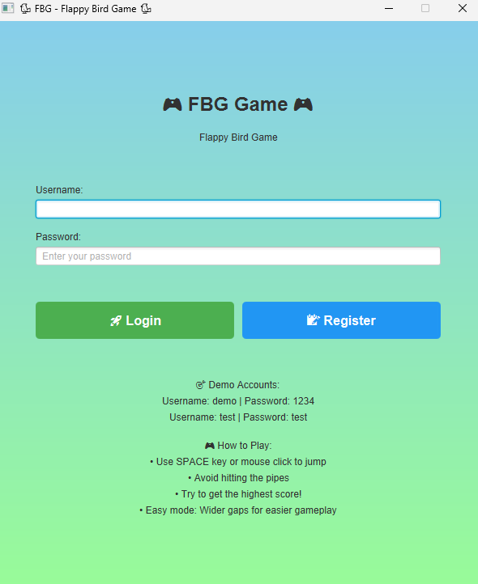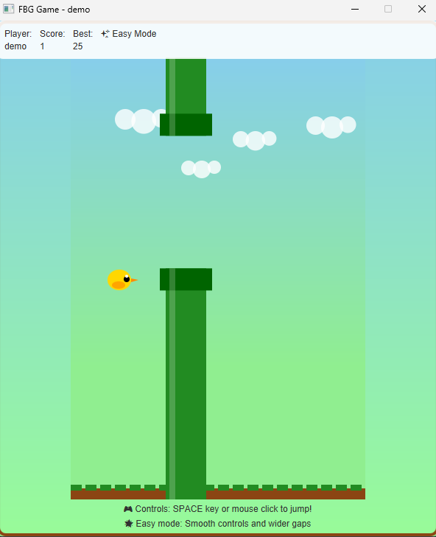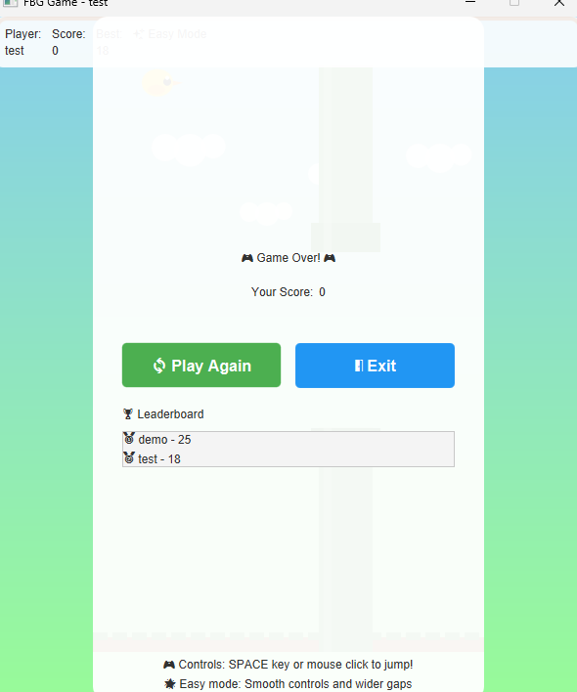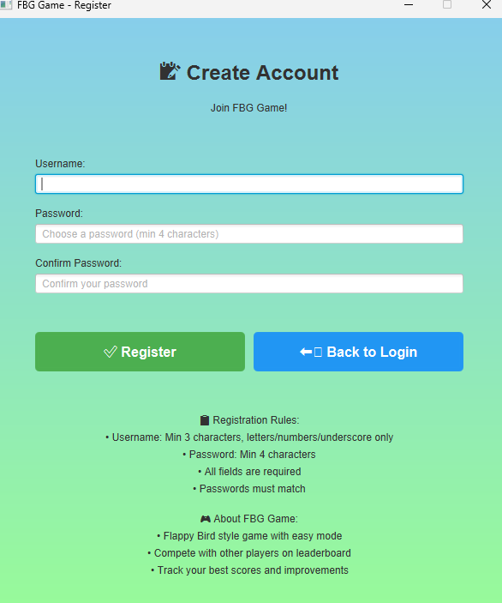

<https://github.com/Efegurayaybek/github-efegurayaybek>

