**Second Approach Using Photodiode**

As a second approach to the project simulation, an online simulation tool [1] which simulates existed components from real life was used. Although the tool has some flaws it helped the purpose. The setup used in the simulation shown below;

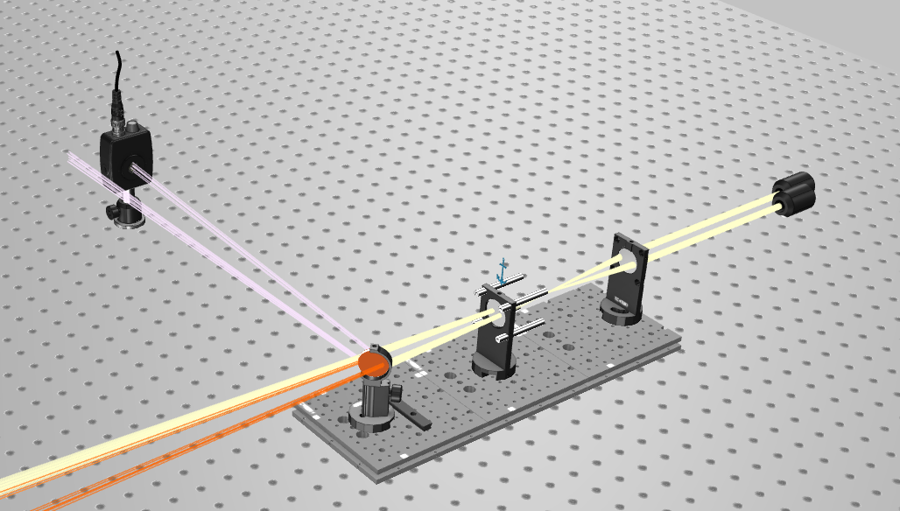

Figure Simulation Setup

The setup consists of two laser light source and two lenses and a reflective surface which can rotates and generate some surface vibration. By using this setup light was captured with photodiode directly in the air, we wanted to move the light in the fiber optic cable, but the simulation tool limitations were not allowed us to do so. However, all these components and the project can be demonstrated in real world by using fiber optic cable, but, of course taking in the consideration its parameters and mathematical model.

In the tool the light captured by the photodiode and its image was processed and shown below;

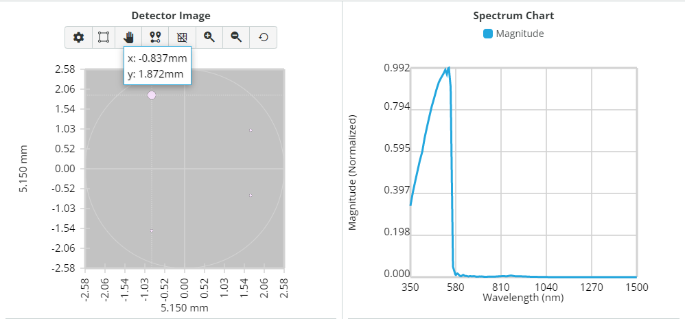

Figure Photodiode Image Capture

As you can see from the figure above 4 light pixels hit the detector, with this tool we can detect the pixel locations, pixels propagation area, and the distances between the pixels, then we can get the magnitude spectrum chart for varying wavelengths.

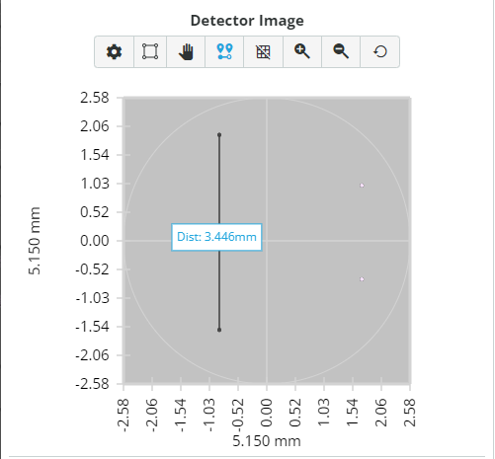

Figure Distance measurement

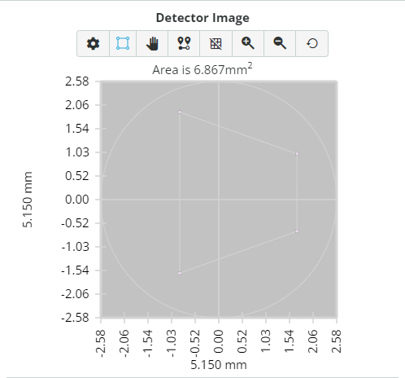

Figure Propagation Area of Pixels

[1] : https://design.3doptix.com/