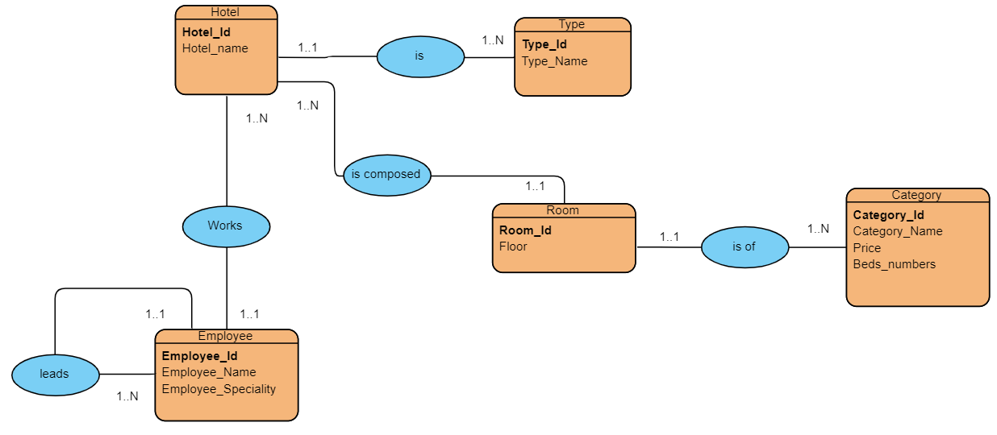

**Fig 1.0 Entity Relationship Model**

**Problem**

1. After the construction of his hotels in one of the tourist areas, a director wishes to prepare a database to facilitate the management of his data. The director has presented the following information to you through the entity relationship model.

* **Instructions**

Convert the entity relationship model to a relational diagram

**Solutions**

1. Hotel ER model converted to Relational model

Solution

1. Hotel (Hotel_id, Hotel_name)
2. Type ER model converted to Relational model

Solution

1. Type (Type_id, Type_Name)
2. Room ER model converted to Relational model

Solution

1. Room (Room_Id, Floor)
2. Employer ER model converted to Relational model

Solution

1. Employee (Employee_id, Employee_Name, Employee_Specialty)
2. Category ER model converted to Relational model

Solution

1. Category (Cartegory_Id, Cartegory_Name, Price, Bed_Numbers)