is.integer(7)

round(7) == 7

is.integer(as.integer(7))

0.33 == 3 \* 0.11

0.45 == 3 \* 0.15

round(0.45, 2) == round(3 \* 0.15, 2)

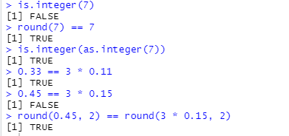

x <- c(7,8,10,45)

y <- c(-7,-8,-10,-45)

x + y

x + c(-7,-8)

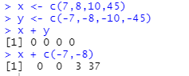

x <- c(1,2,3,4)

x.a <- array(x,dim=c(2,2))

x.a

dim(x.a)

is.vector(x.a)

is.array(x.a)

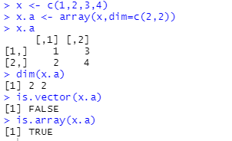

x <- c(1,2,3,4)

x.a <- array(x, dim = c(2,2))

x.a[1,1]

x.a[,1]

which(x.a <= 2)

rowSums(x.a)

x.b <- array(c(-1,-2,-3,-4), dim = c(2,2))

x.c <- x.a + x.b

x.c

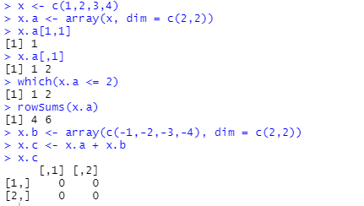

m <- matrix(c(40,1,60,3), nrow=2)

m

is.array(m)

is.matrix(m)

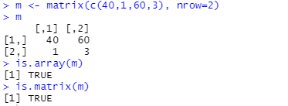

f <- matrix(c(40,1,60,3),nrow=2)

f

six.fives <- matrix(rep(5,6), ncol=3)

six.fives

f %\*% six.fives

f

o <- c(10,20)

o

f %\*% o

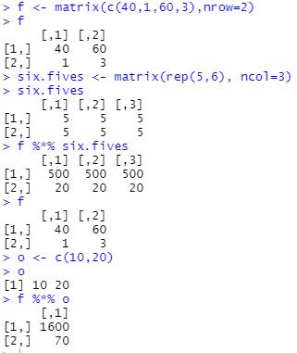

rownames(f) <- c("трудодни","сталь")

colnames(f) <- c("автомобили","грузовики")

f

output <- c(20,10)

names(output) <- c("грузовики","автомобили")

available <- c(1600,70)

names(available) <- c("трудодни","сталь")

f %\*% output[colnames(f)]

apply(f,1,mean)

f

apply(f,2,mean)

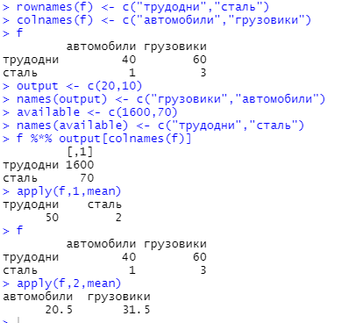

my.lst <- list("exponential",7,FALSE)

my.lst

names(my.lst) <- c("family","mean","is.symmetric")

my.lst

my.lst$family

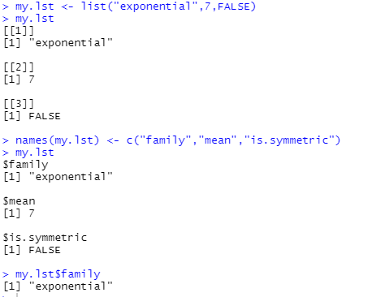

a.matrix <- matrix(c(35,8,10,4),nrow=2)

colnames(a.matrix) <- c("v1","v2")

a.matrix

a.matrix$v1

a.data.frame <- data.frame(a.matrix, logicals=c(TRUE,FALSE))

a.data.frame

a.data.frame$v1

a.data.frame[,"v1"]

a.data.frame[1,]

colMeans(a.data.frame)

rbind(a.data.frame,list(v1=-3,v2=-5,logicals = TRUE))

rbind(a.data.frame,c(3,4,6))

