Vim Tutors

William Rodzen-Staff: 260988756

Efe Ertugrul: 260962235

Timofey Galyanov: 261035970

Jaiten Kang: 261033365

Submission Date: <Enter before submit>

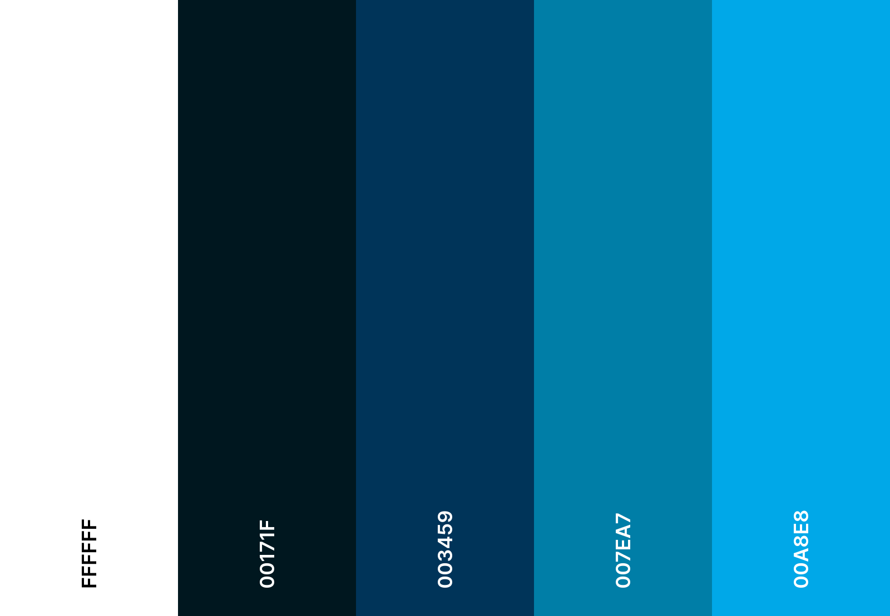Color Palette:

Fonts:

Title Fonts:

Rubik

Oswald

Text Fonts:

--

Logo:

