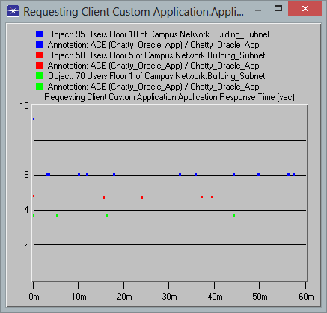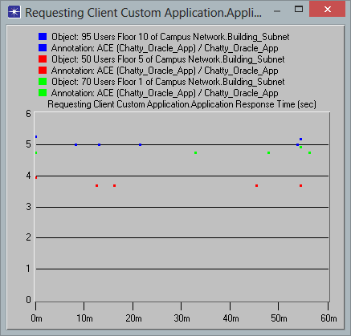

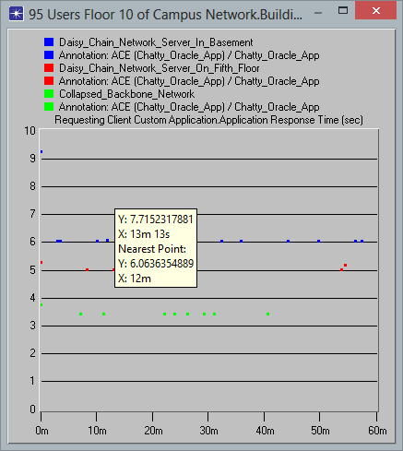

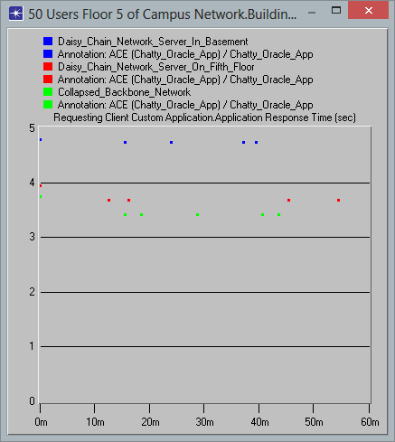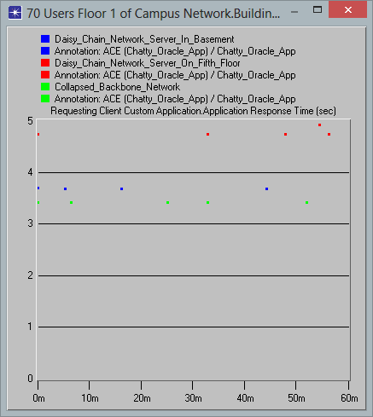

Questions:

1. The scenario that provides the lowest overall response time is the collapsed back bone configuration
2. What probably accounts for the improved performance in that scenario is that the switch on each floor is directly connected to the core switch in the basement
3. Could the ether net cable latency account for the significant part of that delay
4. What might account for the multi-second response time in the best scenario is