F. Colton Parry

Burn Down Charts

Assignment 3

9/18/2014

Chart 1

|  |  |  |  |
| --- | --- | --- | --- |
| Day | Durration | % Comlete | Task |
| 1 | 2 | 5% | Sort Items into importance |
| 3 | 1 | 10% | Garage Sale |
| 4 | 7 | 30% | Start with least important items  Winter Items  Storage Items |
| 11 | 1 | 40% | Garage Sale |
| 12 | 8 | 55% | Pack useful but rarely used items  Excess Clothing  Pillows / Bedding |
| 20 | 1 | 60% | Garage Sale |
| 21 | 8 | 85% | Most Critical Items   1. Bathroom amenities 2. Daily Clothing |
| 29 | 1 | 100% | Ready for movers |

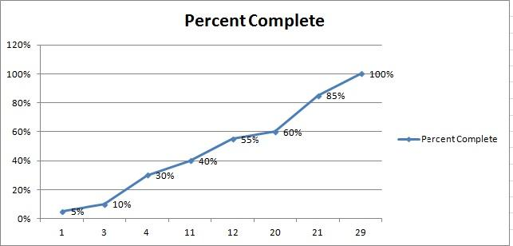

Chart 2

|  |  |  |  |
| --- | --- | --- | --- |
| Day | Duration | Boxes Packed | Task |
| 1 | 1 | 0 | Estimate the boxes needed |
| 2 | 5 | 0 | Gather boxes and packing supplies |
| 6 | 7 | 25 | Start with least important items   1. Offseason items (Winter Clothes) 2. unnecessary items (Camping Gear / Holiday Decorations) |
| 13 | 7 | 75 | Pack useful but rarely used items   1. Excess Clothing 2. Excess Pillows / Bedding 3. Throw Pillows / Home Decor |
| 20 | 7 | 115 | Pack important but not always necessary items   1. Bed Frames 2. Tools |
| 27 | 4 | 150 | Most Critical Items   1. Bathroom amenities 2. Daily clothing |
| 30 | 0 | 150 | Ready for movers |

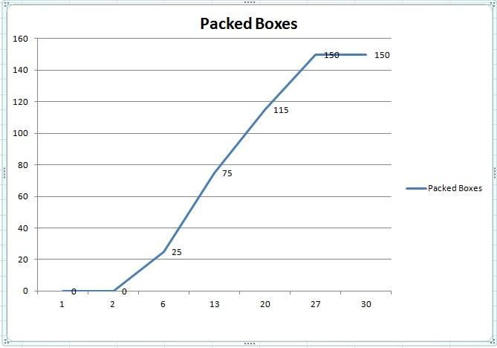

Chart 3

|  |  |  |  |
| --- | --- | --- | --- |
| Day | Duration | Rooms Packed | Task |
| 1 | 1 | 1 | Storage Closet |
| 2 | 5 | 2 | Basement Storage |
| 6 | 2 | 3 | Guest Room |
| 8 | 3 | 4 | Garage |
| 11 | 2 | 5 | Dining room |
| 13 | 4 | 6 | Home office |
| 17 | 4 | 7 | Living room |
| 21 | 4 | 8 | Kitchen |
| 25 | 1 | 9 | Bathroom |
| 26 | 1 | 10 | Bedroom 1 |
| 27 | 1 | 11 | Bedroom 2 |
| 28 | 2 | 12 | Master Bedroom |
| 30 | 0 | 12 | Ready for Movers |

