Lab 03

Joud AlFarra

Tuesday May, 2, 2023

# Packages

library(tidyverse)  
library(sf)

# Data

fl_votes <- st_read("data/fl_votes.shp", quiet = TRUE)  
fl_votes %>%  
 slice(1:6)

## Simple feature collection with 6 features and 5 fields  
## Geometry type: MULTIPOLYGON  
## Dimension: XY  
## Bounding box: xmin: -85.99989 ymin: 25.95675 xmax: -80.01528 ymax: 30.58427  
## Geodetic CRS: NAD83  
## county rep16 dem16 rep20 dem20 geometry  
## 1 Alachua 46834 75820 50972 89704 MULTIPOLYGON (((-82.37389 2...  
## 2 Baker 10294 2112 11911 2037 MULTIPOLYGON (((-82.10107 3...  
## 3 Bay 62194 21797 66097 25614 MULTIPOLYGON (((-85.65968 3...  
## 4 Bradford 8913 2924 10334 3160 MULTIPOLYGON (((-82.274 29....  
## 5 Brevard 181848 119679 207883 148549 MULTIPOLYGON (((-80.49977 2...  
## 6 Broward 260951 553320 333409 618752 MULTIPOLYGON (((-80.29693 2...

# Exercise 1

fl_votes <- fl_votes %>% mutate(winner20 = if_else(rep20 > dem20, "Donald Trump", "Joe Biden"))

# Exercise 2

ggplot(fl_votes) +  
 geom_sf(aes(fill = winner20)) +  
 scale_fill_manual(values = c("#DE0100", "#0015BC")) +  
 labs(title = "Election Winners 2020", fill = "Winner") +  
 theme_bw()

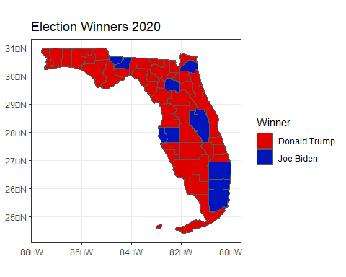

# Exercise #3

fl_votes <- fl_votes %>% mutate(Prop_rep16 = rep16 / (rep16 + dem16),  
 Prop_rep20 = rep20 / (rep20 + dem20))

# Exercise 4

ggplot(fl_votes) +  
 geom_sf(aes(fill = Prop_rep20)) +  
 scale_fill_gradient(low = "#0015BC", high = "#DE0100") +  
 labs(title = "Election 2020 Results", fill = "Republican Share of Votes") +  
 theme_bw()

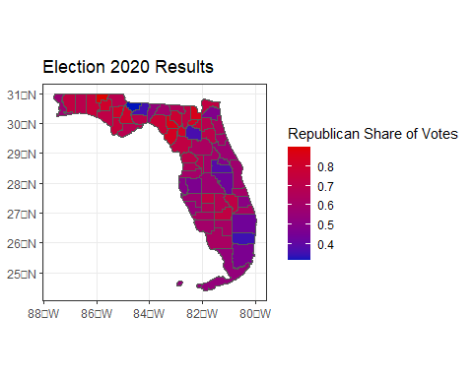

# Exercise 5

fl_votes <- fl_votes %>% mutate(diff_rep = Prop_rep20 - Prop_rep16)

# Exercise 6

ggplot(fl_votes) +  
 geom_sf(aes(fill = diff_rep)) +  
 scale_fill_gradient2(low = "#0015BC", midpoint = 0, high = "#DE0100") +  
 labs(title = "Change in Republican Vote Share Between 2016 and 2020", fill = "Change in Republican Share") +  
 theme_bw()

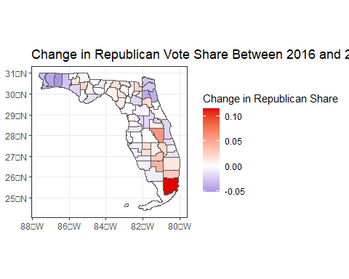

# Exercise 7

-What do the visualizations you developed tell you about the 2016 and 2020 Presidential election in Florida? What are limitations of these visualizations?

The visualizations show that even though the republicans won the 2020 elections, the proportions of the republican party to the democratic party is very close. Limitations of the visualization could be the closeness in shades of colors, which might cause inaccuracy when reading the data.