Lab 03

Layan Jaman

2 May 2023

# Packages

library(tidyverse)  
library(sf)

# Data

fl_votes <- st_read("data/fl_votes.shp", quiet = TRUE)  
fl_votes %>%  
 slice(1:6)

## Simple feature collection with 6 features and 5 fields  
## Geometry type: MULTIPOLYGON  
## Dimension: XY  
## Bounding box: xmin: -85.99989 ymin: 25.95675 xmax: -80.01528 ymax: 30.58427  
## Geodetic CRS: NAD83  
## county rep16 dem16 rep20 dem20 geometry  
## 1 Alachua 46834 75820 50972 89704 MULTIPOLYGON (((-82.37389 2...  
## 2 Baker 10294 2112 11911 2037 MULTIPOLYGON (((-82.10107 3...  
## 3 Bay 62194 21797 66097 25614 MULTIPOLYGON (((-85.65968 3...  
## 4 Bradford 8913 2924 10334 3160 MULTIPOLYGON (((-82.274 29....  
## 5 Brevard 181848 119679 207883 148549 MULTIPOLYGON (((-80.49977 2...  
## 6 Broward 260951 553320 333409 618752 MULTIPOLYGON (((-80.29693 2...

# Exercise 1

#mutate add a new column   
fl_votes <- fl_votes %>% mutate(winner20 = if_else(rep20 > dem20, 'Donald trump','Joe Biden'))

# Exercise 2

ggplot(fl_votes) +  
geom_sf(aes(fill = winner20)) +  
 scale_fill_manual (values = c("#DE0100", "#0015BC")) +  
 labs(title="Election winners 2020", fill="winner") +  
 theme_bw()

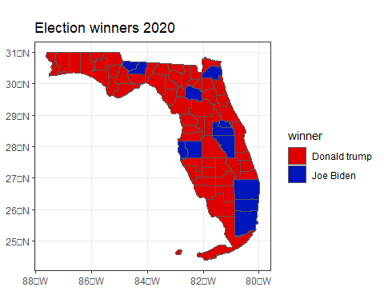

# Exercise #3

fl_votes <- fl_votes %>% mutate(prop_rep16 = rep16/(rep16+dem16))  
fl_votes <- fl_votes %>% mutate(prop_rep20 = rep20/(rep20+dem20))

# Exercise 4

ggplot(fl_votes) +  
geom_sf(aes(fill = prop_rep20 )) +  
scale_fill_gradient(low = "#DE0100", high = "#0015BC") +  
labs(title = "The winner of each county in 2020 election ",fill = "Winner") + theme_bw()

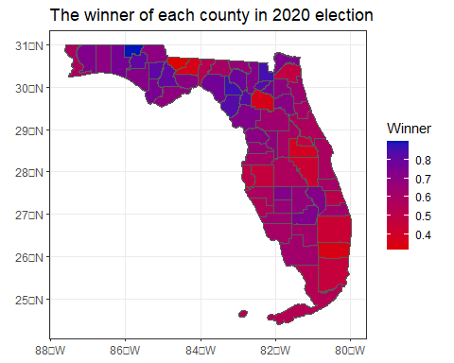

# Exercise 5

fl_votes <- fl_votes %>% mutate(diff_rep = prop_rep20 - prop_rep16)

# Exercise 6

ggplot(fl_votes) +  
 geom_sf(aes(fill = diff_rep)) +  
 scale_fill_gradient2(low = "#0015BC", high = "#FF1D8E") +  
 labs(title = "The change in Republican vote share by county",fill = "Winner") + theme_bw()

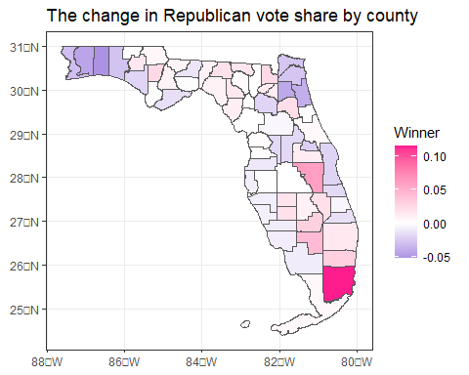

# Exercise 7

They prefer Donald Trump more than Joe Byeden. The limitations of these visualizations: it is only for the 2016 and 2020 U.S.